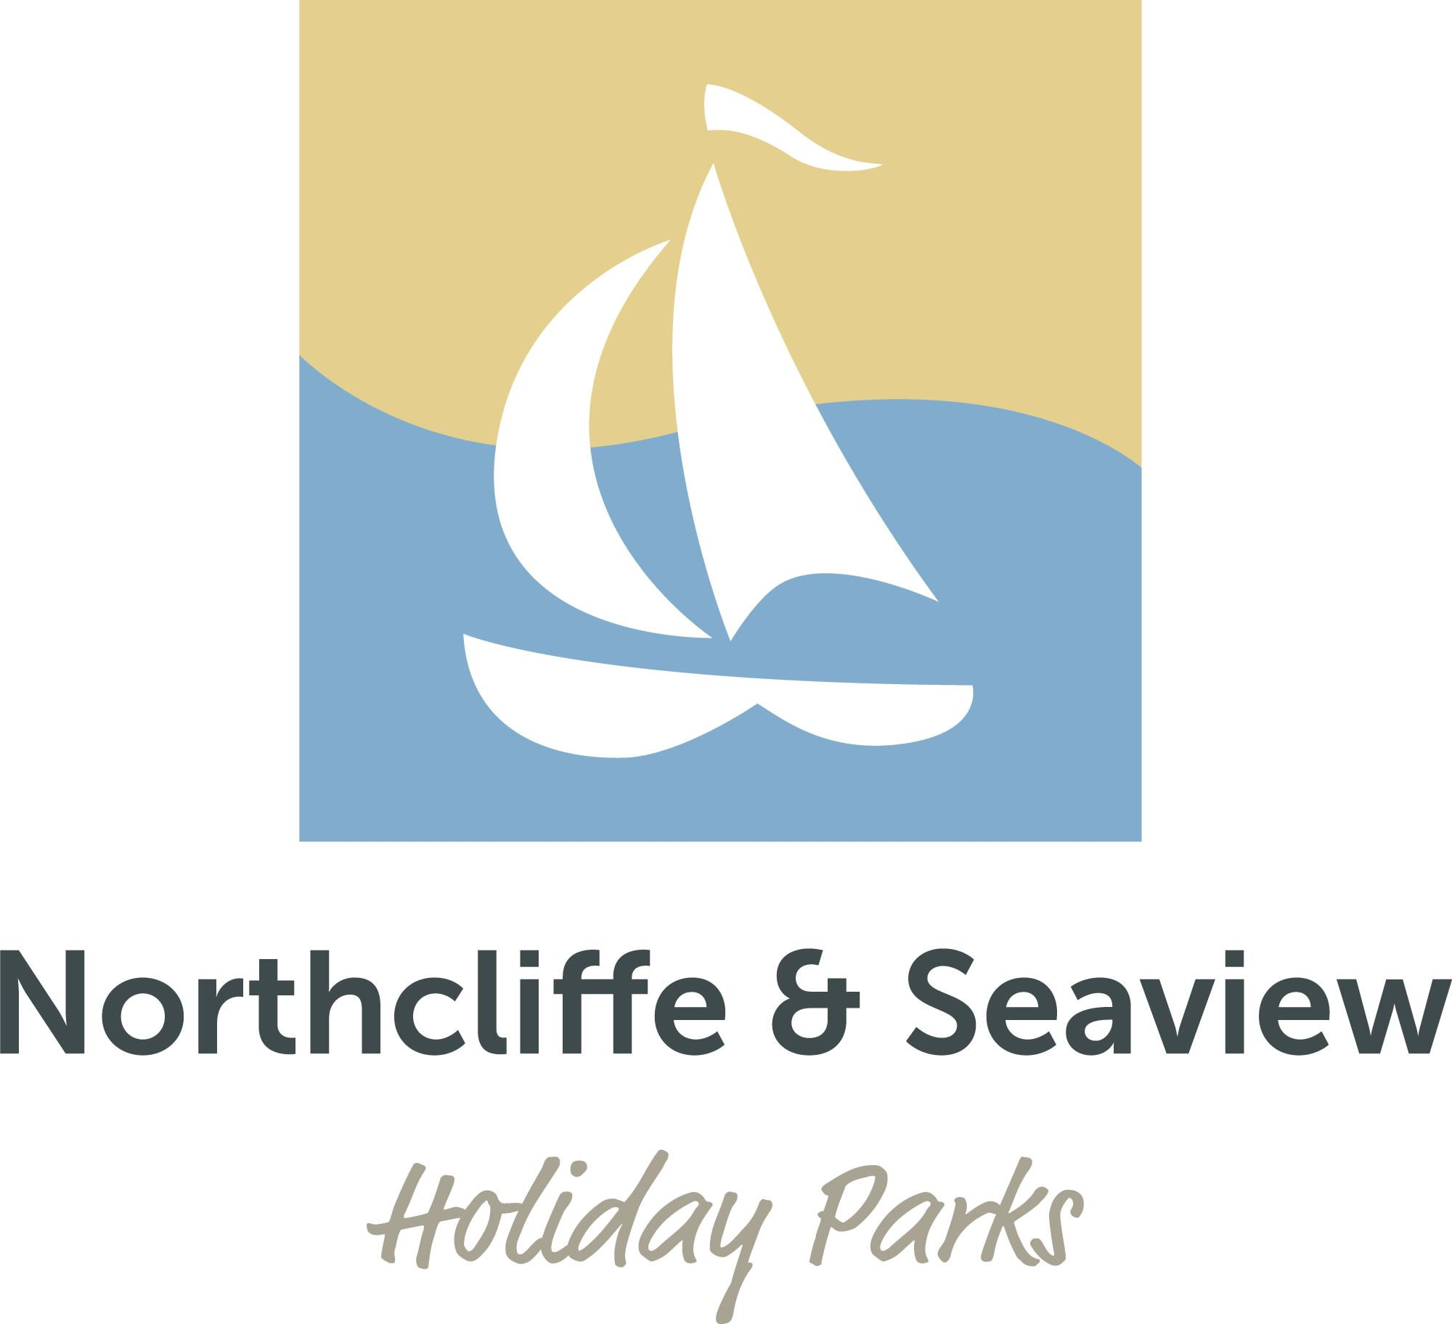

Accessibility Guide for Super Luxury Caravan
enquiries@northcliffe-seaview.com, 01947880477, http://www.northcliffe-seaview.com
Contact for accessibility enquiries: Sophie Martin
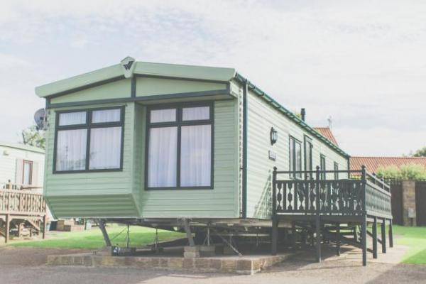

Welcome
Our Super Luxury Holiday Caravans are located on Northcliffe Holiday Parks on Premium Plus Pitches with a front facing sea view & private parking for 2 cars
Bespoke wooden decking with table & chairs.
These caravans have all that our Luxury Caravans offer but with more space, a king sized bed in the master bedroom.
The fabulous spacious kitchen & dining area has an integrated under counter fridge & freezer as well as an integrated microwave. The free-standing dining table & 4 upholstered chairs.
The master bedroom has a walk in wardrobe, dressing table & stool. The king sized bed has a lift up under bed storage.

At a Glance

Level Access
- The main entrance has 4 steps and a handrail. There is no lift and no ramp.
- There is level access from the main entrance to:
  - Lounge

Access with steps
- There are steps from the main entrance to:
  - Northcliffe Reception
  - Northcliffe Laundry

Bedrooms
- We have non-allergic bedding.

Level access bedrooms
- From the main entrance to the bedroom, there is level access.

Hearing
- The (bedroom) TVs have subtitles.

General
- Staff are available 24 hours a day.
- We have emergency evacuation procedures for disabled visitors.

Getting here
Bottoms Lane
High Hawsker
Whitby
North Yorkshire
YO22 4LL

Travel by public transport
- You can get to Super Luxury Caravan by bus.
- The nearest bus stop is located in High Hawsker. The bus stop is 1.0 miles / 1.6 km from Super Luxury Caravan.
- The bus stop is located approximately 1200m from the reception, the bus that runs past the park is the 93.0 or X93.0.

Travel by taxi
- You can get a taxi with Streamline Taxis by calling 01947603306. The taxi company has a wheelchair accessible vehicle.

Parking
- We have a car park. The parking is less than 50 metres from the main entrance. Parking is free.
- There is a drop-off point at the main entrance. The drop-off point has a dropped kerb.
- From the parking to the main entrance, there are 4 steps. There is no ramp and no lift.

Arrival

Path to main entrance
- From the street to the main entrance, there are 4 steps. There is no ramp and no lift.
- The path is sloped.

Main entrance
- The door is 737mm wide.
- The main entrance has 4 steps.
- This entrance has a handrail.
- When you arrive, we can help carry your luggage.

Getting around inside

Northcliffe Reception
- From the main entrance to reception, there are 4 steps. There is no lift and no ramp.
- You can sit down at reception.

Bedrooms
- All bedrooms have windows.
- Bedrooms have ceiling lights and bedside lamps.
- Lights are LED. Some lights can be controlled independently.
- TVs have subtitles.
- All bedrooms are non-smoking.
- We have non-allergic bedding.
- All bedrooms have fitted carpets.
- From the main entrance to this area, there is level access.

Northcliffe Laundry
- From the main entrance to the laundry, there are 4 steps. There is no lift and no ramp.
- We have an iron and ironing board. You can use the ironing board sitting down.

Self catering kitchen

Kitchen
- We have an open plan kitchen.
- From the main entrance to the kitchen, there is level access.

Lounge

Lounge
- From the main entrance to the lounge, there is level access.

Customer care support

Accessibility equipment
- For a list of more items, please go to http://www.whitbydag.org.uk/equip_availability.html.
- You can hire mobility equipment from Whitby Dag by calling 01947 821001.

Customer care support
- Staff are available 24 hours a day.

Guide last updated: 18 January 2019

