Accessibility Guide for Grendon Bed & Breakfast
stay@grendonbnb.co.uk, 01298 436259, www.grendonbnb.co.uk
Contact for accessibility enquiries: Andrea or Neil Curtis
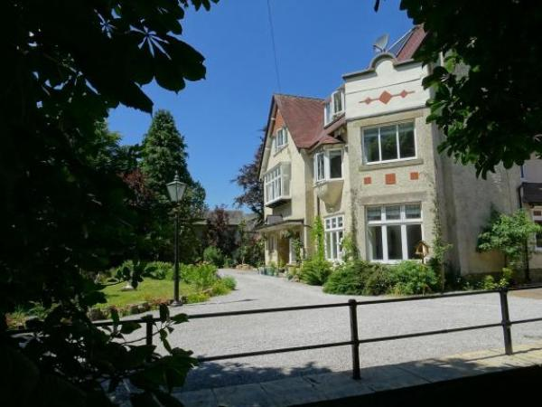

Welcome
Grendon is a stunning Edwardian property, built between 1911 and 1914, situated on a quiet road within walking distance of Buxton town centre.
Having recently undergone a full refurbishment of all bedrooms and ensuite bathrooms, we now offer luxury Bed & Breakfast for those looking for high class accommodation with a homely, personal touch.

At a Glance

Level Access
- The main entrance has 1 step. There is no lift and no ramp.
- There is level access from the main entrance to:
  - Dining Table
  - Guest Lounge

Access with steps
- There are steps from the main entrance to:
  - Bedroom
  - Hallway
  - Garden Areas

Bedrooms
- We have non-allergic bedding.

Hearing
- The (bedroom) TVs have subtitles.

Visual
- Some parts of the venue have low lighting.

General
- Staff are available 24 hours a day.
- We have emergency evacuation procedures for disabled visitors.

Getting here
Grendon Bed & Breakfast
Bishops Lane
Buxton
SK17 6UN

Travel by public transport
- You can get to Grendon Bed & Breakfast by bus and train.
- The nearest bus stop is on St Johns Road. The bus stop is 0.3 miles / 0.5 km from Grendon Bed & Breakfast.
- The nearest train station is Buxton. The train station is 1 miles / 1.6 km from Grendon Bed & Breakfast.

Parking
- We have a car park. The parking is less than 50 metres from the main entrance. Parking is free.
- There is a drop-off point at the main entrance. The drop-off point does not have a dropped kerb.
- From the parking to the main entrance, there is 1 step. There is no ramp and no lift. The driveway and parking area is small grade shingle.

Arrival

Path to main entrance
- From the street to the main entrance, there is 1 step. There is no ramp and no lift.

Main entrance
- The door is 910mm wide.
- The main entrance has 1 steps.
- The main door is side hung and manual.

Getting around inside

Visual Impairment - General Information
- Some parts of the venue have low lighting.

Bedrooms
- All bedrooms have windows.
- Bedrooms have ceiling lights, bedside lamps and natural daylight.
- Lights are LED and traditional filament. TVs have subtitles.
- All bedrooms are non-smoking.
- We have non-allergic bedding.
- All bedrooms have fitted carpets.
- We can move the bedroom furniture, to improve accessibility.
- The bedroom nearest the main entrance has 17 steps.
- All bedrooms are ensuite.
- We have bathrooms with a separate shower.
- We have bathrooms with a bath.

Place to eat and drink

Guest Dining Room
- From the main entrance to the dining area, there is level access. The route is 850mm wide, or more. The door is 850mm wide.
- To get to a table, there are no steps.
- If you need table service, staff can help you.
- There is background music.
- The table and plates have high colour contrast.
- We cater for vegetarian and gluten free (celiacs) specific diets.
- We can cater for most special dietary requirements with advance notice. Only breakfast between 8am and 9.30am is served in this establishment.

Guest Lounge
- From the main entrance to this area, there is level access. The route is 850mm wide, or more.
- The door is 850mm wide.

Hallway
- From the main entrance to this area, there is 1 step. There is no lift and no ramp.

Getting around outside

Garden Areas
- From the main entrance to the area, there are 2 steps.
- All walkways around the gardens are small grade shingle.

Customer care support

Accessibility equipment
- For a list of more items, please go to https://www.mobilityequipmenthiredirect.com.
- Assistance dogs can use the gardens if cleaned up after immediately.
- We have an area to charge mobility scooters and battery powered wheelchairs.
- Battery powered devices can be charged in the garage.
- You can hire mobility equipment from mobilityequipmenthiredirect.com by calling 0800 994 9000.

Customer care support
- Staff are available 24 hours a day.
- Proprietors live in the establishment and are available by phone or in person if in the establishment.

Guide last updated: 4 April 2022

