Accessibility Guide for Corran Bunkhouse
corranbunkhouse@btconnect.com, 01855 821000, www.corranbunkhouse.co.uk
Contact for accessibility enquiries: Alan or Halina Hood
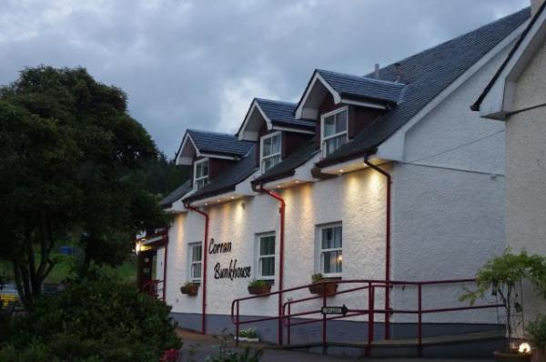

Welcome
Corran Bunkhouse is situated on the A82, seven miles south of Fort William next to the small ferry terminal to Ardgour and Ardnamurchan on the A861. We are two and a half hours' drive from Glasgow Airport and three hours' drive from Edinburgh Airport. There is a bus service from Glasgow and Inverness, which takes you near to our Bunkhouse, with the nearest bus stop located the top of the ferry approach road ( A861).
We are a self catering facility which can cater for up to 41 guests. All our rooms are private with ensuite. We have two ground floor accessible rooms.

At a Glance

Level Access
- The main entrance has level access with a ramp. The ramp is permanent.
- There is level access from the main entrance to:
  - Bedroom: Room 1 and Room 7
  - Washing machine available in Drying Rooms
  - Guests' Lounge
  - Sun Terrace
  - The Garden

Access with steps
- There are steps from the main entrance to:
  - Front Gardens

Bedrooms
- We have non-allergic bedding.

Level access bedrooms
- From the main entrance to the bedroom, there is level access.
- The route to the bedroom is 750mm wide, or more.
- The bedroom door is 750mm wide, or more.
- There is unobstructed floor space 1200mm by 900mm, or more.

Hearing
- Some (bedroom) TVs have subtitles.
- Some staff have disability awareness training.

Visual
- Full-height windows have contrast markings.

General
- Staff are available 24 hours a day.
- Some staff have disability awareness training.
- We have emergency evacuation procedures for disabled visitors.

Getting here
Corran Bunkhouse
Onich
Fort William
Inverness shire
PH33 6SE

Travel by public transport
- You can get to Corran Bunkhouse by bus, train and boat or ferry.
- The nearest bus stop is on the A82 and is 100 metres from our accommodation, which is on the A861. The bus stop is 0.0 miles / 0.0 km from Corran Bunkhouse.
- The nearest train station is Fort William. The train station is 7 miles / 11.3 km from Corran Bunkhouse.

Travel by taxi
- We can provide help with transport whenever possible, depending on our availability.

Parking
- We have a car park. There are accessible parking spaces. The parking is less than 50 metres from the main entrance. Parking is free.
- There is a drop-off point at the main entrance. The drop-off point has a dropped kerb.
- From the car park to the entrance, there is level access. There is a permanent ramp.
- The route is 5000mm wide, or more.
- This is not necesssary, as our guests can be brought directly to the main entrance, or can park directly in front, to enable ease of access.
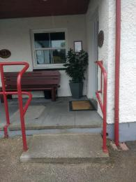
Main entrance to accommodation
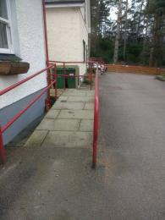
Ramp entrance to accommodation
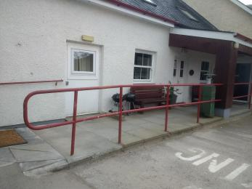
Railings and ramp to accommodation
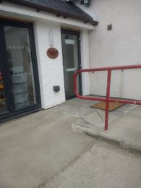

Arrival

Path to main entrance
- From the street to the main entrance, there is level access.
- The path is 5000mm wide, or more.
- The path is sloped.

Main entrance
- The main entrance has level access.
- There is a permanent ramp.
- The door is 1010mm wide.
- The main door is side hung and manual.
- When you arrive, we can help carry your luggage.
- One of the accessibe rooms has a dedicated wheel chair access.

Getting around inside

Visual Impairment - General Information
- We have contrast markings on all full-height windows.

Bedrooms
- All bedrooms have windows.
- Bedrooms have ceiling lights, wall lights, bedside lamps, spot lights and natural daylight.
- Lights are LED and energy saving. Some TVs have subtitles.
- All bedrooms are non-smoking.
- We have non-allergic bedding.
- Some bedrooms have fitted carpets.
- We can move the bedroom furniture, to improve accessibility.
- From the main entrance to this area, there is level access.

Accessible bedrooms

Accessible bedroom Room 1 and Room 7
- From the main entrance to the bedroom, there is level access. There is a ramp. The ramp is Permanent.
- The route to the bedroom is 1000mm wide, or more. The bedroom door is 810mm wide. There is 460mm at the side of the bed. The bed is 525mm high. There is 300mm under the bed.
- There is a low clothes rail. You can use the rail sitting down.
- The bedroom is flexible (either double or twin). The bathroom is ensuite. The bathroom door is 810mm wide.
- The bathroom has a separate shower. The shower has a handrail.
- There is a shower chair available. The toilets have handrails. The direction of transfer onto the toilet is to the left. There is 1000mm at the side of the toilet.
- There is 2000mm in front of the toilet. The toilet seat is 405mm high.
- The basin is 810mm high. The taps are lever operated. There is no space under the basin.
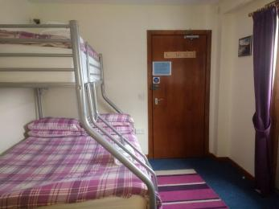
Room 1 door entrance to room
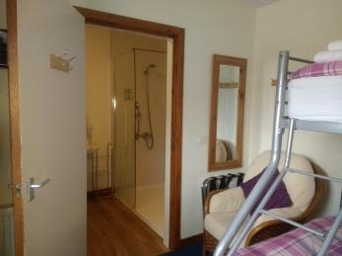
Room 1 access to bathroom
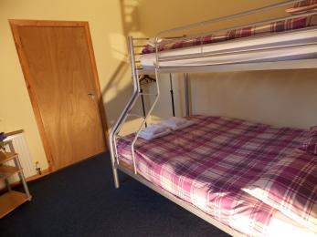
Room 1 double or twin
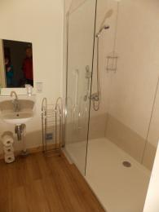
Room 1 shower
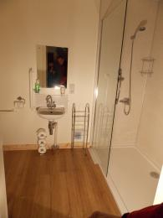
Sink area
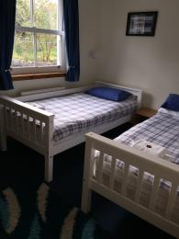
Room 7 has a single and a double bed
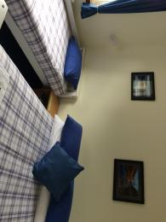
Room 7 has a single and a double bed

Washing machine available in Drying Rooms
- From the main entrance to the laundry, there is level access. The route is 810mm wide, or more. The door is 810mm wide.
- We have an iron and ironing board. You can use the ironing board sitting down.

Self catering kitchen

Kitchen Bunkhouse 1
- We have an open plan kitchen.
- From the main entrance to the kitchen, there is level access.
- There is a permanent ramp. The route is 1000mm wide, or more.
- The door is 1010mm wide.
- The work surface is available at a height between 650mm and 900mm.
- The hob is available at a height between 650mm and 900mm.
- The sink is available at a height between 650mm and 900mm.
- The oven is available at a height between 650mm and 900mm.
- The table and plates have high colour contrast.
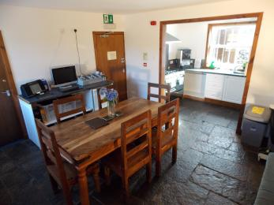
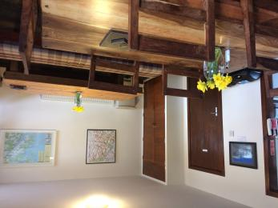
Dining room Bunkhouse 1
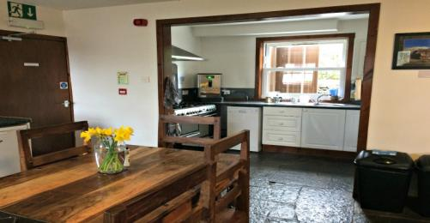
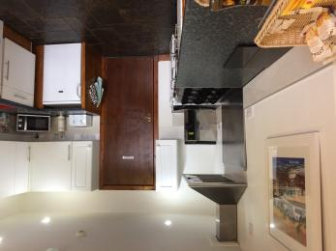
Kitchen Bunkhouse 2
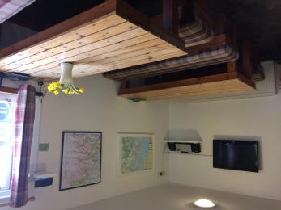
Dining room Bunkhouse 2
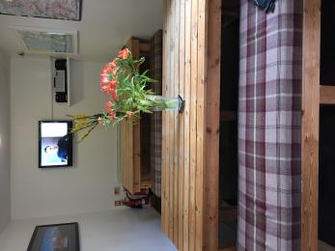
Dining room Bunkhouse 2

Lounge

Guests' Lounge
- From the main entrance to the lounge, there is level access. There is a permanent ramp. The route is 910mm wide, or more. The door is 910mm wide.
- There is an accessible parking space next to the lounge, with a ramp for the entrance to the lounge.
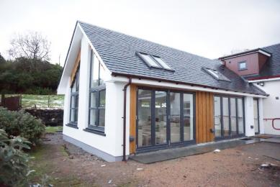
Lounge
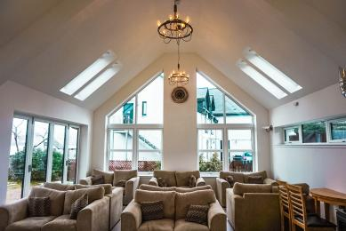
Seating in the lounge
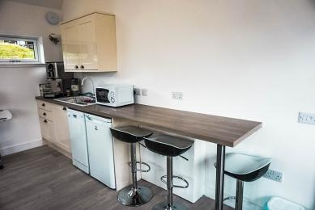
Breakfast bar has a c;lerance of 880 mm.
Ramp access to lounge

Getting around outside

Front Gardens
- From the main entrance to the gardens, there are 3 steps. There is no lift and no ramp.
- The route is sloped.
- Front lawn is grass with a level access (450mm) from the driveway.
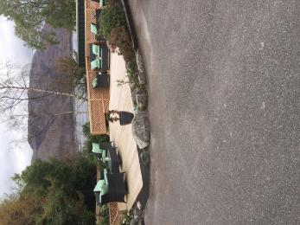
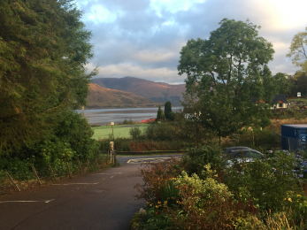
Main entrance to our accommodation with the garden on the right.
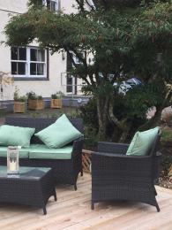

Terrace

Sun Terrace
- From the main entrance to this area, there is level access. There is a permanent ramp. The route is 1000mm wide, or more.
- The entrance is 1000mm wide.
- To get to a table, there are no steps.
- Sun Deck with several low coffee tables and chairs. The Sun deck is on two levels with a 150 mm step down to the lower deck. The first deck has no step to access.

The Garden
- From the main entrance to this area, there is level access. There is a permanent ramp. The route is 1000mm wide, or more. The entrance is 1000mm wide.
- The decking area is accessed easily from either the main entrance or from the car park.
Decking in fhe garden
Entrance to garden from the car park
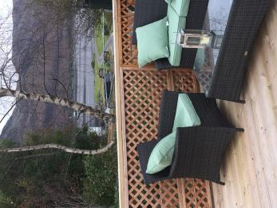
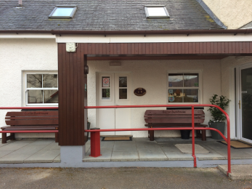
Main entrance

Customer care support

Accessibility equipment
- We have an area to charge mobility scooters and battery powered wheelchairs.
- We have outdoor electrical sockets in the car park and extension cables.

Emergency evacuation procedures
- We have emergency evacuation procedures for disabled visitors.

Customer care support
- Some staff have disability awareness training.
- Staff are available 24 hours a day.
- Owners live on site.

Guide last updated: 18 January 2019

