Accessibility Guide for The Burleigh
reservations@theburleigh.com, 01485 533080, www.theburleigh.com
Contact for accessibility enquiries: Sharon Chauhan-Jennings
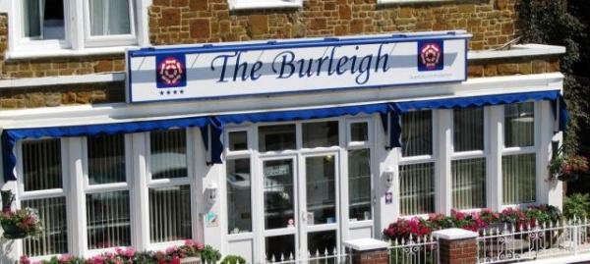

Welcome
The Burleigh is a friendly, family run guesthouse centrally located in Hunstanton on the North Norfolk coast. We have eleven individually decorated bedrooms, all comfortably furnished to provide a relaxing environment.
A delicious choice of breakfasts is served in our bright and airy dining room. We also have a residents only bar, cosy lounge and attractive front terrace for our guests to enjoy.

At a Glance

Level Access
- The main entrance has 1 step. There is no lift and no ramp.
- There is level access from the main entrance to:
  - Dining Table
  - Guest Lounge
  - Residents Bar
  - Hallway

Access with steps
- There are steps from the main entrance to:
  - Bedroom
  - Front Terrace

Bedrooms
- We have non-allergic bedding.

Hearing
- The (bedroom) TVs have subtitles.

General
- Staff are available 24 hours a day.
- We have emergency evacuation procedures for disabled visitors.

Getting here
7 Cliff Terrace
Hunstanton
Norfolk
PE36 6DY

Travel by public transport
- You can get to The Burleigh by bus and train.
- The nearest bus stop is Hunstanton bus station which is located a five minute walk away. The bus stop is 0.2 miles / 0.3 km from The Burleigh.
- The nearest train station is Kings Lynn. The train station is 15 miles / 24.2 km from The Burleigh.

Travel by taxi
- You can get a taxi with Ben Cars by calling 01485 533290.
- You can get a taxi with A149 Cars by calling 01485 779505.

Parking
- We have a car park. The parking is less than 50 metres from the main entrance. Parking is free.
- There is a drop-off point at the main entrance. The drop-off point does not have a dropped kerb.
- From the parking to the main entrance, there are 2 steps. There is no ramp and no lift.

Arrival

Path to main entrance
- From the street to the main entrance, there are 2 steps. There is no ramp and no lift.
- The path is sloped.

Main entrance
- The door is 690mm wide.
- The main entrance has 1 steps.
- The main door is side hung and manual.
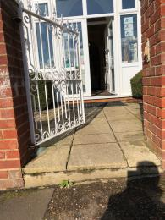
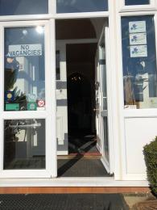

Getting around inside

Bedrooms
- All bedrooms have windows.
- Bedrooms have ceiling lights, wall lights, bedside lamps, desk or table lamps and natural daylight.
- Lights are LED, energy saving and traditional filament. TVs have subtitles.
- All bedrooms are non-smoking.
- We have non-allergic bedding.
- All bedrooms have fitted carpets.
- We do not allow dogs.
- The bedroom nearest the main entrance has 1 steps.
- We have bathrooms with a separate shower.
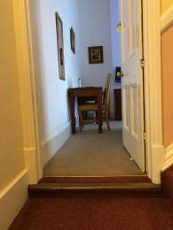

Lounge

Guest Lounge
- From the main entrance to the lounge, there is level access. The route is 660mm wide, or more. The door is 750mm wide.
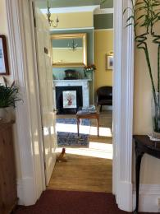

Bar

Residents Bar
- From the main entrance to the bar, there is level access. The route is 660mm wide, or more.
- The door is 750mm wide.
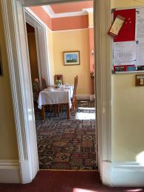

Place to eat and drink

Dining room/ Breakfast room
- From the main entrance to the dining area, there is level access. The route is 660mm wide, or more. The door is 750mm wide.
- To get to a table, there are no steps.
- If you need table service, staff can help you.
- There is background music.
- We cater for sugar free (diabetic), vegetarian, gluten free (celiacs), lactose free (dairy free), nut free, low fat and vegan specific diets.

Hallway
- From the main entrance to this area, there is level access. The route is 660mm wide, or more.
- The door is 660mm wide.

Getting around outside

Terrace

Front Terrace
- To get to a table, there are 1steps steps.
- From the main entrance to the terrace, there is 1 step.

Customer care support
- You can hire mobility equipment from Mobility 2000 by calling 01485 533400.

Emergency evacuation procedures
- We have emergency evacuation procedures for disabled visitors.

Customer care support
- Staff are available 24 hours a day.

Guide last updated: 18 January 2019

