Accessibility Guide for Perrycliff Cottage
stay@grovewoodcottages.co.uk, 07831 091767, grovewoodcottages.co.uk
Contact for accessibility enquiries: Sandra Major
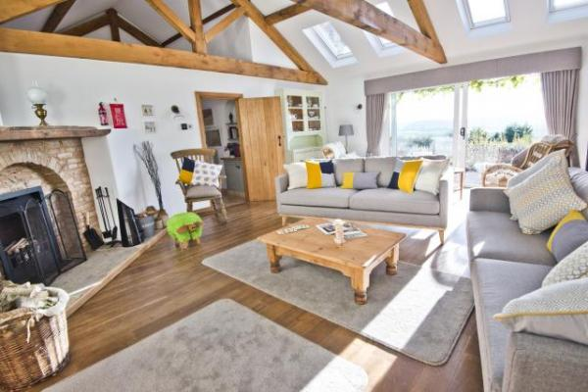

Welcome
Welcome to Grove Wood Cottages,Upton Bishop.
Perrycliff Cottage is set on a ridge on a small country lane, within a private estate, with stunning views. This luxury holiday cottage with 4 en-suite-bedrooms, sleeps 8 in exceptional quality accommodation. Having 2 ground floor bedrooms, a large living room and a second living room, Perrycliff Cottage is ideal for friends or family sharing – especially 3 generations. There are terraced garden areas, private off-road parking, secure cycle storage and use of tennis court. The local gastro pub is a short walk and Ross on Wye, with a wide range of dining and visitor experiences, is 3 miles away.

At a Glance

Level Access
- The main entrance has 1 step and a handrail. There is no lift and no ramp.
- There is level access from the main entrance to:
  - Large living room

Access with steps
- There are steps from the main entrance to:
  - small living room
  - Rear terrace
  - front terrace

Bedrooms
- We have non-allergic bedding.

Hearing
- Some (bedroom) TVs have subtitles.
- Some staff have disability awareness training.

General
The accommodation is rated by the National Accessible Scheme as suitable for:
- Older and less mobile guests
- Some staff have disability awareness training.

Getting here
Perrycliff Cottage
Upton BIshop
Ross-on-Wye
Herefordshire
HR97UF

Travel by public transport
- You can get to Perrycliff Cottage by bus and train.
- Hill Top, Upton Bishop The bus stop is 0.2 miles / 0.3 km from Perrycliff Cottage.
- The nearest train station is Gloucester. The train station is 15 miles / 24.2 km from Perrycliff Cottage.
- Ledbury and Hereford train stations are also near and @15 miles or even less.

Travel by taxi
- You can get a taxi with S&R ( Ross-on-Wye) by calling 01989 566246.
- You can get a taxi with Andy Cars Gloucester by calling 01452 523000. The taxi company has a wheelchair accessible vehicle.
- You can get a taxi with Daz' taxis Ross-on-Wye by calling 01989 768738.

Parking
- We have a car park. The parking is less than 50 metres from the main entrance. Parking is free.
- There is a ramp in the gravelled parking area. So those who are less able can exit the car straight onto hard, flagstone ramp which leads to the front door. The door has a 10cm threshold into hall and a 1cm ledge on inside to floor. From the parking to the main entrance, there is 1 step. There is no ramp and no lift. There are no steps- just door threshold at 10cm external and 1 cm internal and ramp.
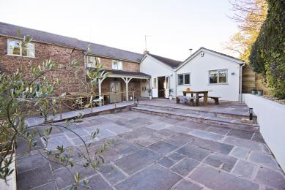
rear courtyard

Arrival

Path to main entrance
- The path is sloped.

Main entrance
- The door is 980mm wide.
- The main entrance has 1 steps.
- This entrance has a handrail.
- When you arrive, we can help carry your luggage.
- The site is level from the road to the front door. There is a 10cm threshold. The parking area is gravel. There is a walk of a few steps from the parking area to the ramp which is hard flagstone and friendly for wheels. There are electric gates which open automatically for cars and with a key pad and button for pedestrian access. We can help with luggage if you request this at time of booking and explain your requirements. We can help you but we are not always on site- and we regret that we are not available 24 hours per day.We welcome everyone here but as it is an older building we have not been able to make it as accessible as we would have liked to and are constrained by its size.
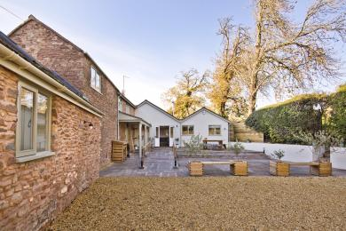
rear courtyard

Getting around inside

Visual Impairment - General Information
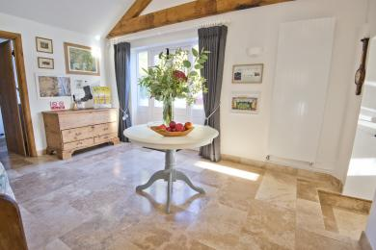
entrance hall
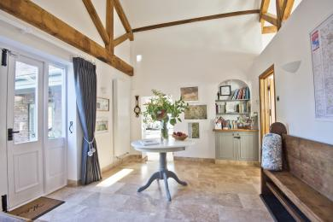
entrance hall

Bedrooms
- All bedrooms have windows.
- Bedrooms have ceiling lights, bedside lamps, spot lights and natural daylight.
- Lights are LED. Some TVs have subtitles.
- All bedrooms are non-smoking.
- We have non-allergic bedding.
- Some bedrooms have fitted carpets.
- No pets allowed ( save guide dogs) . All bed linen is cotton and anti allergy. Egyptian cotton towels. , We can also provide further details including details of our cleaning products on request. and Wood and tiled floors as well as vinyl and carpet . Good ventilation.
- We can move the bedroom furniture, to improve accessibility.
- The bedroom nearest the main entrance has 0 steps.
- All bedrooms are ensuite.
- We have bathrooms with a bath and overhead shower. The shower has a handrail.
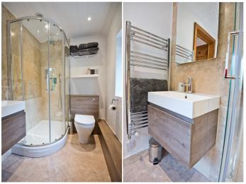
en suite bathroom (upstairs)
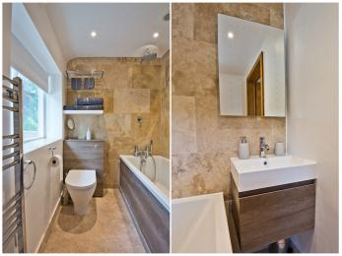
en suite bath/ shower ( upstairs)
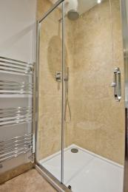
downstairs twin en suite
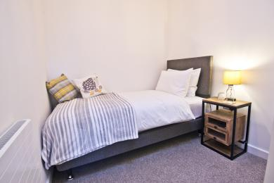
twin room downstairs
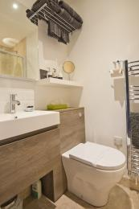
downstairs twin en suite
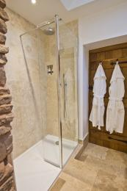
downstairs super king or twin en suite- there is a tiled step into the bathroom from the small living room

Self catering kitchen

Perrycliff
- We have an open plan kitchen.
- From the main entrance to the kitchen, there are 2 steps. There is no lift and no ramp.
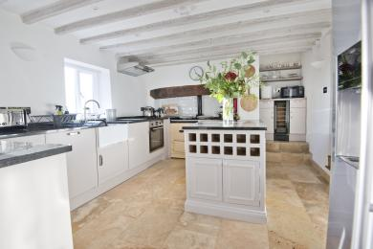
kitchen/ dining area
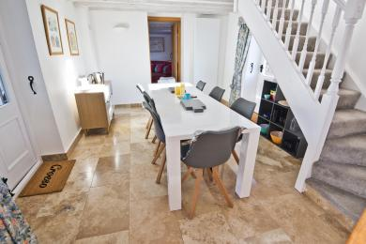
dining area shows alternative rear entrance with 20cm threshold

Lounge

Large living room
- From the main entrance to the lounge, there is level access. The route is 700mm wide, or more. The door is 700mm wide.
- The large living room is accessed from the entrance hall
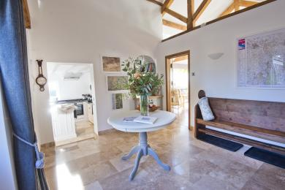
entrance hall

small living room
- From the main entrance to this area, there are 2 steps. There is no lift and no ramp.
- Alternatively you can enter into kitchen diner with a 20cm threshold. This takes you to the small living room and second downstairs en suite bedroom. There is one step up to that bedroom.
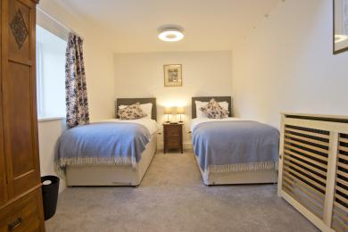
downstairs bedroom- superking or twin
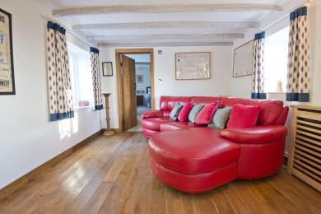
small living room

Getting around outside

Terrace

Rear terrace
- To get to a table, there are 1steps steps.
- From the main entrance to the terrace, there is 1 step.
- There are no steps from the main entrance but there is a 10cm theshold. Or from the kitchen /dining area a 20cm threshold. There are 2 steps in the rear courtyard but can be avoided if you use the ramp.
rear courtyard
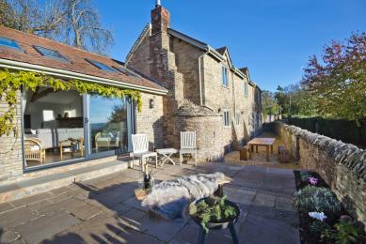
front terrace
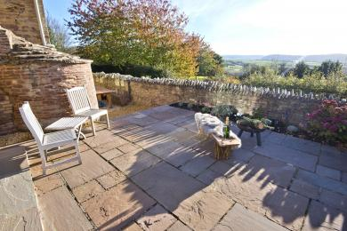
front terrace

front terrace
- From the main entrance to the area, there are 2 steps.
- There are 2 steps on to the terrace from the large living room. A further 2 steps lead down to the table area. Or if you use the front dining room door- there are 2 steps to the table area.. then 2 steps up to front terrace. There are also door thresholds. There are hand rails at all door entrances.

Customer care support

Accessibility equipment
- We have a stool for use inside shower and a flagstone ramp has been built from the car park. We have two perching stools in the kitchen. We also have two chairs with arms for the dining table.
- There is an orchard across the road which belongs to Perrycliff and can be used by guests by arrangement.

Emergency evacuation procedures
- We have a written, fire safety risk assessment, which is in the Cottage and a copy is also kept off site. We have smoke, heat and CO2 alarms and chargeable torches on landing and in the hall. We have a large handbell for alarm raising in the hall if required.

Customer care support
- Some staff have disability awareness training.

Guide last updated: 18 January 2019

