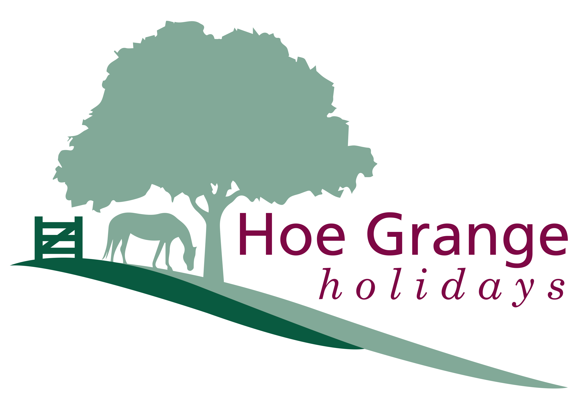

Accessibility Guide for Pinder Log Cabin at Hoe Grange Holidays
info@hoegrangeholidays.co.uk, 01629 540262, www.hoegrangeholidays.co.uk
Contact for accessibility enquiries: David and Felicity Brown
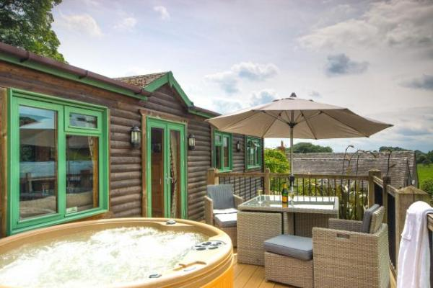

Welcome
At Hoe Grange Holidays you'll receieve a warm welcome. Our aim is to make everyone's stay as enjoyable as possible, and we are committed to providing suitable access for all our guests, whatever their individual needs. We aim to accurately describe our facilities and services so you can confidently book the right cabin for your specific requirements.

Watch the video: Take a 3D tour of Pinder cabin

At a Glance

Level Access
- There is level access from the main entrance to:
  - Farmyard Shop
  - Family Bathroom
  - Pinder Decking

Access with steps
- There are steps from the main entrance to:
  - Farmyard Laundry
  - Children's Play Area

Bedrooms
- We have non-allergic bedding.

Level access bedrooms
- From the main entrance to the bedroom, there is level access.
- The route to the bedroom is 750mm wide, or more.
- The bedroom door is 750mm wide, or more.

Hearing
- The (bedroom) TVs have subtitles.
- We have a hearing loop in the cabins which is portable and can be used in any of the rooms.
- All staff have disability awareness training.

Visual
- We have information in audio and large print.

General
- Staff are available 24 hours a day.
- All staff have disability awareness training.
- We have emergency evacuation procedures for disabled visitors.

Getting here
Hoe Grange Holidays
Brassington
Matlock
DE4 4HP

Travel by public transport
- You can get to Pinder Log Cabin at Hoe Grange Holidays by bus and train.
- The nearest bus stop is in Brassington village. The walk to Hoe Grange is over fields and along roads, some of which do not have pavements. The bus stop is 3.0 miles / 4.8 km from Pinder Log Cabin at Hoe Grange Holidays.
- The nearest train station is Matlock. The train station is 10 miles / 16.1 km from Pinder Log Cabin at Hoe Grange Holidays.
- If arriving by train we advise you to book a taxi in advance

Travel by taxi
- You can get a taxi with Dovelin by calling 07974 665439. The taxi company has a wheelchair accessible vehicle.
- You can get a taxi with A Cabs at Buxton by calling 01298 70423. The taxi company has a wheelchair accessible vehicle.

Parking
- We have a car park. The parking is less than 50 metres from the main entrance. Parking is free.
- There is a drop-off point at the main entrance. The drop-off point does not have a dropped kerb.
- From the car park to the entrance, there is level access. The route is 1080mm wide, or more.
- Our log cabins are situated on a sloping site, however there is easy level access from the car park to the main entrance. There is a dedicated tarmac car parking space outside Pinder cabin with plenty of room for manoeuvring and unloading luggage.
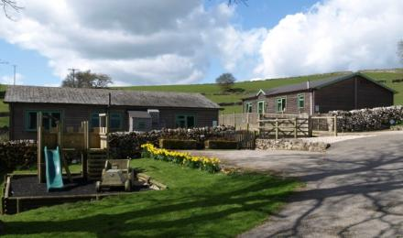
Large double parking space outside Pinder cabin
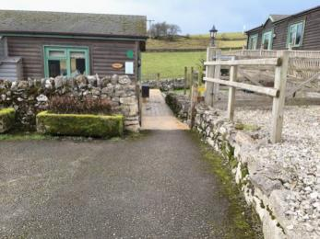
Easy level access from the car park to the main entrance

Arrival

Path to main entrance
- From the street to the main entrance, there is level access.
- The path is 1080mm wide, or more.

Main entrance
- The main entrance has level access.
- The door is 1100mm wide.
- The main door is side hung and manual.
- When you arrive, we can help carry your luggage.
- The main entance is through double doors which open up to 1100mm in width
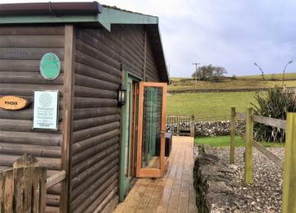
Pinder main entrance with double doors

Getting around inside

Bedrooms
- All bedrooms have windows.
- Bedrooms have ceiling lights, bedside lamps and natural daylight.
- Lights are LED and energy saving. TVs have subtitles.
- All bedrooms are non-smoking.
- We have non-allergic bedding.
- All bedrooms have fitted carpets.
- Allergy sufferers will love the fact that all our cleaning products are eco-friendly. Hoe Grange has been awarded the Peak District Environmental Quality Mark and Green Tourism Gold Award
- We can move the bedroom furniture, to improve accessibility.
- We have bed blocks.
- From the main entrance to this area, there is level access.
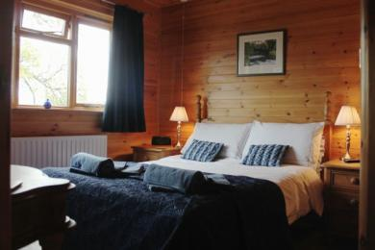
Master double bedroom with ensuite shower
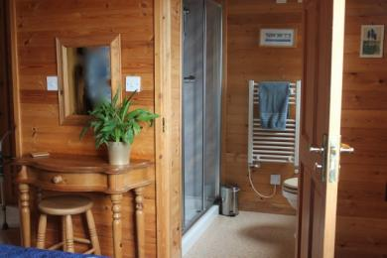
ensuite with large shower cubicle (one step)
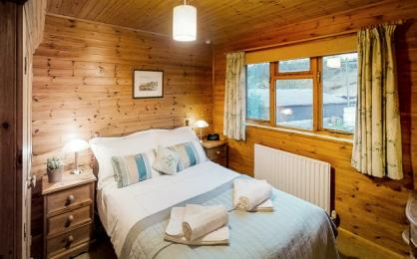
Double bedroom
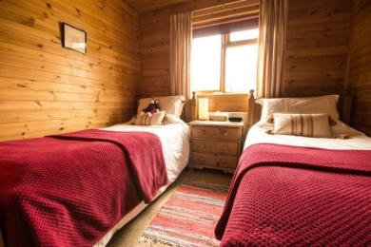
Small cosy twin bedroom

Farmyard Laundry
- From the main entrance to the laundry, there is 1 step. There is no lift and no ramp.
- We have an iron and ironing board. You can use the ironing board sitting down.
- There is no washing machine in Pinder cabin, but there is a separate laundry in the farmyard which guests are welcome to use, however it is not wheelchair accessible

Self catering kitchen

Pinder Kitchen
- We have an open plan kitchen.
- From the main entrance to the kitchen, there is level access.
- The route is 1100mm wide, or more.
- The door is 1100mm wide.
- The hob is available at a height between 650mm and 900mm.
- The oven is available at a height between 650mm and 900mm.
- The table and plates have high colour contrast.
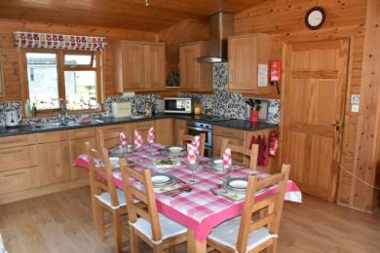
spacious open plan kitchen
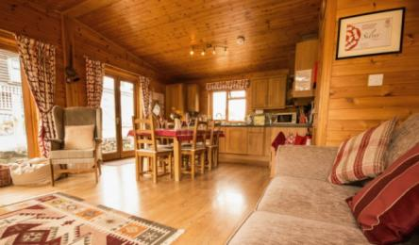
plenty of space for friends and family

Shop

Farmyard Shop
- From the main entrance to the shop, there is level access. The route is 750mm wide, or more. The door is 750mm wide.
- The route through the shop is 800mm wide, or more.
- The shop is situated in the farmyard which is down a steep slope from the cabin. It stocks basic supplies such as milk, bread, eggs, and some local produce.

Family Bathroom
- From the main entrance to this area, there is level access. The route is 800mm wide, or more.
- The door is 800mm wide.
- There is a luxury whirlpool bath with a shower attachment (bathboards and seat available on request) Free floor space clear of door is 127cm x 122cm . The toilet is 42cm high and a 10cm seat riser is available.There are no hand rails at side of toilet, but we can provide a foldable toilet frame.
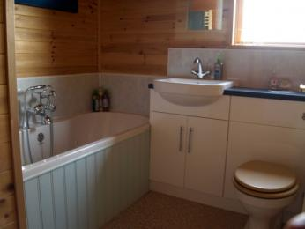
double ended whirlpool bath
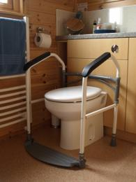
portable toilet frame and other equipment available

Getting around outside

Terrace

Pinder Decking
- From the main entrance to this area, there is level access. The route is 1080mm wide, or more.
- The entrance is 1080mm wide.
- To get to a table, there are no steps.
- You can access the decking area through the double doors in the lounge. There are comfortable chairs so you can watch the farm animals and wildlife, or you can relax in the hot tub.
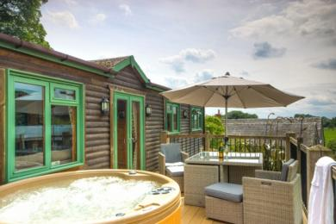
Pinder decking with hot tub
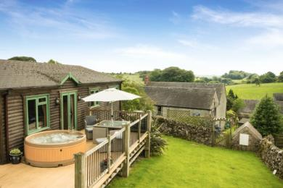
superb views over the garden and farm fields

Children's Play Area
- From the main entrance to the area, there is 1 step.
- There is a small chidlren's pay area with a climbing frame and slide which is situated near the cabin on a slope.
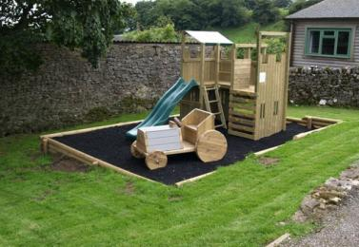
fun for the little ones

Secure Cycle Shelter
- The lockable cycle shelter is situated half way down the steep slope to the farmyard and can be used by guests for storing their own bicycles whilst on holiday. There is a warm hose pipe for washing down bicycles, walking boots and your dogs muddy paws.

Customer care support

Accessibility equipment
- We provide wheelchairs. Wheelchairs are free.
- We have a hearing loop in the cabins which is portable and can be used in any of the rooms.
- A wide range of equipment including, foldable wheelchair, perching stool, bath boards and bath seat, small shower chair, suction grab rail, toilet seat height raiser, portable toilet frame, portable assistance alarm, wake n shake alarm, and bed blocks
- For a list of more items, please go to https://www.hoegrangeholidays.co.uk/accessible-holidays/accessible-equipment/.
- We welcome up to 2 dogs in Pinder cabin. The nearest toilet area for dogs is located in the paddock to the rear of the cabin, and there are plenty of wonderful walks from the door.
- We have an area to charge mobility scooters and battery powered wheelchairs.
- You can hire mobility equipment from Arjo Huntleigh by calling 01234 555 666.
- You can hire mobility equipment from Clarke and Partners by calling 01234 666 777.

Emergency evacuation procedures
- We have emergency evacuation procedures for disabled visitors.

Customer care support
- All staff have disability awareness training.
- We have information in audio and large print.
- Staff are available 24 hours a day.
- Guest information files in the cabin gives details of local services and emergency procedures.
Mobile phone reception is variable depending on your network. A coin-operated payphone is provided in the conservatory at the farmhouse for emergency use and is accessible 24 hours.
You can order a delivery of local Peak District produce ready for your arrival.
- We have other services for people with accessibility requirements.
- Guests can hire our Boma 7 off-road wheelchair to explore the farm fields and local trails
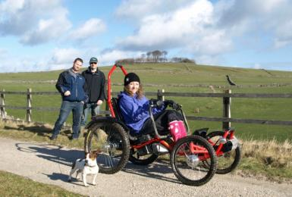
Hire our off-road wheelchair to explore the Peak District countryside with family and friends

Guide last updated: 17 November 2021

