Accessibility Guide for The Toll House
mail@tollhousealdeburgh.com, 07540 943001, www.tollhousealdeburgh.com
Contact for accessibility enquiries: Mrs Olga Owen
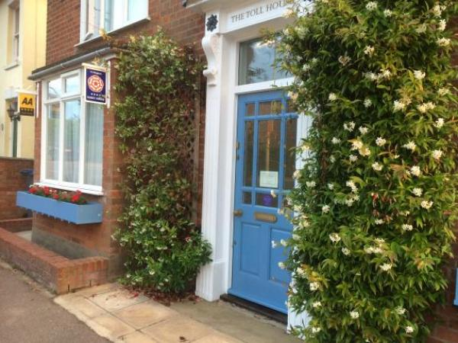

Welcome
Toll House is a cozy B&B located only minutes away from the famous Aldeburgh sea front. It is arranged over two floors, with seven en-suite guest rooms. All en-suites have showers for easy access. There are three ground floor rooms, two of which are twin-bedded, and all of them are on single level.

At a Glance

Access with steps
- There are steps from the main entrance to:
  - breakfast room-conservatory

Bedrooms
- We have non-allergic bedding.

Level access bedrooms
- From the main entrance to the bedroom, there is level access.
- The route to the bedroom is 750mm wide, or more.

Hearing
- The (bedroom) TVs have subtitles.

General
- Staff are available 24 hours a day.
- We have emergency evacuation procedures for disabled visitors.

Getting here
50 Victoria Road
Aldeburgh
Suffolk
IP15 5EJ

Travel by public transport
- You can get to The Toll House by bus and train.
- Nearest bus stop is on the Victoria Road between doctor's surgery and the library. If travelling by train, take bus 64 or 65 from Saxmundham station to Aldeburgh. Timetables can be found online on www.travelineeastanglia.org.uk The bus stop is 0.2 miles / 0.3 km from The Toll House .
- The nearest train station is Saxmundham. The train station is 8 miles / 12.9 km from The Toll House .

Travel by taxi
- You can get a taxi with New Penny Cars by calling 01728 452142.
- You can get a taxi with OsCars by calling 01728 830614.
- You can get a taxi with A2B Cars by calling 01728 633003.

Parking
- We have a car park. The parking is less than 50 metres from the main entrance. Parking is free.
- Our car park can be used for drop-off From the car park to the entrance, there is level access. The path is sloped.
- The route is 2000mm wide, or more.
- Car park is located along side of the house, accessed by public pavement and road

Arrival

Path to main entrance
- From the street to the main entrance, there is level access.
- The path is 2000mm wide, or more.

Main entrance
- The main entrance has level access.
- The door is 850mm wide.
- The main door is side hung and manual.

Getting around inside

Bedrooms
- All bedrooms have windows.
- Bedrooms have ceiling lights, bedside lamps and natural daylight.
- Lights are LED and traditional filament. TVs have subtitles.
- All bedrooms are non-smoking.
- We have non-allergic bedding.
- All bedrooms have fitted carpets.
- We can move the bedroom furniture, to improve accessibility.
- From the main entrance to this area, there is level access.

Place to eat and drink

breakfast room-conservatory
- From the main entrance to the dining area, there is 1 step. There is no lift and no ramp.
- If you need table service, staff can help you.
- The route through the dining area is 800mm wide, or more.
- There is background music sometimes.
- The table and plates have high colour contrast.
- We cater for sugar free (diabetic), vegetarian, gluten free (celiacs), lactose free (dairy free), nut free, low fat, high fibre and vegan specific diets.
- We are happy to cater for most dietary restrictions, given notice

Customer care support

Accessibility equipment
- We have an area to charge mobility scooters and battery powered wheelchairs.
- We are happy to charge our guests mobility aids in our hallway
- You can hire mobility equipment from British Red Cross, Ipswich by calling 01473 219 261.

Emergency evacuation procedures
- When we have visitors with reduced mobility, hearing dificulties or visual impairment we will offer them our downstairs bedrooms as they are closest to the emergency exit.
We will also stay on the premises ( when required ), to ensure their safety.

Customer care support
- Staff are available 24 hours a day.
- Despite not living on premises, we are easily contacted and are available 24 hours. When required we will spend the night on the premises.

Guide last updated: 18 January 2019

