Accessibility Guide for Clayhanger Guest House
info@clayhangerguesthouse.co.uk, 01782714428, www.clayhangerguesthouse.co.uk
Contact for accessibility enquiries: David or Andy

Welcome
The Clayhanger Guest House is a Victorian town house situated in the historic market town of Newcastle-under-Lyme. Bordering the conservation area of the Brampton with excellent local amenities, choose from a show at the New Vic Theatre, Regent Theatre and Victoria Hall, a stroll in Town, shopping at the heart of The Potteries, a day to experience breathtaking views of the Peak District or an exhilarating ride at Alton Towers. Within walking distance of the Royal Stoke University Hospital and a short drive away from Keele University and Staffordshire University Campus.
With 13 bedrooms comprising single rooms, twin rooms, double rooms, and a triple room.

At a Glance

Level Access
- The main entrance has 1 step. There is no lift and no ramp.
- There is level access from the main entrance to:
  - Dining Table
  - Guest Lounge

Access with steps
- There are steps from the main entrance to:
  - Bedroom
  - Courtyard

Bedrooms
- We have non-allergic bedding.

Hearing
- The (bedroom) TVs have subtitles.
- Some staff have Next Generation Text and disability awareness training.

Visual
- Glass doors and full-height windows have contrast markings.
- The menu is in large print.
- We have information in large print.

General
- Staff are available 24 hours a day.
- Some staff have disability awareness training.
- We have emergency evacuation procedures for disabled visitors.

Getting here
Clayhanger Guest House
40-42 King Street
Newcastle-under-Lyme
Staffordshire
ST5 1HX

Travel by public transport
- You can get to Clayhanger Guest House by bus and train.
- The nearest bus stop to Clayhanger Guest House is 55 metres away. This stop is called Borough Arms Hotel and is located on King Street. There are 68 bus stops within 1km of Clayhanger Guest House. The bus stop is 0.1 miles / 0.2 km from Clayhanger Guest House.
- The nearest train station is Stoke-on-Trent. The train station is 2.6 miles / 4.2 km from Clayhanger Guest House.

Travel by taxi
- You can get a taxi with Sids Taxis by calling 01782565200.

Parking
- We have a car park. The parking is less than 50 metres from the main entrance. Parking is free.
- You may park on street as near to the Clayhanger Guest House as is possible From the parking to the main entrance, there is 1 step. There is no ramp and no lift. there is one step down from the parking area to the guest house courtyard and then one step up to the front door and a macclesfield step at the front door.

Arrival

Path to main entrance
- From the street to the main entrance, there is 1 step. There is no ramp and no lift.

Main entrance
- The door is 820mm wide.
- The main entrance has 1 steps.
- The main door is side hung and manual.
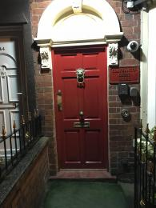

Getting around inside

Visual Impairment - General Information
- We have contrast markings on all glass doors and contrast markings on all full-height windows.

Bedrooms
- All bedrooms have windows.
- Bedrooms have ceiling lights, wall lights, bedside lamps and natural daylight.
- Lights are LED and energy saving. TVs have subtitles.
- We have non-allergic bedding.
- All bedrooms have fitted carpets.
- We can move the bedroom furniture, to improve accessibility.
- The bedroom nearest the main entrance has 15 steps.
- We have bathrooms with a separate shower.

Lounge

Guest Lounge
- From the main entrance to the lounge, there is level access. The route is 1000mm wide, or more. The door is 820mm wide.

Place to eat and drink

Dining Room
- From the main entrance to the dining area, there is level access. The route is 1000mm wide, or more. The door is 820mm wide.
- To get to a table, there are no steps.
- The menu is offered in large print.
- There is background music.
- We cater for sugar free (diabetic), vegetarian and gluten free (celiacs) specific diets.
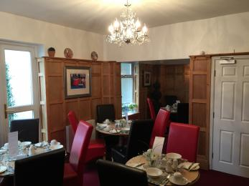

Getting around outside

Terrace

Courtyard
- From the main entrance to the terrace, there is 1 step.
- there is one step down from the main entrance to accesss the courtyard from the front of the property.
If accessing the courtyard from the rear parking area there is also one step down.
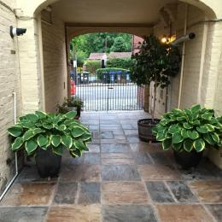

Customer care support

Accessibility equipment
- For a list of more items, please go to https://nationalmobilityhire.com/?gclid=EAIaIQobChMI9KzHxNbf2AIVCRIbCh16IQNnE....
- at the rear of the property past our parking area is a grass verge that is adjacent to the local authority car park.
- We have an area to charge mobility scooters and battery powered wheelchairs.
- You can hire mobility equipment from National Mobility Hire by calling 03700 949 808.

Emergency evacuation procedures
- We have emergency evacuation procedures for disabled visitors.

Customer care support
- Some staff have disability awareness training.
- Some staff have Next Generation Text training.
- We have information in large print.
- Staff are available 24 hours a day.

Guide last updated: 18 January 2019

