Accessibility Guide for King's College
tourism@kings.cam.ac.uk, 01223 331212, http://www.kings.cam.ac.uk/
Contact for accessibility enquiries: Visitor Services Administrator
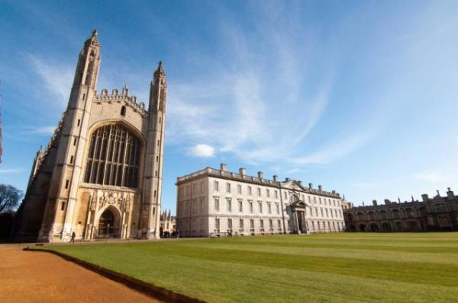

Welcome
King’s College welcomes visitors to its iconic Chapel and extensive grounds. A visit to the College includes seeing the world’s largest fan vaulted ceiling, medieval stained glass, an informative exhibition and the Adoration of the Magi by Rubens.
We are a member of the Visitor Attraction Quality Assurance Scheme.
King's College Chapel is accessible to wheelchair users.

At a Glance

Level Access
- The main entrance has 6 steps and a handrail. There is no lift and no ramp.
- There is level access from the main entrance to:
  - Chapel
  - College Grounds

Access with steps
- There are steps from the main entrance to:
  - Chapel Kiosk
  - King's College Visitor Centre

Visual
- Some parts of the venue have low lighting.

General
- We have a concessionary rate for disabled visitors.
- Staff are available 24 hours a day.
- We have emergency evacuation procedures for disabled visitors.

Getting here
King's Parade
Cambridge
Cambridgeshire
CB2 1ST

Travel by public transport
- You can get to King's College by bus and train.
- The nearest bus stop is at Drummer Street Bus Station The bus stop is 0.50 miles / 62.8 km from King'.0;s College .
- The nearest train station is Cambridge. The train station is 1.5 miles / 2.4 km from King's College .

Travel by taxi
- You can get a taxi with Panther Taxis by calling 01223 715715. The taxi company has a wheelchair accessible vehicle.

Parking
- There is a drop-off point at the main entrance. The drop-off point has a dropped kerb.
- Parking for Disabled badge holders and drop off immediately opposite main entrance

Arrival

Path to main entrance
- From the street to the main entrance, there is level access.
- The path is 1600mm wide, or more.

Main entrance
- The door is 370mm wide.
- The main entrance has 6 steps.
- This entrance has a handrail.
- The main door is side hung and manual.
- The other entrance door is 1000.00mm wide.
- The entrance with ramp access is located on the opposite side of the Chapel. Staff will direct you. The doors can be fully opened to allow wheelchairs through.
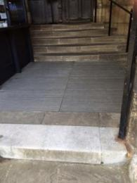
Chapel entrance (North Door)
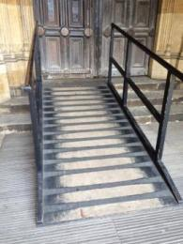
Ramped entrance (South Door)

Getting around inside

Visual Impairment - General Information
- Some parts of the venue have low lighting.

Ticket/ information desk

Chapel Kiosk
- From the main entrance to this desk, there is 1 step. There is no lift and no ramp.

Things to See and Do
- We have a concessionary rate for disabled visitors.

Chapel
- From the main entrance to this area, there is level access. There is a permanent ramp. Some display information is low, for wheelchair users. There are seats.
- Virtual tour of the Chapel http://www.kings.cam.ac.uk/chapel/virtual-tour/index.html
Free leaflets are available inside the main attraction allowing visitors to follow a self-guided tour.
The main areas of the Chapel are fully accessible with wide aisles to pass through.
There is seating located throughout the Chapel for visitors to use.
Access from the ante-chapel to the choir area is via an access ramp to the right of the organ screen.
There is restricted access to the side chapels with entry via a steep worn step.
Access to the Memorial Chapel is via four uneven steps.
Access to the exhibition area is via two steps with handrail. The first three rooms of the exhibition have wide openings between rooms. The fourth room is accessed via three steps and a 610mm doorway. Access to the fifth room is via a 610mm doorway.
The final exhibition room containing information about the stained glass can be accessed from the ante-chapel via a 670mm doorway.
The exhibition area is well lit with accessible information panels.

Shop

King's College Visitor Centre
- From the main entrance to the shop, there is 1 step. There is no lift and no ramp.
- The King's College Visitor Centre, on King’s Parade opposite the main gate, has limited access due to the historic nature of the building but staff assistance and a ramp are available on request. It is located on a busy street opposite the main attraction.
Access is via one step and the door width is 840mm.
There are wide access areas within the Visitor Centre with accessible display racks and assistance available on request.
Access to the rear of the Visitor Centre is via a 740mm corridor.
The counter is accessible to customers when served from the side.

Getting around outside

College Grounds
- From the main entrance to the gardens, there is level access.
- Virtual tour of the grounds http://www.kings.cam.ac.uk/visit/virtual-tour/
The grounds are accessible to visitors with wide, fairly even, paved paths.
There is a steep bridge over the river.

Customer care support
- You can hire mobility equipment from Shopmobility by calling (01223) 457452 or (01223) 461858.

Customer care support
- Staff are available 24 hours a day.

Guide last updated: 18 January 2019

