Accessibility Guide for Doodale Cottage
01653 694530, www.thedoodales.co.uk
Contact for accessibility enquiries: Sally
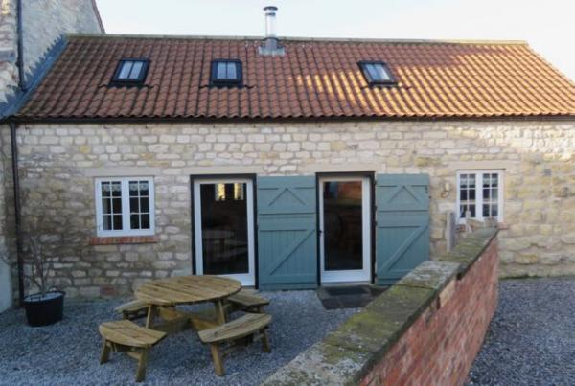

Welcome
Doodale Cottage is located on a working farm at the edge of the village of Old Malton in North Yorkshire. The pretty village of Old Malton is a conservation area and has two pubs serving food, 400m and 150m from Doodale Cottage. The market town of Malton, with a selection of shops and restaurants and a mainline railway station is just over a mile away.
In 2012 the grade II listed stone barn attached to our farmhouse was converted into Doodale Cottage and now provides a unique, spacious, one bedroom self catering holiday cottage sleeping 2 people. The bedroom is located upstairs on the first floor.
We look forward to welcoming you.

At a Glance

Level Access
- There is level access from the main entrance to:
  - Living Area
  - Utility Room
  - Outside Area

Access with steps
- There are steps from the main entrance to:
  - Bedroom

Getting here
Barr Farm, Town Street
Old Malton
Malton
YO17 7HD

Travel by public transport
- You can get to Doodale Cottage by bus and train.
- The nearest bus stop is The Wentworth Arms on Town Street, 180 metres from the cottage. The bus times for the No 840 Coastliner can be found on https://www.transdevbus.co.uk/coastliner/services/YCD/840? The bus stop is 0.1 miles / 0.2 km from Doodale Cottage.
- The nearest train station is Malton. The train station is 1.3 miles / 2.1 km from Doodale Cottage.
- There is a tarmac pavement outside the front of the cottage that continues to the bus stop and further to Malton. The walk to the bus stop is flat. There are street lights from the cottage to Malton.
There is an hourly train service between York and Malton on weekdays, Saturdays and Sundays. Taxis are available at the station.

Travel by taxi
- You can get a taxi with Malton Station Taxis by calling 01653 696969.

Parking
- We have a car park. The parking is less than 50 metres from the main entrance. Parking is free.
- From the car park to the entrance, there is level access. The route is 1170mm wide, or more.
- Vehicle and personnel entrance to the farmyard and the cottage is via an electrically operated gate. A key fob will be provided to enable the gate to be opened at the press of a button during your stay.
Parking is available for one car 10m from the rear door of the cottage. Parking may be available for a second car upon prior request.
The parking area has a level gravel surface. There is a small paved area outside the rear door of the cottage. There is a gate between the car parking area and the rear door of the cottage of 117cm wide.
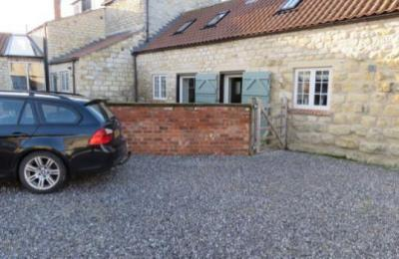
Car Parking at Doodale Cottage
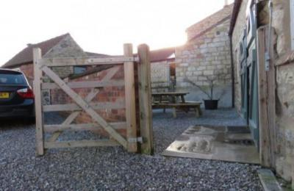
Gate at Doodale Cottage
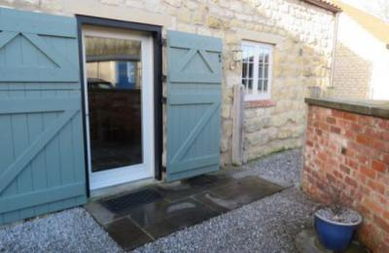
Paved Area outside main door at Doodale Cottage

Arrival

Path to main entrance
- From the street to the main entrance, there is level access.
- The path is 1170mm wide, or more.

Main entrance
- The main entrance has level access.
- The door is 990mm wide.
- The main door is side hung and manual.
- When you arrive, we can help carry your luggage.
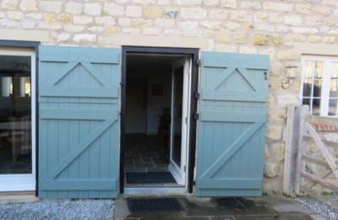
Main door with level threshold at Doodale Cottage

Getting around inside

Bedrooms
- All bedrooms have windows.
- Bedrooms have wall lights, bedside lamps and natural daylight.
- Lights are halogen and LED. Some lights can be controlled independently.
- All bedrooms are non-smoking.
- No bedrooms have fitted carpets.
- Wi-fi to the cottage can be switched off if required.
- We can move the bedroom furniture, to improve accessibility.
- The bedroom nearest the main entrance has 12 steps.
- All bedrooms are ensuite.
- We have bathrooms with a separate shower.
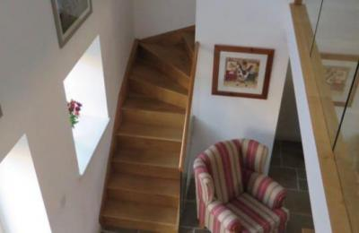
Stairs to bedroom at Doodale Cottage
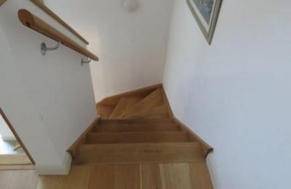
Stairs to bedroom at Doodale Cottage
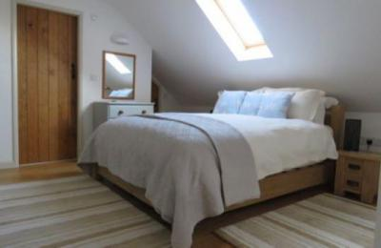
Bedroom at Doodale Cottage

Self catering kitchen

Kitchen Area
- We have an open plan kitchen.
- From the main entrance to the kitchen, there is level access.
- The route is 990mm wide, or more.
- The work surface is available at a height between 650mm and 900mm.
- The hob is available at a height between 650mm and 900mm.
- The sink is available at a height between 650mm and 900mm.
- The table and plates have high colour contrast.
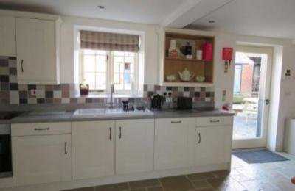
Level access from main entrance to kitchen at Doodale Cottage
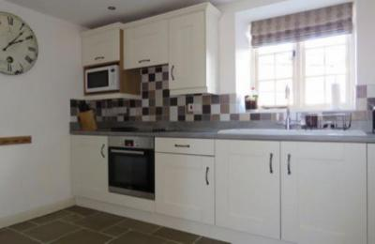
Sink, oven and hob at Doodale Cottage
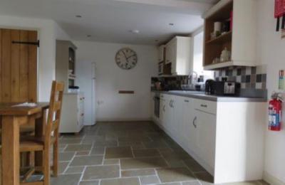
Open plan kitchen and dining area at Doodale Cottage
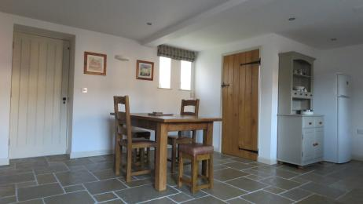
Dining Area at Doodale Cottage

Lounge

Living Area
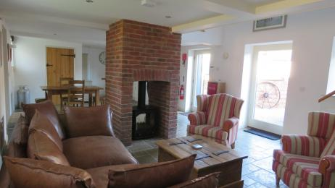
Level access from main entrance to living area at Doodale Cottage
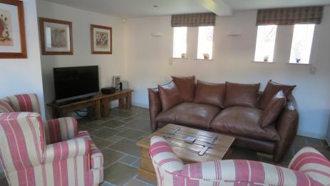
Living Area at Doodale Cottage
- From the main entrance to the lounge, there is level access. The route is 990mm wide, or more.

Utility Room
- From the main entrance to this area, there is level access. The route is 770mm wide, or more.
- The door is 770mm wide.
- The downstairs utility room contains a toilet.
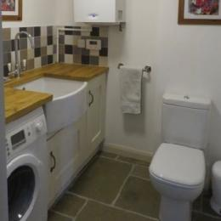
Utility room at Doodale Cottage

Getting around outside

Outside Area
- From the main entrance to the gardens, there is level access.
- The route is 990mm wide, or more.
- Doodale cottage has a small gravel garden with plants in pots.
Seating is provided by a wooden circular table with attached seats for 8.
Access is available to our adjoining farmland
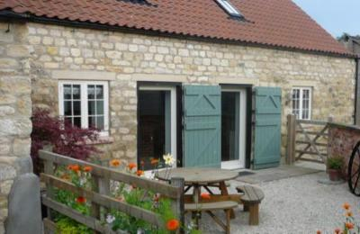
Outside Area at Doodale Cottage

Customer care support

Accessibility equipment
- The nearest toilet area for assistance dogs is located on the farm land approx 50m from the cottage.
- We have an area to charge mobility scooters and battery powered wheelchairs.

Guide last updated: 15 February 2023

