Accessibility Guide for Scott Monument
museumsandgalleries@edinburgh.gov.uk, +44 (0) 131 529 4068 , https://www.edinburghmuseums.org.uk/venue/scott-monument
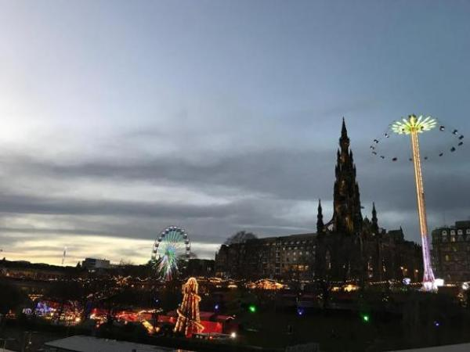

Welcome
The Scott Monument, the largest monument to a writer anywhere in the world, is a truly unique building. On the death of Sir Walter Scott in 1832, the great and good of the city came together to agree on a fitting monument to this outstanding Scottish literary figure. Come pay us a visit and enjoy the breathtaking views of the city from Edinburgh's most iconic monument.
Unfortunately, due to the nature of the building, the upper levels are only accessible via a narrow spiral staircase. There are 221 steps in total.

At a Glance

Level Access
- The main entrance has 1 step. There is no lift and no ramp.

Access with steps
- There are steps from the main entrance to:
  - Main Entrance desk
  - Upper floors
  - Princes Street Gardens

Visual
- Some parts of the venue have low lighting.

General
- We have a complimentary ticket policy for personal assistants.

Getting here
East Princes St Gardens
Edinburgh
EH2 2EJ

Travel by public transport
- You can get to Scott Monument by bus, train and tram.
- Princes Street (Stop PR) is the nearest bus stop The bus stop is 0.1 miles / 0.2 km from Scott Monument.
- The nearest train station is Waverley Railway Station. The train station is 0.2 miles / 0.3 km from Scott Monument.
- The nearest tram station is Princes Street Tram Stop. The tram station is 0.2 miles / 0.3 km from Scott Monument.
- Princes Street is an incredibly busy street so please use the designated pedestrian crossings.

Travel by taxi
- You can get a taxi with CIty Cabs by calling 0131 228 1211. The taxi company has a wheelchair accessible vehicle.

Parking
- Unfortunately, there is no drop off point outside the main entrance. There is an available drop off point on Market Street approximately 0.2 miles from Princes Gardens.

Arrival

Path to main entrance
- From the street to the main entrance, there is 1 step. There is no ramp and no lift.

Main entrance
- The main entrance has 1 steps.
- Visitors must cross a turnstile ticket barrier to access the monument.
Unfortunately, due to the historic nature of the building, the upper levels are only accessible via a narrow spiral staircase. There are 221 steps in total.
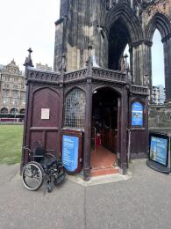
A wheelchair next to the entrance and ticket counter for the Scott Monument

Getting around inside

Visual Impairment - General Information
- Some parts of the venue have low lighting.
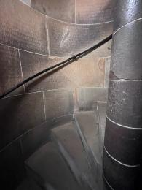
Dark, winding stairwell with handrail.

Ticket/ information desk

Main Entrance desk
- From the main entrance to this desk, there is 1 step. There is no lift and no ramp.
- Tickets must be purchased at the entrance.
Unfortunately, due to the nature of the building, the upper levels are only accessible via a narrow spiral staircase. There are 221 steps in total.

Things to See and Do
- We have a complimentary ticket policy for personal assistants.
- There is an audio display in the 1st Level Museum that is translated into French, German, Spanish and Italian.

1st Level Museum
- There are seats.
- There is an audio display translated into French, German, Spanish and Italian.
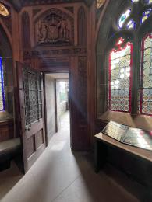
1st Level Museum Exhibit room.

Upper floors
- From the main entrance to this area, there are 221 steps. There is no lift and no ramp.
- Please note: Due to the historic nature of the building, access to the upper levels is by stairs only.
The tour takes visitors to three levels, the first with the museum exhibit and the upper two with sweeping views of the city. The staircases between levels are narrow and have very low ceilings in places. The platforms provide a time and place for visitors to rest before continuing up stairs to the next level. The platforms can are outdoors and can be slippery when it is raining.
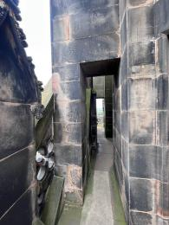
1st Level Platform with narrow doorways.
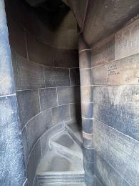
Narrow, winding staircase to the second floor.
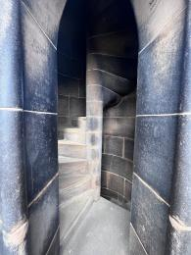
Narrow, winding staircase to the top floor.

Getting around outside

Princes Street Gardens
- The route is sloped. From the main entrance to the gardens, there is 1 step. There is no lift and no ramp.
- Located just outside the Monument, feel free to enjoy a picnic or walk through the City Centre Gardens.

Customer care support

Accessibility equipment
- Princes Street Gardens.

Emergency evacuation procedures
- This site is inaccessible for wheelchairs and walking aids.

Guide last updated: 4 July 2023

