Accessibility Guide for Queens Head, Troutbeck
info@queensheadtroutbeck.pub, 015394 32404 , www.queensheadtroutbeck.pub
Contact for accessibility enquiries: Samantha Robinson
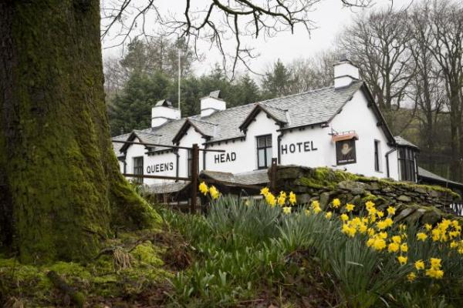

Welcome
Located 4 miles from Ambleside and Windermere and nestled on the side of the fells which overlook the Troutbeck Valley stands The Queens Head, a 17th century coaching inn.
The new Queens Head features a cosy drinking area with newly-refurbished dining areas and 10 comfortable en-suite guest bedrooms providing the perfect base for guests to Cumbria and, of course, their four legged companions.
Renowned for serving some of the finest food in the area, The Queens Head’s new menu will highlight a mixture of homely classic pub food with a Cumbrian flair.

At a Glance

Level Access
- There is level access from the main entrance to:
  - Bedroom: UA Room
  - Bar area
  - Accessible Toilet
  - Covered Smoking Area

Bedrooms
- We have non-allergic bedding.
- There is an emergency call system next to the bed.

Level access bedrooms
- From the main entrance to the bedroom, there is level access.
- The route to the bedroom is 750mm wide, or more.
- The bedroom door is 750mm wide, or more.
- There is unobstructed floor space 1200mm by 900mm, or more.
- The bathroom has a level access shower.

Hearing
- The fire alarm has flashing lights.
- The (bedroom) TVs have subtitles.
- Some staff have disability awareness training.

Visual
- The walls and the doors have high colour contrast.
- Some parts of the venue have low lighting.

General
- Some staff have disability awareness training.

Getting here
Queens Head
Town Head
Windermere
Cumbria
LA231PW

Travel by public transport
- You can get to Queens Head, Troutbeck by bus.
- Close to entrance The bus stop is 0.1 miles / 0.2 km from Queens Head, Troutbeck.
- Buses will stop outside pub on request

Travel by taxi
- You can get a taxi with Ace Taxis by calling 01539445445.

Parking
- We have a car park. There are accessible parking spaces. The parking is less than 50 metres from the main entrance. Parking is free.
- There is a drop-off point at the main entrance. The drop-off point has a dropped kerb.
- From the car park to the entrance, there is level access. The path is sloped.
- The route is 1300mm wide, or more.

Arrival

Path to main entrance
- From the street to the main entrance, there is level access.
- The path is 5000mm wide, or more.
- The path is sloped.

Main entrance
- The main entrance has level access.
- The door is 845mm wide.
- The main door is side hung and manual.

Getting around inside

Visual Impairment - General Information
- We have high colour contrast between walls and doorframes.
- Some parts of the venue have low lighting.

Lift
- We have 1 lift.
- You can get a lift to all floors.

Lift to first floor
- The lift is a platform lift.
- The lift door is 945mm wide.
- The lift is 1050mm wide. The lift is 1365mm deep.
- The lift says the floor number at each floor.
- The lift buttons have raised numbers or letters.
- The lift shows the floor number, at each floor.

Bedrooms
- All bedrooms have windows.
- Bedrooms have ceiling lights, wall lights, floor standing lights, bedside lamps, desk or table lamps and natural daylight.
- Lights are energy saving. Some lights can be controlled independently.
- TVs have subtitles.
- All bedrooms are non-smoking.
- We have non-allergic bedding.
- No bedrooms have fitted carpets.
- We can move the bedroom furniture, to improve accessibility.
- From the main entrance to this area, there is level access.
- The shower has a handrail.
- The toilets have handrails.
- The direction of transfer onto the toilet is to the left.
- There is 600mm in front of the toilet.
- The toilet seat is 495mm high.
- The basin is 765mm high. The taps are lever operated. There is space under the basin, with no pedestal or boxing.
- The bathroom has an emergency call system.

Accessible bedrooms

Accessible bedroom UA Room
- From the main entrance to the bedroom, there is level access. There is a lift. The route to the bedroom is 820mm wide, or more. The bedroom door is 810mm wide. There is 1750mm at the side of the bed. The bed is 625mm high. There is a low clothes rail. You can use the rail sitting down.
- There is an emergency call system next to the bed.
- The bedroom is flexible (either double or twin). The bedroom has an interconnecting room. The bathroom is ensuite. The bathroom door is 810mm wide.
- The bathroom has a separate shower. The shower has a handrail.
- The bathroom has a level access shower. The level access shower has handrails.
- The toilets have handrails. The direction of transfer onto the toilet is to the left. There is 1650mm at the side of the toilet.
- There is 600mm in front of the toilet. The toilet seat is 495mm high.
- The basin is 765mm high. The taps are lever operated. There is space under the basin, with no pedestal or boxing.
- The bathroom has an emergency call system.
- The walls and the bathroom fittings have high colour contrast.
- White fittings with grey tiles, grey grout and dark floor

Bar

Bar area
- From the main entrance to the bar, there is level access. The route is 1300mm wide, or more.
- The door is 810mm wide.

Public toilet

Accessible Toilet
- There is a public toilet for disabled visitors.
- The toilet is a Changing Places toilet.
- From the main entrance to the public toilet, there is level access. The route is 765mm wide, or more.
- The toilet door is 1020mm wide.
- The direction of transfer onto the toilet is to the left.
- There is 945mm at the side of the toilet. There is 600mm in front of the toilet. The toilet seat is 480mm high. The toilets have handrails.

Getting around outside

Smoking

Covered Smoking Area
- From the main entrance to the smoking area, there is level access. The route is 2000mm wide, or more.
- The entrance is 710mm wide.
- The smoking area has a shelter.
- Sheltered smoking area

Customer care support

Accessibility equipment
- The nearest toilet area for assistance dogs is located within the front garden

Emergency evacuation procedures
- We have emergency evacuation procedures for disabled visitors.
- The fire alarm has flashing lights.

Customer care support
- Some staff have disability awareness training.
- Staff are not available 24 hours for reservations and bar but are contactable in case of emergency throughout the evening for residents.

Guide last updated: 18 January 2019

