Accessibility Guide for Manchester Cathedral
office@manchestercathedral.org, 0161 833 2220, www.manchestercathedral.org
Contact for accessibility enquiries: Cathedral Administrator
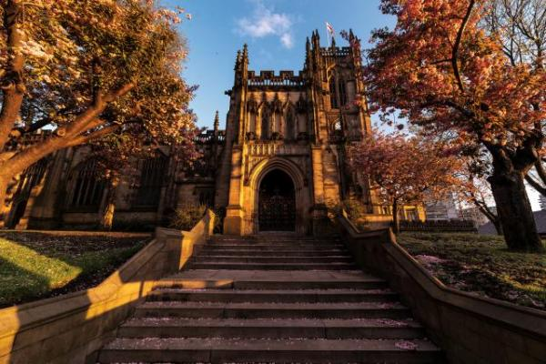

Welcome
Manchester Cathedral has been centre stage in its city’s history for nearly 600 years. In 1421 Henry V signed a royal charter granting permission for a collegiate church to be built. In 1847 a new Manchester diocese was created and this historic church became a Cathedral.
This Grade I listed masterpiece has not only provided a stage on which the city of Manchester’s compelling history has been played out but also provided some of the leading actors for this narrative. Century after century the stone walls have survived wars and bombings, Henry VIII’s reformation and Queen Elizabeth I’s spy and witnessed the birth of the world’s anti-slavery movement.
Watch the video: How Awesome Is This Place

At a Glance

Level Access
- The main entrance has level access with a ramp. The ramp is permanent.
- There is level access from the main entrance to:
  - The Cathedral Nave
  - Quire
  - Fraser Chapel

Access with steps
- There are steps from the main entrance to:
  - Regiment Chapel
  - Lady Chapel
  - Chapter House
  - Jesus Chapel

Hearing
- We have a hearing loop in the nave of the Cathedral.
- Some staff have disability awareness training.

Visual
- Glass doors have contrast markings.

General
- Some staff have disability awareness training.

Getting here
Victoria Street
Manchester
M3 1SX

Travel by public transport
- You can get to Manchester Cathedral by bus, train and tram.
- The nearest bus stop is on Deansgate outside Barton Arcade (stop NA). The bus stop is 0.2 miles / 0.3 km from Manchester Cathedral.
- The nearest train station is Manchester Victoria . The train station is 0.2 miles / 0.3 km from Manchester Cathedral.
- The nearest tram station is The nearest Metrolink stations are Manchester Victoria and Exchange Square.. The tram station is 0.2 miles / 0.3 km from Manchester Cathedral.
- Travelling from the North and East
M62 - leave by junction 17 (A56)
This is a main road passing the Cathedral and is signposted for Manchester City Centre etc. Travel along this road for approximately 5 miles. When you pass Manchester Arena the Cathedral is under the bridge on the left.
Travelling from the South and West M6 - M62 - M602
Take the left turn into Deansgate and continue to the end - the Cathedral is on the right.

Parking
- The nearest drop-off points are Victoria Street and Cateaton Street less than 200 metres away. There are no car parking spaces available at the Cathedral.
The nearest car park is Q-Park Deansgate North which is located at 2 Chapel Street, Manchester, just a few minutes walk away, discounted parking for is available if you pre-book. Enter the code of “MC1421” to receive a further 10%, click here to pre-book.

Arrival

Path to main entrance
- From the street to the main entrance, there is level access.
- The path is 1000mm wide, or more.
- The path is sloped.

Main entrance
- The main entrance has level access.
- There is a permanent ramp.
- The door is 900mm wide.
- The main door is side hung and manual.
- In addition to the main entrance at the south porch of the Cathedral, we also have ground level access at the east end of the Cathedral with glazed automatic doors.
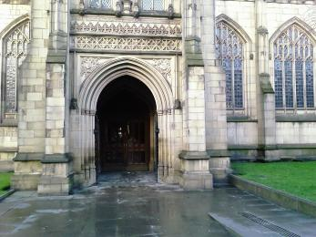
Image displaying the south porch entrance and pathway
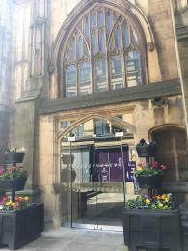
Image displaying the east entrance with automatic opening glazed doors

Getting around inside

Visual Impairment - General Information
- We have contrast markings on all glass doors.

Things to See and Do
- We have a designated quiet space.

The Cathedral Nave
- From the main entrance to this area, there is level access. The door is 950mm wide.
- Some display information is low, for wheelchair users. There are seats.
- There is a hearing loop.
- Volunteer Welcomers are typically available to assist with access. At all other times a Cathedral Verger is able to provide assistance upon request.
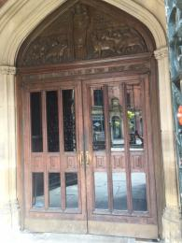
Image displaying the double wooden doors with glass panels to enter the Cathedral

Regiment Chapel
- From the main entrance to this area, there are 3 steps. There is no lift and no ramp.
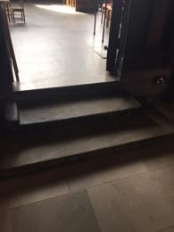
Image showing three wooden steps leading to the Regiment Chapel

Lady Chapel
- From the main entrance to this area, there is 1 step. There is no lift and no ramp.
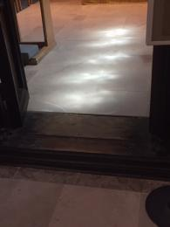
Image showing one step leading to the Lady Chapel

Quire
- From the main entrance to this area, there is level access. There is a permanent ramp. The route is 1500mm wide, or more.
- The door is 1500mm wide.
- There is limited accessibility within the Quire area with two steps from the High Altar area leading down to the Quire stalls.
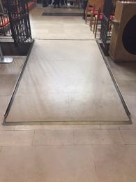
Image showing permanent ramp leading to the Quire

Fraser Chapel
- From the main entrance to this area, there is level access. The route is 1100mm wide, or more.
- The door is 1100mm wide.
- This chapel is designated as a quiet space within the Cathedral and is glazed to help reduce background noise.

Chapter House
- From the main entrance to this area, there are 4 steps. There is no lift and no ramp.
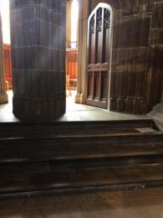
Image showing four stone steps leading to the Chapter House

Jesus Chapel
- From the main entrance to this area, there are 3 steps. There is no lift and no ramp.
- There are two access points to the Jesus Chapel - one has 3 steps and the other has 4 steps with handrails.
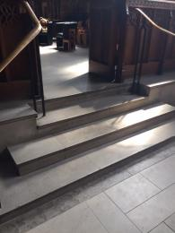
Image showing steps with handrails leading to the Jesus Chapel
Image showing steps without handrails leading to the Jesus Chapel

Customer care support

Accessibility equipment
- We have a hearing loop in the nave of the Cathedral.
- You can hire mobility equipment from Shop Mobility Manchester by calling 0161 791 1494.

Emergency evacuation procedures
- We have emergency evacuation procedures for disabled visitors.

Customer care support
- Some staff have disability awareness training.

Guide last updated: 30 May 2019

