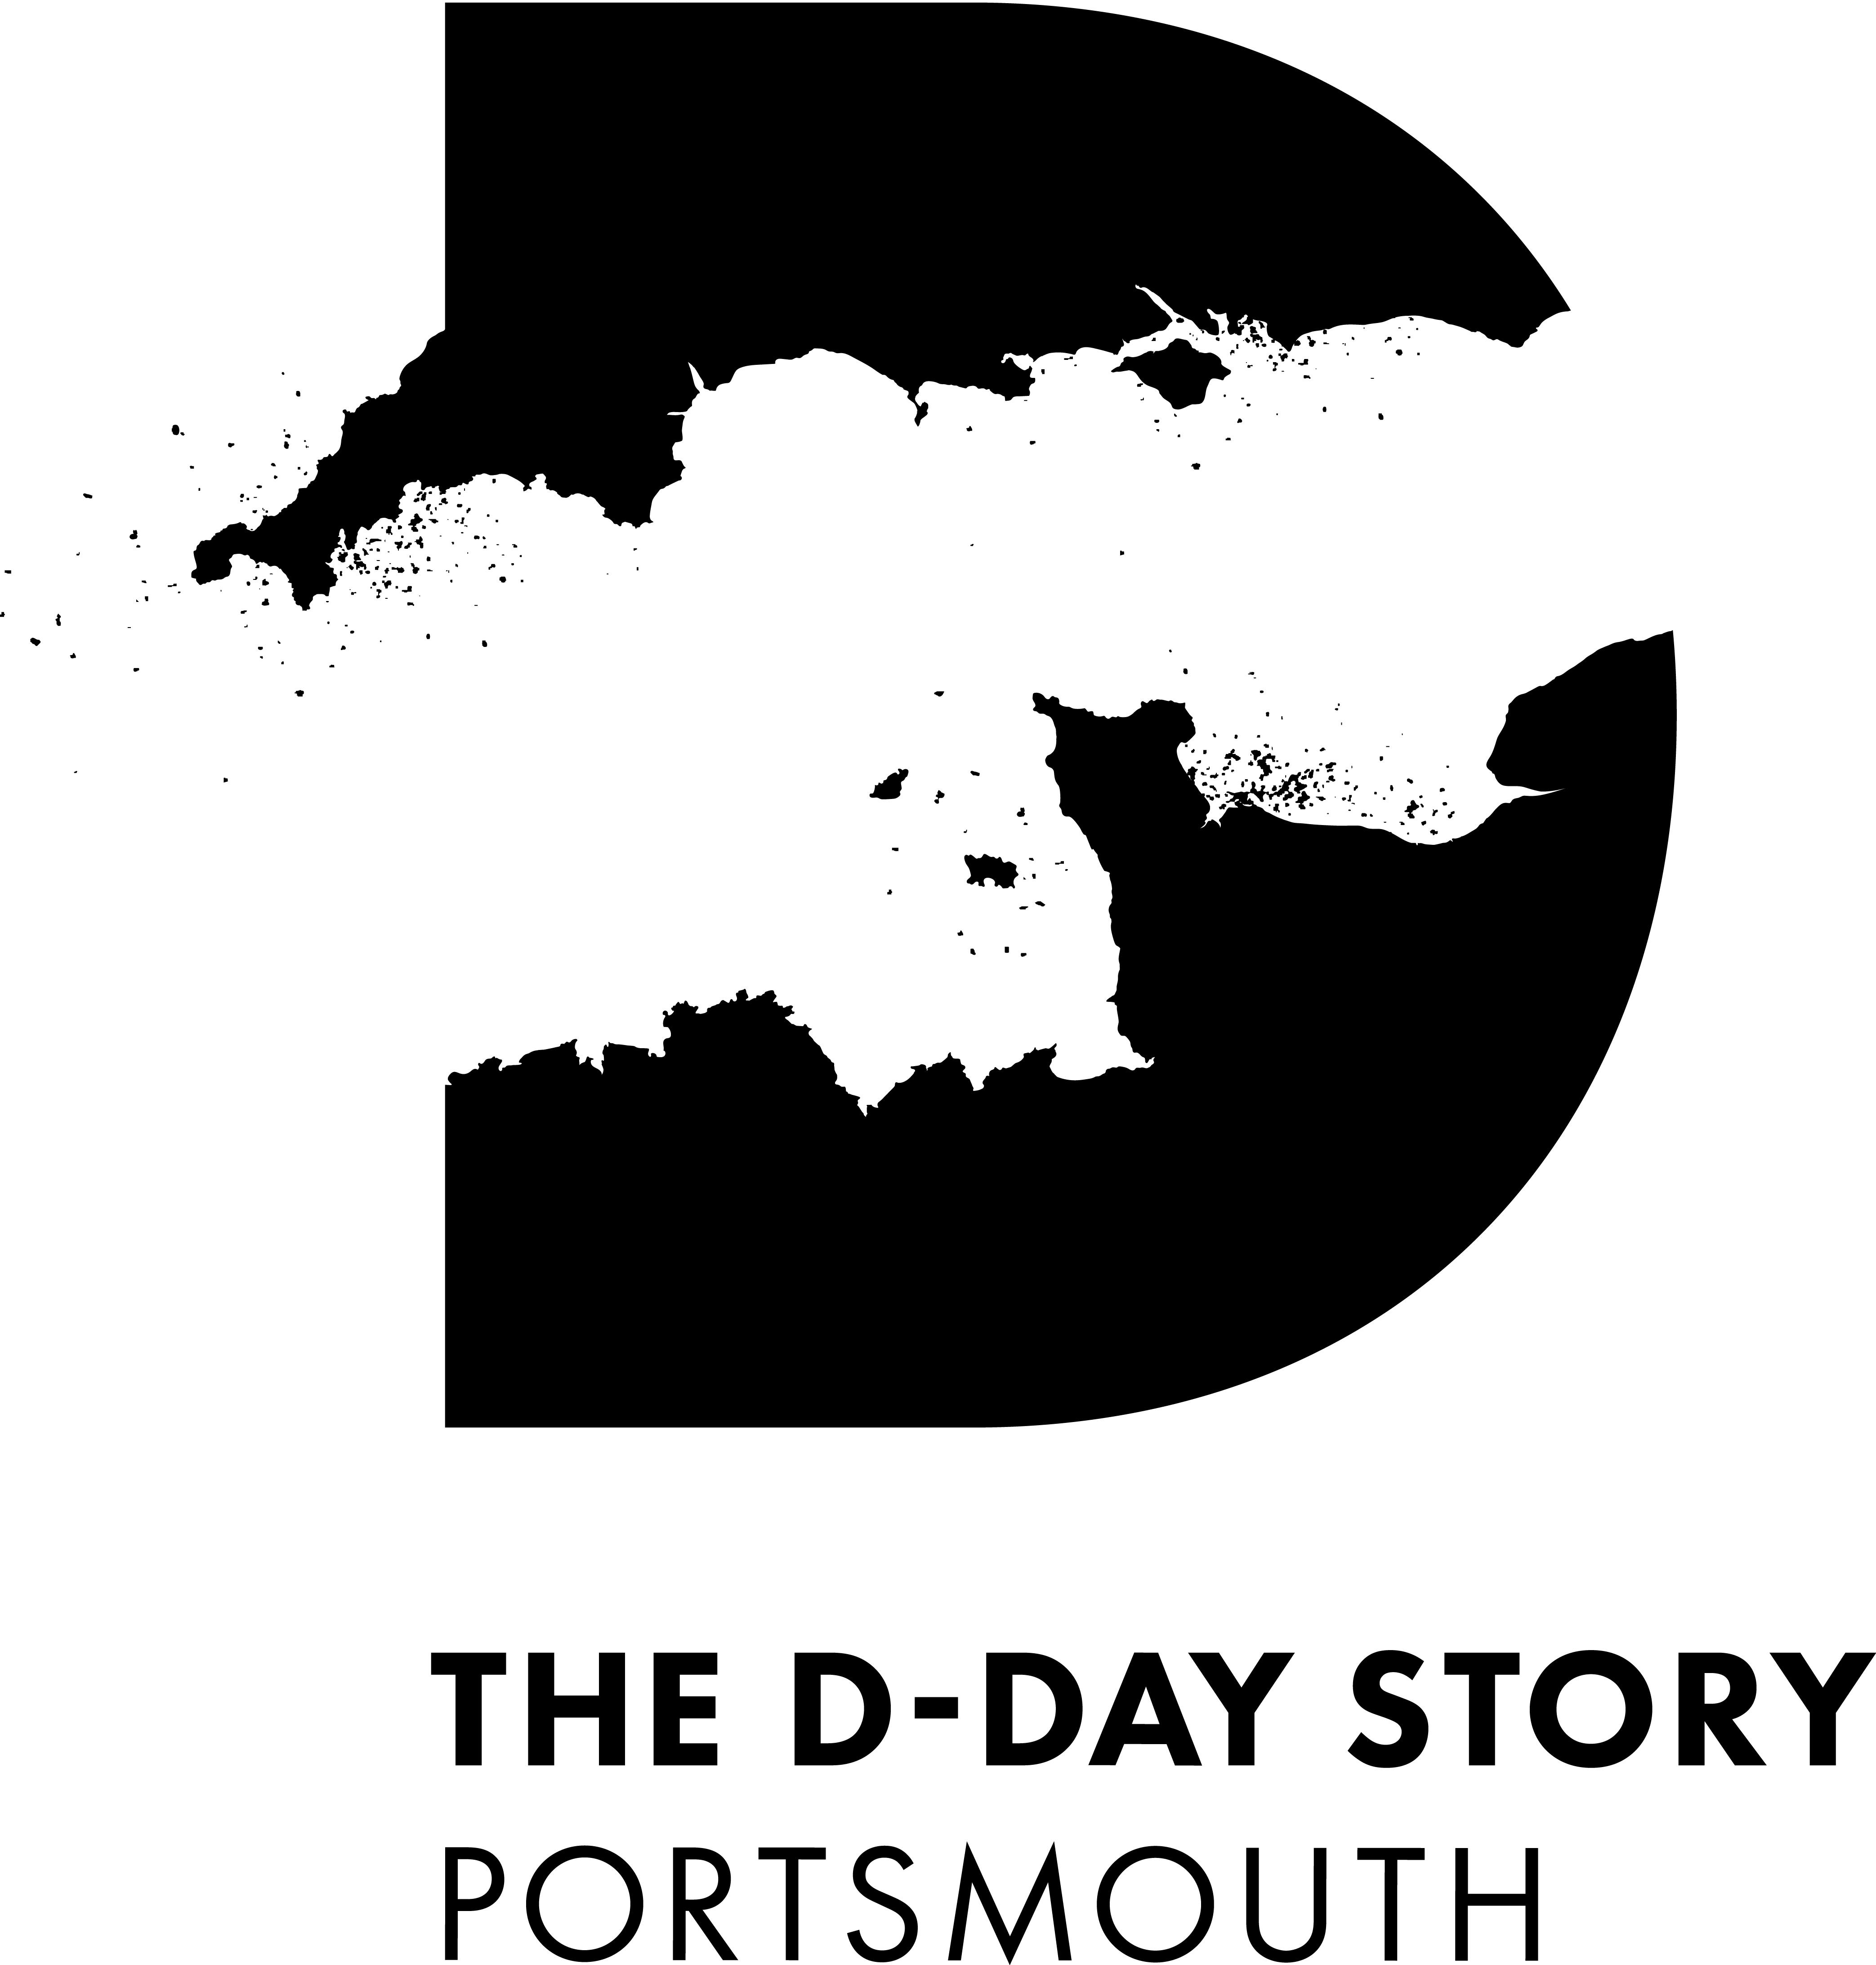

Accessibility Guide for The D-Day Story
theddaystory@portsmouthcc.gov.uk, 02392 882555, http://www.theddaystory.com/
Contact for accessibility enquiries: Felicity Wood
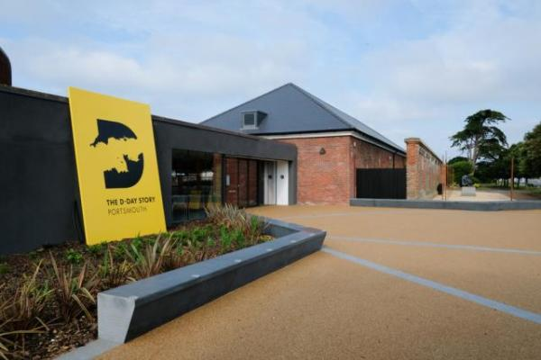

Welcome
The focus of The D-Day Story is the liberation of Europe from Nazi Germany occupation. It is told using the personal possessions and words of the people who took part.
Stunning imagery, audio-visual presentations and hands-on interactives help to bring the story to life.
www.theddaystory.com

At a Glance

Level Access
- There is level access from the main entrance to:
  - Dining Table
  - Main exhibition
  - Front desk
  - The D-Day Story shop
  - Landing Craft Tank 7074

Hearing
- The fire alarm has flashing lights.
- We have a hearing loop in Throughout the venue, providing coverage of the majority of the museum..
- All staff have disability awareness training. Some staff have Next Generation Text training

Visual
- Glass doors and full-height windows have contrast markings.
- The walls and the doors have high colour contrast.
- Some parts of the venue have low lighting.
- We have display information in audio, braille and other.

General
- We have a concessionary rate for disabled visitors.
- We have a complimentary ticket policy for personal assistants.
- All staff have disability awareness training.

Getting here
Clarence Esplanade
Portsmouth
Hampshire
PO5 3NT

Travel by public transport
- You can get to The D-Day Story by bus, train and boat or ferry.
- On the corner of Clarendon Road and Palmerston Road, a 10 minute walk from the Museum. The bus stop is 0.4 miles / 0.6 km from The D-Day Story.
- The nearest train station is Portsmouth and Southsea. The train station is 1.5 miles / 2.4 km from The D-Day Story.
- The nearest port is Portsmouth International Port. The port is 2.7 miles / 4.3 km from The D-Day Story.
- For visitors travelling from the Isle of Wight, Southsea Hoverport is 0.6 miles away.

Travel by taxi
- You can get a taxi with Aqua Cars by calling 02392 654 321. The taxi company has a wheelchair accessible vehicle.
- We have a Tourist Information point on site, please ask at reception if you need help with travel or transport in the area.

Parking
- We have a car park. There are accessible parking spaces. Parking is not free.
- There is a drop-off point at the main entrance. The drop-off point does not have a dropped kerb.
- From the car park to the entrance, there is level access. The path from the car park is wider than 2000mm at all points along the route. There is a slight gradient leading up to the front of the museum. The car park is owned by Portsmouth City Council. Disabled parking is free.
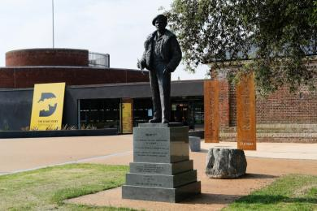
Front of the museum from Clarence Esplanade showing statue of General Montgomery, the museum sign and main entrance

Arrival

Path to main entrance
- From the street to the main entrance, there is level access.
- The path is 1700mm wide, or more.
- The path is sloped.

Main entrance
- The main entrance has level access.
- The door is 2000mm wide.
- The main door is sliding and automatic.
- There are granite blocks in route that leads from the car park and along the front of the main entrance to the building, they are 430mm high and there is a 1700mm wide gap between them. The blocks do not contrast clearly with the pavement so may not be seen by partially sighted visitors. There is a slight gradient from the bollards to the front door of the museum.

Getting around inside

Visual Impairment - General Information
- We have contrast markings on all glass doors, contrast markings on all full-height windows and high colour contrast between walls and doorframes.
- Some parts of the venue have low lighting.
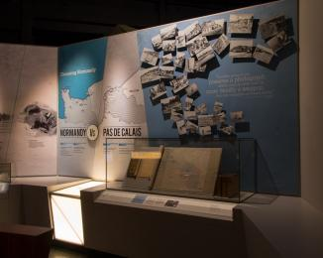
The first gallery of the D-Day Story. Light levels are low and there are spotlights.

Ticket/ information desk

Front desk
- From the main entrance to the desk, there is level access. The desk has a low section.
- The desk is situated in a large atrium area, there are no barriers or corridors between the front door and the desk. The low section is situated on the left hand side of the desk and the clearance between the desk and the floor is 700mm. There are perspex screens on the desk which may make visibility or hearing difficult for visitors.
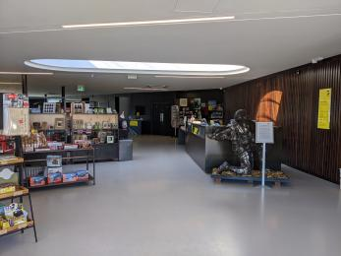
Just inside the main entrance to the museum. There is a desk on the right hand side and shop furniture and shelving to the left.

Things to See and Do
- We have a concessionary rate for disabled visitors.
- We have a complimentary ticket policy for personal assistants.
- We have performances with: captioned, British Sign Language interpreted, relaxed and touch tour.
- We have display information in: audio, braille .
- A Quick and Easy guide for adults with learning difficulties and An audio tour of the Overlord Embroidery designed for blind and partially sighted visitors

Main exhibition
- From the main entrance to this area, there is level access. The route is 1320mm wide, or more. Some display information is low, for wheelchair users. There are seats.
- There is a hearing loop.
- Videos have subtitles.
- The light level drops as you enter display areas. Most areas have low light levels, apart from the 'Making it' gallery. The displays can be crowded when the museum is busy.
The displays areas 'Preparation', 'Ready to Go' and 'D-Day and the Battle of Normandy' have loud video and audio.
'Legacy' and 'Overlord Embroidery' have touchscreens devices that play audio tracks, but generally this the quietest area of the museum.
The majority of floors are completely level and all ramps are designed for wheelchair users.
The majority of paths through the museum displays are 1,500mm or wider. There are some narrower areas but there are alternative paths through the displays.
The majority of turning circles in the exhibition are at least 1,500mm.
There are no low level barriers or trip hazards in any of the displays.
There are no internal doors in the museum displays. If there is a doorway between one gallery and another, it will be at least 1,300mm wide.
All activities and text in the displays have been designed to be viewed from a wheelchair.
All corners and joints in the displays have smooth edges.
Every exhibition gallery apart from one (‘Battle of Normandy’) has seating with arm rests. The seating is 620mm high with low arm rests.
We have four touchable models and two maps that have descriptions written in Braille.
The fonts used in the exhibition are at least 20pt or above. On most of the display panels there is a clear contrast between the writing and the background colour.
There is a clear contrast between the colour of display plinths and the floor, although light levels are low in the museum displays.
There are no low level barriers or trip hazards in any of the displays.
Each month we hold a ‘Chilled out museum’ for visitors who would like a more relaxed experience. We turn the lights up and sound down in the museum. See our website for more details.
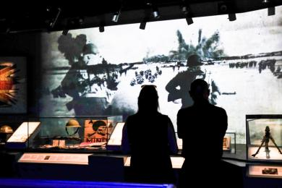
A couple stand in front of an audio visual display in the main exhibition area. They are in shadow as there is low lighting.

Shop

The D-Day Story shop
- From the main entrance to the shop, there is level access.
- The shop is in the main atrium area opposite the front desk. Stands are placed so that there is room to turn a wheelchair between them.
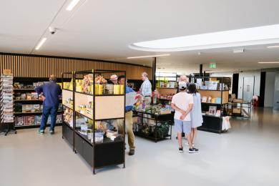
The museum shop area. There are free standing shelving units with room to fit two wheelchairs between them.

Place to eat and drink

The D-Day Story cafe
- From the main entrance to the dining area, there is level access. To get to a table, there are no steps.
- The route through the dining area is 800mm wide, or more.
- There is no background music.
- The table and plates have high colour contrast.
- We cater for vegetarian, gluten free (celiacs) and vegan specific diets.
- Sugar and lactose free drinks are available. Dietary needs can be catered for with advance notice.
Staff are happy to help with carrying trays and bringing food out to customers if required.

Getting around outside

Landing Craft Tank 7074
- From the main entrance to this area, there is level access. There is a permanent ramp.
- Landing Craft Tank 7074 is outside the museum. Leave the museum and turn left to reach it. The ship is outside. It is under a cover but it may be cold and wet when the weather is bad.
The ground floor is accessible by most wheelchairs. The floor is bumpy and uneven. There is a slope up to the entrance to the ship and a steep slope just inside. Access to the upper deck is by steps only, and there are narrow doorways. Access to the bridge deck, the highest point of the ship, is by ladder only.
There are touchable models on board the ship.
In the 'engine room' there are display screens with BSL interpretation.
Staff will be happy to help you if needed.
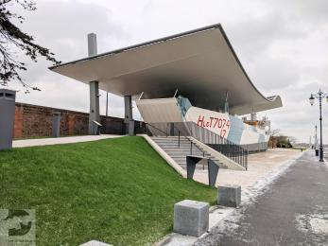
A photograph of Landing Craft Tank 7074 on display outside The D-Day Story museum. There is a ramp leading up to the entrance.
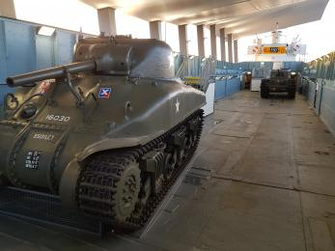
A photograph of the ground floor deck of the Landing Craft Tank. The floor is uneven and bumpy.
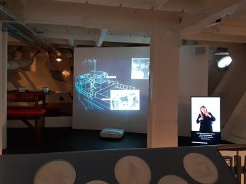
A photograph of the 'engine room' display. There is a screen with BSL interpretation.

Customer care support

Accessibility equipment
- We provide wheelchairs. Wheelchairs are free.
- We have a hearing loop in Throughout the venue, providing coverage of the majority of the museum..
- Magnifying glasses with an LED light.
An audio guide of the Overlord Embroidery designed specifically for blind and partially sighted visitors. Please ask at reception.
- Assistance dogs are welcome. There is a park and green space (Castle Field) within 100 metres of the museum where you can take them for a break.

Emergency evacuation procedures
- We have emergency evacuation procedures for disabled visitors.
- The fire alarm has flashing lights.

Customer care support
- All staff have disability awareness training.
- Some staff have Next Generation Text training.

Guide last updated: 15 February 2021

