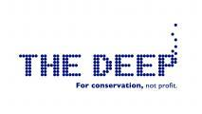

Accessibility Guide for The Deep
access@thedeep.co.uk, 01482 381000, www.thedeep.co.uk
Contact for accessibility enquiries: Zoe Montgomerie
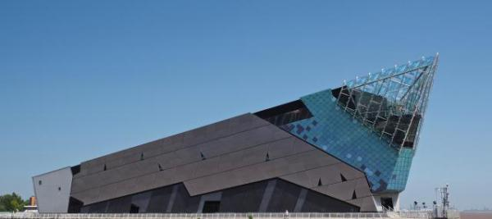

Welcome
Welcome to The Deep, Hull’s award winning aquarium, offering a great family day out for visitors with access or additional needs.
Home to a whopping 3,500 fish including Green sawfish, spectacular sharks, rays, Loggerhead turtles and a colony of Gentoo penguins. We aim to deliver excellent service to all visitors and continually strive to improve and provide a quality experience for all. We are committed to accessibility for all visitors, we are continually updating and adding to our wide range of tools and information to ensure an accessible family day out.

At a Glance

Level Access
- There is level access from the main entrance to:
  - Dining Table
  - Awakening Seas/ Timeline
  - Lagoon of Light
  - Endless Ocean, Slime, Changing Seas and Amazon Flooded Forest
  - Cool Seas - UNDERGOING REFURBISHMENT
  - Kingdom of Ice
  - Deep Blue One
  - Underwater Tunnel
  - Reception desk
  - Changing Places - Ground Floor
  - Ground Floor Toilets
  - Learning Centre Corridor
  - First Floor Toilets
  - Third Floor Toilets
  - Deepartment store (gift shop)
- There is level access from the car park to:
  - Outdoor Picnic Area
  - Indoor Picnic Area

Hearing
- The fire alarm has flashing lights.
- We have a hearing loop in Reception/ticketing desk/gift shop.
- Some staff have Next Generation Text and disability awareness training.

Visual
- Glass doors and full-height windows have contrast markings.
- Some parts of the venue have low lighting.
- We have display information in audio, braille, large print and other.
- There is audio descriptive commentary.
- We have information in audio, braille and large print.

General
- We have a complimentary ticket policy for personal assistants.
- There is at least 1 public toilet for disabled visitors.At least one toilet is a Changing Places toilet.
- Some staff have disability awareness training.

Getting here
The Deep
Tower Street
Hull
East Yorkshire
HU1 4DP

Travel by public transport
- You can get to The Deep by bus and train.
- The nearest bus stop is approximately 5 minutes from The Deep across a footbridge. The footbridge can be accessed via sloped walkways so is accessible for those using mobility aids or push chairs. The bus stop is 0.1 miles / 0.2 km from The Deep.
- The nearest train station is Hull Paragon Interchange. The train station is 1 miles / 1.6 km from The Deep.
- The Deep is easily accessed via bus or car. For up to date information on bus timetables from Hull Interchange to The Deep please call Traveline on 0871 200 22 33 open daily from 8am - 8pm (calls to Traveline cost 10p per minute, plus any charges your network provider makes). Train times into Hull can be found via National Rail.

Travel by taxi
- You can get a taxi with Hull Cars by calling 01482 828282.
- You can get a taxi with Drive by calling 01482 575757. The taxi company has a wheelchair accessible vehicle.

Parking
- We have a car park. There are accessible parking spaces. The parking is less than 50 metres from the main entrance. Parking is not free.
- There is a drop-off point at the main entrance. The drop-off point has a dropped kerb.
- From the car park to the entrance, there is level access. There is a permanent ramp.
- The path is sloped.
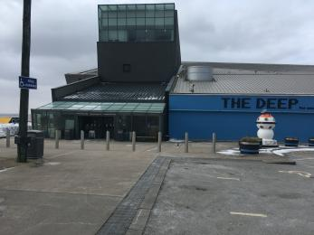
The Deep

Arrival

Path to main entrance
- From the street to the main entrance, there is level access.
- The path is 2130mm wide, or more.
- The path is sloped.

Main entrance
- The main entrance has level access.
- The door is 1440mm wide.
- The main door is side hung and automatic.
- The main door is sliding and automatic.
- The Deep has an dedicated accessible entrance which it situated towards the front of the building. The doors at this entrance are wider and operate on automatic opening. Once inside, visitors are directed to a dedicated accessible ticketing/information desk.
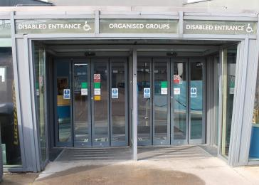
The Deep

Getting around inside

Visual Impairment - General Information
- We have contrast markings on all glass doors and contrast markings on all full-height windows.
- Some parts of the venue have low lighting.

Lift
- We have 5 lifts.
- You can get a lift to all floors.

Main lifts
- The lift door is 1080mm wide.
- The lift is 1750mm wide. The lift is 2060mm deep.
- The lift buttons have raised numbers or letters.
- The lift shows the floor number, at each floor.
- There are two main lifts that are used to take visitors to and from the third floor, which is where the exhibition begins and is the location of The Deep's café.
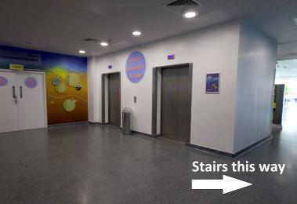
The Deeps lifts

Lift to Observatory
- The lift door is 1060mm wide.
- The lift is 1600mm wide. The lift is 1370mm deep.
- The lift buttons have raised numbers or letters.
- The lift shows the floor number, at each floor.
- This lift is for visitors to access the Observatory level. This level also has a small outdoor viewing platform.

Bubble Lift
- The lift door is 1100mm wide.
- The lift is 1440mm wide. The lift is 2040mm deep.
- The lift buttons have raised numbers or letters.
- This is a glass-fronted lift that transports visitors from the ground to third floor whilst enjoying views of the Endless Ocean exhibit (this display contains some of The Deep's largest animals including sharks, rays, turtles and sawfish). The lift can become busy during peak operating periods, so visitors also have the option of a 'scenic staircase' to exit the exhibition should they be able to use it. Alternatively, if visitors don't want to/cannot use this lift, an alternative exit can provided via a fire escape directly to ground floor level.
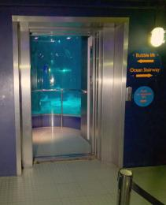
The Deep bubble lift

Wheelchair Lift
- The lift is a chairlift.
- The lift door is 900mm wide.
- The lift is 1160mm wide. The lift is 1450mm deep.
- The lift buttons have raised numbers or letters.
- This lift is situated in Deep Blue One to allow access for those who cannot use the steps to enter.
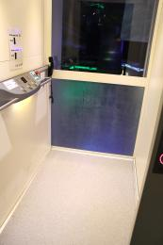
The Deep wheelchair lift

Ticket/ information desk

Reception desk
- From the main entrance to the desk, there is level access. The route is 1650mm wide, or more.
- The door is 1410mm wide, or more.
- The desk has a low section.
- There is a low desk for wheelchair users situated to the left hand side of the reception desk, based within the accessibile till point area.
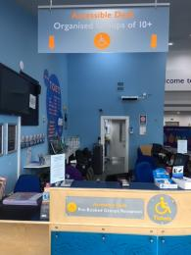
The Deep Reception

Things to See and Do
- We have a complimentary ticket policy for personal assistants.
- We have performances with: British Sign Language interpreted.
- We have display information in: audio, braille, large print .
- On any day The Deep can offer access to large print, braille and audio guides, as well as information in a variety of foreign languages. , The Deep runs Quiet Day events twice per year during which we provide presentations with BSL interpretation. and On every Tuesday (excluding school holidays) The Deep holds Tranquil Tuesdays, from 3pm until closing, the sounds will be turned down and lights will be brighter. We have a designated quiet space.

Awakening Seas/ Timeline
- From the main entrance to this area, there is level access. There is a permanent ramp. There is a lift.
- Some display information is low, for wheelchair users.
- This zone is dark so that lights from the interactive stations can be more visible. There are also sound effects played throughout from the displays and interactive stations.
During Quiet Day or Tranquil Tuesday sessions, the lights in this area are brighter, and sounds are turned down.
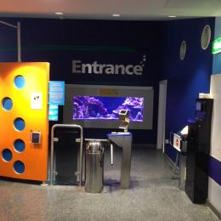
The Deep Awakening Seas

Lagoon of Light
- From the main entrance to this area, there is level access. There is a lift.
- Some display information is low, for wheelchair users. There are seats.
- Some videos have subtitles.
- The Lagoon of Light is brightly lit with few sound effects. The tank is open topped and at a lower level with clear acrylic sides so is very easy to see into for those in a seated/lower down position. During peak periods space in front of the display may become busy.
There are presentations delivered in this zone throughout the day via microphone, which increases the noise level.
There are iPad stations that contain information about animals, which can 'flash' on occasion.
Seating is provided in this area in the form of wooden 'bleachers' of different heights. These are in direct view of the display, however during peak periods the view may be obscured by visitors on the main thoroughfare.
This zone is also home to Dylan's Discovery Corner, a tactile area which hosts an interactive floor, fossil brushing station, artifact handling with our Guiding team and sensory objects.
The interactive floor area is smaller and may be difficult to access with mobility aids.
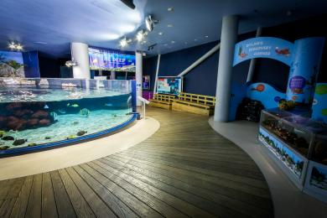
The Deep Lagoon Discovery corner

Endless Ocean, Slime, Changing Seas and Amazon Flooded Forest
- From the main entrance to this area, there is level access. There is a lift.
- Some display information is low, for wheelchair users. There are seats.
- Videos have subtitles.
- This area of the attraction is open-plan so all these zones are within the same area.
These zones are darker and generate noise from sound effects and the film shown on the large projector. Additionally, there are presentations delivered via a microphone in this area which can enhance the noice levels, due to the open plan nature of the exhibition the noise can carry and appear louder.
During Quiet Day/ Tranquil Tuesday sessions, the lights are brighter and the sounds turned down.
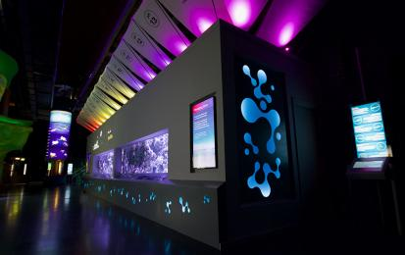
The Deep Changing Seas
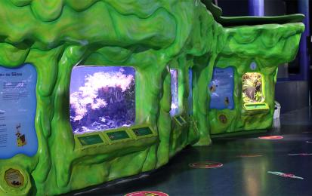
The Deep Slime

Cool Seas - UNDERGOING REFURBISHMENT
- From the main entrance to this area, there is level access. There is a permanent ramp. There is a lift.
- Some display information is low, for wheelchair users.
- This zone is very dark and has sound effects, voice overs and music playing on a loop. Displays are lit appropriately to the natural habitat of the animals.
During Quiet Day's/ Tranquil Tuesday sessions the lights in this area are brighter and sounds are turned down.
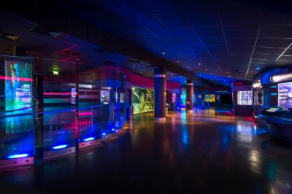
The Deep Cool Seas

Kingdom of Ice
- From the main entrance to this area, there is level access. There is a lift.
- Some display information is low, for wheelchair users.
- This zone is lit by blue-toned lighting and is 'corridor-style'. Noise is generated through video played in this area. There are two ice walls on the left hand side that can be touched, to the right is an area that plays a video which can be viewed via tv-sized gaps at two different heights.
At the end of this zone is the penguin exhibit. This area has large windows which allow viewing from a seated position, however during very peak periods this area can become crowded. On occassion there may be presentations given via a microphone which creates additional noise.
During Quiet Day and Tranquil Tuesday sessions sound effects are turned down.
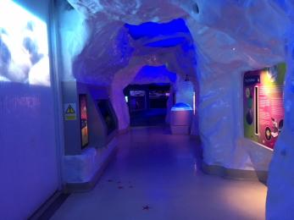
The Deep Ice tunnel

Deep Blue One
- From the main entrance to this area, there is level access. There is a permanent ramp. There is a lift.
- Some display information is low, for wheelchair users. There are seats.
- Some videos have subtitles.
- This zone is accessed via a walkway which bears illuminated rainbow-coloured lighting that changes every few seconds but does not flash. The zone is moderately lit and omits noise from a video playing on a loop and general sound effects, which can be loud.
The exhibits are stationed around the outer of the zone.
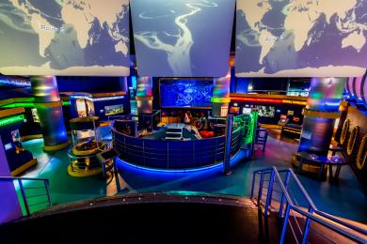
The Deep Deep Blue One

Underwater Tunnel
- From the main entrance to this area, there is level access. There is a permanent ramp. There is a lift.
- Some display information is low, for wheelchair users.
- The tunnel goes through our 10m deep Endless Oceans exhibit and leads to a corridor where visitors can take the scenic stairs or the bubble lift through Endless Oceans.
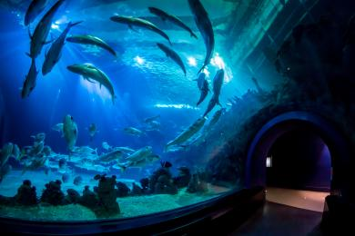
The Deep Tunnel

Spectator/ Audience viewing areas
- There are stewards to help disabled visitors.
- There is audio descriptive commentary.
- You can listen to audio commentary in some of the venue.
- From the main entrance to the viewing area, there is level access. There is a permanent ramp. There is a lift.

Public toilet

Changing Places - Ground Floor
- There is a public toilet for disabled visitors.
- The toilet is a Changing Places toilet.
- You need a RADAR key to open the public toilet.
- From the main entrance to the public toilet, there is level access. From the lift to the public toilet, the route is 1930mm wide, or more.
- The toilet door is 890mm wide.
- The direction of transfer onto the toilet is to the left.
- There is 1400mm at the side of the toilet. There is 2340mm in front of the toilet. The toilet seat is 470mm high. The toilets have handrails.
- The Changing Places facility is situated on the ground floor, past the reception desk. It can be accessed using a RADAR key or ask a member of our team for assistance.
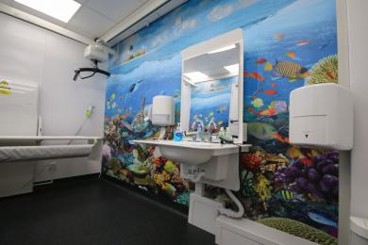
The Deep Changing Places

Public toilet

Ground Floor Toilets
- There is a public toilet for disabled visitors.
- The toilet is a Changing Places toilet.
- From the main entrance to the public toilet, there is level access. There is a permanent ramp.
- From the lift to the public toilet, the route is 1930mm wide, or more.
- The toilet door is 820mm wide.
- The direction of transfer onto the toilet is to the right.
- There is 450mm at the side of the toilet. There is 1280mm in front of the toilet. The toilet seat is 450mm high. The toilets have handrails.
- This facility is on the ground floor, past the reception desk.

Public toilet

Learning Centre Corridor
- There is a public toilet for disabled visitors.
- From the main entrance to the public toilet, there is level access. The toilet door is 820mm wide.
- The direction of transfer onto the toilet is to the right.
- There is 760mm at the side of the toilet. There is 720mm in front of the toilet. The toilet seat is 430mm high. The toilets have handrails.
- These toilets are on the ground floor, along the corridor, on the right from the main reception area.These toilets are used by school groups in term time and can be busy and noisy.

Public toilet

First Floor Toilets
- There is a public toilet for disabled visitors.
- From the main entrance to the public toilet, there is level access. There is a lift.
- The toilet door is 820mm wide.
- The direction of transfer onto the toilet is to the left.
- There is 760mm at the side of the toilet. There is 1300mm in front of the toilet. The toilet seat is 470mm high. The toilets have handrails.

Public toilet

Third Floor Toilets
- There is a public toilet for disabled visitors.
- From the main entrance to the public toilet, there is level access. There is a lift.
- The toilet door is 770mm wide.
- The direction of transfer onto the toilet is to the front only.
- There is 1230mm in front of the toilet. The toilet seat is 450mm high. The toilets have handrails.

Shop

Deepartment store (gift shop)
- From the main entrance to the shop, there is level access. The route through the shop is 800mm wide, or more.
- The gift shop is located on the ground floor which is usually passed through to get to The Deep's main exit, however visitors can choose to exit via the accessible entrance if they would prefer not to visit the gift shop.
There are a variety of products available at varying heights on display - including breakable items.
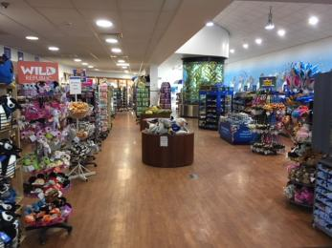
The Deepartment store

Place to eat and drink

Third Floor Cafe
- From the main entrance to the dining area, there is level access. There is a lift. To get to a table, there are no steps.
- The dining area is self-service. If you need table service, staff can help you.
- The route through the dining area is 800mm wide, or more.
- There is no background music.
- We cater for vegetarian, gluten free (celiacs), lactose free (dairy free) specific diets.
- We will try to cater for other specific dietary requirements where possible. Please speak to member of our team when in the cafe.
- Our cafe has tables that are at a raised height to allow wheelchair access. Should a person with access requirements need assistance in collecting/purchasing their meal they should speak to a member of catering team on arrival to the cafe area. Vegetarian and a small number of gluten free options are offered as standard, other dietary options can be catered for on request when possible.
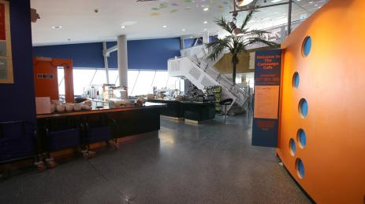
The Deep cafe

Getting around outside

Picnic Area

Outdoor Picnic Area
- From the car park to the picnic area, there is level access. Some tables have space for wheelchair users. You can bring your own food to the picnic area.
- The tables in the outdoor picnic area are static wooden benches, a wheelchair can be seated at either end.

Picnic Area

Indoor Picnic Area
- From the car park to the picnic area, there is level access. The entrance is 3450mm wide.
- Some tables have space for wheelchair users. You can bring your own food to the picnic area.
- This picnic area is situated within the exhibition space on the first floor. It is comprised of moveable table and chairs, so a wheelchair can be seated where required.
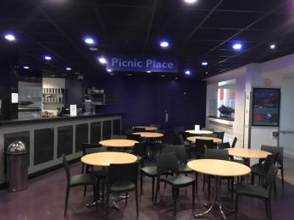
The Deep Halfway Cafe

Customer care support

Accessibility equipment
- We provide wheelchairs. Wheelchairs are free.
- We have a hearing loop in Reception/ticketing desk/gift shop.
- The Deep offers complimentary use of wheelchairs, mobility scooters, rollators, ear defenders, audio guides and literature in alternative formats such as braille and large print. Mobility aids can be booked in advance with the exception of mobility scooters.
- For a list of more items, please go to https://www.thedeep.co.uk/plan-your-visit/access-for-all.

Emergency evacuation procedures
- We have emergency evacuation procedures for disabled visitors.
- The fire alarm has flashing lights.

Customer care support
- Some staff have disability awareness training.
- Some staff have Next Generation Text training.
- We have information in audio, braille and large print.

Guide last updated: 26 July 2022

