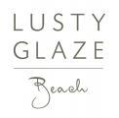
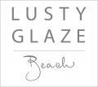

Accessibility Guide for Lusty Glaze Beach
info@lustyglaze.co.uk, 01637872444, www.lustyglaze.co.uk
Contact for accessibility enquiries: Andi Millson
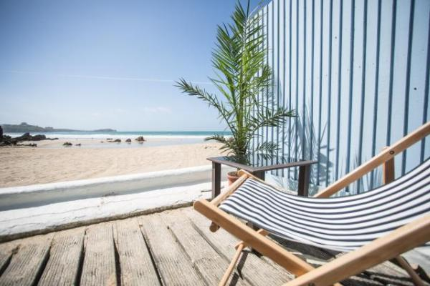

Welcome
Private. Unique. Memorable. Laid back. That's Lusty!
Privately owned since the 1920’s, Lusty Glaze is a spectacular horseshoe shaped cove on the outskirts of Newquay. This beautiful, secluded beach is your home away from home by the sea.
Adventurous activities for all ages and abilities, spectacular music events, exclusive corporate hosting, beautiful civil wedding ceremonies, luxury day packages and of course splendid beach dining are all part of our day throughout the year.
Watch the video: Accommodation - Explore The Cottage

At a Glance

Level Access
- The main entrance has 133 steps and a handrail. There is no lift and no ramp.

Access with steps
- There are steps from the main entrance to:
  - Bedroom
  - Dining Table
  - Main Bar
  - Public Toilets
  - Marquee
  - The Beach
  - The Terrace
  - Rum & Pizza Bar

Hearing
- The (bedroom) TVs have subtitles.

Visual
- Some parts of the venue have low lighting.

Getting here
Lusty Glaze Beach
Lusty Glaze Road
Newquay
Cornwall
TR7 3AE

Travel by public transport
- You can get to Lusty Glaze Beach by bus and train.
- The nearest bus stop is located on Narrowcliff Road opposite Tesco Express. A 5 minute walk from the beach. The bus stop is 0.1 miles / 0.2 km from Lusty Glaze Beach.
- The nearest train station is Newquay. The train station is 0.2 miles / 0.3 km from Lusty Glaze Beach.

Travel by taxi
- You can get a taxi with 123 by calling 01637 851234.
- You can get a taxi with A2B by calling 01637 877777.
- You can get a taxi with Pats Cabs by calling 01637 830637.

Parking
- There is parking near the venue. The parking is less than 50 metres from the main entrance. Parking is not free.
- The nearest drop off point is in the public pay and display car park at the top of our 133 steps. From the parking to the main entrance, there are 133 steps. There is no ramp and no lift.
- Our famous 133 steps are the ONLY public access to the beach. A handrail runs the length of the steps and there are rest stops every 10 or so steps. Due to the nature of the steps being carved out of the cliff face, some of the steps have an uneven surface and are not of a uniform size.
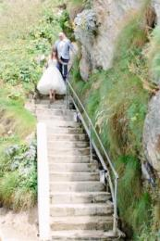
The Steps down to Lusty Glaze Beach
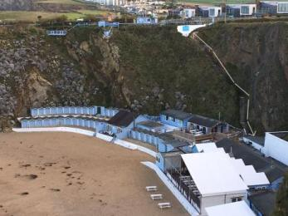
Our famous 133 steps

Arrival

Path to main entrance
- From the street to the main entrance, there are 133 steps. There is no ramp and no lift.

Main entrance
- The door is 1500mm wide.
- The main entrance has 133 steps.
- This entrance has a handrail.

Getting around inside

Visual Impairment - General Information
- Some parts of the venue have low lighting.

Bedrooms
- All bedrooms have windows.
- Bedrooms have ceiling lights, wall lights, bedside lamps, desk or table lamps and natural daylight.
- Lights are LED, energy saving and traditional filament. Some lights can be controlled independently.
- TVs have subtitles.
- All bedrooms are non-smoking.
- No bedrooms have fitted carpets.
- We can move the bedroom furniture, to improve accessibility.
- The bedroom nearest the main entrance has 133 steps.
- We have bathrooms with a bath and overhead shower. The direction of transfer onto the toilet is to the right.

Bar

Main Bar
- From the main entrance to the bar, there are 133 steps. There is no lift and no ramp.

Public toilet

Public Toilets
- From the main entrance to the public toilet, there are 133 steps. There is no lift and no ramp.

Place to eat and drink
- From the main entrance to the dining area, there are 133 steps. There is no lift and no ramp.
- To get to a table, there are 133 steps.
- There is background music.
- The table and plates have high colour contrast.
- We cater for vegetarian, gluten free (celiacs) and vegan specific diets.

Marquee
- From the main entrance to this area, there are 133 steps. There is no lift and no ramp.

Getting around outside

Smoking

The Beach
- The route is 2000mm wide, or more.
- The entrance is 2000mm wide.
- From the main entrance to the smoking area, there are 133 steps.
- Smoking is allowed on the beach only and ashtrays are provided.

Terrace

The Terrace
- The entrance is 1000mm wide.
- To get to a table, there are 133steps steps.
- From the main entrance to the terrace, there are 133 steps.
- All areas of the beach, restaurant and accommodation are accessed via 133 steps.

Rum & Pizza Bar
- From the main entrance to the area, there are 133 steps.
- All areas of the beach, restaurant and accommodation are accessed via 133 steps.
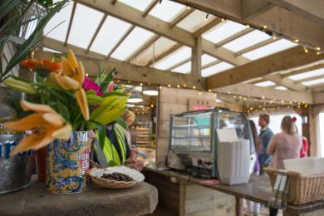
Rum & Pizza Bar

Customer care support

Accessibility equipment
- Dogs may go to the toilet on the beach provided that any waste is picked up and removed from the beach.
- You can hire mobility equipment from Cornwall Mobility by calling 01872 254920.

Guide last updated: 18 January 2019

