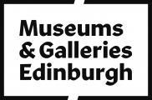

Accessibility Guide for The People's Story Museum
museumsandgalleries@edinburgh.gov.uk, 0131 529 4057, http://www.edinburghmuseums.org.uk/Venues/The-People-s-Story
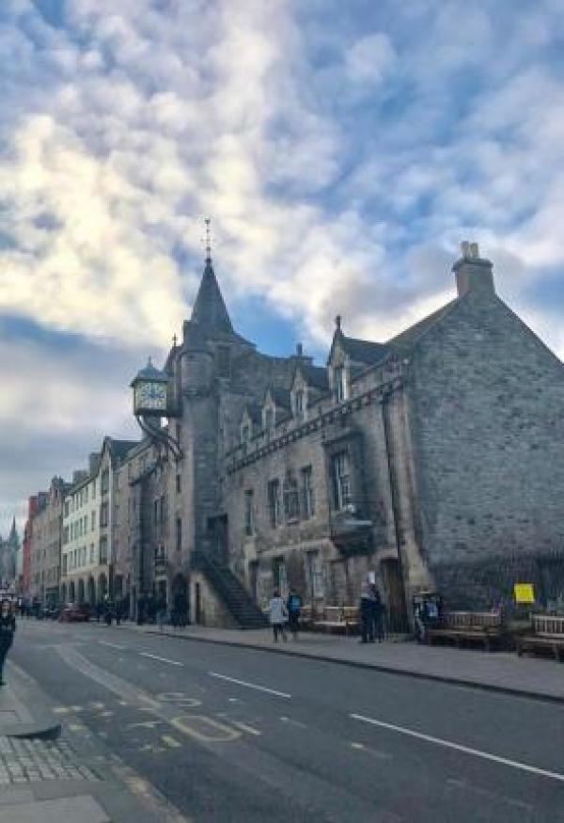

Welcome
The People’s Story explores the lives of Edinburgh’s ordinary people at work and play from the late 18th century to today. Visitors can see displays showing a bookbinder’s workshop, a wartime kitchen and much more, all packed with real objects. You can even see a former jail, an original part of this historic building.
The People’s Story is housed in the Canongate Tollbooth, a Royal Mile landmark built in 1591 and used in the past to conduct burgh affairs, collect taxes and as a jail. Visitors can imagine the ghostly rattle of the jailor’s keys as they peer into an original cell.

At a Glance

Level Access
- The main entrance has level access with a ramp. The ramp is permanent.
- There is level access from the main entrance to:
  - Ground floor exhibition space
  - Visitor reception
  - Ground floor accessible toilet
  - First floor

Access with steps
- There are steps from the main entrance to:
  - Second floor: exhibition space and third floor: video room

Hearing
- We have a hearing loop in The video room at the 3rd floor.

Visual
- Some parts of the venue have low lighting.
- We have information in large print.

General
- There is at least 1 public toilet for disabled visitors.

Getting here
163 Canongate
Royal Mile
Edinburgh
EH8 8BN

Travel by public transport
- You can get to The People's Story Museum by bus, train and tram.
- There is a stop conveniently outside the museum entrance and the opposite side of the road. Service 35 runs between the Heriot-Watt University Campus and Ocean Terminal. Here is a link to the online timetable: https://www.lothianbuses.com/timetable/?service_name=35 The nearest train station is Waverley Railway Station. The train station is 0.40 miles / 57.0 km from The People's Story Museum.
- The nearest tram station is St Andrews Square . The tram station is 0.7 miles / 1.1 km from The People's Story Museum.
- If not using public transport and travelling via foot to Princes Street, we recommend travelling via Jeffrey Street, then Market Street opposed to via the Royal Mile. Jeffrey Street is downhill, sloped and wheelchair accessible as there are no stairs.

Travel by taxi
- You can get a taxi with City Cabs by calling 0131 228 1211. The taxi company has a wheelchair accessible vehicle.
- If you require a taxi, please contact the front desk and they will be happy to help you.

Parking
- There is a drop-off point at the main entrance. The drop-off point has a dropped kerb.
- The Museum is located on the Royal Mile, which gets very busy during the day. There is no on-street parking and restricted drop-off areas. However, there is a bus stop with a dropped kerb outside the museum. A quick drop-off is then possible, but it is difficult to wait for people for a long period of time.
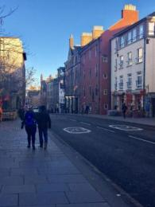
There is a bus stop about 100 feet beyond the museum in the direction of Ocean Terminal.

Arrival

Path to main entrance
- From the street to the main entrance, there is level access.
- There is a permanent ramp.
- The path is sloped.

Main entrance
- The main entrance has level access.
- There is a permanent ramp.
- The door is 950mm wide.
- The main door is side hung and manual.
- It is a push and pull door. The desk is on the opposite side of the door so the staff can help you anytime.
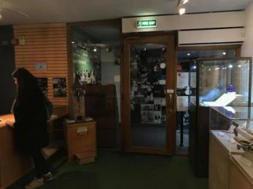
Main entrance door taken from reception area
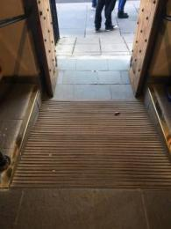
View of the ramp to the street level

Getting around inside

Visual Impairment - General Information
- Some parts of the venue have low lighting.
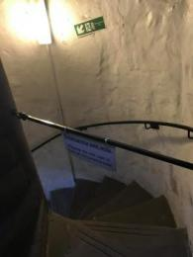
The spiral stairs up to the video room are dimly lit

Lift
- We have 1 lift.
- You can get a lift to some floors.

Lift to first floor exhibit
- The lift door is 770mm wide.
- The lift is 770mm wide. The lift says the floor number at each floor.
- The lift shows the floor number, at each floor.
- The lift only takes visitors to the first floor. On the first floor, there is a member of staff to welcome you and assist you if you need. The corridor at the ground floor is quite narrow for turning: 910mm, and it is opposite to fire exit. For evacuation purposes, the museum limits the number of wheelchairs on the first floor to 2 at any one time, depending on how busy it is. If you want to visit the museum in a group, please contact the museum in advance.
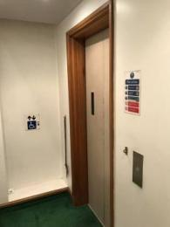
Doors of the lift at the ground floor.
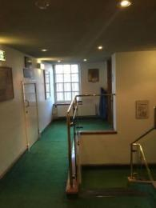
View of the lift arrival on the first floor.
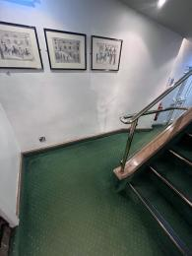
The tight corner on the way to the lift.
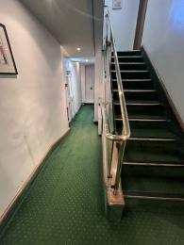
The hallway to the lift doors on the ground floor.

Ticket/ information desk

Visitor reception
- From the main entrance to the desk, there is level access. There is a permanent ramp. The door is 950mm wide, or more.
- Large print guides are available at the main desk, please ask to borrow it. The reception is always staffed if you have any questions or queries concerning your visit.
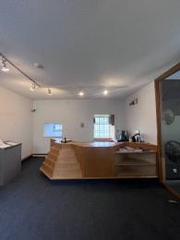
Visitor reception desk
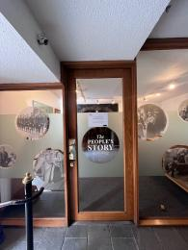
Door to visitor reception desk and museum

Ground floor exhibition space
- From the main entrance to this area, there is level access. There is a permanent ramp. The door is 950mm wide.
- Some display information is low, for wheelchair users. There are seats.
- The ground floor layout is open plan and then, some on the display labels are not readable from a seated position.On some days, there are volunteers in the space who would be happy to answer your questions about the exhibits.
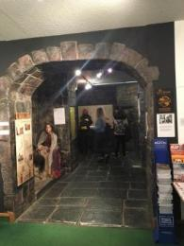
Entrance to the ground floor exhibition space.

Public toilet

Ground floor accessible toilet
- There is a public toilet for disabled visitors.
- From the main entrance to the public toilet, there is level access. There is a permanent ramp.
- The toilet door is 850mm wide.
- The direction of transfer onto the toilet is to the right.
- There is 1400mm in front of the toilet. The toilet seat is 420mm high. The toilets have handrails.
- There is also a baby changing facility is the accessible toilet room.
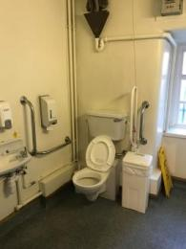
Ground floor accessible toilet
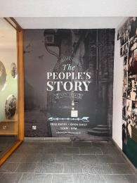
Door to the accessible toilet, just inside the main entrance

First floor
- From the main entrance to this area, there is level access. There is a lift.
- The door is 770mm wide.
- You can access the first floor both by stairs and lift. There are 16 steps up to the first floor and a banister.
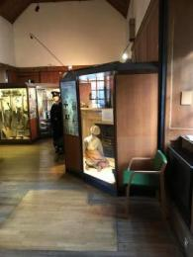
First floor exhibit
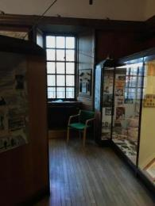
First floor exhibit (2)

Second floor: exhibition space and third floor: video room
- From the main entrance to this area, there are 13 steps. There is no lift and no ramp.
- The second floor exhibit is not accessible for wheelchair users. There is also a video room located on the top floor but accessible via a narrow staircase. the door at the top of the stairs is 750mm wide and only 1650mm high.
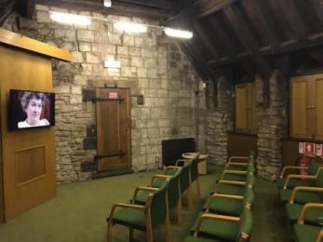
The video room
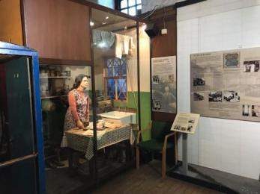
Example of the second floor exhibits

Customer care support

Accessibility equipment
- We have a hearing loop in The video room at the 3rd floor.
- Large print guides are available at the main desk in the entrance.
- There is not toilet area for assistance dogs in the museum. The nearest place is a public park (Holyrood Park) about 0, 3 miles from the museum.
- You can hire mobility equipment from North East Mobility Solutions Limited by calling 0131 554 3200.

Emergency evacuation procedures
- We have emergency evacuation procedures for disabled visitors.
- There is an evacuation chair for wheelchair users on the first floor which the staff are trained to use.

Customer care support
- We have information in large print.

Guide last updated: 20 June 2023

