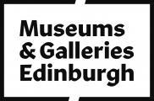

Accessibility Guide for The Museum of Edinburgh
MuseumsAndGalleries@edinburgh.gov.uk, 0131 529 4143, https://www.edinburghmuseums.org.uk/venue/museum-edinburgh
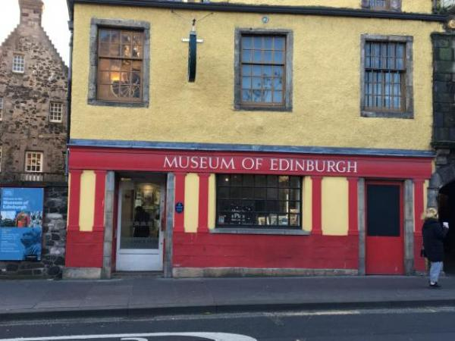

Welcome
The Museum of Edinburgh is the City’s treasure box - a maze of historic rooms crammed full of iconic objects from the Capital’s past.
Find out about the history of Edinburgh from the earliest times to the present day. Discover more about the city, its people, crafts and trades and the beautiful objects they created.
Although the ground floor is accessible (with one small step, that does not affect wheelchair access, to the entrance), due to the historic nature of the building, the upper levels are accessible by stairs only.

At a Glance

Level Access
- There is level access from the main entrance to:
  - Ground Floor temporary exhibition
  - Ground floor toilets
  - Courtyard

Visual
- Some parts of the venue have low lighting.

General
- There is at least 1 public toilet for disabled visitors.

Getting here
Huntly House
142 Canongate
Edinburgh
EH8 8DD

Travel by public transport
- You can get to The Museum of Edinburgh by bus, train and tram.
- There is a stop conveniently outside the museum entrance and the opposite side of the road. Service 35 runs between the Heriot-Watt University Campus and Ocean Terminal. Here is a link to the online timetable: https://www.lothianbuses.com/timetable/?service_name=35 The nearest train station is Waverley Railway Station. The train station is 0.40 miles / 57.0 km from The Museum of Edinburgh.
- The nearest tram station is St Andrews Square . The tram station is 0.7 miles / 1.1 km from The Museum of Edinburgh.
- If not using public transport to get to Princes Street, we recommend travelling via Jeffrey Street; then Market Street opposed to via the Royal Mile because Jeffrey Street is mostly flat and downhill.

Travel by taxi
- You can get a taxi with City Cabs by calling 0131 228 1211. The taxi company has a wheelchair accessible vehicle.

Parking
- There is a drop-off point at the main entrance. The drop-off point has a dropped kerb.
- The Museum is located on the main road, which gets very busy at certain times of the day. There is no on-street parking and restricted drop-off areas. However, there is a bus stop with a dropped kerb outside the museum: a quick drop-off is then possible, but it is difficult to wait for people for a long period of time.
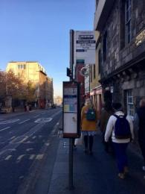
Bus stop outside the main entrance, Bus 35 in the direction of Heriot-Watt University.

Arrival

Path to main entrance
- From the street to the main entrance, there is level access.

Main entrance
- The main entrance has level access.
- The door is 1070mm wide.
- The main door is side hung and manual.
- The main entrance is accessed through the courtyard to the left of the building. There is also a door (h: 2020 x w: 920mm) to the courtyard entrance with a very small step, however, it does not affect wheelchair access.
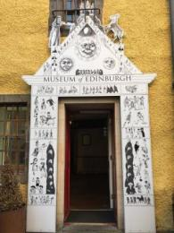
The main entrance with a white archway with the words 'Museum of Edinburgh' in black text over the door.
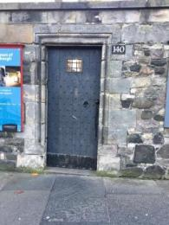
Courtyard door, opened during museum opening hours
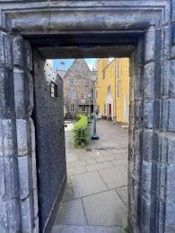
The path from the courtyard door to the main entrance.

Getting around inside

Visual Impairment - General Information
- Some parts of the venue have low lighting.
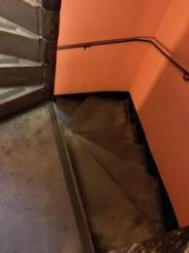
The stairs are dimly lit, especially later in the day in winter
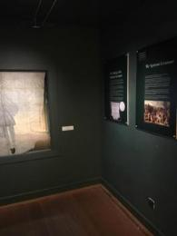
Examples of low lighting in some rooms

Ticket/ information desk
- From the main entrance to the desk, there is level access. The desk has a low section.
- The main desk with the till is 1m off the ground; the lowest section is 72cm.
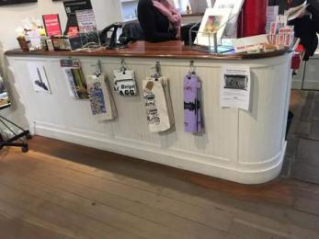
Main desk
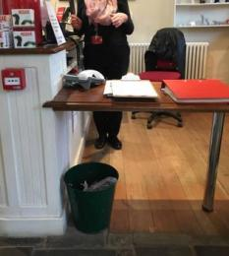
Lower section for wheelchair users

Ground Floor temporary exhibition
- From the main entrance to this area, there is level access. Some display information is low, for wheelchair users.
- The ground floor temporary exhibit, the toilet, the shop and buggy park are all accessible to wheelchair users by the side entrance. The rest of the museum exhibits are located upstairs and, unfortunately, are only accessible via the stairs on multiple levels. The museum is housed in a series of 16th to 18th centuries buildings, so there is also no lift. If you have mobility issues but are able to use the stairs, there is a handrail to help you and seats in the exhibition rooms if you need to rest.
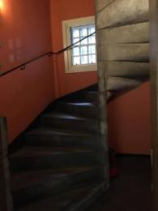
Stairs between ground and first floor (18 steps)
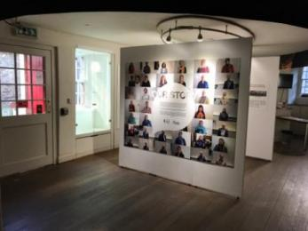
Temporary exhibition on the ground floor

Public toilet

Ground floor toilets
- There is a public toilet for disabled visitors.
- From the main entrance to the public toilet, there is level access. The toilet door is 900mm wide.
- The direction of transfer onto the toilet is to the left.
- There is 1400mm in front of the toilet. The toilet seat is 460mm high. The toilets have handrails.
- In the accessible toilet, you can find baby changing facilities.
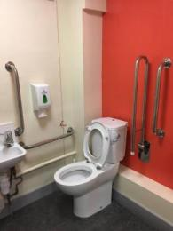
Accessible toilet

Shop

Ground Floor shop
- The route through the shop is 800mm wide, or more.
- The information desk is located in the shop. It is open plan with no aisles, but there are some high shelves. There is always a member of staff on duty if you need any assistance.
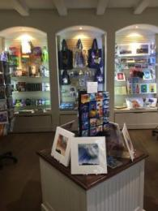
The shop on the ground floor

Buggy Park
- There is allocated space to leave buggies and wheelchairs on the ground floor. If you have limited mobility but are able to walk upstairs, it is possible to leave your wheelchair, walking aid, or mobility scooter in this space. Please, ask a member of staff to highlight this area on arrival.

Getting around outside

Courtyard
- From the main entrance to the gardens, there is level access.
- The courtyard is accessible by entrance on the street level on your way to the main entrance of the building. As previously stated, wheelchair users can enjoy this space and access the ground floor via the courtyard.
No smoking permitted in this area.
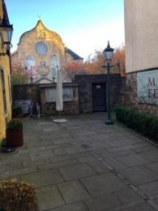
View on Canongate Kirk from back of courtyard

Picnic Area

2nd courtyard
- You can bring your own food to the picnic area.
- This courtyard is accessible via the upper museum levels, via the silver room. Also, for wheelchair users, it is accessible via a side gate called "Bakehouse Close" to the right of the museum's main entrance. The gate is locke, however please ask staff for assistance with the gate. You can access the courtyard where there is a ramp and, then the basement Courtyard Gallery where there is an interactive display. There is a small step but the staff have a portable ramp, so please ask them for help.
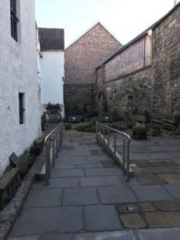
The access ramp in the courtyard
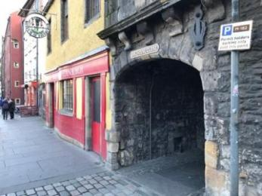
Gate accessible from the street called
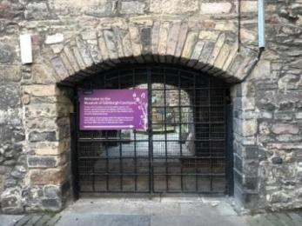
Wheelchairs access to the courtyard
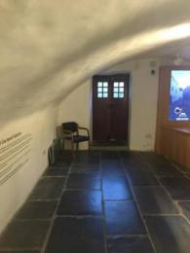
Courtyard Gallery
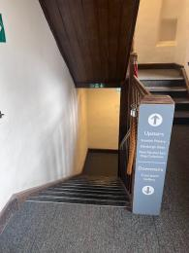
Sign for the stairs to the internal courtyard

Customer care support

Accessibility equipment
- There is not toilet area for assistance dogs in the museum. The nearest place is a public park (Holyrood Park) about 0, 3 miles from the museum.
- You can hire mobility equipment from North East Mobility Solutions Limited by calling 0131 554 3200.
- We have other services for people with accessibility requirements.
- Please, ask for assistance if you need help in any way.

Guide last updated: 20 June 2023

