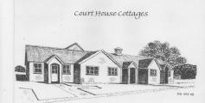

Accessibility Guide for Court House Cottages
courthouse369@btinternet.com, 01493 369665, www.courthousecottages.co.uk
Contact for accessibility enquiries: Julia Hawkins
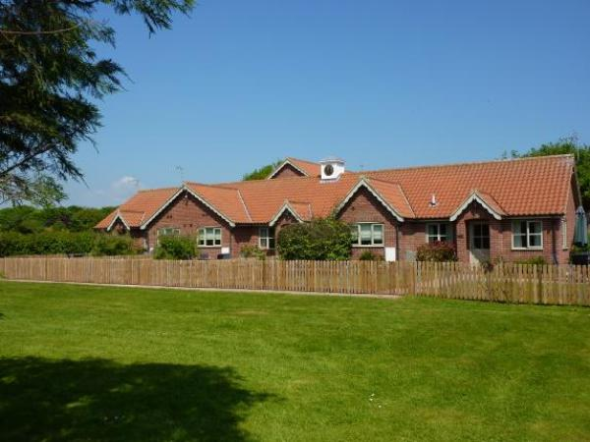

Welcome
Four 4 star Gold Award Self Catering Cottages set in quiet, rural location.
Three cottages sleep 4 and are all on one level. Built to latest building standards, wheelchair accessible.One cottage has a walk-in wet room.
One cottage sleeps 8 and is on two storeys.
Pets welcome.
Two cottages have private hot tubs.
Mobility/disability aids available to hire from local Red Cross Office, collection and pick up arranged for a donation.

At a Glance

Level Access
- There is level access from the main entrance to:
  - Bedroom: Bedroom
  - Exterior of cottage

Bedrooms
- We have non-allergic bedding.
- We have a portable hoist.

Level access bedrooms
- From the main entrance to the bedroom, there is level access.
- The route to the bedroom is 750mm wide, or more.
- The bedroom door is 750mm wide, or more.
- There is unobstructed floor space 1200mm by 900mm, or more.
- The bathroom has a level access shower.

Hearing
- The (bedroom) TVs have subtitles.

General
- Staff are available 24 hours a day.
- We have emergency evacuation procedures for disabled visitors.

Getting here
Court House Cottages
Rollesby
GREAT YARMOUTH
Norfolk
NR29 5HG

Travel by public transport
- Nearest railway station is Acle or Great Yarmouth. A taxi from there would be required.

Travel by taxi
- You can get a taxi with Caister Cabs by calling 01493 722722. The taxi company has a wheelchair accessible vehicle.

Parking
- We have a car park. There are accessible parking spaces. The parking is less than 50 metres from the main entrance. Parking is free.
- There is a drop-off point at the main entrance. The drop-off point has a dropped kerb.
- From the car park to the entrance, there is level access. The route is 1200mm wide, or more.

Arrival

Path to main entrance
- From the street to the main entrance, there is level access.
- There is a permanent ramp.
- The path is 2400mm wide, or more.

Main entrance
- The main entrance has level access.
- When you arrive, we can help carry your luggage.
- Luggage trolley available on request and/or further help if required.

Getting around inside

Bedrooms
- All bedrooms have windows.
- Bedrooms have ceiling lights, bedside lamps and natural daylight.
- Lights are LED, energy saving and traditional filament. TVs have subtitles.
- All bedrooms are non-smoking.
- We have non-allergic bedding.
- All bedrooms have fitted carpets.
- We can move the bedroom furniture, to improve accessibility.
- We have a portable hoist.
- From the main entrance to this area, there is level access.

Accessible bedrooms

Accessible bedroom Bedroom
- The bedroom door is 810mm wide. The bedroom is twin. The bathroom is ensuite. The bathroom door is 810mm wide.
- The bathroom has a separate shower. The bathroom has a level access shower. There is a shower chair available. The direction of transfer onto the toilet is to the front only. There is no space under the basin.
- The walls and the bathroom fittings have high colour contrast.
- Shower chairs etc can be hired if required from Red Cross

Getting around outside

Exterior of cottage
- From the main entrance to the gardens, there is level access.
- The route is sloped. The route is 1200mm wide, or more.

Customer care support

Accessibility equipment
- For a list of more items, please go to http://www.redcross.org.uk/Where-we-work/In-the-UK/Southern-England/Cambridge....
- We have an area to charge mobility scooters and battery powered wheelchairs.
- In the cottage

Emergency evacuation procedures
- Normal evacuation procedures in case of fire are in all cottages

Customer care support
- Staff are available 24 hours a day.
- Owners live on site
- We have other services for people with accessibility requirements.
- Delivery of oxygen can be arranged

Guide last updated: 18 January 2019

