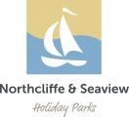

Accessibility Guide for Lemon Cottage
enquiries@northcliffe-seaview.com, 01947 880477, www.northcliffe-seaview.com
Contact for accessibility enquiries: Sophie Martin
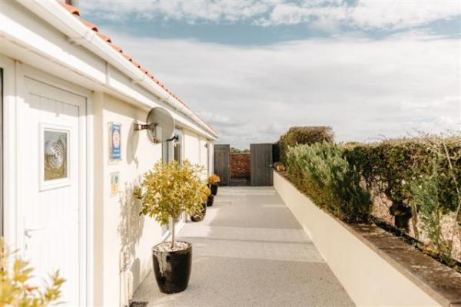

Welcome
This beautifully appointed holiday cottage has been designed to resemble a "villa" and is all on one convenient level with two en-suite bedrooms. There are three sets of patio doors leading onto a private, south west facing patio with views over open countryside towards the Esk Valley. The private terrace has an outdoor table & 4 chairs, which is perfect for al-fresco dining on sunny days & summer evenings. This beautiful little cottage is fully equipped to an exceptionally high standard & with double glazing, central heating & full insulation, it is perfect for those early & late season breaks.
Watch the video: Northcliffe & Seaview Holiday Parks Video

At a Glance

Level Access
- There is level access from the main entrance to:
  - Northcliffe Reception
  - Main Lounge Lemon Cottage
  - Outdoor patio
  - Patio outside Lemon Cottage

Access with steps
- There are steps from the main entrance to:
  - Seaview Laundry - located next door to Seaview Reception (this reception is not in use)

Bedrooms
- We have non-allergic bedding.

Level access bedrooms
- From the main entrance to the bedroom, there is level access.

Hearing
- The (bedroom) TVs have subtitles.

General
- Staff are available 24 hours a day.
- We have emergency evacuation procedures for disabled visitors.

Getting here
Bottoms Lane
High Hawsker
Whitby
YO22 4LL

Travel by public transport
- You can get to Lemon Cottage by bus.
- The nearest bus stop is approximately 250 metres from Lemon Cottage. The bus stop is 0.1 miles / 0.2 km from Lemon Cottage.
- The bus stop towards Robin Hood's Bay is to the left of the entrance to Northcliffe & Seaview Holiday Parks & the bus stop towards Whitby is across the road from the entrance to the parks.

Travel by taxi
- You can get a taxi with Streamline by calling 01947 603306. The taxi company has a wheelchair accessible vehicle.

Parking
- We have a car park. There are accessible parking spaces. Parking is free.
- There is a drop-off point at the main entrance. The drop-off point does not have a dropped kerb.
- From the car park to the entrance, there is level access. We have a transport service, to take visitors from the car park to the main entrance.

Arrival

Path to main entrance
- From the street to the main entrance, there is level access.
- The path is 4876mm wide, or more.

Main entrance
- The main entrance has level access.
- The door is 790mm wide.
- The main door is side hung and manual.
- The main door is sliding and manual.
- When you arrive, we can help carry your luggage.

Getting around inside

Northcliffe Reception
- From the main entrance to reception, there is level access. The door is 910mm wide.
- You can sit down at reception.

Bedrooms
- All bedrooms have windows.
- Bedrooms have ceiling lights, bedside lamps and natural daylight.
- Lights are energy saving. TVs have subtitles.
- All bedrooms are non-smoking.
- We have non-allergic bedding.
- All bedrooms have fitted carpets.
- We can move the bedroom furniture, to improve accessibility.
- From the main entrance to this area, there is level access.

Seaview Laundry - located next door to Seaview Reception (this reception is not in use)
- From the main entrance to the laundry, there is 1 step. There is no lift and no ramp.
- We have an iron and ironing board. You can use the ironing board sitting down.

Self catering kitchen

Lemon Cottage Kitchen
- We have an open plan kitchen.
- From the main entrance to the kitchen, there is level access.
- The route is 900mm wide, or more.
- The work surface is available at a height between 650mm and 900mm.
- The hob is available at a height between 650mm and 900mm.
- The sink is available at a height between 650mm and 900mm.
- The oven is available at a height between 650mm and 900mm.

Lounge

Main Lounge Lemon Cottage
- From the main entrance to the lounge, there is level access. The route is 900mm wide, or more.

Outdoor patio
- From the main entrance to this area, there is level access. The route is 1200mm wide, or more.
- The door is 790mm wide.

Getting around outside

Patio outside Lemon Cottage
- From the main entrance to this area, there is level access. The route is 1200mm wide, or more. The entrance is 790mm wide.

Customer care support

Accessibility equipment
- For a list of more items, please go to http://www.whitbydag.org.uk/.
- We have an area to charge mobility scooters and battery powered wheelchairs.
- Could be done within Lemon Cottage.
- You can hire mobility equipment from Whitby Dag by calling 01947 821001.

Emergency evacuation procedures
- We have emergency evacuation procedures for disabled visitors.

Customer care support
- Staff are available 24 hours a day.
- There are 2 x emergency contact numbers for out of office hours & the office managers live on park. These numbers can be found on the Northcliffe main reception door, Seaview Reception door & within the guest information folder in the cottage.

Guide last updated: 29 January 2024

