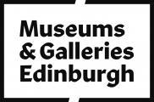

Accessibility Guide for City Art Centre
MuseumsAndGalleries@edinburgh.gov.uk, 0131 529 3993, http://www.edinburghmuseums.org.uk/
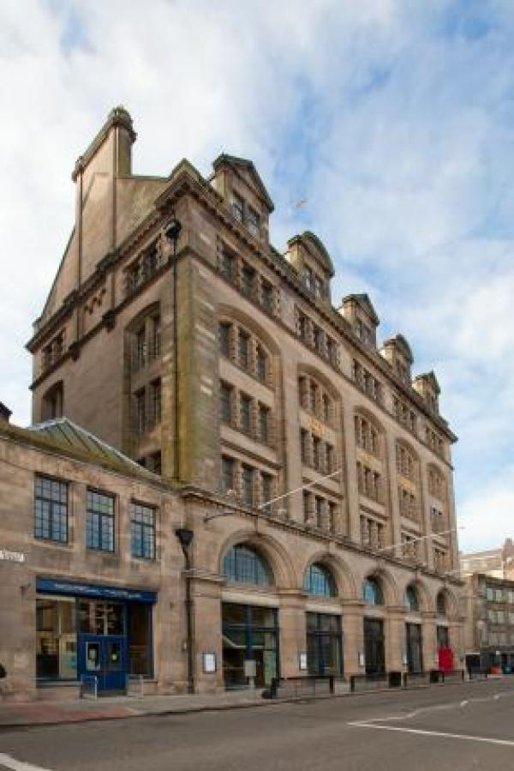

Welcome
Enjoy a visit to the City Art Centre, with one of the best collections of Scottish art. We show interesting exhibitions from our own collections and from all over the world. We can also tempt you with an attractive shop located on the ground floor.
The City Art Centre has a programme of exhibitions which change to suit the interests of our visitors. People come to see favourites from the City’s nationally Recognised collection of Scottish art; new work from local or international artists or exhibitions from other countries. Exhibitions of historic and modern photography, contemporary art and design, architecture and the built environment are staged in a rolling programme.

At a Glance

Level Access
- There is level access from the main entrance to:
  - Dining Table
  - Galleries
  - Information desk
  - Accessible toilet at the ground floor
  - City Art Centre shop
  - Fergusson Room- 5th floor

Hearing
- We have a hearing loop in Please ask at front desk.

Visual
- Some parts of the venue have low lighting.
- We have display information in large print.

General
- There is at least 1 public toilet for disabled visitors.

Getting here
City Art Centre
2 Market Street
Edinburgh
EH1 1DE

Travel by public transport
- You can get to City Art Centre by bus, train and tram.
- The 27 and 23 all stop nearby on the Mound and there are many busses which stop in the City Centre. The bus stop is 0.3 miles / 0.5 km from City Art Centre.
- The nearest train station is Waverley Railway Station. The train station is 0.1 miles / 0.2 km from City Art Centre.
- The nearest tram station is St Andrews Square . The tram station is 0.4 miles / 0.6 km from City Art Centre.

Travel by taxi
- You can get a taxi with City Cabs by calling 0131 228 1211. The taxi company has a wheelchair accessible vehicle.

Parking
- There is a drop-off point at the main entrance.
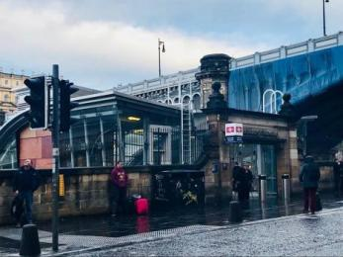
Waverley south entrance
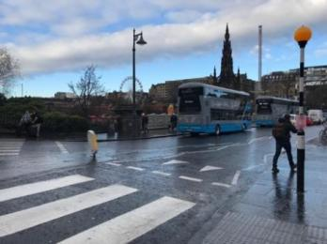
Bus stops on Waverley bridge
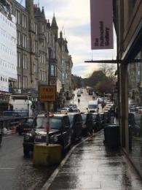
Market Street Taxi rank opposite to the City Art Centre

Arrival

Path to main entrance
- From the street to the main entrance, there is level access.

Main entrance
- The main entrance has level access.
- The door is 1000mm wide.
- The door has a push button to open it.
- The main door is revolving and manual.
- There is an accessible door with a push button located direclty next to the revolving door.
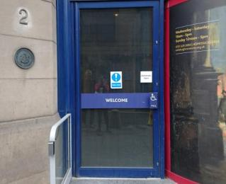
Front door from outside

Getting around inside

Visual Impairment - General Information
- Some parts of the venue have low lighting.

Lift
- We have 1 lift.
- You can get a lift to all floors.

City Art Centre lift
- The lift door is 1300mm wide.
- The lift is 1460mm wide. The lift is 2740mm deep.
- The lift says the floor number at each floor.
- The lift buttons have raised numbers or letters.
- The lift shows the floor number, at each floor.
- The lift is just opposite the main entrance.
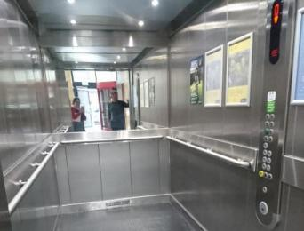
City Art Centre lift

Ticket/ information desk

Information desk
- From the main entrance to the desk, there is level access. There is a permanent ramp. The route is 1000mm wide, or more.
- The desk has a low section.
- The desk is accessible by sloped floor ramp
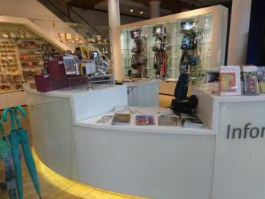
Information desk
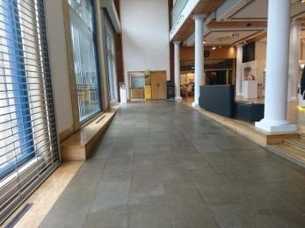
Slope from front door to front desk

Things to See and Do
- We have display information in: large print.

Galleries
- From the main entrance to this area, there is level access. There is a lift.
- From the lift to this area, the route is 1300mm wide, or more. Some display information is low, for wheelchair users. There are seats.
- There is a hearing loop.
- Some videos have subtitles.
- Exhibitions change regularly. Please contact us for more information on the contents of specific exhibitions.
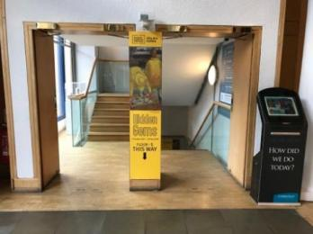
Access to the lower ground floor

Public toilet

Accessible toilet at the ground floor
- There is a public toilet for disabled visitors.
- From the main entrance to the public toilet, there is level access. There is a permanent ramp.
- The toilets have handrails.
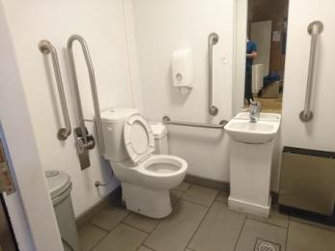
Inside the ground floor accessible toilet

Shop

City Art Centre shop
- From the main entrance to the shop, there is level access. There is a permanent ramp. The route is 1000mm wide, or more. The route through the shop is 800mm wide, or more.
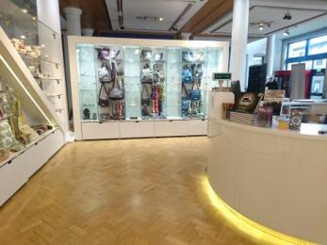
City Art Centre shop
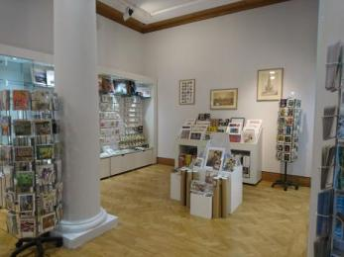
City Art Centre shop
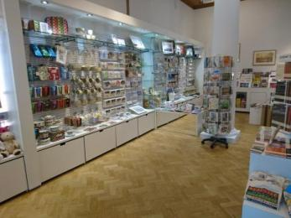
City Art Centre shop

Place to eat and drink

Mimi's Bakehouse
- From the main entrance to the dining area, there is level access. There is a permanent ramp. The route is 1000mm wide, or more. To get to a table, there are no steps.
- There is background music.
- We cater for vegetarian, gluten free (celiacs) and lactose free (dairy free) specific diets.
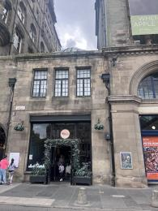
Outside entrance to Mimi's Bakehouse

Fergusson Room- 5th floor
- From the main entrance to this area, there is level access. There is a lift.
- From the lift to this area, the route is 1300mm wide, or more. The door is 840mm wide.
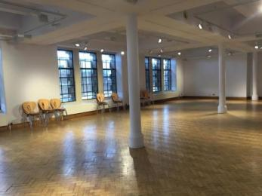
5th floor conference room sometimes used for events
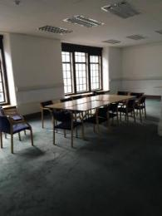
Fergusson Room regularly used for the Art in the City group meetings

Customer care support

Accessibility equipment
- We provide wheelchairs. Wheelchairs are free.
- We have a hearing loop in Please ask at front desk.
- We welcome assistance dogs.
If you require any assistance please ask a member of staff.
- We do not have a dedicated area. However we are near to Princes Street Gardens.

Emergency evacuation procedures
- We have emergency evacuation procedures for disabled visitors.

Guide last updated: 18 July 2023

