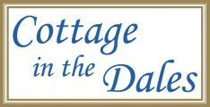

Accessibility Guide for The Dairy
stay@cottageinthedales.co.uk, 01969 662766 / 07880622291, www.cottageinthedales.co.uk
Contact for accessibility enquiries: Diane Howarth
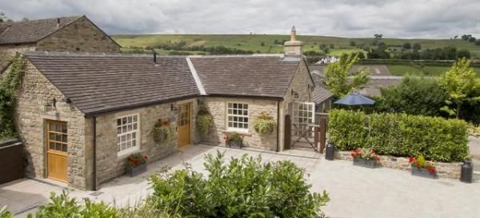

Welcome
Awarded Best in Yorkshire 2016 & Best in England 2017, Cottage in the Dales delivers a luxury experience in 3 cottages in the Yorkshire Dales National Park, where nothing is too much trouble & no detail overlooked. The Dairy, 2nd in the Blue Badge Style Awards 2017, provides mobility, hearing & visual facilities to National Accessibility Scheme standards. If you don't need them, the facilities almost all just disappear! We aim to accurately describe the facilities, so you can be assured The Dairy meets your personal needs. Follow the link http://bit.ly/2yEDJ3p to find out what others think of The Dairy. Our pleasure is to ensure yours.
Watch the video: Cottage in the Dales - The Dairy

At a Glance

Level Access
- There is level access from the main entrance to:
  - Bedroom: There is one master bedroom in The Dairy
  - The Dairy, Newbiggin - lounge
  - Hallway &Kitchen
  - Eastburn Farmhouse Gardens serving The Dairy and The Byre
  - Eastburn Farmhouse patios/terraces supporting The Dairy and The Byre
  - The Dairy - private patio

Bedrooms
- We have non-allergic bedding.
- There is an emergency call system next to the bed.
- We have a portable hoist.

Level access bedrooms
- From the main entrance to the bedroom, there is level access.
- The route to the bedroom is 750mm wide, or more.
- The bedroom door is 750mm wide, or more.
- There is unobstructed floor space 1200mm by 900mm, or more.
- The bathroom has a level access shower.

Hearing
- The fire alarm has a vibrating pillow pad and flashing lights.
- The (bedroom) TVs have subtitles.
- We have a hearing loop in Portable induction loop so can be used wherever needed in The Dairy.
- Some staff have disability awareness training.

Visual
- The walls and the doors have high colour contrast.
- We have information in large print.

General
The accommodation is rated by the National Accessible Scheme as suitable for:
- Older and less mobile guests
- Part-time wheelchair users
- Assisted wheelchair users
- Independent wheelchair users
- Guests with hearing loss
- Visually impaired guests
- Staff are available 24 hours a day.
- Some staff have disability awareness training.
- We have emergency evacuation procedures for disabled visitors.

Getting here
Cottage in the Dales, Eastburn Farmhouse
Newbiggin
Leyburn
North Yorkshire
DL8 3TD

Travel by public transport
- The Dairy is in Newbiggin in Bishopdale, a hamlet in the heart of the Yorkshire Dales National Park. Being so rural, there is a limited bus service which stops half a mile away down a hill, so is not suitable. All visitors arrive, and travel around, by car, as there is no real other option.

Travel by taxi
- You can get a taxi with Hello Coopers by calling 01677 424252 or 01609 772295. The taxi company has a wheelchair accessible vehicle.
- Wheelchair accessible taxis are available from http://www.hellocoopers.co.uk

Parking
- We have a car park. There are accessible parking spaces. The parking is less than 50 metres from the main entrance. Parking is free.
- There is a drop-off point at the main entrance. The drop-off point does not have a dropped kerb.
- From the car park to the entrance, there is level access. The route is 3000mm wide, or more.
- There is both a drop off point immediately outside the main door of The Dairy, with designated parking just a few metres away, all within a courtyard setting, which is completely on one level surface - no slopes, steps, thresholds, and well lit by movement sensors - so fully accessible. There is ample room for both unloading and manouvering cars.
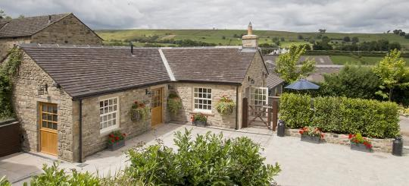
Level courtyard parking, drop-off and access to The Dairy, Newbiggin, Yorkshire
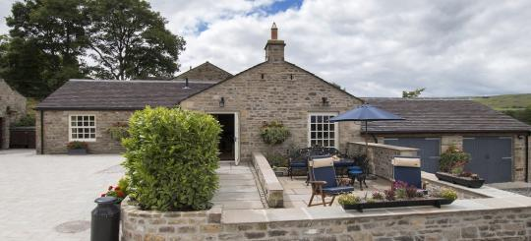
The Dairy private patio with level access directly from the lounge

Arrival

Path to main entrance
- From the street to the main entrance, there is level access.
- There is a portable ramp.
- The path is 3000mm wide, or more.
- The path is sloped.

Main entrance
- The main entrance has level access.
- The door is 1100mm wide.
- The main door is side hung and manual.
- When you arrive, we can help carry your luggage.
- From the road in Newbiggin into the driveway of Eastburn Farmhouse (to access The Dairy and The Byre), there is a 20mm step into the driveway if arriving on foot/by wheelchair. (This is purely to stop rainwater coming off the road onto the drive). A portable lightweight ramp is available on request if needed. Otherwise all access is via car. From the driveway, there is a short slope down to the courtyard where there is a drop-off point immediately outside The Dairy main door. Designated parking is just a few metres away across the level courtyard, adjacent to parking for The Byre. Level access (without thresholds/ramps) is provided into the main door of The Dairy and also through the gate to the private patio for The Dairy, as well as direct access across the 3/4 acre garden of Eastburn Farmhouse. They are all interconnected on one level.
Level courtyard access to The Dairy
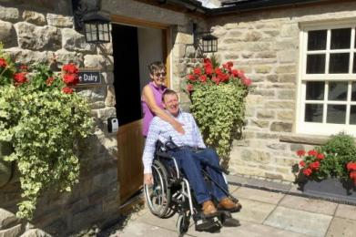
Level access to the wide main stable door of The Dairy

Getting around inside

Visual Impairment - General Information
- We have high colour contrast between walls and doorframes.

Bedrooms
- All bedrooms have windows.
- Bedrooms have ceiling lights, floor standing lights, bedside lamps and natural daylight.
- Lights are LED. TVs have subtitles.
- All bedrooms are non-smoking.
- We have non-allergic bedding.
- No bedrooms have fitted carpets.
- Non-allergenic bedlinen (duvets, pillows, protectors, sheets, pillowcases) are available on request. Cleaning with 'Ecover' products can be done throughout the cottage prior to arrival, on request.
- We can move the bedroom furniture, to improve accessibility.
- We have bed blocks.
- We have a portable hoist.
- From the main entrance to this area, there is level access.
- Watch the video: The Dairy accessible wet room

Accessible bedrooms

Accessible bedroom There is one master bedroom in The Dairy
- The route to the bedroom is 900mm wide, or more. The bedroom door is 900mm wide. There is 900mm at the side of the bed. The bed is 600mm high. There is 0mm under the bed.
- There is a low clothes rail. You can use the rail sitting down.
- There is an emergency call system next to the bed.
- The bedroom is flexible (either double or twin). The bathroom is ensuite. The bathroom door is 900mm wide.
- The bathroom has a separate shower. The shower has a seat. The shower has a handrail.
- The bathroom has a bath.
- The bath has a handrail.
- The bathroom has a level access shower. The level access shower has a seat. There is a shower chair available. The level access shower has handrails.
- The toilets have handrails. The direction of transfer onto the toilet is to the left. There is 1000mm at the side of the toilet.
- There is 2000mm in front of the toilet. The toilet seat is 460mm high.
- The basin is 740mm high. The taps are lever operated. There is space under the basin, with no pedestal or boxing.
- The walls and the bathroom fittings have high colour contrast.
- A variety of LED lighting is provided - all ceiling lighting is controlled by dimmer switches in each room (hallway, lounge, kitchen and bedroom). There are also table lamps and floor standing reading lamps in both the lounge and the bedroom, all of which can be moved and positioned to suit personal requirements.
All sockets and switches are polished chrome, which contrast to the cream walls. The floors contrast with the walls as all skirtings are in solid oak. Around each room the Karndean flooring has a black line to help mark out the edges of the floors, thereby aiding spacial awareness, as well as looking good too!.
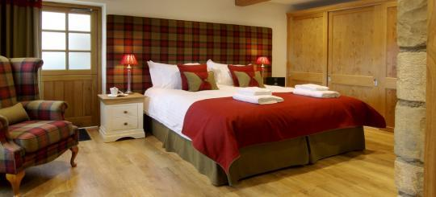
The Dairy bedroom as a super king zip/link master bed
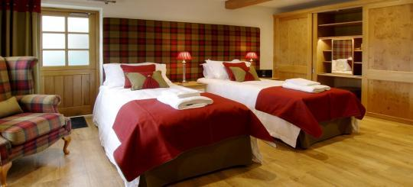
The Dairy bedroom as two single beds, each with double (not single) duvets.
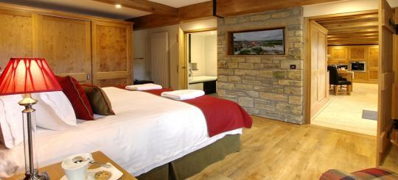
The Dairy bedroom is easily accessible to the hallway and the bathroom.
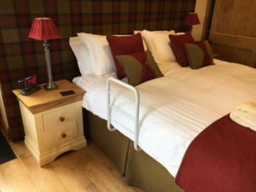
The Dairy bedroom - bed rail
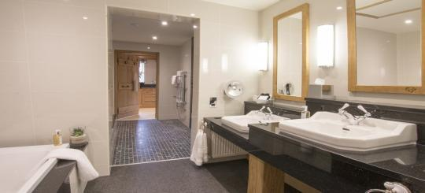
The Dairy bathroom - double sinks at different heights
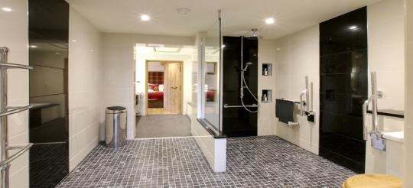
The Dairy - large wet room with removable rails/bars/shower seat
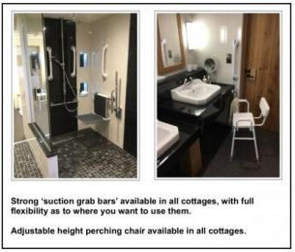
Portable equipment for use in bathroom at The Dairy
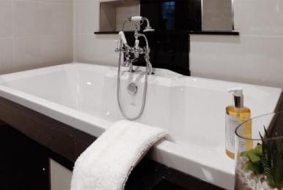
The Dairy bathroom - low double ended bath

Self catering kitchen

The Dairy kitchen
- We have an open plan kitchen.
- From the main entrance to the kitchen, there is level access.
- The route is 900mm wide, or more.
- The work surface is available with clear underspace and available at a height between 650mm and 900mm.
- The hob is available with clear underspace and available at a height between 650mm and 900mm.
- The sink is available with clear underspace and available at a height between 650mm and 900mm.
- The oven is available with clear underspace and available at a height between 650mm and 900mm.
- The table and plates have high colour contrast.
- The kitchen is open plan to the dining area and lounge. The cupboards under the sink and hob are removable on casters (and can be taken out of the cottage prior to your arrival if needed). Pull down cupboard storage is provided in 2 wall cupboards. All crockery/glassware is stored in wall cupboards at eye level above the oven/microwave but can easily be moved to lower levels when required. There is a pull out worksurface in the kitchen to enable wheelchair users to prepare food. This can also double up as an ironing board as there is a socket immediately adjacent the work surface.
Under the microwave and oven there are pull out heat-resistant boards to enable hot ovenware to be placed as they go in/out of the oven.
The double sink has lever taps that are clearly identified as red/blue for hot/cold.
The dining table extends so that it can seat 4 people to dine comfortably. Carver dining chairs are available on request. The crockery is white which sit upon black table mats, which also contrast with the oak dining table.
- The Dairy kitchen - accessible facilities
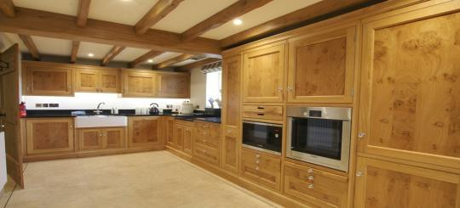
The Dairy, Newbiggin, - kitchen highlighting where NO accessible facilities are needed
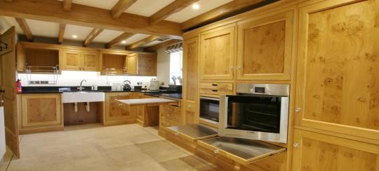
The Dairy, Newbiggin, - kitchen highlighting where accessible facilities are needed
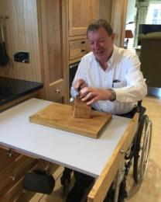
The Dairy, Newbiggin - kitchen pull out accessible work surface

Lounge

The Dairy, Newbiggin - lounge
- From the main entrance to the lounge, there is level access. The route is 1100mm wide, or more.
- The hallway, dining area, lounge and kitchen are all open plan with no doorways. There is a level access patio door that opens outwardly to enable direct access to the private patio outside. The log burning stove is accessible and can be tended from a wheelchair.
- Watch the video: Tour of The Dairy, Newbiggin
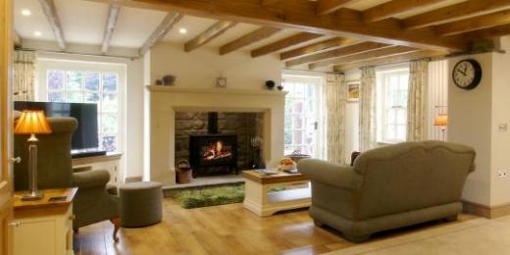
The Dairy, Newbiggin - lounge with log burning stove & access to the private patio
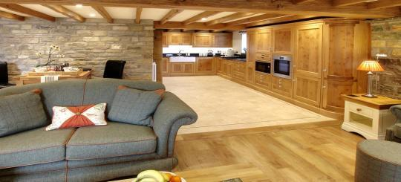
The Dairy - Spacious access from the lounge to the kitchen
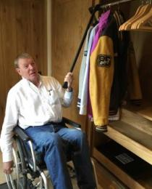
The Dairy - hallway cupboard provides accessible coat hanging space and pull out drawers for footwear and bags.
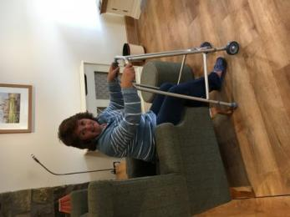
The Dairy - additional equipment available for request (shopping trolley, zimmer frame, hand bell, walking sticks)

Hallway &Kitchen
- From the main entrance to this area, there is level access.
- There is level access from the main entrance to the hallway, which opens up to the dining area, kitchen and lounge area. From the lounge, the level access continues through internal doors to the bedroom and bathroom and an external patio door to the private patio. Also from the bedroom there is an emergency exit directly outside.

Getting around outside

Eastburn Farmhouse Gardens serving The Dairy and The Byre
- From the main entrance to the gardens, there is level access.
- The route is 1200mm wide, or more.
- From the main entrance of The Dairy or from the private patio, there is level access across the courtyard (without the need for a ramp/threshold) to the main path that runs through the garden of Eastburn Farmhouse. This path is 1200mm wide with flower borders on either side. This path leads down to the thoroughfare through to the working garden which can be seen but only accessed on the grass at the moment (as at autumn 2017). An additional path will be available in the next 2 years to go fully round the garden.
The Dairy - level access from the courtyard to the main door
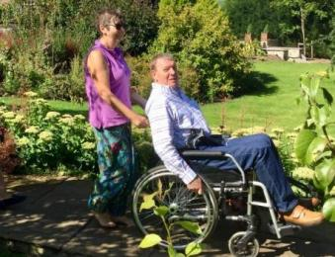
The Dairy - level access from the courtyard across the path to view the larger garden
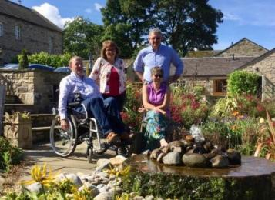
The Dairy - enjoying the larger garden in the grounds of Eastburn Farmhouse

Terrace

Eastburn Farmhouse patios/terraces supporting The Dairy and The Byre
- From the main entrance to this area, there is level access. The route is 1100mm wide, or more.
- The entrance is 1100mm wide.
- To get to a table, there are no steps.
- Level access is also available from the courtyard through the patio area of The Byre to enable guests to use the large patios of The Farmhouse, which are accessible both at the same level and also down a 1:12 slope. Hence all patios for all three properties are fully accessible on the level and available to all guests.

The Dairy - private patio
- From the main entrance to this area, there is level access. The route is 1100mm wide, or more. The entrance is 1100mm wide.
- Access to the private patio is available in two ways - internally, directly from the lounge through a patio door, that has level access, down a 1:12 slope to the patio. Alternatively, there is level access from the courtyard outside the main door to The Dairy, through a 5 bar gate, down the same 1:12 slope to the patio.
- Watch the video: The Dairy - external patio
The Dairy - private patio with direct access from the lounge down a slope to the patio
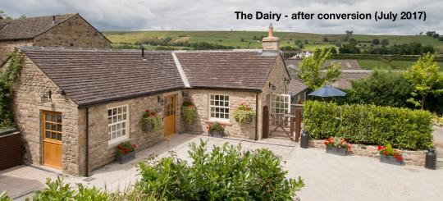
The Dairy - private patio with direct access from the main courtyard area through a gate
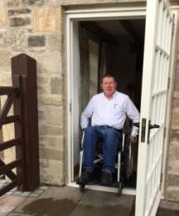
The Dairy - direct level access from the lounge to the private patio
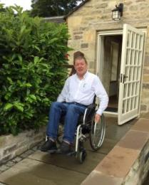
The Dairy - down 1:12 slope to the private patio
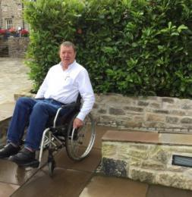
The Dairy - wide turning access to the private patio
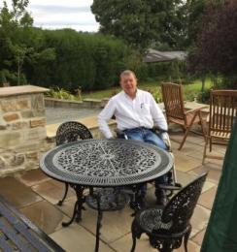
The Dairy - ample place to enjoy the view from the patio over the 3/4 acre garden

Customer care support

Accessibility equipment
- We have a hearing loop in Portable induction loop so can be used wherever needed in The Dairy.
- Accessibility equipment available on request, with our compliments :
Kitchen
* Perching tool
Bathroom
* Perching Stool
* Bath step
* Bath board and seat
* Portable Suction grab rails
* Integrated shower seat
* Portable toilet frame
* Toilet riser
* Swing rather than pedal bins in bathrooms
Bedroom
* Wake and shake alarm clock
* Bed rail
Dining
* Dining chair with arms (carver chair)
General
* Walking trolley
* Walking sticks
* Pick-up stick
* Zimmer frame with wheels at front
* Hand bell
Throughout
* Kerb/doorstep ramp (for use elsewhere)
* Portable induction hearing loop
Further larger accessible equipment such as rise/recliner chairs, profile beds, wheelchairs and scooters can be hired in for the duration of your stay by arrangement in advance with our partner Change Mobility of Harrogate. There is a charge for these items, which we would be happy to quote for you. Delivery is free to The Dairy ready for your arrival.
- For a list of more items, please go to https://www.cottageinthedales.co.uk/holiday-cottages/39/Accessibility.
- The nearest toilet area for assistance dogs is a gravelled area adjacent to the courtyard parking area.
- We have an area to charge mobility scooters and battery powered wheelchairs.
- External power points are available for charging adjacent to The Dairy. There is also a Electic Vehical Charging Point (EVCP) in an adjacent area for guests arriving with electric vehicles if they need charging. This is a complimentary service. Access is down a slope and is currently a gravelled area (autumn 2017).
- You can hire mobility equipment from Change Mobility, Harrogate by calling 01423 500666.

Emergency evacuation procedures
- We have emergency evacuation procedures for disabled visitors.
- The fire alarm has a vibrating pillow pad.
- The fire alarm has flashing lights.
- Fire and CO2 alarms have both audible and flashing visual alarms, if they go off. If there is a power cut, the ceiling lights immediately inside each of the 3 external doors (main door, exit to patio, emergency exit in bedroom) will remain on, to enable guests to depart easily. There is a 'wake and shake' alarm clock in the bedroom. There is a 'clangy hand bell' that can be used - very loud - to attract attention from people in nearby buildings.

Customer care support
- Some staff have disability awareness training.
- We have information in large print.
- Staff are available 24 hours a day.
- The owners live on site and are therefore available almost always, though it is not advertised as a 24 hours service.

Guide last updated: 18 January 2019

