Accessibility Guide for Dr Jenner's House, Museum and Garden
info@edwardjenner.co.uk, 01453 810631, https://jennermuseum.com
Contact for accessibility enquiries: Owen Gower
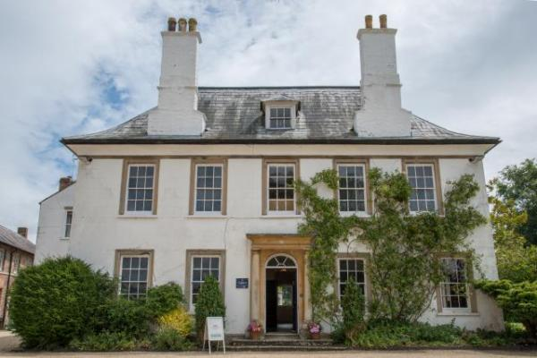

Welcome
Dr Jenner's House, Museum and Garden: the home of the country doctor who changed the world.
From Gloucestershire in the 1790s to Somalia in the 1970s, Dr Jenner’s House, Museum and Garden traces the impact of one of the pivotal events in world history, in the place where it happened. This is the house where Edward Jenner, pioneer of vaccination against smallpox, lived and told the world about his work. Less than 200 years later, smallpox had been eradicated, with countless lives saved in the process.
Today the whole family can find out more about Jenner’s life and work, whilst Jenner’s beautiful garden is the perfect place to relax.

At a Glance

Level Access
- The main entrance has 2 steps. There is no lift and no ramp.
- There is level access from the main entrance to:
  - Dining Room
  - Drawing Room
  - Study
  - Visitor Reception
  - Old Cyder House toilets
  - Museum shop
  - Old Cyder House
  - Physic Garden
  - Temple of Vaccinia
  - Main garden
- There is level access from the car park to:
  - Old Cyder House

Access with steps
- There are steps from the main entrance to:
  - Upstairs displays
  - Potting Shed and Vinery

Hearing
- We have a hearing loop in Visitor Reception and Museum shop.

Visual
- Some parts of the venue have low lighting.
- We have display information in audio, braille and large print.
- We have information in audio, braille and large print.

General
- We have a complimentary ticket policy for personal assistants.
- There is at least 1 public toilet for disabled visitors.

Getting here
Church Lane
Berkeley
Gloucestershire
GL13 9BN

Travel by public transport
- You can get to Dr Jenner's House, Museum and Garden by bus and train.
- The nearest bus stop is on Salter Street, by Berkeley Post Office. The bus stop is 0.20 miles / 62.8 km from Dr Jenner'.0;s House, Museum and Garden.
- The nearest train station is Cam & Dursley. The train station is 6 miles / 9.7 km from Dr Jenner's House, Museum and Garden.
- Cam & Dursley station is served by trains from Bristol and Gloucester. There are no direct bus services from Cam & Dursley station to Berkeley, it is a 10 minute walk to connect with the 62 bus route. There is no taxi rank at Cam & Dursley so you are advised to pre-book taxis if required.

Travel by taxi
- You can get a taxi with Castle Cars by calling 01453511793.
- You can get a taxi with CJ's by calling 07840338889.
- You can get a taxi with Christopher's by calling 07971864105.

Parking
- We have a car park. There are accessible parking spaces. The parking is less than 50 metres from the main entrance. Parking is free.
- There is a drop-off point at the main entrance. The drop-off point does not have a dropped kerb.
- From the car park to the entrance, there is level access. The route is 1000mm wide, or more.
- There is free parking in the level, gravel covered car park outside the museum. There is an accessible parking space to the left of the main building, clearly signposted, which can be reserved by contacting the museum.
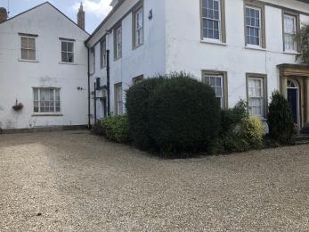
Location of accessible parking and ramp entrance.

Arrival

Path to main entrance
- From the street to the main entrance, there is level access.
- The path is 2000mm wide, or more.
- The path is sloped.

Main entrance
- The door is 900mm wide.
- The main entrance has 2 steps.
- The main door is side hung and manual.
- The other entrance door is 900.00mm wide.
- To the left hand side of the main building, next to the blue badge parking space.
- The main front door is unlocked when the museum is open, although on cold days you may have to turn the handle to open the door. The alternative entrance has a wooden ramp and is normally locked so please ring the bottom doorbell if you need any assistance accessing the museum through this doorway.
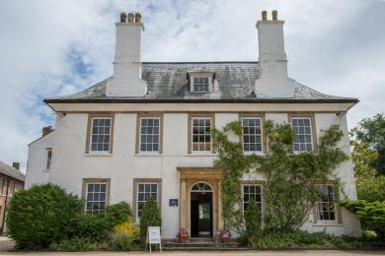
Main entrance with door open.
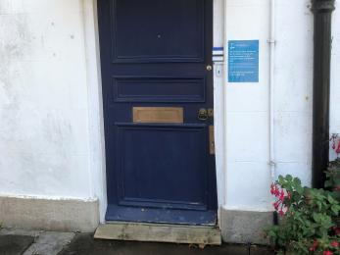
Ramped entrance door.

Getting around inside

Visual Impairment - General Information
- Some parts of the venue have low lighting.

Ticket/ information desk

Visitor Reception
- From the main entrance to the desk, there is level access. There is a permanent ramp. The route is 850mm wide, or more.
- The door is 850mm wide, or more.
- Please start your visit at Visitor Reception, which is through the door on the left as you enter the museum entrance hall. There is a small wooden ramp leading down to this room. A portable hearing loop is available should you require this facility.
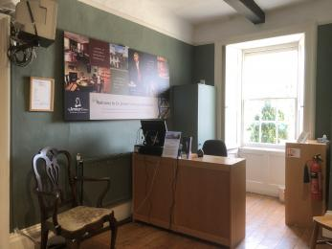
Visitor Reception desk
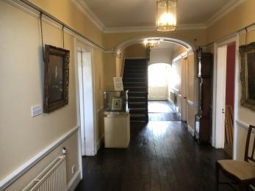
Entrance Hall with door to Visitor Reception on left

Things to See and Do
- We have a complimentary ticket policy for personal assistants.
- We have display information in: audio, braille and large print.

Dining Room
- From the main entrance to this area, there is level access. The route is 850mm wide, or more. The door is 850mm wide.
- Some display information is low, for wheelchair users. There are seats.
- Videos have subtitles.
- The Dining Room is used to show our introductory film. Please ask a member of the Welcome Team if you require a subtitled version.
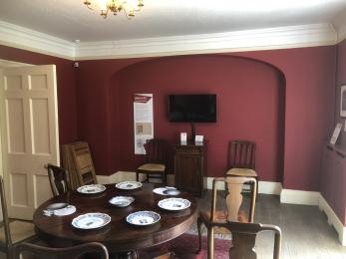
Dining Room showing seating and screen for introductory film

Drawing Room
- From the main entrance to this area, there is level access. The route is 850mm wide, or more. The door is 850mm wide.
- Some display information is low, for wheelchair users. There are seats.
- This room displays exhibits concerning Edward Jenner's life. Some of the displays may be dimly lit and torches can be borrowed from a member of the Welcome Team if you require.

Study
- From the main entrance to this area, there is level access. There is a permanent ramp. The route is 850mm wide, or more. The door is 850mm wide.
- Some display information is low, for wheelchair users.
- The doorway to the Study requires access at a right angle and the doorway width is 850mm. The Study viewing area is quite small (approx 1300mm x 1300mm) which might be awkward for some wheelchair users – the Welcome Team can assist if required. There is very low lighting in this room.
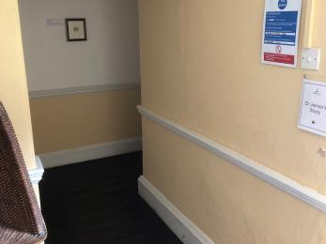
Entrance corridor to Study

Upstairs displays
- From the main entrance to this area, there are 16 steps. There is no lift and no ramp.
- Some display information is low, for wheelchair users. There are seats.
- The upstairs displays are accessed by two flights of stairs, linked with a short landing. The stair depth is 160mm. Those who are unable to use the stairs are invited to view our Access Folder which contains copies of material from the upstairs displays.
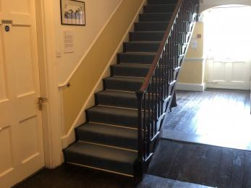
Stairs to upstairs displays

Public toilet

Old Cyder House toilets
- There is a public toilet for disabled visitors.
- From the main entrance to the public toilet, there is level access. The route is 720mm wide, or more.
- The toilet door is 720mm wide.
- The direction of transfer onto the toilet is to the front only.
- The toilet seat is 420mm high. The toilets have handrails.
- The accessible toilet does not meet current recommended standards in terms of space and this may make use difficult for some wheelchair users with restricted space for turning and manoeuvring. There is no transfer space for the accessible toilet. There are vertical and horizontal rails either side of the toilet. There is a low-level coat hook but no alarm cord.
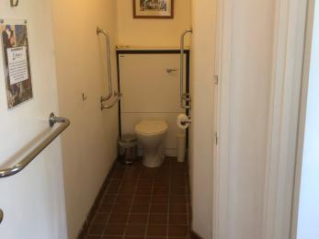
Accessible toilet

Shop

Museum shop
- From the main entrance to the shop, there is level access. There is a permanent ramp. The route is 850mm wide, or more. The door is 850mm wide.
- The route through the shop is 800mm wide, or more.
- The museum shop is located in Visitor Reception.

Old Cyder House
- From the main entrance to this area, there is level access. The route is 850mm wide, or more.
- The door is 1130mm wide.
- The Old Cyder House is used as an exhibition space and for picnics and sales of secondhand books. There is a slight lip at the entrance and we can provide a ramp if required.

Getting around outside

Physic Garden
- From the main entrance to the gardens, there is level access.
- There is a permanent ramp.
- The route is 970mm wide, or more.
- The Physic Garden is a new addition to the grounds since 2016. There are four large raised plant beds arranged around a centrepiece. All pathways are gravel and level. Pathways through the Physic Garden are all wide enough to accommodate wheelchairs, with the minimum width at any point 97cm. There is room to manoeuvre around the centrepiece.

Potting Shed and Vinery
- From the main entrance to the gardens, there are 4 steps. There is no lift and no ramp.
- The interior of Vinery is accessed through a door to which there is one step (depth 30cm) and then a further 3 steps (depth 25cm). These steps lead to a viewing gallery but this is unlikely to be accessible to people with some mobility needs owing to its restricted dimensions.
The Vinery Potting Shed houses temporary exhibitions. It is accessed at two points – the main entrance is located opposite the back door of the house and access is via a small ramp to accommodate wheelchair users. The second entrance is from the Physic Garden and, while this is on the level, there is restricted space and so may not be suitable for wheelchair users.

Temple of Vaccinia
- From the main entrance to the gardens, there is level access.
- There is a permanent ramp.
- The route is 750mm wide, or more.
- The small thatched hut called the Temple of Vaccinia is where Jenner vaccinated the poor free of charge on certain days. Access is level and there is sufficient space for wheelchair users.

Main garden
- From the main entrance to the gardens, there is level access.
- There is a permanent ramp.
- The route is 1150mm wide, or more.
- Entry to the garden from the house is via an inwards opening wide back door to the house on the Ground Floor. There is a ramp over the one step which has non-slip strips. The garden paths are level and gravelled. There are numerous benches and seats throughout the garden.

Picnic Area

Old Cyder House
- From the car park to the picnic area, there is level access. The path is 1150mm wide, or more.
- The entrance is 950mm wide.
- Some tables have space for wheelchair users. You can bring your own food to the picnic area.
- The indoor picnic area is in the Old Cyder House and accessed via the museum main entrance. Seats are flexible and can be rearranged to suit, please ask a member of the Welcome Team if you require assistance.

Customer care support

Accessibility equipment
- We have a hearing loop in Visitor Reception and Museum shop.
- We have a DiscoveryPen audio guide designed specifically for visually impaired visitors. We also have a hearing loop in Visitor Reception and an Access Folder for those unable to take the stairs to the first floor. Some material is available in braille.

Emergency evacuation procedures
- We have emergency evacuation procedures for disabled visitors.
- Please make a member of the welcome team aware if you believe you will need particular assistance in the event of an emergency.

Customer care support
- We have information in audio, braille and large print.

Guide last updated: 9 August 2019

