Accessibility Guide for Ambler's Retreat
info@coquetcottages.co.uk, 01665 710 700, https://www.coquetcottages.co.uk/northumberland-holiday-cottages/amblers-retreat-in-amble/
Contact for accessibility enquiries: Any of our Reservations team can help with any queries
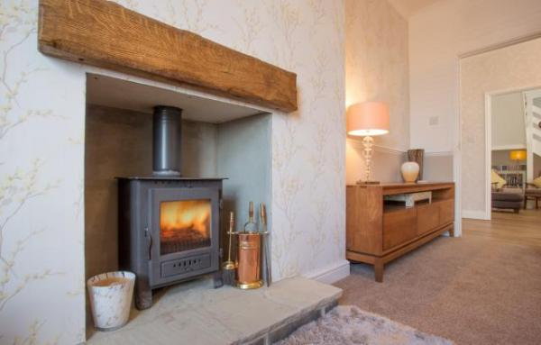

Welcome
Located in the heart of the fishing town of Amble, Ambler’s Retreat is perfect for returning to after exploring the sights and wonders of Northumberland. Great restaurants, shops and of course, the sea, are just yards from your door, yet inside it is quiet and peaceful and true to it’s name; a retreat. Please see our full website listing for more details: https://www.coquetcottages.co.uk/northumberland-holiday-cottages/amblers...

At a Glance

Level Access
- The main entrance has 2 steps. There is no lift and no ramp.
- There is level access from the main entrance to:
  - Ambler's Retreat Lounge

Access with steps
- There are steps from the main entrance to:
  - Bedroom

Bedrooms
- We have non-allergic bedding.

Hearing
- The (bedroom) TVs have subtitles.

Visual
- Glass doors have contrast markings.

Getting here
6 North Street
Amble
NE65 0BU

Travel by public transport
- You can get to Ambler's Retreat by bus and train.
- The nearest bus stop is at the top of Queen Street, approximately 200 yds from Ambler's Retreat. The bus stop is 0.20 miles / 62.8 km from Ambler'.0;s Retreat.
- The nearest train station is Alnmouth. The train station is 4.5 miles / 7.2 km from Ambler's Retreat.
- Alnmouth train station is on the main East Coast line running between London and Edinburgh and most trains stop there. Taxi's are readily available and we can help organise this for you if required.

Travel by taxi
- You can get a taxi with Amble Taxi's by calling 01665 710988.
- You can get a taxi with J L Taxi's by calling 01665 713800.

Parking
- We have a car park. The parking is less than 50 metres from the main entrance. Parking is free.
- There is a drop-off point at the main entrance. The drop-off point has a dropped kerb.
- From the parking to the main entrance, there are 2 steps. There is no ramp and no lift.
- Private parking is available in front of a private garage just yards from the property.
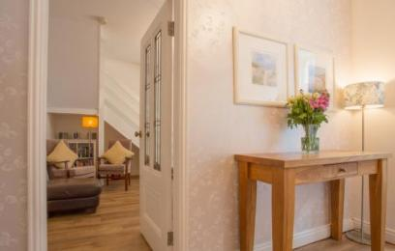
Ambler's Retreat Hall
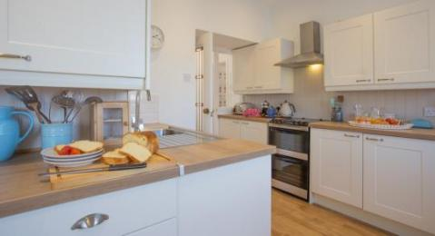
Ambler's Retreat Kitchen
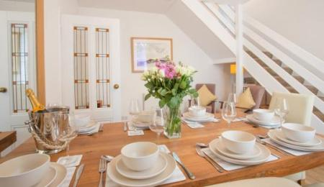
Ambler's Retreat Dining Room
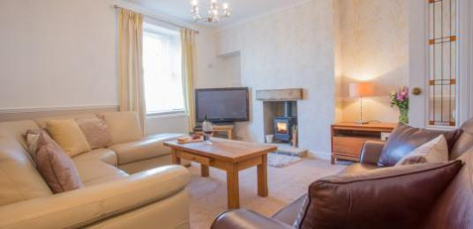
Ambler's Retreat Lounge
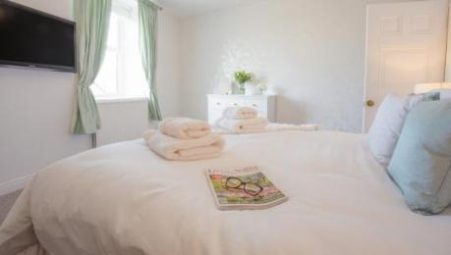
Ambler's Retreat Master Bedroom
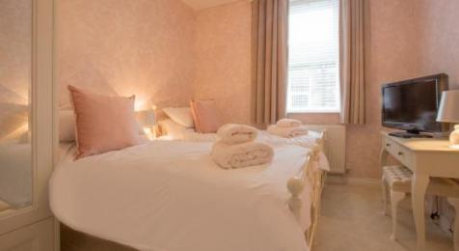
Ambler's Retreat Bedroom 2
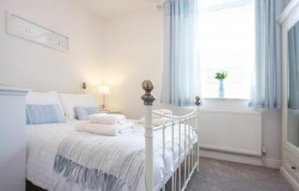
Ambler's Retreat Bedroom 3
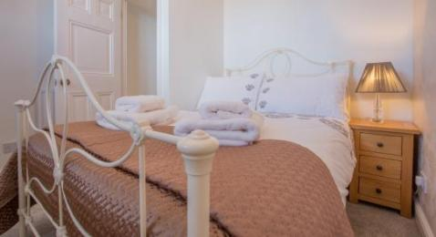
Ambler's Retreat Bedroom 4
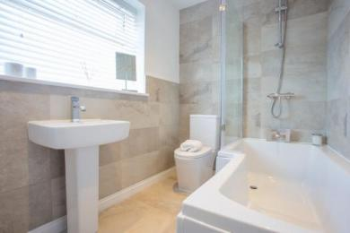
Ambler's Retreat Bathroom
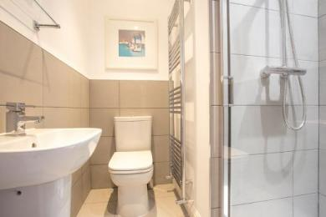
Ambler's Retreat Shower Room
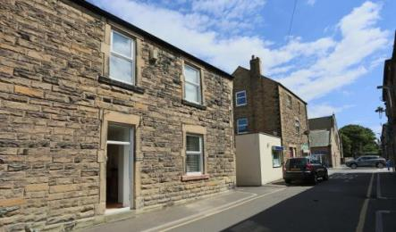
Ambler's Retreat from the outside
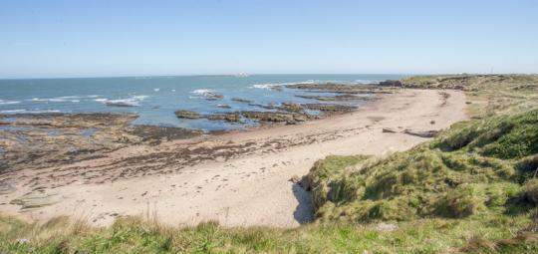
Amble Beach

Arrival

Path to main entrance
- From the street to the main entrance, there are 2 steps. There is no ramp and no lift.

Main entrance
- The main entrance has 2 steps.
- The main door is side hung and manual.
Ambler's Retreat Main Entrance

Getting around inside

Visual Impairment - General Information
- We have contrast markings on all glass doors.

Bedrooms
- All bedrooms have windows.
- Bedrooms have ceiling lights, bedside lamps and natural daylight.
- Lights are energy saving and traditional filament. TVs have subtitles.
- All bedrooms are non-smoking.
- We have non-allergic bedding.
- All bedrooms have fitted carpets.
- We can move the bedroom furniture, to improve accessibility.
- The bedroom nearest the main entrance has 18 steps.
- We have bathrooms with a separate shower.
- We have bathrooms with a bath and overhead shower. The walls and the fittings have high colour contrast.
Ambler's Retreat Master Bedroom
Ambler's Retreat Bedroom 2
Ambler's Retreat Bedroom 3
Ambler's Retreat Bedroom 4
Ambler's Retreat Family Bathroom
Ambler's Retreat Shower Room

Self catering kitchen

Ambler's Retreat Kitchen
- We have a separate kitchen and dining room. From the main entrance to the kitchen, there is level access.
- The table and plates have high colour contrast.
Ambler's Retreat Kitchen
- From the main entrance to the dining room, there is level access.

Lounge

Ambler's Retreat Lounge
Ambler's Retreat Hall
Ambler's Retreat Lounge
- From the main entrance to the lounge, there is level access.

Customer care support

Accessibility equipment
- For a list of more items, please go to http://bit.ly/1sGRz9v.
- The Braid grassy public area, which is approximately 100yds from the property.
- You can hire mobility equipment from British Red Cross by calling 0344 871 11 11.

Guide last updated: 9 April 2021

