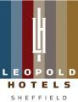

Accessibility Guide for Leopold Hotel Sheffield
res.sheffield@leopoldhotels.com, 01142524000, www.leopoldhotels.com
Contact for accessibility enquiries: Reservation Team
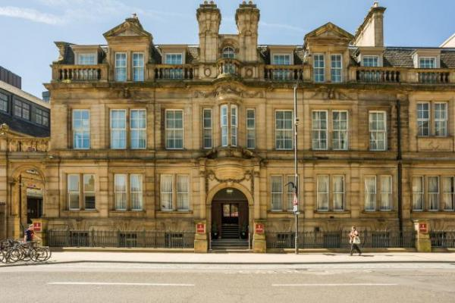

Welcome
Built on the former site of a Grade II listed Boys Grammar School, the Leopold Hotel is Sheffield’s only four star boutique hotel. This historic property offers a quirky yet luxurious place to meet and sleep, situated centrally on Leopold Square amongst an array of upmarket bars and eateries. The imposing building has been sympathetically restored to retain its charming architectural character. Each of the hotel’s 90 en-suite bedrooms is uniquely furnished, offering every modern amenity for the discerning traveller. Taking great care of the individual needs of our guests, our friendly staff are professional and efficient.
Watch the video: Leopold Hotel Sheffield

At a Glance

Level Access
- The main entrance has 11 steps and a handrail. There is no lift and no ramp.
- There is level access from the main entrance to:
  - Reception
  - Dining Table
  - Bar and Lounge
  - Bar and Lounge
  - Fitness Suite changing area
  - Public Toilet
  - Terrace

Access with steps
- There are steps from the main entrance to:
  - Bedroom

Bedrooms
- We have non-allergic bedding.

Hearing
- The fire alarm has a vibrating pillow pad.
- We have a hearing loop in Reception Desk.
- Some staff have Next Generation Text and disability awareness training.

Visual
- Some parts of the venue have low lighting.

General
- Staff are available 24 hours a day.
- Some staff have disability awareness training.
- We have emergency evacuation procedures for disabled visitors.

Getting here
2 Leopold Street
2 Leopold Street
Sheffield
South Yorkshire
S1 2GZ

Travel by public transport
- You can get to Leopold Hotel Sheffield by bus, train and tram.
- The nearest bus stop is located across from the main entrance The bus stop is 0.0 miles / 0.0 km from Leopold Hotel Sheffield.
- The nearest train station is Sheffield Train Station. The train station is 0.5 miles / 0.8 km from Leopold Hotel Sheffield.
- The nearest tram station is City Hall. The tram station is 0.1 miles / 0.2 km from Leopold Hotel Sheffield.

Travel by taxi
- You can get a taxi with City Taxis by calling 01142393939. The taxi company has a wheelchair accessible vehicle.

Parking
- There is parking near the venue. There are accessible parking spaces. Parking is not free.
- There is a drop-off point at the main entrance. The drop-off point has a dropped kerb.
- From the car park to the entrance, there is level access. There is a lift. The path is sloped.
- Watch the video: Leopold Hotel Car Parking Directions

Arrival

Path to main entrance
- From the street to the main entrance, there are 11 steps. There is no ramp and no lift.

Main entrance
- The main entrance has 11 steps.
- This entrance has a handrail.
- The main door is side hung and manual.
- Accessible entrance is located to the rear of the hotel.

Getting around inside

Visual Impairment - General Information
- Some parts of the venue have low lighting.

Lift
- We have 2 lifts.
- You can get a lift to all floors.

Lift to all floors
- The lift says the floor number at each floor.
- The lift buttons have raised numbers or letters.
- The lift shows the floor number, at each floor.

Reception
- From the main entrance to reception, there is level access. The check-in desk has a low section for wheelchair users. You can sit down at reception.

Bedrooms
- All bedrooms have windows.
- Bedrooms have wall lights, bedside lamps and spot lights.
- Lights are energy saving. All bedrooms are non-smoking.
- We have non-allergic bedding.
- All bedrooms have fitted carpets.
- We can move the bedroom furniture, to improve accessibility.
- The bedroom nearest the main entrance has 8 steps.
- All bedrooms are ensuite.
- We have bathrooms with a separate shower.
- Some showers have a seat.
- Some showers have a handrail.
- We have bathrooms with a bath and overhead shower. The shower has a handrail.
- Some toilets have handrails.
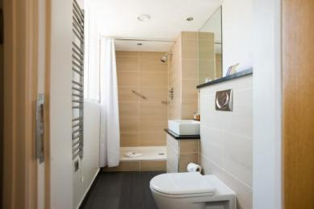

Lounge

Bar and Lounge
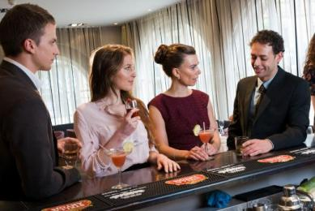
- From the main entrance to the lounge, there is level access.

Bar

Bar and Lounge
- From the main entrance to the bar, there is level access.

Gym

Fitness Suite
- From the main entrance to the gym changing area, there is level access. There is a lift.

Public toilet

Public Toilet
- There is a public toilet for disabled visitors.
- The toilet is a Changing Places toilet.
- From the main entrance to the public toilet, there is level access. There is a lift.
- The direction of transfer onto the toilet is to the left.
- The toilets have handrails.

Place to eat and drink

Bar and Lounge
- From the main entrance to the dining area, there is level access. To get to a table, there are no steps.
- There is background music.
- We cater for vegetarian, gluten free (celiacs), lactose free (dairy free), vegan, kosher and halal specific diets.

Getting around outside

Terrace

Terrace
- From the main entrance to this area, there is level access. There is a lift.
- To get to a table, there are no steps.
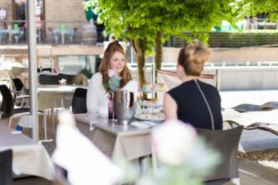

Customer care support

Accessibility equipment
- We have a hearing loop in Reception Desk.
- We have an area to charge mobility scooters and battery powered wheelchairs.

Emergency evacuation procedures
- We have emergency evacuation procedures for disabled visitors.
- The fire alarm has a vibrating pillow pad.

Customer care support
- Some staff have disability awareness training.
- Some staff have Next Generation Text training.
- Staff are available 24 hours a day.

Guide last updated: 18 January 2019

