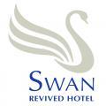

Accessibility Guide for Swan Revived Hotel
info@swanrevived.co.uk, 01908610565, www.swanrevived.co.uk
Contact for accessibility enquiries: Wendy Allford
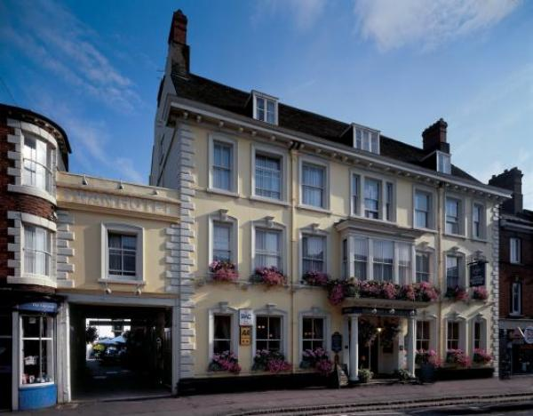

Welcome
The Swan Revived Hotel is a family run, independent hotel in the heart of Newport Pagnell, just a few miles from the M1 junction 14 and Milton Keynes.
Situated in an elegant 15th Century coaching inn, we have 40 comfortable bedrooms, all with en-suites, the latest amenities, including free WiFI
The Cob and Pen Restaurant, Lounge Bar and Frog and Nightgown, the hotel's own pub serve a mixture of modern and traditional dishes with an emphasis on fresh produce.
The Swan Revived offers a stylish venue for your wedding reception or civil ceremony celebrations. We have two conference rooms with natural lighting.

At a Glance

Level Access
- The main entrance has 2 steps. There is no lift and no ramp.
- There is level access from the main entrance to:
  - Reception and Lounge
  - Bedroom: 103, 104, 203, 204, 205, 206
  - Dining Table
  - Lounge
  - Lounge Bar
  - Frog and Nightgown Pub
  - Ladies Toilet in Frog and Nightgown Pub
  - Gentlemens Toilet
  - Patio Area outside Frog and Nightgown Pub

Bedrooms
- We have non-allergic bedding.

Level access bedrooms
- From the main entrance to the bedroom, there is level access.
- The route to the bedroom is 750mm wide, or more.
- The bedroom door is 750mm wide, or more.
- There is unobstructed floor space 1200mm by 900mm, or more.

Hearing
- The (bedroom) TVs have subtitles.
- Some staff have Next Generation Text and disability awareness training.

Visual
- Some parts of the venue have low lighting.

General
- Staff are available 24 hours a day.
- Some staff have disability awareness training.
- We have emergency evacuation procedures for disabled visitors.

Getting here
Swan Revived Hotel
33 High Street
Newport Pagnell
Buckinghamshire
MK16 8AR

Travel by public transport
- You can get to Swan Revived Hotel by bus and train.
- The nearest bus stop is at Market Hill on the High Street. The bus stop is 0.2 miles / 0.3 km from Swan Revived Hotel.
- The nearest train station is Central Milton Keynes. The train station is 6 miles / 9.7 km from Swan Revived Hotel.

Travel by taxi
- You can get a taxi with Skyline by calling 01908222111.
- You can get a taxi with Eezy Cabs by calling 01908218218. The taxi company has a wheelchair accessible vehicle.
- Eezycabs have a wheelchair accessible vehicle, which requires advance notice, to ensure they are available on the day required.

Parking
- We have a car park. There are accessible parking spaces. The parking is less than 50 metres from the main entrance. Parking is free.
- There is a drop-off point at the main entrance. The drop-off point does not have a dropped kerb.
- From the car park to the entrance, there is level access. There is a permanent ramp.
- The path is sloped.
- The route is 1300mm wide, or more.
- There are two main entrances to the hotel, the one under the arch, has the ramp, the surface here is cobbled though.
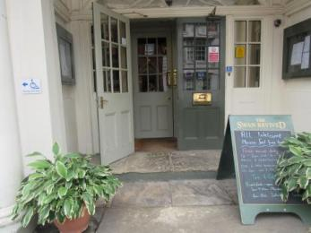
Front entrance
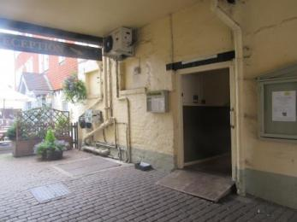
Side entrance with ramp
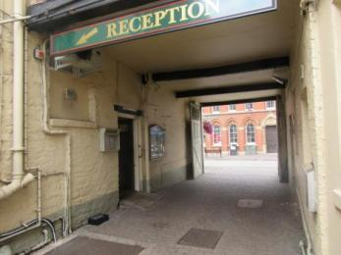
Side entrance with ramp from car park side
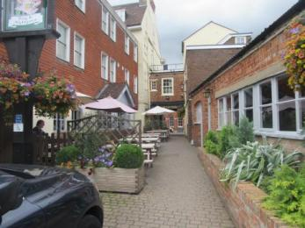
Route from car park to side entrance with ramp

Arrival

Path to main entrance
- From the street to the main entrance, there are 2 steps. There is no ramp and no lift.

Main entrance
- The door is 600mm wide.
- The main entrance has 2 steps.
- The main door is side hung and manual.
- The other entrance door is 1000.00mm wide.
- Under the arch
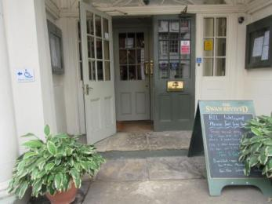
Main entrance
Side entrance from car park

Getting around inside

Visual Impairment - General Information
- Some parts of the venue have low lighting.

Lift
- We have 1 lift.
- You can get a lift to some floors.

Lift to 2nd floor
- The lift door is 730mm wide.
- The lift is 1190mm wide. The lift is 870mm deep.
- The lift buttons have raised numbers or letters.
- The lift shows the floor number, at each floor.
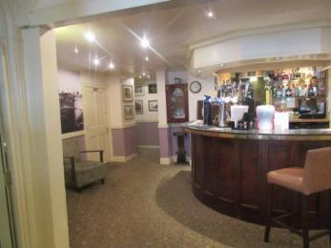
Route to lift from reception, past Lounge bar
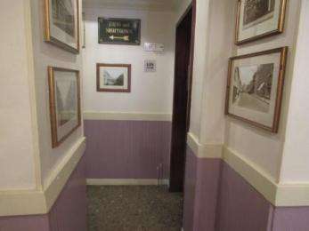
Route to lift
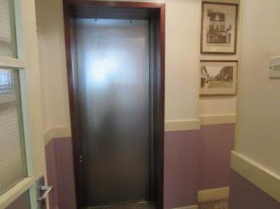
Lift

Reception and Lounge
- From the main entrance to reception, there is level access. You can sit down at reception.
- Reception is next to the main entrance. Seating is available in the Lounge area directly in front of reception
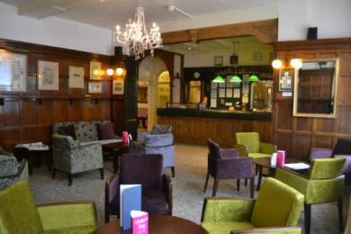
Reception and Lounge

Bedrooms
- All bedrooms have windows.
- Bedrooms have ceiling lights, wall lights and bedside lamps.
- Lights are fluorescent tube, halogen, LED, energy saving and traditional filament. Some lights can be controlled independently.
- TVs have subtitles.
- All bedrooms are non-smoking.
- We have non-allergic bedding.
- All bedrooms have fitted carpets.
- We can move the bedroom furniture, to improve accessibility.
- From the main entrance to this area, there is level access.

Accessible bedrooms

Accessible bedroom 103, 104, 203, 204, 205, 206
- From the main entrance to the bedroom, there is level access. There is a lift. The route to the bedroom is 730mm wide, or more. The bedroom door is 800mm wide. There is 600mm at the side of the bed. The bed is 600mm high. There is 0mm under the bed.
- The bedroom is flexible (either double or twin). The bathroom is ensuite. The bathroom door is 660mm wide.
- The bathroom has a separate shower. The shower has a handrail.
- There is a shower chair available. The direction of transfer onto the toilet is to the front only. There is 750mm in front of the toilet. The toilet seat is 400mm high.
- The basin is 840mm high. There is no space under the basin.
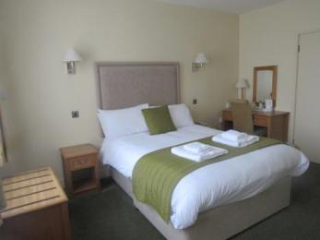
104
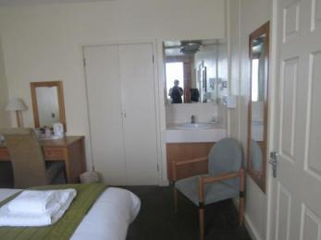
104
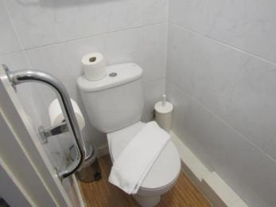
Shower and toilet room
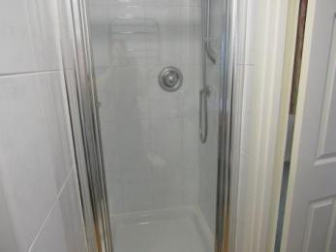
Shower in shower and toilet room

Lounge

Lounge
- From the main entrance to the lounge, there is level access. The route is 930mm wide, or more. The door is 930mm wide.
- The lounge is just inside the main entrance, the measurements apply to the side door which has the ramp.

Bar

Lounge Bar
- From the main entrance to the bar, there is level access.

Bar

Frog and Nightgown Pub
- From the main entrance to the bar, there is level access.

Public toilet

Ladies Toilet in Frog and Nightgown Pub
- From the main entrance to the public toilet, there is level access. The route is 650mm wide, or more.
- The toilet door is 650mm wide.
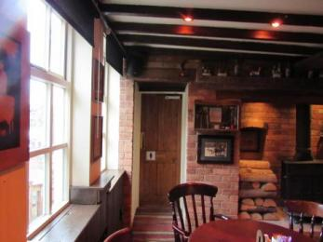
Ladies Toilet in the Frog and Nightgown
- The toilet seat is 40mm high.

Public toilet

Gentlemens Toilet
- From the main entrance to the public toilet, there is level access. There is a permanent ramp.
- The route is 830mm wide, or more.
- The toilet door is 830mm wide.
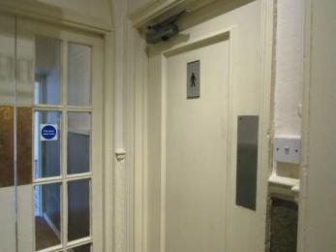
Gentlemens Toilet
- The toilet seat is 400mm high.

Place to eat and drink

Cob and Pen Restaurant
- From the main entrance to the dining area, there is level access. The route is 840mm wide, or more. The door is 840mm wide.
- To get to a table, there are no steps.
- The route through the dining area is 800mm wide, or more.
- There is background music.
- The table and plates have high colour contrast.
- We cater for sugar free (diabetic), vegetarian, gluten free (celiacs), lactose free (dairy free), nut free, low fat, low potassium, low sodium, high fibre and vegan specific diets.
- We can cater for most dietary requirements, with advance notice, but we cannot guarantee that there will be no traces of allergens, as we have one kitchen where all allergens are present.

Patio Area outside Frog and Nightgown Pub
- From the main entrance to this area, there is level access. There is a permanent ramp. The route is 730mm wide, or more.
- The door is 730mm wide.
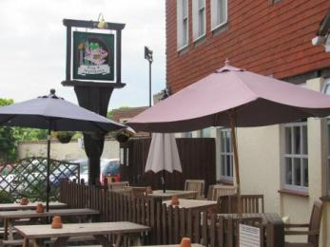
Patio area

Customer care support

Accessibility equipment
- The nearest toilet area is in the graveyard next to St Peter and St Paul Church, 70 metres from the hotel main entrance.
- We have an area to charge mobility scooters and battery powered wheelchairs.
- A mobility scooter or battery powered wheelchair maybe charged, close to reception.
- You can hire mobility equipment from Carver Care and Mobility by calling 01908644133.

Emergency evacuation procedures
- We have emergency evacuation procedures for disabled visitors.
- A record is kept at reception, of any guests who may require assistance, which would be passed to the emergency services on their arrival for evacuation to be carried out by the professionals, if physical assistance is required in addition to alerting and guiding guests.

Customer care support
- Some staff have disability awareness training.
- Some staff have Next Generation Text training.
- Staff are available 24 hours a day.
- There are staff on duty 24 hours on reception.

Guide last updated: 18 January 2019

