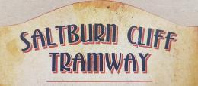

Accessibility Guide for Saltburn Cliff Tramway
saltburnclifftramway@redcar-cleveland.gov.uk, 01287 622528, http://www.redcar-cleveland.gov.uk/accommodation.nsf/TouristList/F6737A1C45441CC7802579CF00558787?OpenDocument
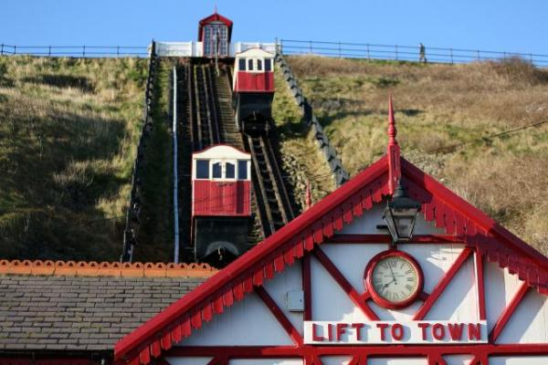

Welcome
The Saltburn Cliff Tramway links the town of Saltburn with the only remaining pleasure pier on the whole North East and Yorkshire Coast.
Saltburn Cliff Tramway is the oldest water balanced funicular still in operation in Great Britain. In 1924 an electrically operated water pump was installed. The installation has been lovingly refurnished over the past decade restoring the Tramway to its former Victorian glory.

At a Glance

Level Access
- There is level access from the main entrance to:
  - Ticket Desk - Main Entrance

Access with steps
- There are steps from the main entrance to:
  - Entry and exit onto the Trams from the top station

Hearing
- Some staff have disability awareness training.

Visual
- The walls and the doors have high colour contrast.
- We have information in large print.

General
- Some staff have disability awareness training.

Getting here
Saltburn Cliff Tramway
Lower Promenade
Saltburn
TS12 1HQ

Travel by public transport
- You can get to Saltburn Cliff Tramway by bus and train.
- The nearest bus stop is located on Station Square with bus numbers 3, X3 and 708 servicing the stop. The bus stop is 0.4 miles / 0.6 km from Saltburn Cliff Tramway.
- The nearest train station is Saltburn Train Station. The train station is 0.4 miles / 0.6 km from Saltburn Cliff Tramway.
- Saltburn Train Station is serviced by the Northern Rail service from Bishop Auckland to Saltburn.

Travel by taxi
- You can get a taxi with Saltburn Taxis by calling 01287 623567.

Parking
- There is parking near the venue. There are accessible parking spaces. The parking is less than 50 metres from the main entrance. Parking is not free.
- The nearest drop-off point is outside the top station of the Cliff Tramway on Marine Parade. Please be aware that the path from Marine Parade to the top station is sloped. From the car park to the entrance, there is level access. Parking is free for visitors with a valid Disabled Badge - Disabled badges must be displayed when parked in a designated Disabled Bays. In non-disabled bays parking is free for 3 hours provided a valid Disabled Badge and time disc are correctly displayed.
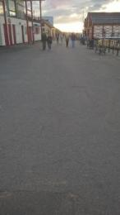
Path from the car park to Saltburn Cliff Tramway.
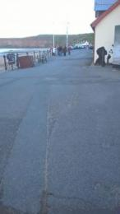
Path from Saltburn Cliff Tramway to the car park

Arrival

Path to main entrance
- From the street to the main entrance, there is level access.

Main entrance
- The main entrance has level access.
- The door is 910mm wide.
- The main door is side hung and manual.
- Although the doors are manual opening, when the attraction is open both the entrance and exit doors are always open with a door wedge.
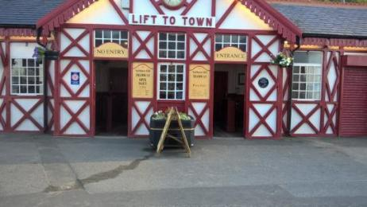
Saltburn Cliff Tramway entrance and exit .

Getting around inside

Visual Impairment - General Information
- We have high colour contrast between walls and doorframes.

Lift
- We have 2 lifts.
- You can get a lift to all floors.

Tram from the main entrance upto the top station
- The lift door is 760mm wide.
- The lift is 920mm wide. The lift is 1800mm deep.
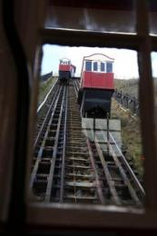
Trams on the track at Saltburn Cliff Tramway

Tram from the top station down to the main entrance
- The lift door is 760mm wide.
- The lift is 920mm wide. The lift is 1800mm deep.
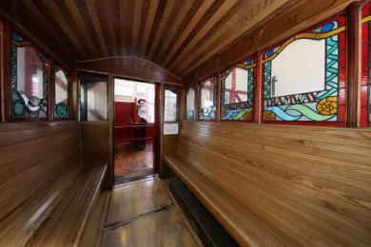
Inside a Tram at Saltburn Cliff Tramway

Ticket/ information desk

Ticket Desk - Main Entrance
- From the main entrance to the desk, there is level access. The route is 1030mm wide, or more.
- The door is 910mm wide, or more.
- Staff will come from behind the ticket desk to help any wheelchair user into the station and onto the Tram.

Entry and exit onto the Trams from the main entrance
- There are seats.
- There is a slight ramp up to enter the Trams from the main entrance up to the top station.
There is a slight ramp down to exit the Trams from the top station to the main entrance.
Staff will provide assistance with any accessibility needs if needed.
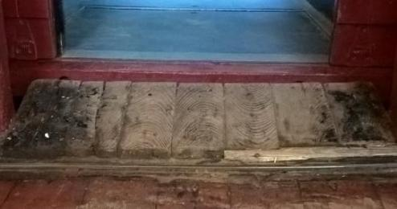
Ramp in and out of the Tram at Saltburn Cliff Tramway

Entry and exit onto the Trams from the top station
- From the main entrance to this area, there is 1 step. There is no lift and no ramp.
- There is 1 step up to exit the tram at the top station from the main entrance.
There is 1 step down to enter the tram from the top station to the main entrance.
Staff will provide assistance with any accessibility needs if needed.
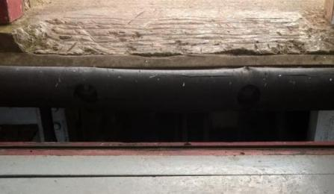
Step in and out of the Tram at Saltburn Cliff Tramway

Customer care support
- You can hire mobility equipment from Redcar & Cleveland ROC Information & Shopmobility Services by calling 01642 498894.

Emergency evacuation procedures
- We have emergency evacuation procedures for disabled visitors.

Customer care support
- Some staff have disability awareness training.
- We have information in large print.
- We have other services for people with accessibility requirements.
- Staff will provide assistance with any accessibility needs to enter and exit the trams.
If you have any queries or would like to speak to a member of the Saltburn Cliff Tramway team before you visit please call 01287 622528.

Guide last updated: 18 January 2019

