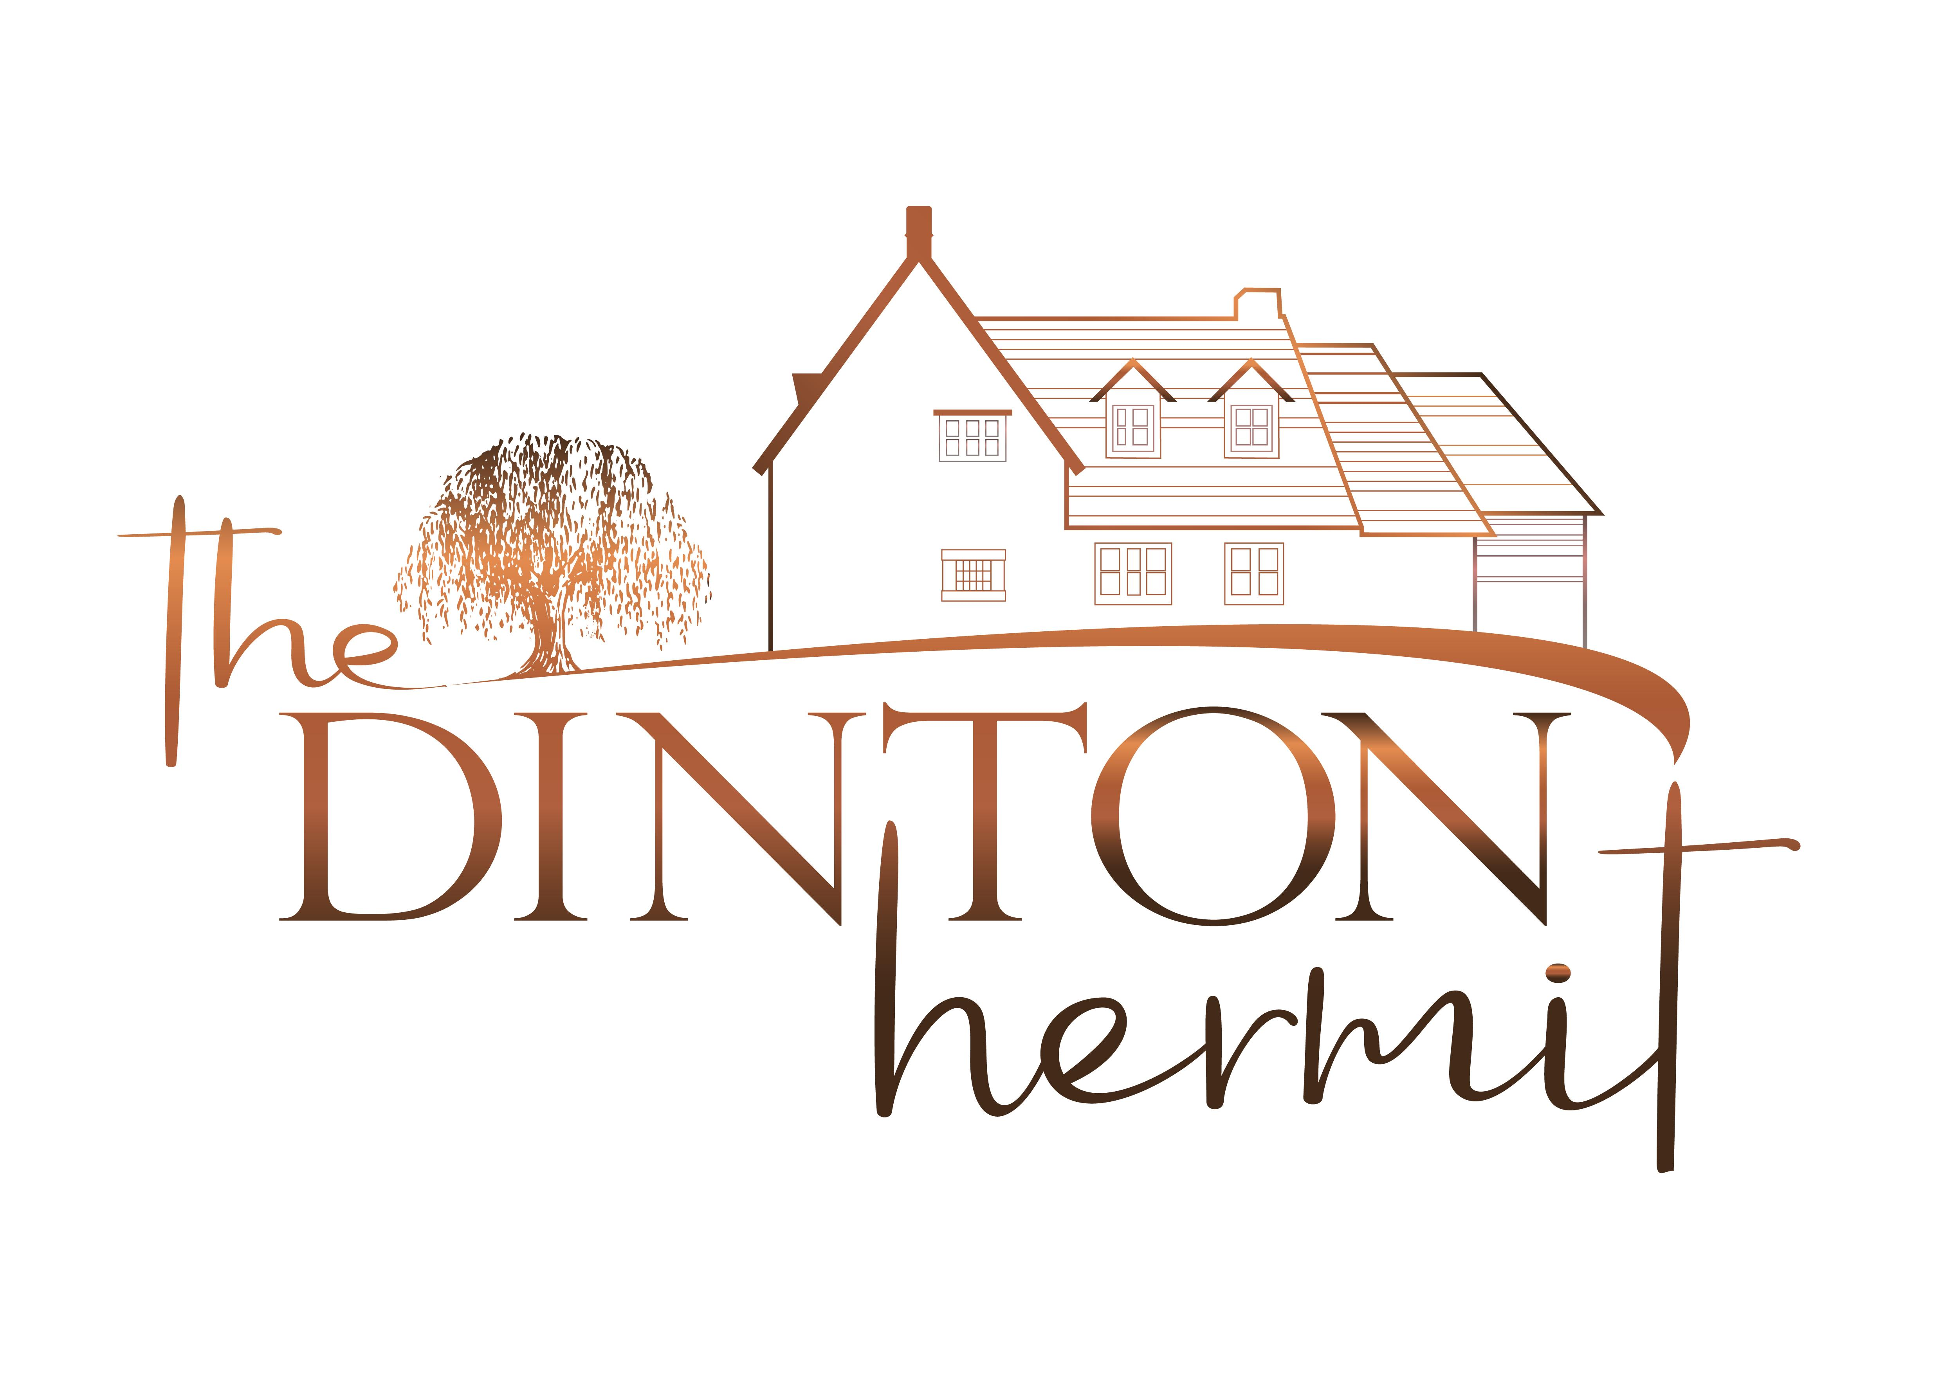

Accessibility Guide for The Dinton Hermit
hello@thedintonhermit.co.uk, 01296312877, www.thedintonhermit.co.uk
Contact for accessibility enquiries: James Demagalski
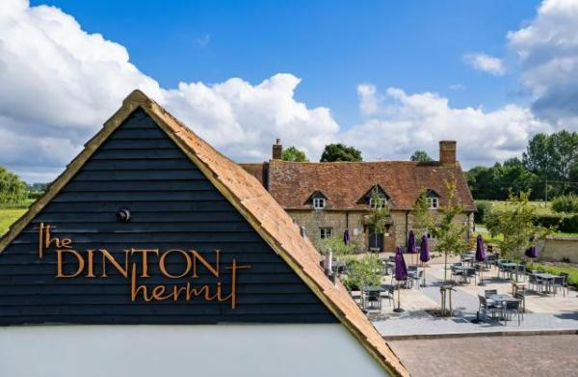

Welcome
The Dinton Hermit is a charming 17th century Grade II listed country inn with accommodation (8 bedrooms).
You’ll always find great craft ales, quality wines and an extensive menu with pub favourites, seasonal dishes and a wide selection of vegetarian and vegan dishes. There’s a Little Tummies menu for smaller appetites and a host of bar snacks and sharing dishes. Our food is freshly prepared using locally sourced and homegrown ingredients where possible and we display full allergen information on all our menus.
We’ve got a terrific team, all passionate about warm hospitality and great service. We welcome families, food aficionados, dog walkers, local residents and those from futher afield!

At a Glance

Level Access
- There is level access from the main entrance to:
  - Bedroom: Barn Room No. 6
  - Front Patio
  - Restaurant Patio
  - Gardens

Access with steps
- There are steps from the main entrance to:
  - Entrance Reception
  - Bar
  - Dining Table
  - Main Bar
  - Restrooms
  - Restaurant

Bedrooms
- We have non-allergic bedding.

Level access bedrooms
- From the main entrance to the bedroom, there is level access.
- The route to the bedroom is 750mm wide, or more.
- The bedroom door is 750mm wide, or more.
- There is unobstructed floor space 1200mm by 900mm, or more.
- The bathroom has a level access shower.

Hearing
- The fire alarm has flashing lights.
- The (bedroom) TVs have subtitles.

General
- There is at least 1 public toilet for disabled visitors.
- Staff are available 24 hours a day.
- We have emergency evacuation procedures for disabled visitors.

Getting here
Water Lane
Ford
Aylesbury
HP17 8XH

Travel by public transport
- You can get to The Dinton Hermit by bus.
- Adjacent to the pub. The bus stop is 0.1 miles / 0.2 km from The Dinton Hermit.
- Bus route 111 between Oakley & Aylesbury.
Bus route 112 between Waddesdon & Aylesbury.

Travel by taxi
- You can get a taxi with Cabco Taxis by calling 01844 299444. The taxi company has a wheelchair accessible vehicle.
- You can get a taxi with Falcon Taxis by calling 01296 247247. The taxi company has a wheelchair accessible vehicle.

Parking
- We have a car park. There are accessible parking spaces. The parking is less than 50 metres from the main entrance. Parking is free.
- There is a drop-off point at the main entrance. The drop-off point has a dropped kerb.
- From the car park to the entrance, there is level access. The route is 1000mm wide, or more.
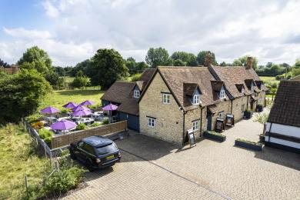
Level Access From Car Park To Entrance

Arrival

Path to main entrance
- From the street to the main entrance, there is level access.
- The path is 1000mm wide, or more.

Main entrance
- The main entrance has level access.
- The door is 750mm wide.
- The main door is side hung and manual.
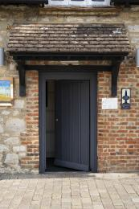
Front Entrance

Getting around inside

Entrance Reception
- From the main entrance to reception, there is 1 step. There is no lift and no ramp.
- The check-in desk has a low section for wheelchair users. You can sit down at reception.
- There is one step down from the main entrance into the bar / reception area as shown in the photograph.
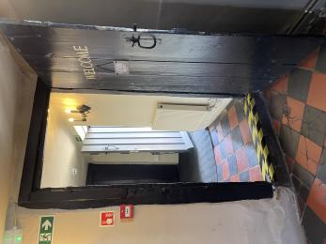
Showing the single step down into the bar / reception.

Bedrooms
- All bedrooms have windows.
- Bedrooms have ceiling lights, wall lights, floor standing lights, bedside lamps, desk or table lamps, spot lights and natural daylight.
- Lights are LED. TVs have subtitles.
- All bedrooms are non-smoking.
- We have non-allergic bedding.
- No bedrooms have fitted carpets.
- We can move the bedroom furniture, to improve accessibility.
- From the main entrance to this area, there is level access.

Accessible bedrooms

Accessible bedroom Barn Room No. 6
- The route to the bedroom is 1000mm wide, or more. The bedroom door is 750mm wide. There is 1500mm at the side of the bed. The bed is 650mm high. There is 300mm under the bed.
- The bedroom is flexible (either double or twin). The bathroom is ensuite. The bathroom door is 750mm wide.
- The bathroom has a separate shower. The bathroom has a level access shower. The toilets have handrails. The direction of transfer onto the toilet is to the left. There is 750mm at the side of the toilet.
- There is 600mm in front of the toilet. The basin is 920mm high. The taps are lever operated. There is no space under the basin.
- The bathroom has an emergency call system.
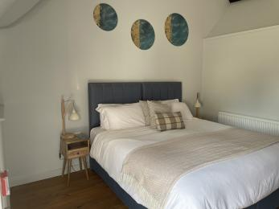
Our Accessible Bedroom. Barn Room 6
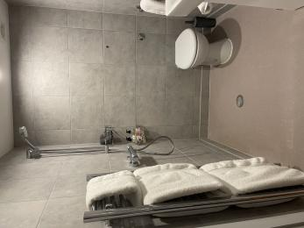
Accessible Bathroom
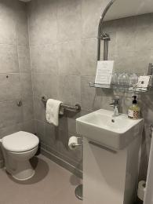
Accessible Bathroom

Bar

Main Bar
- From the main entrance to the bar, there is 1 step. There is no lift and no ramp.

Public toilet

Restrooms
- There is a public toilet for disabled visitors.
- From the main entrance to the public toilet, there is 1 step. There is no lift and no ramp.
- As an alternative, level access is available to the toilets via our patio doors.
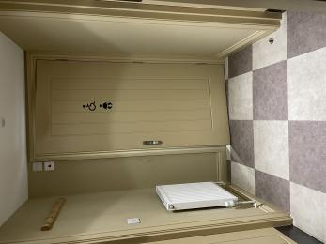
Public Access Disabled Toilet
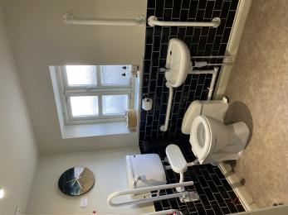
Public Access Disabled Toilet

Place to eat and drink

Bar
- From the main entrance to the dining area, there is 1 step. There is no lift and no ramp.
- To get to a table, there is 1 step.
- The route through the dining area is 800mm wide, or more.
- There is background music.
- We cater for vegetarian, gluten free (celiacs), lactose free (dairy free), nut free, low fat, low sodium and vegan specific diets.
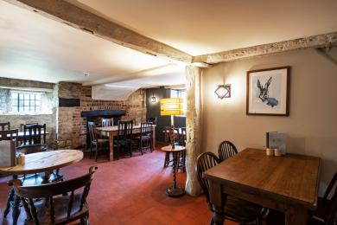
Bar

Restaurant
- From the main entrance to this area, there is 1 step. There is no lift and no ramp.
- Alternative direct access available via our patio doors.
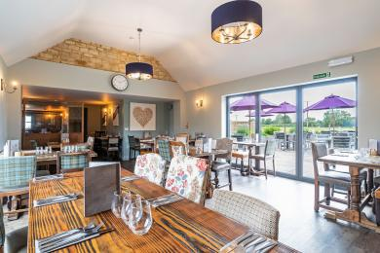
Restaurant

Getting around outside

Front Patio
- From the main entrance to the gardens, there is level access.
- Wide access from main entrance to front patio as shown in photograph.
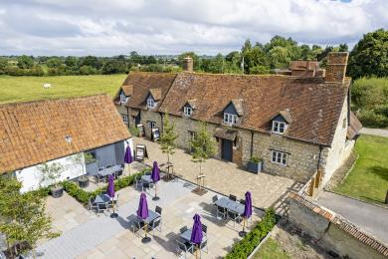
Front Patio

Restaurant Patio
- From the main entrance to the gardens, there is level access.
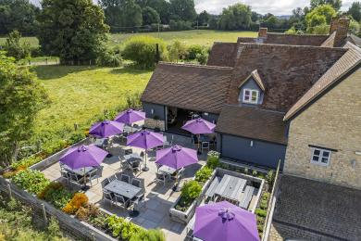
Restaurant Terrace
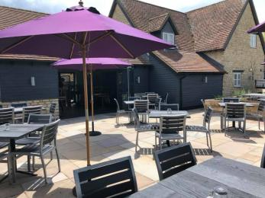
Restaurant Patio

Smoking

Gardens
- From the main entrance to the smoking area, there is level access.

Customer care support

Accessibility equipment
- We have a beer garden which would be suitable for any assistance dogs for their toilet needs but respectfully ask owners to clear up after their dogs or to inform a member of our staff if they need support.
- We have an area to charge mobility scooters and battery powered wheelchairs.
- There are multiple external and internal power sockets available.

Emergency evacuation procedures
- We have emergency evacuation procedures for disabled visitors.
- The fire alarm has flashing lights.

Customer care support
- Staff are available 24 hours a day.
- We have a Manager on site durig opening hours and outside of our opening hours we have an emergency number to call

Guide last updated: 9 January 2024

