Accessibility Guide for The Woodhouse
enquiries@oakwrights.co.uk, 01432 353353, https://www.oakwrights.co.uk/products-services/services/showhome/
Contact for accessibility enquiries: Effie Seal
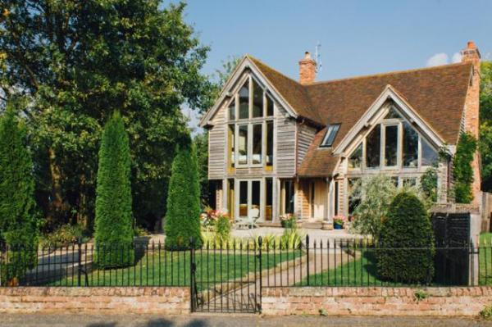

Welcome
Experience the pleasure of living with oak in our 5 star Show Home.
Oakwrights offer prospective clients the unique opportunity of staying overnight in our fully functioning show home in our ‘Try Before You Buy’ option.
Designed and built by Oakwrights, it serves to demonstrate both how attractive and enhancing an oak frame home can be to live in, and as an example of how creative and intelligent design can be used to stunning effect.
Our Show Home is located in the Herefordshire countryside, approximately 2 miles from our offices. The Show Home is approx. 5 miles from the city centre with a discounted taxi service available upon request.
Watch the video: Oakwrights Try Before You Buy Show Home | The Woodhouse

At a Glance

Level Access
- The main entrance has level access with a ramp. The ramp is permanent.

Access with steps
- There are steps from the main entrance to:
  - Bedroom

General
- Staff are available 24 hours a day.
- We have emergency evacuation procedures for disabled visitors.

Getting here
The Lakes
Swainshill
Hereford
HR4 7PU

Travel by taxi
- You can get a taxi with Blue Line Taxi by calling 01432 343435.

Parking
- We have a car park. The parking is less than 50 metres from the main entrance. Parking is free.
- There is a drop-off point at the main entrance. The drop-off point has a dropped kerb.
- From the car park to the entrance, there is level access. There is a permanent ramp.
- The path is sloped.
- The route is 640mm wide, or more.
- We have a transport service, to take visitors from the car park to the main entrance.
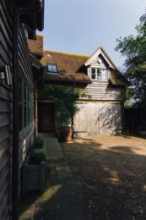
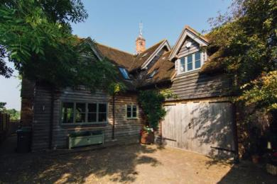
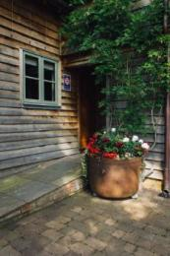

Arrival

Path to main entrance
- From the street to the main entrance, there is level access.
- There is a permanent ramp.
- The path is 640mm wide, or more.

Main entrance
- The main entrance has level access.
- There is a permanent ramp.
- When you arrive, we can help carry your luggage.

Getting around inside

Bedrooms
- All bedrooms have windows.
- Bedrooms have ceiling lights, wall lights, bedside lamps, spot lights and natural daylight.
- Lights are LED. All bedrooms are non-smoking.
- No bedrooms have fitted carpets.
- We can move the bedroom furniture, to improve accessibility.
- The bedroom nearest the main entrance has 13 steps.
- All bedrooms are ensuite.
- We have bathrooms with a separate shower.
- We have bathrooms with a bath and overhead shower. We have bathrooms with a bath.

Self catering kitchen
- We have an open plan kitchen.
- The work surface is available with clear underspace.
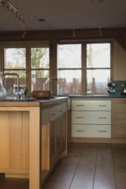
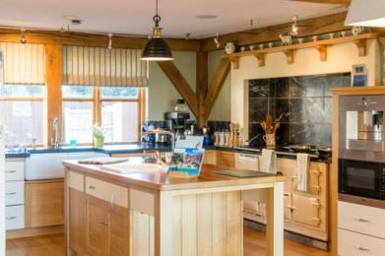

Lounge
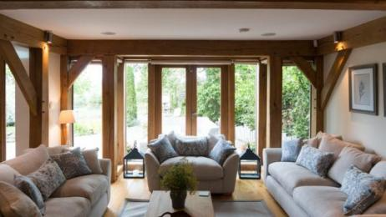
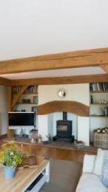
- From the main entrance to this area, there are 2 steps. There is no lift and no ramp.
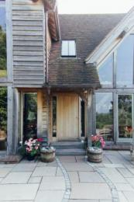
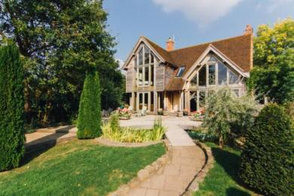

Getting around outside
- From the main entrance to the gardens, there are 2 steps. There is no lift and no ramp.
- There is level access via a back entrance.

Terrace
- To get to a table, there are no steps.
- From the main entrance to the terrace, there are 2 steps.
- There is level access via a back entrance.

Customer care support

Emergency evacuation procedures
- There is a fire safey statement available in the house detailing where exit routes are and safety procedures.

Customer care support
- Staff are available 24 hours a day.
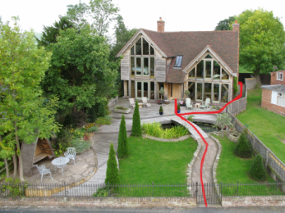
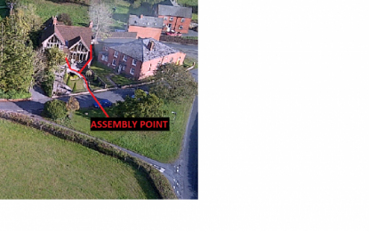
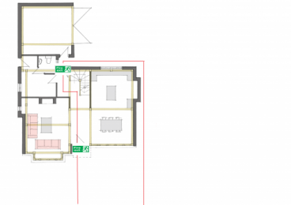

Guide last updated: 14 January 2022

