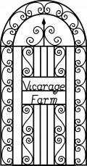

Accessibility Guide for Hope Cross Cottage at Vicarage Farm
gordonandann@vicaragefarm.co.uk, 01298 871737, http://www.vicaragefarm.co.uk/accommodation/cottages/hope-cross/
Contact for accessibility enquiries: 01298 871737
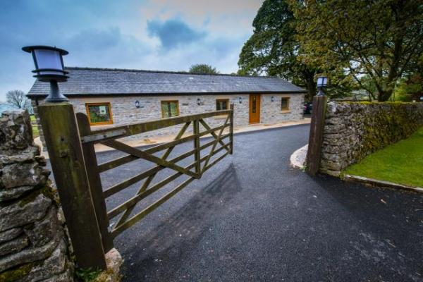

Welcome
Hope Cross is a new accessible holiday bungalow in the heart of the Peak District. Designed specifically with access needs in mind, it has two bedrooms and a spacious open lounge/dining area/kitchen with a large patio and glorious views over fields and dales. It can also be booked as part of our other cottages and B&B accommodation for groups of 15.
Highly energy efficient, warm and cosy, Hope Cross features profiling bed, mobile hoist, riser/recliner and shower chairs in a beautiful, bespoke cottage with hand crafted finishes.
Other equipment can be hired and delivered to suit your needs.
Watch the video: Guest's video

At a Glance

Level Access
- There is level access from the main entrance to:
  - Bedroom: Twin bedroom
  - Bedroom: Double bedroom
  - Laundry
  - Hope Cross lounge
  - Dining area
  - Hope Cross garden & patio area

Bedrooms
- We have non-allergic bedding.
- We have a portable hoist.

Level access bedrooms
- From the main entrance to the bedroom, there is level access.
- The route to the bedroom is 750mm wide, or more.
- The bedroom door is 750mm wide, or more.
- There is unobstructed floor space 1200mm by 900mm, or more.
- The bathroom has a level access shower.

Hearing
- The fire alarm has flashing lights.
- The (bedroom) TVs have subtitles.

Visual
- The walls and the doors have high colour contrast.
- We have information in large print.

Getting here
Vicarage Farm, Wheston
Tideswell
Buxton
Derbyshire
SK17 8JA

Travel by public transport
- You can get to Hope Cross Cottage at Vicarage Farm by bus and train.
- The nearest bus stop is in Tideswell Village, 1.3 miles / 2.1 km down the hill from Vicarage Farm. The bus stop is 1.3 miles / 2.1 km from Hope Cross Cottage at Vicarage Farm.
- The nearest train station is Buxton and Hope. The train station is 7 miles / 11.3 km from Hope Cross Cottage at Vicarage Farm.
- Hope Cross Cottage is in a beautiful rural loction; holidays here are easier if you have your own transport. The road up from the village is paved and single track in places; there are no pavements or street lights for the last mile.
Our closest train stations are Buxton and Hope (both seven miles) and Chesterfield (18 miles). Manchester airport is 28 miles away.

Travel by taxi
- You can get a taxi with A Cabs by calling 0129870423. The taxi company has a wheelchair accessible vehicle.
- You can get a taxi with A2Z Cars by calling 01298 918101. The taxi company has a wheelchair accessible vehicle.
- You can get a taxi with JAM Taxis by calling 01298 72333. The taxi company has a wheelchair accessible vehicle.

Parking
- We have a car park. There are accessible parking spaces. The parking is less than 50 metres from the main entrance. Parking is free.
- There is a drop-off point at the main entrance. The drop-off point has a dropped kerb.
- From the car park to the entrance, there is level access. Parking is directly outside the front door with level access.
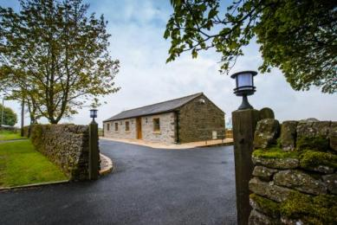
Hope Cross front entrance
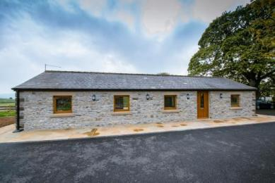
Hope Cross front view from entrance gate

Arrival

Path to main entrance
- From the street to the main entrance, there is level access.
- The path is 3880mm wide, or more.

Main entrance
- The main entrance has level access.
- The door is 875mm wide.
- The main door is side hung and manual.
- When you arrive, we can help carry your luggage.
- Please ask in advance if you need assistance so we can ensure we are here to help.
The cottage has security lighting with sensors on all sides.
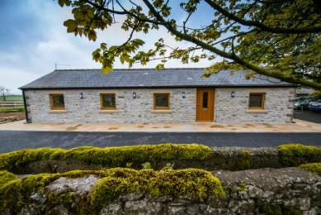
Hope Cross Cottage front with level access and parking at the door
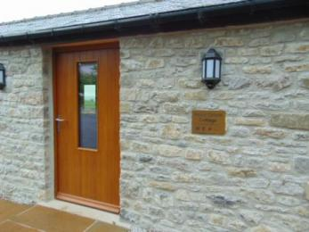
Front entrance with level access & parking

Getting around inside

Visual Impairment - General Information
- We have high colour contrast between walls and doorframes.
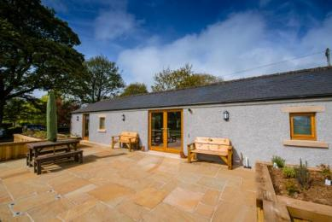
There is sensor security lighting all around the cottage which can be turned off completely if required. There are no street lights around the property.
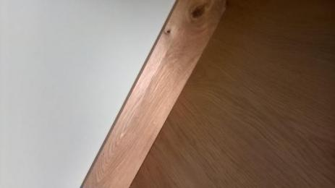
Walls and flooring are in contrasting colours
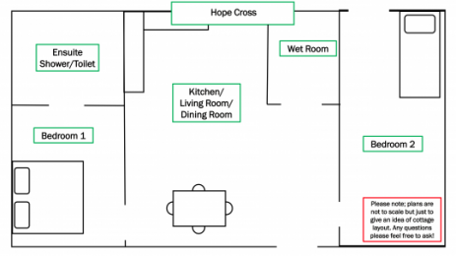
Cottage floor plan - outline only, not to scale
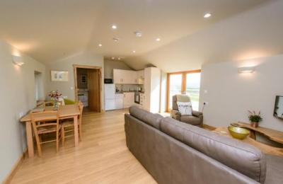
Lounge lighting can be dimmed and changed from brilliant white to opaque

Bedrooms
- All bedrooms have windows.
- Bedrooms have ceiling lights, wall lights, spot lights and natural daylight.
- Lights are LED and energy saving. TVs have subtitles.
- All bedrooms are non-smoking.
- We have non-allergic bedding.
- No bedrooms have fitted carpets.
- There are no carpets or rugs in Hope Cross; all flooring is laminate wood or wet room vinyl, the twin bedroom (with profiling bed) has a full length escape door which is integrated with the fire & smoke alarm system; if the alarm goes off it will open automatically for access, we can give details of our cleaning products on request; please let us know if there is anything you might need on this issue, if you have a visual impairment and need markings on the glass doors, please let us know and we will do this for your stay and the wi-fi can be turned off in the entire cottage if required
- We can move the bedroom furniture, to improve accessibility.
- We have bed blocks.
- We have a portable hoist.
- From the main entrance to this area, there is level access.

Accessible bedrooms

Accessible bedroom Twin bedroom
- The route to the bedroom is 1500mm wide, or more. The bedroom door is 870mm wide. There is 1600mm at the side of the bed. The bed is 630mm high. There is 260mm under the bed.
- The bedroom is twin. The bathroom is separate. It is not an ensuite.
- The bathroom door is 880mm wide.
- The bathroom has a separate shower. The shower has a seat. The shower has a handrail.
- The bathroom has a level access shower. There is a shower chair available. The level access shower has handrails.
- The toilets have handrails. The direction of transfer onto the toilet is to the right. There is 3000mm at the side of the toilet.
- There is 480mm in front of the toilet. The toilet seat is 480mm high.
- The basin is 730mm high. The taps are lever operated. There is space under the basin, with no pedestal or boxing.
- The walls and the bathroom fittings have high colour contrast.
- This bedroom has two single beds - one full profiling and one electric tilting with optional bed guard and raisers.
Wet room walls are tiled on all sides, flooring is high grade safety wet room flooring in light colour. There are grab rails on both sides of the toilet and shower and a heated towel ladder beside the basin. All pipework is concealed where possible and heating is underfloor.
The self propelling shower chair can be locked in position to make a safe and comfortable seat for showering
Lighting is from four recessed spots in the ceiling, backlit mirror above the basin and a large frosted glass window.
There is a portable double sided/magnified shaving mirror in both bathrooms.
The twin bedroom has a flat screen Freeview television on the wall opposite the bed.
The hoist is a Molift Smart - please remember to bring your own sling!
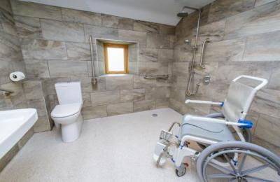
Wet room with self propelling shower/commode chair
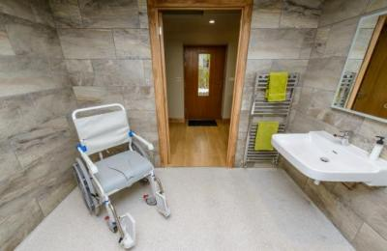
The wet room has wheelchair accessible basin with hand grips on both sides.
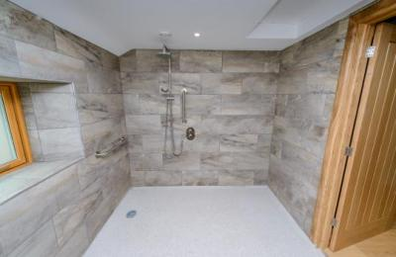
The wet room shower has two heads, one fixed overhead and one hand held, with grab rails on both sides of the shower bar.
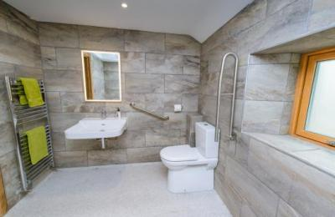
Wet room with accessible basin, comfort height (48cm) toilet, backlit mirror, large window with frosted glass and heated towel ladder.
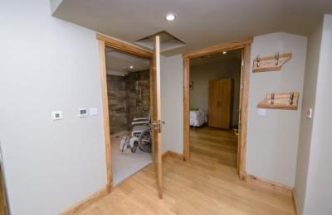
The large wet room is beside the twin bedroom with profiling bed.
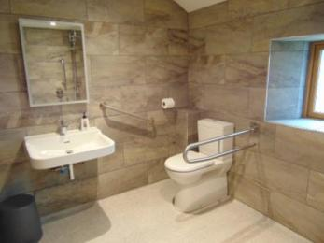
Toilet has grab rails on both sides
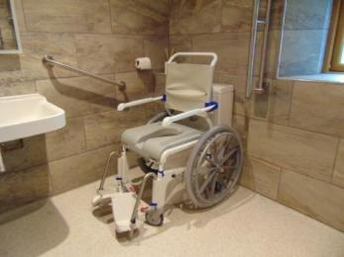
Commode chair fits over toilet
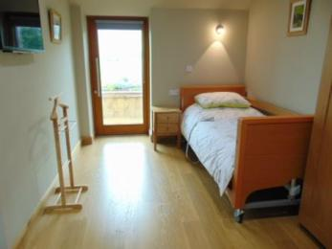
Twin bedroom with profiling bed, windows to both sides and escape door to patio
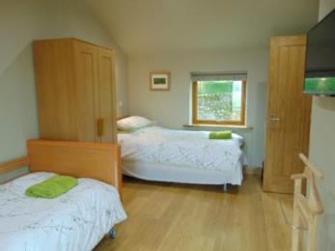
Twin berdoom with prifiling and tilting beds, ample turning space, tv and storage

Accessible bedrooms

Accessible bedroom Double bedroom
- The route to the bedroom is 1530mm wide, or more. The bedroom door is 860mm wide. There is 850mm at the side of the bed. The bed is 580mm high. There is 0mm under the bed.
- The bedroom is double. The bathroom is ensuite. The bathroom door is 720mm wide.
- The bathroom has a separate shower. The direction of transfer onto the toilet is to the front only. There is 1370mm in front of the toilet. The toilet seat is 420mm high.
- The basin is 835mm high. The taps are lever operated. There is no space under the basin.
- The walls and the bathroom fittings have high colour contrast.
- The en suite is smaller than the wetroom and not accessible by wheelchairs.
The walls are tiled throughout with lighter coloured high grade non-slip wet room flooring.
The shower has a small lip (850mm) and sliding doors; width 800 x length 1200mm.
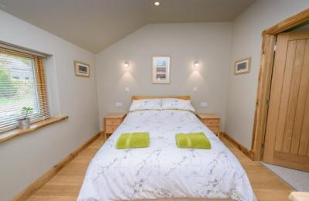
Double bedroom - bed can be moved to one side or turned round for more space .
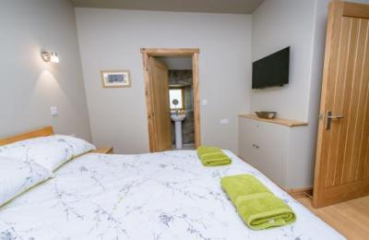
Double bedroom with en suite shower room.
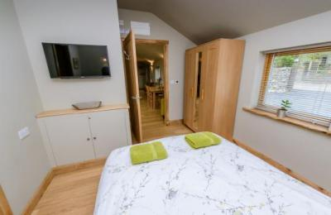
The double bedroom is next to the lounge/dining area.
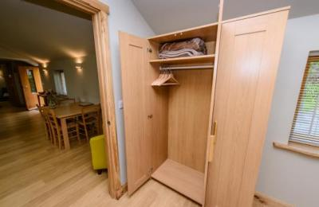
The double bedroom has a triple wardrobe giving ample storage space.
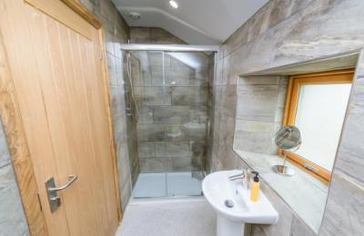
En suite to double bedroom; shower measures 1200x800mm with sliding door and storage for toiletries.
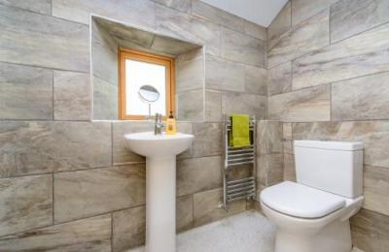
Double bedroom en suite with standard height toilet and basin, south facing window for natural light and heated towel ladder. There is also a backlit mirror and shaving mirror.

Laundry
- From the main entrance to the laundry, there is level access. The route is 3880mm wide, or more. The door is 770mm wide.
- We have an iron and ironing board. You can use the ironing board sitting down.
- We can provide iron and ironing board on request.
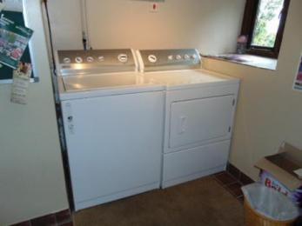
Laundry facilities are across the road with our other cottages

Self catering kitchen

Hope Cross kitchen
- We have an open plan kitchen.
- From the main entrance to the kitchen, there is level access.
- The route is 1530mm wide, or more.
- The oven is available at a height between 650mm and 900mm.
- The table and plates have high colour contrast.
- Due to space restrictions we are unable to offer lower height surfaces. However, we can extend the dining table and put the microwave, toaster and kettle on it if required.
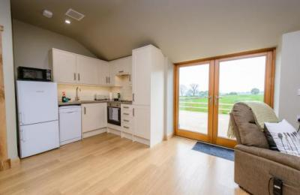
Kitchen area
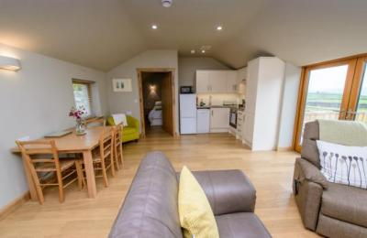
Kitchen & dining area
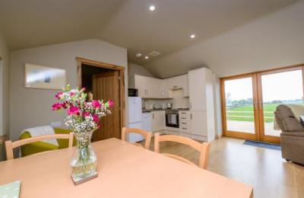
Open plan cooking & dining
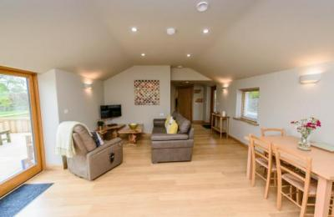
Open plan living space
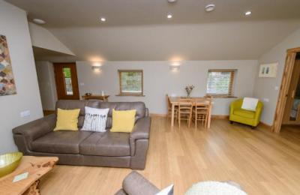
Lounge and dining area
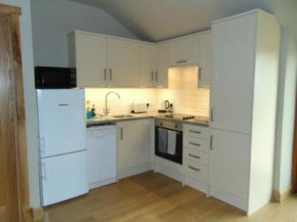
Hope Cross kitchen
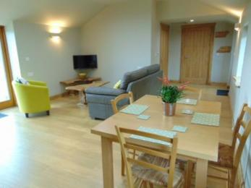
The dining table can be extended; height to underside max 720mm

Lounge

Hope Cross lounge
- From the main entrance to the lounge, there is level access. The route is 1530mm wide, or more.
- The lounge, kitchen and dining areas of the cottage are open plan with wide patio doors onto a large paved area and gorgeous views over open countryside and hills.
The two bedrooms are off either end of the lounge.
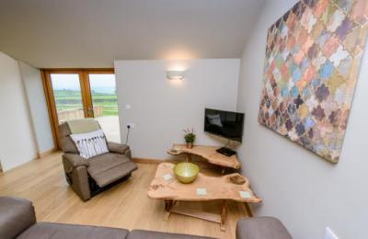
Hope Cross lounge with riser/recliner chair
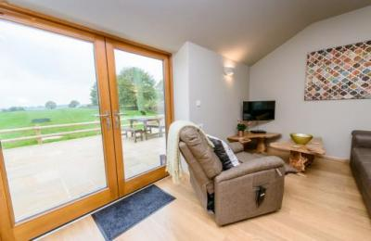
Lounge with large patio doors and glorious views.
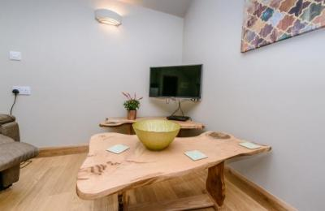
Lounge with Freeview television and DVD player
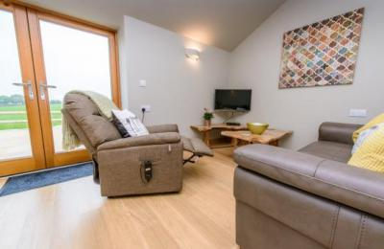
Relax in the lounge
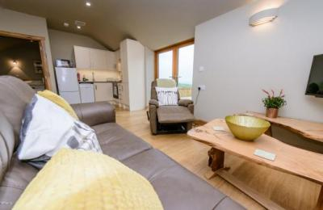
Open plan lounge & kitchen
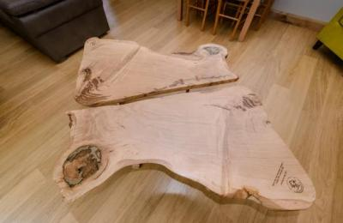
Bespoke coffe tables in the lounge
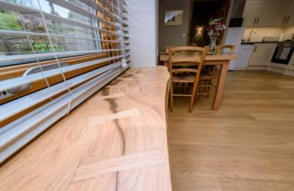
Hand crafted sills throughout the cottage

Dining area
- From the main entrance to this area, there is level access. The route is 1530mm wide, or more.
- The dining area is part of the open plan lounge and kitchen.
The table seats four and is standard height with 650mm clearance to the underside - when extended there is clearance of 720mm.
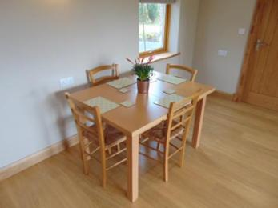
The dining table seats four comfortably and can be moved out from the wall.
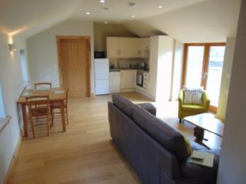
The dining table can be extended for extra clearance underneath.

Getting around outside

Hope Cross garden & patio area
- From the main entrance to this area, there is level access. The route is 3880mm wide, or more. The entrance is 3880mm wide.
- The rear patio measures 7.8m x 5.5m and can be accessed from the double doors in the lounge or round either side of the cottage by the well lit path.
The patio is bordered on two sides by raised beds with planting of a sensory nature; the main view is open to fields and hills. There will be cattle or sheep grazing in the field behind the cottage at times; some of our guests have seen calves being born! As the fence is timber post and rail it is very important that assistance dogs are kept on a lead outside at all times so they cannot go into the field.
We have a paved path around all four sides of the cottage giving completely level access. It is 1070mm wide at its narrowest point.
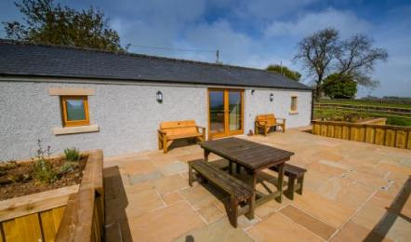
Rear patio with picnic table and benches
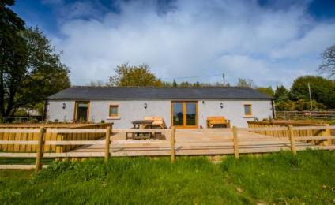
Hope Cross view from the field
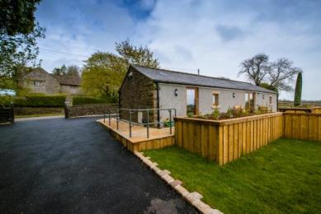
Rear and side view
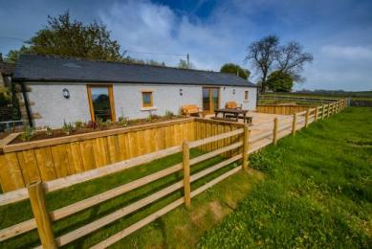
Rear garden and patio
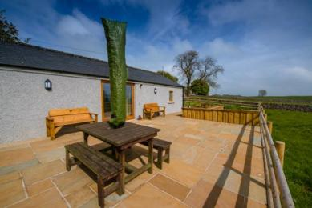
Picnic table with large umbrella for shade
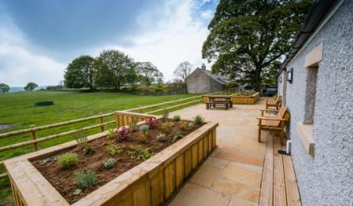
Raised beds, patio and adjoining fields
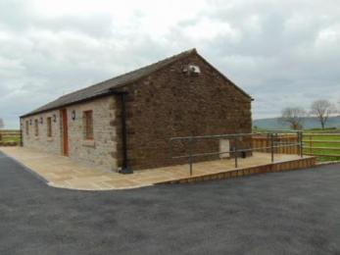
Side wall with power socket

Customer care support

Accessibility equipment
- We have a Molift Smart 150 mobile hoist, Aquatec Self Propelling Shower and Commode Wheelchair with locking wheels and an electric riser/recliner armchair in the lounge. All new in 2017.
The twin room has a full profiling bed and an electric tilting bed with optional bed guard and bed raisers.
- The nearest toilet area for assistance dogs is a grass area in the garden to the side of the cottage - please be sure to clean up after your dog!
- We have an area to charge mobility scooters and battery powered wheelchairs.
- Wheelchairs can be charged in the cottage; there is also an external double power socket on the path.
- You can hire mobility equipment from Clark and Partners, Sheffield by calling 0114 229 33 74. http://clarkshop.co.uk/.
- You can hire mobility equipment from Buxton Volunteer Centre by calling 01298 23970. Wheelchair loan - refundable deposit, no charge.

Emergency evacuation procedures
- We have emergency evacuation procedures for disabled visitors.
- The fire alarm has flashing lights.
- There is an intergrated fire, smoke and CO2 detection system in the cottage. In the event of an alarm, the twin room has extra fire protection; the bedroom door will close automatically and the escape door to the rear patio will unlock to enable access from outside.

Customer care support
- We have information in large print.
- The cottage is self catering and designed for independent travellers. We live on site (across the road from Hope Cross) and are happy to help if we can.
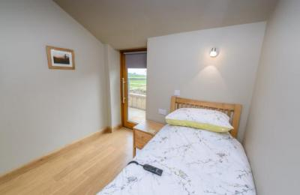
Fire escape door opens automatically in event of alarm sounding

Guide last updated: 28 March 2021

