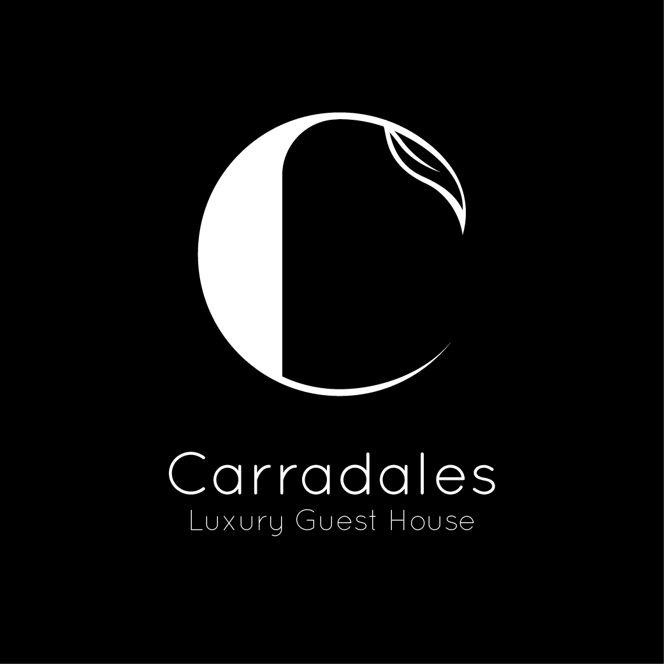

Accessibility Guide for Carradales
01583 431119, www.carradales.com
Contact for accessibility enquiries: Maurice Whelan
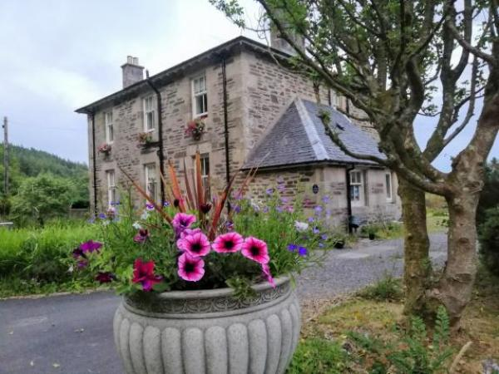

Welcome
In one of Scotland’s most picturesque regions is “Carradales.” This is a traditionally built Victorian detached house, originally built as a Church of Scotland Manse in 1880. Purchased in 2016 and opened in 2018 having been lovingly restored to a high-end fully licensed Guest House and intimate wedding venue and is Kintyre’s Only 5 Star VisitScotland Guest House. Expertly prepared cuisine, excellent facilities, and some of the most beautiful outdoor experiences anywhere, are just some of the reasons to plan a trip to Carradales.

At a Glance

Level Access
- There is level access from the main entrance to:
  - Dining Room
  - Dining Table
  - Lounge

Access with steps
- There are steps from the main entrance to:
  - Bedroom
  - Patio

Bedrooms
- We have non-allergic bedding.

Hearing
- The (bedroom) TVs have subtitles.
- All staff have disability awareness training.

General
- Staff are available 24 hours a day.
- All staff have disability awareness training.
- We have emergency evacuation procedures for disabled visitors.

Getting here
Carradales
Carradale
Campbeltown
PA28 6QG

Travel by public transport
- You can get to Carradales by bus.
- Bus stop from Campbeltown Bus Station and will stop outside Carradales on request. The bus stop is 0.1 miles / 0.2 km from Carradales.

Travel by taxi
- You can get a taxi with Fona Taxi by calling 01586 554001. The taxi company has a wheelchair accessible vehicle.
- We have a transfer service for visitors. Wheelchair users can use the transfer service.
- We can arrange this on request with taxi firm.

Parking
- We have a car park. Parking is free.
- There is a drop-off point at the main entrance. The drop-off point has a dropped kerb.
- From the car park to the entrance, there is level access. The route is 700mm wide, or more.
- The car park is a made of gravel. It is level and wheelchair can be easily pushed to the front door where there are 2 steps into porch.

Arrival

Path to main entrance
- From the street to the main entrance, there is level access.
- The path is 700mm wide, or more.

Main entrance
- The door is 1000mm wide.
- The main entrance has 2 steps.
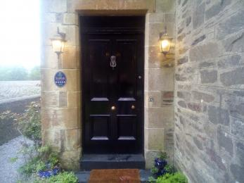
front door to Carradales Guest House

Getting around inside

Dining Room
- From the main entrance to reception, there is level access. The door is 800mm wide.
- You can sit down at reception.
- We have no formal reception area. We are very relaxed and flexible and all assistance will be given.

Bedrooms
- All bedrooms have windows.
- Bedrooms have ceiling lights, bedside lamps, desk or table lamps and natural daylight.
- Lights are LED. TVs have subtitles.
- All bedrooms are non-smoking.
- We have non-allergic bedding.
- All bedrooms have fitted carpets.
- Hypo allergenic pillows only provided
- We can move the bedroom furniture, to improve accessibility.
- The bedroom nearest the main entrance has 1 steps.
- All bedrooms are ensuite.
- We have bathrooms with a separate shower.
- We have bathrooms with a bath.

Lounge

Lounge
- From the main entrance to the lounge, there is level access. The route is 840mm wide, or more. The door is 810mm wide.
- Lounge is just across the hallway from the ground floor bedroom called Tarbert

Place to eat and drink

Dining Room
- From the main entrance to the dining area, there is level access. The route is 810mm wide, or more. The door is 810mm wide.
- To get to a table, there are no steps.
- The route through the dining area is 800mm wide, or more.
- There is background music.
- The table and plates have high colour contrast.
- We cater for vegetarian, gluten free (celiacs), lactose free (dairy free) and vegan specific diets.
- This is sent out in advance of arrival:
Dear
Thank you for choosing Carradales.
IMPORTANT INFORMATION
Your Dining Experience:
You are booked on a B&B basis. We want to let you know that we also serve evening meals. As there are very few places to eat in the village, I would be grateful if you could let me know what days you wish to dine at Carradales as we are very busy and so that we can reserve a table for you.
The latest we serve is around 7pm.
Times of meals will be agreed during your stay.
You must let us know in advance and prior to your stay if you have any allergies or dietary restrictions.
Meals will be staggered to observe social distancing, but also to ensure that everyone has a pleasant dining experience.
On the first night, should you dine at Carradales, you will experience a selection of house specials subject to your dietary restrictions.
If you choose to dine thereafter, you will have a choice of 3 starters, main courses and desserts.
A 3- course meal will cost between £40 - £45 per head.
We have been awarded with a “Taste Our Best” accreditation from VisitScotland. This means that Steve takes pride in only sourcing the freshest local ingredients in our menu items whenever possible. Locally sourced ingredients ensure we are serving the freshest Scotch and best tasting food possible and also help support local farmers and preserve the environment by reducing our carbon footprint.
Steve, our Chef will take your Breakfast order the night before and your evening meal order in the morning. He is passionate about his food and all options and choices can be discussed with him on a personal basis.
Alternative places to eat must also be pre-booked in advance.
These can be found online and include:
The Glen Bar & Restaurant, Carradale – 01583 431105
Number 42, Campbeltown – 01586 554642
The Royal Hotel, Campbeltown – 01586 810030
The Ardshiel Hotel, Cmpbeltown – 01586 552133
Thank you again for choosing Carradales and we look forward to hearing from you and to welcome you soon.
Best regards

Getting around outside

Patio
- From the main entrance to the gardens, there is 1 step. There is no lift and no ramp.
- The route to the garden is taken via exit from the front door which has 1 step then turn left and there is a gravel path which will then lead you to the flat and level patio. All assistance will be given whre necessary.
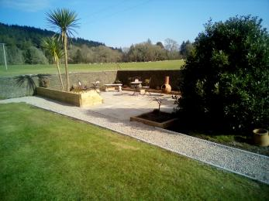
Carradales - Patio area

Terrace

Patio as already stated
- To get to a table, there are 1steps steps.
- The ground floor bedroom does not have a separate terrace. Tere is one communal patio area which you exit via the front foor and turn right along a gravel path to a flat and level patio

Customer care support

Accessibility equipment
- Bath mats
- The nearest toilet area for dogs is next door on common land. Please note that in other circumstances we do not allow dogs.

Emergency evacuation procedures
- We have emergency evacuation procedures for disabled visitors.
- Audible alarm only

Customer care support
- All staff have disability awareness training.
- Staff are available 24 hours a day.
- Owners live on site.

Guide last updated: 6 July 2022

