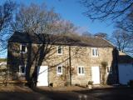

Accessibility Guide for The Barn
alanpkitchener@gmail.com, 07810424926, www.thebarnholwick.co.uk
Contact for accessibility enquiries: Alan Kitchener
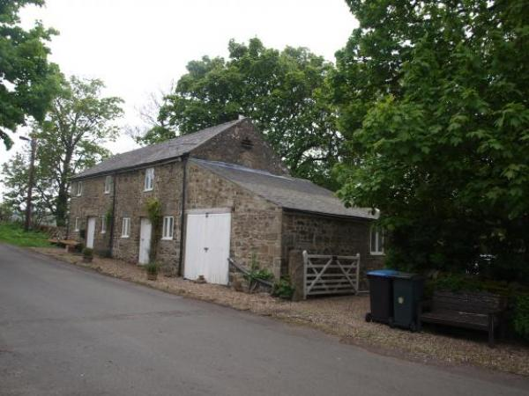

Welcome
The Barn is in Holwick, a hamlet near Middleton in Teesdale in Upper Teesdale. It is made from the local Whinstone under a Welsh slate roof. The Barn was converted in 2000-2001 to a house which sleeps six in three bedrooms, one of which is on the ground floor. There is a large lounge with dining area and a large, well equipped kitchen with access to the rear garden. Upstairs there are two further twin bedded bedrooms, a bathroom with bath, pedestal hand was basin and toilet. There is in addition a separate shower room with pedestal wash basin, toilet and walk in shower. Outside there are large gardens mainly lawned with a stream and views across open farmland and hills, and parking for at least four cars.

At a Glance

Level Access
- There is level access from the main entrance to:
  - Bedroom: One ground floor bedroom.
  - Bedroom: 2 upstairs bedrooms
  - Large lounge with dining area
  - Rear garden and off road parking area

Level access bedrooms
- From the main entrance to the bedroom, there is level access.
- The route to the bedroom is 750mm wide, or more.
- The bedroom door is 750mm wide, or more.
- There is unobstructed floor space 1200mm by 900mm, or more.

Hearing
- Some (bedroom) TVs have subtitles.

General
- Staff are available 24 hours a day.
- We have emergency evacuation procedures for disabled visitors.

Getting here
The Barn
Holwick
Middleton-in-Teesdale
Durham
DL120NJ

Travel by public transport
- There are buses to Middleton in Teesdale four miles away, thereafter there is no public transport to Holwick.

Travel by taxi
- You can get a taxi with Mauds..Barnard Castle or Hodgsons, Barnard Castle

Parking
- We have a car park. The parking is less than 50 metres from the main entrance. Parking is free.
- There is a drop-off point at the main entrance. The drop-off point has a dropped kerb.
- From the car park to the entrance, there is level access. The path is sloped.
- The route is 3000mm wide, or more.
- We have a transport service, to take visitors from the car park to the main entrance. Our transport service is wheelchair accessible.
- Access to the front door from the car park is via a gravel drive followed by roadside to the front door up a gradual slope. It is possible to drop off immediately outside the front door. Access from the parking area to the rear is via double French doors up three steps.

Arrival

Path to main entrance
- From the street to the main entrance, there is level access.
- The path is 1500mm wide, or more.

Main entrance
- The main entrance has level access.
- The door is 1200mm wide.
- The main door is side hung and manual.
- When you arrive, we can help carry your luggage.
- I normally greet guests on arrival so if I am there I would help with access.

Getting around inside

Bedrooms
- All bedrooms have windows.
- Bedrooms have ceiling lights, bedside lamps, desk or table lamps, spot lights and natural daylight.
- Lights are LED and energy saving. Some TVs have subtitles.
- All bedrooms are non-smoking.
- Some bedrooms have fitted carpets.
- We can move the bedroom furniture, to improve accessibility.
- From the main entrance to this area, there is level access.

Accessible bedrooms

Accessible bedroom One ground floor bedroom.
- The route to the bedroom is 1000mm wide, or more. The bedroom door is 1000mm wide. There is 1000mm at the side of the bed. The bed is 700mm high. There is 0mm under the bed.
- The bedroom is twin. The bathroom is separate. It is not an ensuite.
- The direction of transfer onto the toilet is to the front only. There is no space under the basin.

Accessible bedrooms

Accessible bedroom 2 upstairs bedrooms
- The route to the bedroom is 1000mm wide, or more. The bedroom door is 1000mm wide. The bed is 600mm high. There is 0mm under the bed.
- There is a low clothes rail. You can use the rail sitting down.
- The bedroom is twin. The bathroom is separate. It is not an ensuite.
- The bathroom has a separate shower. The bathroom has a bath.
- The direction of transfer onto the toilet is to the front only. There is 1000mm in front of the toilet. The toilet seat is 450mm high.
- The basin is 900mm high. There is no space under the basin.

Self catering kitchen

Kitchen-diner
- We have an open plan kitchen.
- From the main entrance to the kitchen, there is 1 step. There is no lift and no ramp.
- The table and plates have high colour contrast.

Lounge

Large lounge with dining area
- From the main entrance to the lounge, there is level access. The route is 1000mm wide, or more. The door is 1000mm wide.

Getting around outside

Rear garden and off road parking area
- From the main entrance to this area, there is level access.
- Access to the rear has one internal step down and three steps down outside the double french doors. Narrowest internal door is 750mm

Customer care support

Accessibility equipment
- The nearest toilet area for assistance dogs is located in the rear garden adjacent to the property.
- No designated charging point, if vehicle needs domestic charge then it can be plugged in to domestic supply.

Customer care support
- Staff are available 24 hours a day.
- Owner can be phoned in emergency.

Guide last updated: 20 February 2020

