Accessibility Guide for The Bosham Boathouse B&B
jane@theboshamboathouse.co.uk, 07966735395, www.theboshamboathouse.co.uk
Contact for accessibility enquiries: Jane Young
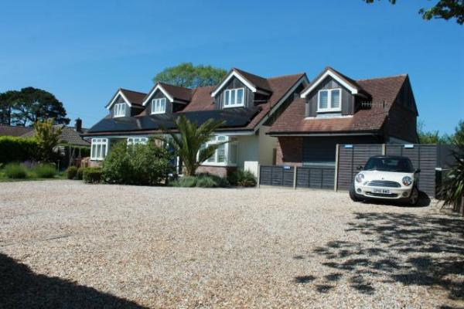

Welcome
The Bosham Boathouse is located on the edge of the beautiful village of Bosham between the South Downs and Chichester Harbour. Chichester is to our east and Emsworth to our west and with a bus stop just outside these can be easily reached by bus or car.
We have four guest bedrooms; three located on the ground floor and all with their own independant access. The Apuldram room has its own level pathway directly from the carpark along with a ramp to its entrance and a low door threshold.
We look forward to welcoming you. If you have any queries or require any assistance, please phone 07966735395 or email jane@the boshamboathouse.co.uk

At a Glance

Level Access
- The main entrance has level access with a ramp. The ramp is portable.
- There is level access from the main entrance to:
  - Bedroom: The Apuldram
  - Dining Table
  - Rear Gardens

Bedrooms
- We have non-allergic bedding.

Level access bedrooms
- From the main entrance to the bedroom, there is level access.
- The route to the bedroom is 750mm wide, or more.
- The bedroom door is 750mm wide, or more.
- There is unobstructed floor space 1200mm by 900mm, or more.

Hearing
- The (bedroom) TVs have subtitles.
- Some staff have BSL and disability awareness training.

Visual
- We have information in large print.

General
- Staff are available 24 hours a day.
- Some staff have disability awareness training.
- We have emergency evacuation procedures for disabled visitors.

Getting here
Main Road
Bosham
PO18 8EH

Travel by public transport
- You can get to The Bosham Boathouse B&B by bus and train.
- The nearest bus stop is directly outside the entrance to The Bosham Boathouse. Travelling from Chichester the 700 or 56 Stage coach buses stop at Chequer Lane opposite The Bosham Boathouse. Leaving the Bosham Boathouse to travel to Chichester the bus stop is to the left as you exit the car park. The bus stop is 0.0 miles / 0.0 km from The Bosham Boathouse B&B.
- The nearest train station is Bosham. The train station is 0.8 miles / 1.3 km from The Bosham Boathouse B&B.

Travel by taxi
- You can get a taxi with Station Taxis by calling 01243884884. The taxi company has a wheelchair accessible vehicle.

Parking
- We have a car park. There are accessible parking spaces. The parking is less than 50 metres from the main entrance. Parking is free.
- There is a drop-off point at the main entrance. The drop-off point has a dropped kerb.
- From the car park to the entrance, there is level access. There is a portable ramp.
- The route is 90mm wide, or more.
- We have seven car parking bays with gravel surface. One bay is directly alongside a paved pathway that is just over 10 metres metres from the entrance to The Apuldram guest room. The car park is lit with security lights (motion sensor controlled) at night. Our other guest rooms entrances are up to 20 metres from the car park.
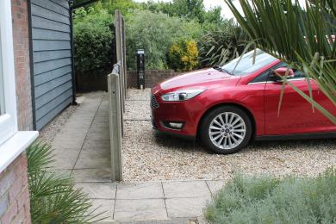
View of parking bay and pathway to the Apuldram guest room.
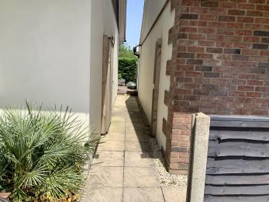
Guest pathway to guest rooms(Chidham, Garden and Sail Loft), garden terrace and breakfast room
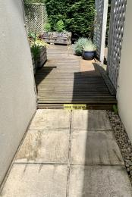
Main pathway to rear showing 10cm step

Arrival

Path to main entrance
- From the street to the main entrance, there is level access.
- There is a portable ramp.
- The path is 90mm wide, or more.

Main entrance
- The main entrance has level access.
- There is a portable ramp.
- Guests are welcomed in the car park and shown to their guest room which all have their own direct access from the pathway. The narrowest part of the pathway is 90mm (through the side gateway). To pathway to the Garden Room , Sail Loft , Garden Terrace an Breakfast Room has one step. A portable ramp can be put in place when required.
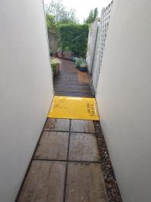
Portable ramp in place on pathway to rear guest room, garden terrace and Breakfast Room

Getting around inside

Bedrooms
- All bedrooms have windows.
- Bedrooms have ceiling lights, wall lights, bedside lamps, spot lights and natural daylight.
- Lights are LED and traditional filament. TVs have subtitles.
- All bedrooms are non-smoking.
- We have non-allergic bedding.
- All bedrooms have fitted carpets.
- We have hypo allergic duvets and pillows are available on request.
- From the main entrance to this area, there is level access.

Accessible bedrooms

Accessible bedroom The Apuldram
- From the main entrance to the bedroom, there is level access. There is a ramp. The ramp is Permanent.
- The route to the bedroom is 900mm wide, or more. The bedroom door is 870mm wide. There is 1000mm at the side of the bed. The bed is 570mm high. There is 0mm under the bed.
- The bedroom is flexible (either double or twin). The bedroom has an interconnecting room. The bathroom is ensuite. The bathroom door is 800mm wide.
- The bathroom has a separate shower. There is a shower chair available. The direction of transfer onto the toilet is to the left. There is 200mm at the side of the toilet.
- There is 800mm in front of the toilet. The toilet seat is 420mm high.
- The basin is 860mm high. The taps are lever operated. There is no space under the basin.
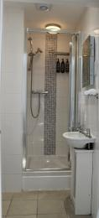
Apuldram shower and sink

Place to eat and drink

Breakfast Room
- From the main entrance to the dining area, there is level access. There is a portable ramp. The route is 900mm wide, or more. The door is 1000mm wide.
- To get to a table, there are no steps.
- The route through the dining area is 800mm wide, or more.
- There is no background music.
- We cater for sugar free (diabetic), vegetarian, gluten free (celiacs), lactose free (dairy free), low fat and vegan specific diets.

Getting around outside

Rear Gardens
- From the main entrance to the gardens, there is level access.
- There is a portable ramp.
- The route is 900mm wide, or more.

Customer care support

Accessibility equipment
- We have a adjustable shower stool and non slip shower mat on site.
- The Apuldram has its own private terrace suitable for assistance dog's toileting.
- You can hire mobility equipment from Clear Mobility by calling 012438839699.

Customer care support
- Some staff have disability awareness training.
- Some staff have BSL training.
- We have information in large print.
- Staff are available 24 hours a day.
- We are able to provide literature on the area in large print..

Guide last updated: 20 June 2022

