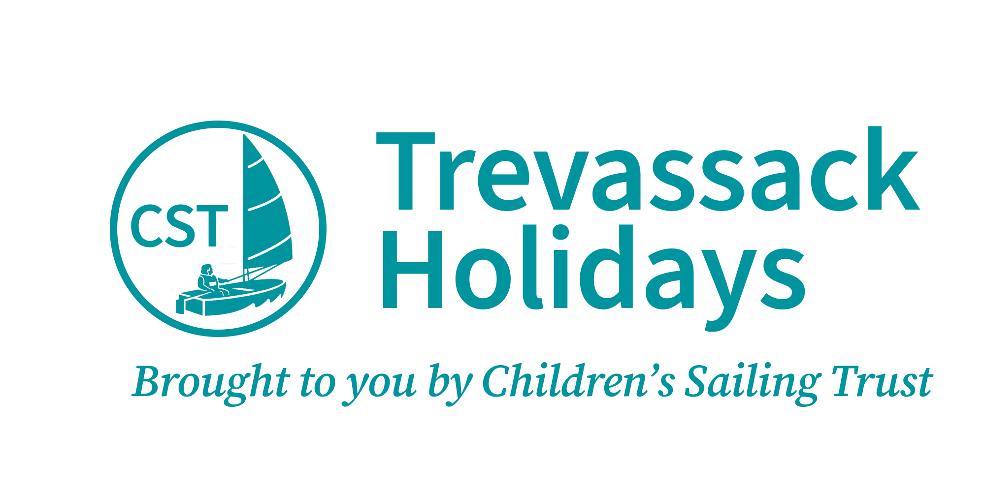

Accessibility Guide for Serpentine Cabin
katie@childrenssailingtrust.org.uk, 01326702326, www.trevassackholidays.com
Contact for accessibility enquiries: Deborah Lawson
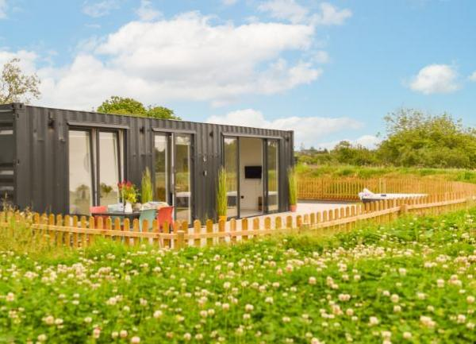

Welcome
Serpentine Cabin is a dog-friendly holiday home with a hot tub in Cornwall – the perfect place for an adventure holiday for all the family or couples. All abilities and ages are welcome to stay at Serpentine Cabin on Trevassack Lake, where a watersports centre awaits with trained staff skilled in helping beginners and those with special needs. The well-appointed accommodation is all on one level and sleeps up to five people plus their four-legged friend.

At a Glance

Level Access
- There is level access from the main entrance to:
  - Bedroom: Open plan living room with bedroom area
  - Automatic washer/drier in wet room
  - Open plan living room with sitting area
  - Bedroom 1
  - Serpentine lawn with deck

Bedrooms
- We have non-allergic bedding.
- We have a portable hoist.

Level access bedrooms
- From the main entrance to the bedroom, there is level access.
- The route to the bedroom is 750mm wide, or more.
- The bedroom door is 750mm wide, or more.
- There is unobstructed floor space 1200mm by 900mm, or more.
- The bathroom has a level access shower.

Hearing
- Some staff have disability awareness training.

Visual
- Glass doors and full-height windows have contrast markings.

General
- Staff are available 24 hours a day.
- Some staff have disability awareness training.
- We have emergency evacuation procedures for disabled visitors.

Getting here
Trevassack Lake
Garras
Helston
TR12 6LH

Travel by public transport
- You can get to Serpentine Cabin by bus.
- The Bus Route to Serpentine Cabin is as follows: www.gocornwallbus.co.uk Helston to St Keverne Route: 36A Start: Blue Anchor Inn 50 Coinagehall Street Helston TR13 8EL Finish: Trelowarren Estate Entrance TR12 6AF The bus stops 0.8 miles / 1.3 km away from Serpentine Cabin at Trevassack Holidays Please visit www.gocornwallbus.co.uk for up to date time tables and accessibility information The bus stop is 0.8 miles / 1.3 km from Serpentine Cabin.
- Please note that the bus route is 0.80 miles away from Serpentine Cabin at Trevassack Holidays

Travel by taxi
- You can get a taxi with Cornwall Wheelchair Taxis - www.cambornetaxis.co.uk by calling 01209 719999. The taxi company has a wheelchair accessible vehicle.
- You can get a taxi with Kernow Cabs by calling 01326 464646. The taxi company has a wheelchair accessible vehicle.
- You can get a taxi with A2B Taxis by calling 01872 272989. The taxi company has a wheelchair accessible vehicle.
- The main entrance to Trevassack Holidays and Lake is clearly signposted from the main road. The main entrance has a wide level vehicular access. Access to Serpentine Cabin is through an automatic safety barrier with a number keypad entry.
Keypad entry code will be sent beforehand with the arrival details. Arrival details can be sent in larger text.
Automatic Safety barrier height 980mm.
The keypad is back lit and numbers are raised.
Entry keypad height 900mm and can be accessed whilst still in your vehicle.
Keypad verbal call button option.
Ambient lighting.
CCTV in operation.

Parking
- We have a car park. The parking is less than 50 metres from the main entrance. Parking is free.
- Serpentine Cabin has a dedicated level access parking space Parking space is in excess of 50 meters on a slight slope Dedicated pedestrian tarmac path from drop off point From the car park to the entrance, there is level access. The path is sloped.
- The route is 2100mm wide, or more.
- The entrance to Serpentine Cabin is via a hinged swing wooden gate opening inwards. Gate width 1060mm
Width 2100mm dedicated pedestrian tarmac path
Gripsure wooden decking
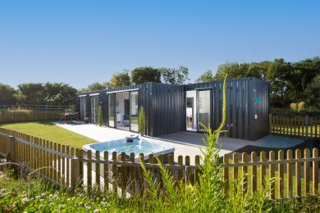
Serpentine Cabin, level access, deck and garden

Arrival

Path to main entrance
- The path is sloped.

Main entrance
- The main entrance has level access.
- The door is 900mm wide.
- When you arrive, we can help carry your luggage.
- The main entrance door 900mm is hinged and opens outwards
Front door handle height 1040mm
We can help you to unload and load your luggage
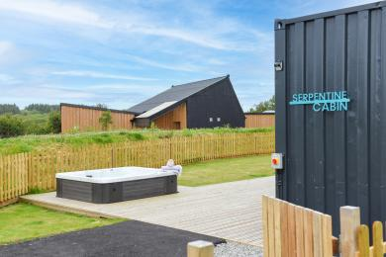
Entrance pathway to Serpentine

Getting around inside

Visual Impairment - General Information
- We have contrast markings on all glass doors and contrast markings on all full-height windows.
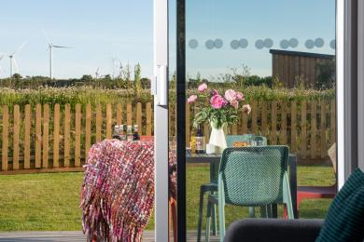
Serpentine Cabin - contrast marking patio doors

Bedrooms
- All bedrooms have windows.
- Bedrooms have bedside lamps, spot lights and natural daylight.
- Lights are LED and energy saving. All bedrooms are non-smoking.
- We have non-allergic bedding.
- No bedrooms have fitted carpets.
- All bedding is hypoallergenic and We can provide details of the laundry services
- We can move the bedroom furniture, to improve accessibility.
- We have bed blocks.
- We have a portable hoist.
- From the main entrance to this area, there is level access.
- The direction of transfer onto the toilet is to the front only.
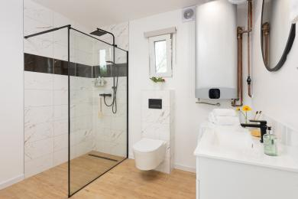
Wet-room in Serpentine
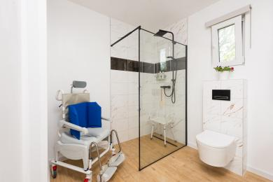
Serpentine wet-room

Accessible bedrooms

Accessible bedroom Open plan living room with bedroom area
- The route to the bedroom is 2200mm wide, or more. There is 500mm at the side of the bed. The bed is 500mm high. There is 160mm under the bed.
- The bedroom is double. The bathroom is separate. It is not an ensuite.
- The bathroom door is 900mm wide.
- The bathroom has a separate shower. The shower has a handrail.
- The bathroom has a level access shower. There is a shower chair available. The level access shower has handrails.
- The direction of transfer onto the toilet is to the front only. There is 1670mm in front of the toilet. The toilet seat is 480mm high.
- The basin is 850mm high. The taps are lever operated. There is no space under the basin.
- Open plan living room with bedroom area with king-size bed (5'). Please note that the bed can be moved over to one side against the wall to gain more access down the side 500mm. The transfer to the bed would be from the front only.
Hypoallergenic bedding is provided. Waterproof protectors. Details of laundry service can be provided beforehand
We can make any reasonable adjustments
Wetroom is off the living area with level access and pocket door 900mm
Wetroom has separate shower, toilet, basin set in vanity unit, front loading washer/drier, wall mounted heated wall towel rail and mirror.
Equipment available at no charge
Medley Ergo Profiling Adjustable Bed Plus Softform Premier Original Mattress with side rails and bumpers
T70 Self Propelled shower commode chair
Ocean VIP Tilt In Space Shower and Commode Chair
Freestanding Lifting Pole
Perch chair
Portable suction grab rail
Mowbray Lite Adjustable Toilet Frame with Seat
Curved transfer board
Elephant feet 90mm and 140mm
Evo Birdie portable hoist 150kg
Riser recliner chair 420mm seat height
Sensory star projector
Gantry Hot Tub Hoist
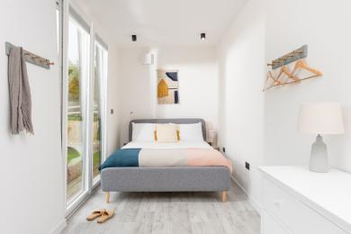
King-size bed in Serpentine
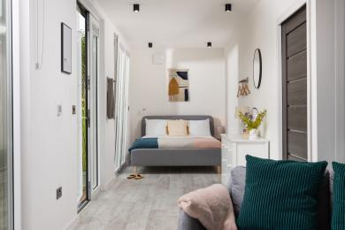
View of king-size bed in Serpentine

Automatic washer/drier in wet room
- From the main entrance to the laundry, there is level access. The route is 900mm wide, or more. The door is 900mm wide.
- We have an iron and ironing board. You can use the ironing board sitting down.
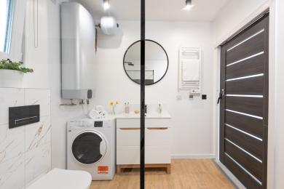
Serpentine's wet-room with washer-drier

Self catering kitchen

Open plan living room with kitchen area
- We have an open plan kitchen.
- From the main entrance to the kitchen, there is level access.
- The route is 2200mm wide, or more.
- The work surface is available at a height between 650mm and 900mm.
- The hob is available at a height between 650mm and 900mm.
- The sink is available at a height between 650mm and 900mm.
- The oven is available at a height between 650mm and 900mm.
- Furniture can be removed and altered for your stay
The route is level and 1000mm wide or more
Space for manoeuvrability and transfers
Full size fridge/freezer
Full size dishwasher
Lever tap kitchen sink
Low level access oven 660mm handle height with 4 ring induction hob
Fire blanket and fire extinguisher
Smoke and heat detector
Dining table height 750mm
Dining chairs height to seat 470mm
Air conditioning
Equipment available at no charge
Tripp Trapp adjustable highchair from 6 months and above available
RNIB liquid level indicator available
Elephant feet 90mm and 140mm
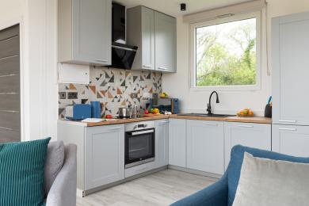
Kitchen area of Serpentine
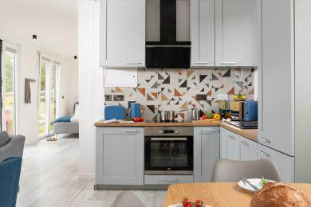
Kitchen area of Serpentine
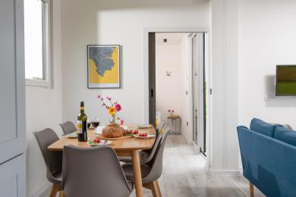
Dining area of Serpentine

Lounge

Open plan living room with sitting area
- From the main entrance to the lounge, there is level access. The route is 2200mm wide, or more. The door is 1600mm wide.
- Sliding double patio doors open to 1600mm
Black out blinds throughout
3 seater sofa height to seat 470mm
2 seater sofa height to seat 440mm
High colour contrast sofas with cushions
Space from front of sofa to patio door 1600mm
Room for manoeuverability and transfers
Furniture can be removed and altered for your stay
Wall hung smart television with subtitles and remote control
Spotlights in the ceiling and table lamps
Equipment available at no charge
Tripp Trapp adjustable highchair from 6 months and above available
RNIB liquid level indicator available
Elephant feet 90mm and 140mm
Star sensory projector
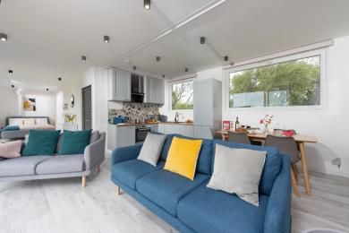
Sitting area of Serpentine
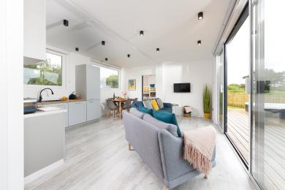
View of sitting area of Serpentine
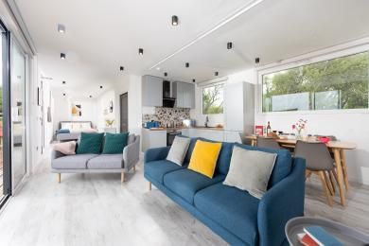
Another view of the sitting area of Serpentine

Bedroom 1
- From the main entrance to this area, there is level access. The route is 770mm wide, or more.
- The door is 770mm wide.
- Level access via open plan living area
Pocket sliding door 770mm
Double bed (4'6") and single (3') bunk bed over
Sliding patio door 740mm slight lip and access onto Gripsure decking
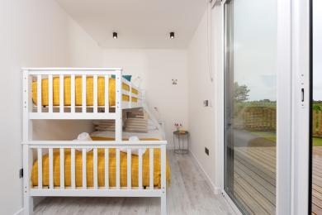
Bedroom 1 with double bed and single bunk bed over in Serpentine
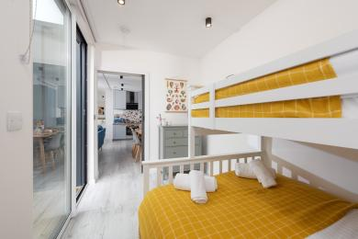
Bedroom 1 in Serpentine

Getting around outside

Serpentine lawn with deck
- From the main entrance to the gardens, there is level access.
- The route is 2100mm wide, or more.
- Serpentie Cabin has a level access, fully enclosed garden, with post and rail fencing and a large Gripsure deck running along the front of the cabin with table, chairs and inset hot tub.
The route to the garden is in excess of 1000mm wide
Decking area at the narrowest point is 2300mm
Inset hot tub height 480mm
Table height 780mm
Chair height to seat 470mm
Outside lighting
Level access to hot tub with room for manoeuvrability and transfer
There is 1 hinged gate width 1060mm which swing inwards on to dedicated tarmac path 2100mm
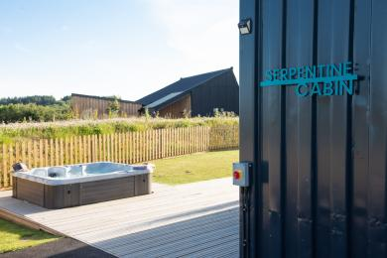
Serpentine hot tub inset into the deck
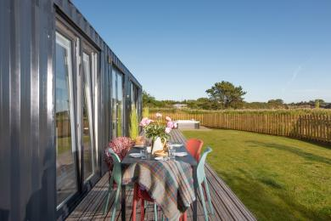
Serpentine level deck and lawn area
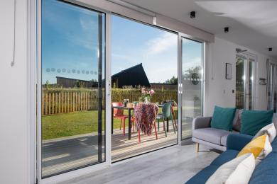
Looking out to the deck and lawn from Serpentine's living-area
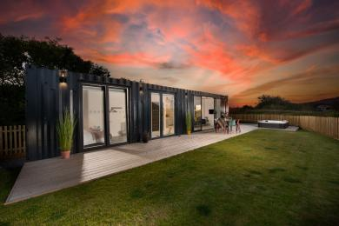
Serpentine fully enclosed garden with large deck

Customer care support

Accessibility equipment
- We provide wheelchairs. Wheelchairs are free.
- Medley Ergo Profiling Adjustable Bed Plus Softform Premier Original Mattress with side rails and bumpers
T70 Self Propelled shower commode chair
Ocean VIP Tilt In Space Shower and Commode Chair
Perch stool
Perch chair
Portable suction grab rail
Mowbray light adjustable toilet seat
Sensory star projector
Elephant feet 90mm and 140mm
Evo Birdie portable hoist 150kg
Portable slings in medium, large and extra large
Remote controlled high back reclining chair 420mm height to seat
Curve transfer board
Stoke Tripp Trapp adjustable highchair from 6 months and above
RNIB liquid level indicator
- Serpentine Cabin has its own enclosed garden for dogs
- We have an area to charge mobility scooters and battery powered wheelchairs.
- Mobility scooter can be charged inside Serpentine Cabin

Emergency evacuation procedures
- We have emergency evacuation procedures for disabled visitors.
- Fire extinguisher and fire blanket are provided
The Information Folder in the accommodation holds a Fire Risk assessment sheet
Staff are first aid and fire warden trained
Fire muster point at Trevassack Holidays is illuminated
Defribulator on site

Customer care support
- Some staff have disability awareness training.
- Staff are available 24 hours a day.
- Staff are available 24 hours a day
Trevassack Holidays provides 24 hour staff cover. After hours is via an on-site warden
- We have other services for people with accessibility requirements.
- Watersports
We are passionate about providing the best watersports activities at Trevassack Lake. With our expert instructors and quality equipment you can be sure to have an incredible experience out on our beautiful, private and secluded lake. No matter what your level of experience or ability we have activities to suit all. You can book a private instructor for you and your guests or you can join in on any of our planned sessions. You can sail around the lake in one of our sailing lessons, glide and explore the lake by kayak, learn to paddleboard or take part in one of our wild swimming sessions. There really is an activity for all of the family.
We also have a variety of accessible watersports activities on offer with our specialist equipment. Our fabulous ‘Learning Centre’ is level accessed and had automatic doors entrance doors and is level access throughout. Our public facilities include a ‘Changing Places’ room and accessible wet-room and toilets. Level pathways with safety surfacing will guide you around the site and at the lakeside you will find wide, stable pontoons with ramp access and hoists to help those with limited mobility onto our adapted watercraft.
Our activity staff are experienced teaching young people and adults with special educational needs and disabilities. We offer integrated watersports sessions with adapted equipment so visitors with physical disabilities can participate in group sessions and focused sessions so that visitors with special educational needs can learn at a pace that is right for them.
Our Lakeside Cafe provides guests and visitors a place to eat away from the accommodation and to pre-book private dining. Level access with plenty of room for maneouverability and transfers.

Guide last updated: 8 February 2024

