Accessibility Guide for Prudhoe Villa
info@coquetcottages.co.uk, 01665 710700, https://coquetcottages.co.uk/northumberland-holiday-cottages/prudhoe-villa/
Contact for accessibility enquiries: Reservations Team
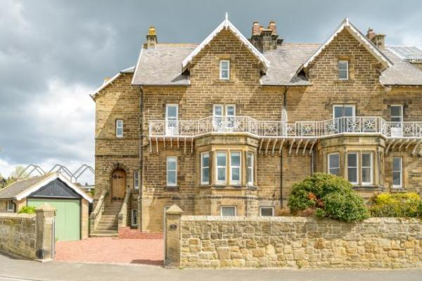

Welcome
Overlooking the beach and mouth of the estuary leading out to sea, Prudhoe Villa is positioned in one of the most sought-after locations in Alnmouth village and stands proudly as one of the first houses to be built on the beachfront.
Sleeping up to 8 guests, this traditional Victorian property occupies the top left half of the original huge ‘Prudhoe Villas’ and is spread across 3 floors, giving you a taste of the size and grandeur of this impressive home.
With private parking – a rarity in Alnmouth – for up to two cars, Prudhoe Villa is dog-friendly and welcomes two dogs. Play park with a BBQ area for younger visitors. Free Wi-Fi as standard.

At a Glance

Level Access
- The main entrance has 12 steps and a handrail. There is no lift and no ramp.

Access with steps
- There are steps from the main entrance to:
  - Bedroom
  - Lounge
  - Balcony

Bedrooms
- We have non-allergic bedding.

Hearing
- The (bedroom) TVs have subtitles.

Getting here
26 Riverside Road
Alnmouth
NE66 2SD

Travel by public transport
- You can get to Prudhoe Villa by bus and train.
- The nearest bus stop is approximately 0.2 miles / 0.3 km from the cottage, on Northumberland Street. The bus stop is 0.2 miles / 0.3 km from Prudhoe Villa .
- The nearest train station is Alnmouth for Alnwick. The train station is 1.3 miles / 2.1 km from Prudhoe Villa .
- Taxi's or buses are available from the train station to your desitination.

Travel by taxi
- You can get a taxi with Sovereign Taxis by calling 01665 602200.

Parking
- We have a car park. The parking is less than 50 metres from the main entrance. Parking is free.
- You can park directly outside the front entrance therefore no need for a drop off point. From the parking to the main entrance, there are 12 steps. There is no ramp and no lift.
- The driveway is gravelled.
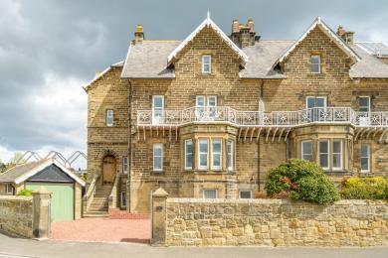
Main entrance to Prudhoe Villa from driveway.

Arrival

Path to main entrance
- From the street to the main entrance, there are 12 steps. There is no ramp and no lift.

Main entrance
- The door is 900mm wide.
- The main entrance has 12 steps.
- This entrance has a handrail.
- The main door is side hung and manual.
- Once in the main entrance, there is another large flight of stairs leading to the living area.

Getting around inside

Bedrooms
- All bedrooms have windows.
- Bedrooms have ceiling lights, bedside lamps, desk or table lamps and natural daylight.
- Lights are LED. TVs have subtitles.
- All bedrooms are non-smoking.
- We have non-allergic bedding.
- All bedrooms have fitted carpets.
- The bedroom nearest the main entrance has 22 steps.
- We have bathrooms with a separate shower.
- We have bathrooms with a bath.
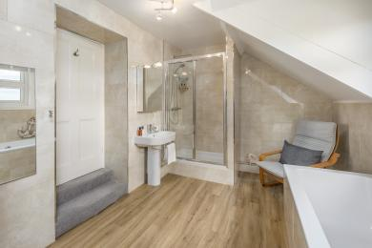
Main bathroom with bath and separate shower
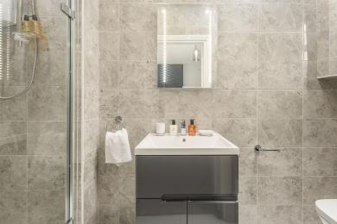
En suite with shower only to the main bedroom
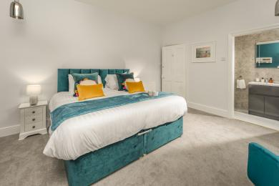
Main bedroom
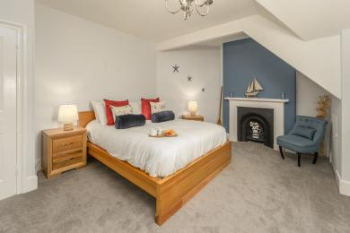
Second bedroom
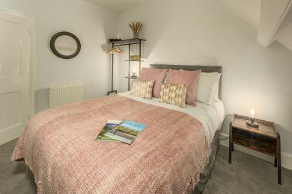
Fourth bedroom
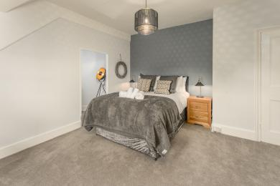
Third bedroom

Self catering kitchen

Kitchen
- We have a separate kitchen and dining room. From the main entrance to the kitchen, there are 24 steps. There is no lift and no ramp.
- The table and plates have high colour contrast.
- From the main entrance to the dining room, there are 22 steps. There is no lift and no ramp.
- There are 22 steps up from the main entrance with 2 steps down int the kitchen area.
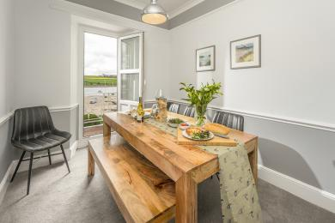
Dining room
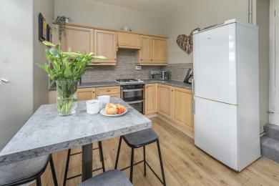
Kitchen
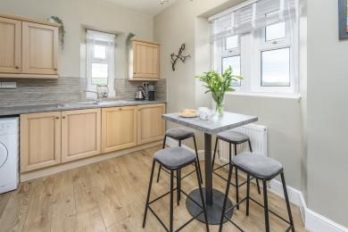
Kitchen

Lounge

Lounge
- From the main entrance to the lounge, there are 22 steps. There is no lift and no ramp.
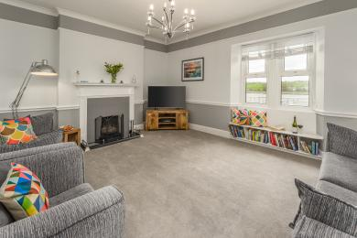
Lounge
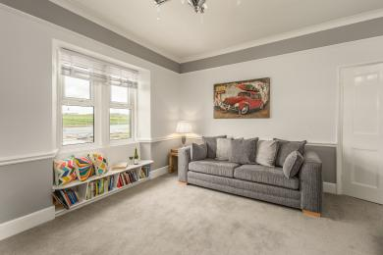
Lounge

Getting around outside

Balcony
- From the main entrance to the area, there are 22 steps.
- Balcony's access is through the dining room and there is a thresh to step over to get outside.
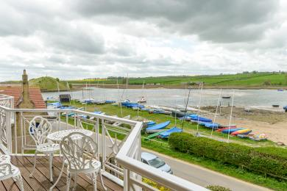
Balcony

Customer care support

Accessibility equipment
- For a list of more items, please go to https://www.redcross.org.uk/get-help/borrow-a-wheelchair.
- The nearest toilet area for assistance dogs is directly over the road from the driveway there is a park area and the beach.
- You can hire mobility equipment from Red Cross by calling 01912 737961.

Guide last updated: 19 December 2022

