Accessibility Guide for Bath World Heritage Centre
01225 477785, https://www.bathworldheritage.org.uk/

Welcome
At the Bath World Heritage Centre you can:
- Discover what makes Bath such a unique place
- Find out more about the city’s attributes of Outstanding Universal Value: the hot springs, Roman remains, Georgian architecture, Georgian town planning, the social setting of the Georgian spa town and the city’s natural landscape setting.
- Meet the Bath World Heritage Centre staff and volunteers who will give you more information on the amazing history and heritage of Bath.
The Centre features a host of interactive exhibits and displays designed to inspire, excite and inform. There are also free walking trails and guides to help visitors to the city explore all it has to offer.
Watch the video: Discover Bath World Heritage Centre

At a Glance

Level Access
- There is level access from the main entrance to:
  - The main space
  - Information desk

Hearing
- The fire alarm has flashing lights.
- All staff have disability awareness training.

Visual
- Glass doors and full-height windows have contrast markings.
- The walls and the doors have high colour contrast.
- Some parts of the venue have low lighting.

General
- All staff have disability awareness training.

Getting here
10 York Street
Bath
BA1 1NH

Travel by public transport
- You can get to Bath World Heritage Centre by bus and train.
- As the Bath World Heritage Centre is in the centre of the city there are numerous bus stops nearby. The central bus station is next to the train station which is a five minute walk away. The nearest train station is Bath Spa. The train station is 0.3 miles / 0.5 km from Bath World Heritage Centre.

Travel by taxi
- You can get a taxi with V Cars by calling 01225 464646. The taxi company has a wheelchair accessible vehicle.

Parking
- The nearest drop-off point to the Bath World Heritage Centre is on Terrace Walk, Bath, BA1 1LN. This is approximately 149 metres from the main entrance.

Arrival

Path to main entrance
- From the street to the main entrance, there is level access.

Main entrance
- The main entrance has level access.
- The door is 1205mm wide.
- The main door is side hung and manual.
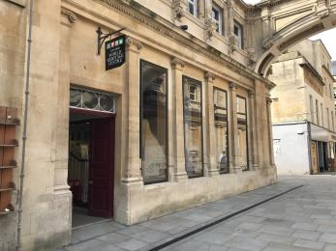
Exterior of the Bath World Heritage Centre

Getting around inside

Visual Impairment - General Information
- We have contrast markings on all glass doors, contrast markings on all full-height windows and high colour contrast between walls and doorframes.
- Some parts of the venue have low lighting.

Ticket/ information desk

Information desk
- From the main entrance to the desk, there is level access. The route is 1205mm wide, or more.
- The desk has a low section.
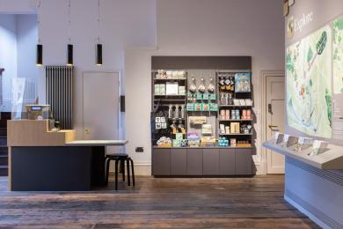
Image: The information desk and retail area

The main space
- From the main entrance to this area, there is level access. The route is 1205mm wide, or more. Some display information is low, for wheelchair users. There are seats.
- There is a hearing loop.
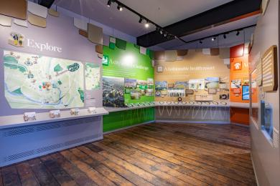
Image: Inside the Bath World Heritage Centre

Shop
- From the main entrance to the shop, there is level access. The route is 1205mm wide, or more. The route through the shop is 800mm wide, or more.

Customer care support
- You can hire mobility equipment from Assured Mobility by calling 01225 831960.

Emergency evacuation procedures
- We have emergency evacuation procedures for disabled visitors.
- The fire alarm has flashing lights.

Customer care support
- All staff have disability awareness training.

Guide last updated: 15 January 2024

