Accessibility Guide for Lilac Cottage
info@coquetcottages.co.uk, 01665 710700, https://coquetcottages.co.uk/northumberland-holiday-cottages/lilac-cottage/
Contact for accessibility enquiries: Reservations Team
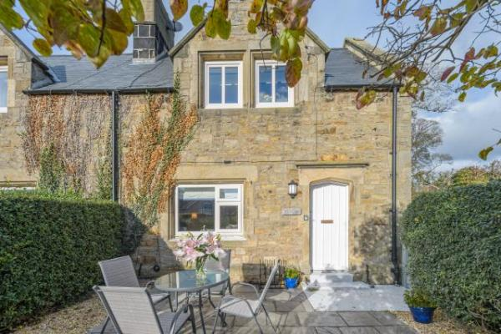

Welcome
Lilac Cottage near Alnmouth is a traditional, semi-detached period stone cottage nestled in the very pretty little village of Lesbury, that has been freshly renovated to a modern standard.
This luxury cottage is the neighbouring inland village to coastal Alnmouth, famous for it’s 7-mile stretch of sandy beach, multi-coloured houses and great pubs. You can walk to Alnmouth in just over 20 minutes from Lilac Cottage.
Sleeping four guests and welcoming one dog, Lilac Cottage is ideal for those looking to switch off, enjoy walking and exploring the coastline from the front door and returning to enjoy the last of the sunshine on the private garden patio, or put your feet up in front of the fire.

At a Glance

Level Access
- The main entrance has 2 steps. There is no lift and no ramp.
- There is level access from the main entrance to:
  - Living Room

Access with steps
- There are steps from the main entrance to:
  - Bedroom
  - Washing Machine
  - Patio Garden

Bedrooms
- We have non-allergic bedding.

Hearing
- The (bedroom) TVs have subtitles.

Getting here
Lilac Cottage
Lesbury
NE66 3AZ

Travel by public transport
- You can get to Lilac Cottage by bus.
- The nearest bus stop is approximately 150 metres from Lilac Cottage. The bus stop is 0.1 miles / 0.2 km from Lilac Cottage.

Travel by taxi
- You can get a taxi with Sovereign Taxis by calling 01665 602200.

Parking
- We have a car park. The parking is less than 50 metres from the main entrance. Parking is free.
- There is a drop-off point at the main entrance. The drop-off point has a dropped kerb.
- From the parking to the main entrance, there are 2 steps. There is no ramp and no lift.
- There is level access (on a slight slope) from the private parking area at the back of the property to the front patio. There are then 2 steps in to the property at the front door.
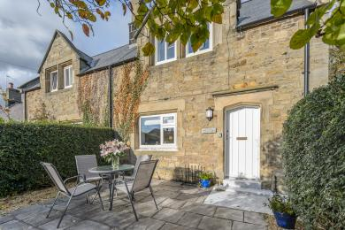
Lilac Cottage - Steps at Front Door

Arrival

Path to main entrance
- From the street to the main entrance, there are 2 steps. There is no ramp and no lift.
- The path is sloped.

Main entrance
- The door is 762mm wide.
- The main entrance has 2 steps.
- The main door is side hung and manual.

Getting around inside

Bedrooms
- All bedrooms have windows.
- Bedrooms have ceiling lights, bedside lamps, desk or table lamps and natural daylight.
- Lights are LED. TVs have subtitles.
- All bedrooms are non-smoking.
- We have non-allergic bedding.
- All bedrooms have fitted carpets.
- The bedroom nearest the main entrance has 13 steps.
- We have bathrooms with a separate shower.
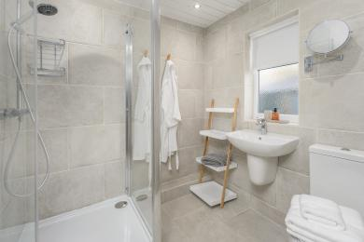
Lilac Cottage - Bathroom
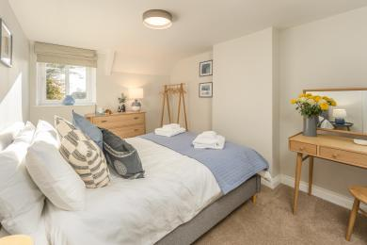
Lilac Cottage - Bedroom 1
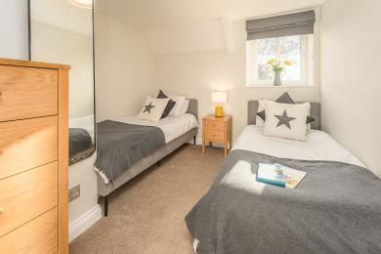
Lilac Cottage - Bedroom 2

Washing Machine
- From the main entrance to the laundry, there are 2 steps. There is no lift and no ramp.
- We have an iron and ironing board.
- The washing machine is located in the out house at the rear of the cottage. From the main entrance of the cottage, there is one step down at the back door, and one step up in to the out house.

Self catering kitchen

Kitchen
- We have a separate kitchen and dining room. From the main entrance to the kitchen, there is level access.
- The route is 762mm wide, or more.
- The door is 762mm wide.
- From the main entrance to the dining room, there is level access. The route is 762mm wide, or more. The door is 762mm wide.
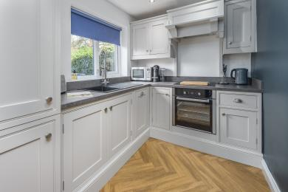
Lilac Cottage - Kitchen
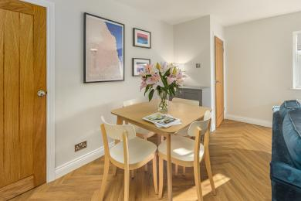
Lilac Cottage - Dining Area

Lounge

Living Room
- From the main entrance to the lounge, there is level access. The route is 762mm wide, or more. The door is 762mm wide.
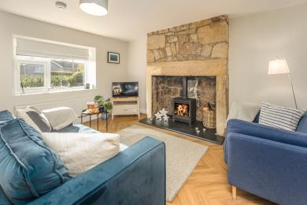
Lilac Cottage - Living Room

Getting around outside

Terrace

Patio Garden
- To get to a table, there are 2steps steps.
- From the main entrance to the terrace, there are 2 steps.
- To access the patio from the cottage, there are 2 steps down from the front door.
Lilac Cottage - Patio Garden

Customer care support

Accessibility equipment
- For a list of more items, please go to https://www.redcross.org.uk/get-help/borrow-a-wheelchair.
- The nearest toilet area for assistance dogs is in the patio garden.
- You can hire mobility equipment from Red Cross by calling 01912 737961.

Guide last updated: 27 June 2022

