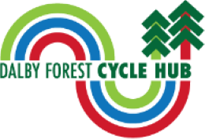

Accessibility Guide for Dalby Forest Cycle Hub
info@dalbyforestcyclehub.co.uk, 01751 460585, https://www.dalbyforestcyclehub.co.uk/
Contact for accessibility enquiries: Peter Blood
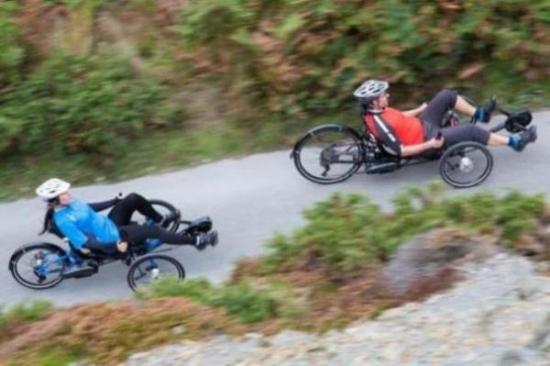

Welcome
From riding fast on the red route to taking it easy with the family or making the most of our adapted cycles, Dalby Forest Cycle Hub helps you do it all.
Set firmly in the epicentre of Yorkshire’s top mountain biking destination, with trails for all ages and abilities, heading right from our front door, we’re here to ensure you get the best cycling experience to meet your needs.

At a Glance

Level Access
- The main entrance has 1 step. There is no lift and no ramp.
- There is level access from the main entrance to:
  - Dalby Forest Cycle Hub and Shop
  - Till and Information Point at the Cycle Hub and Shop
  - Toilet facilities next to the Cycle Hub
- There is level access from the car park to:
  - Picnic benches near the Dalby Forest Cycle Hub (two areas).

Hearing
- Some staff have disability awareness training.

Visual
- Glass doors have contrast markings.
- The walls and the doors have high colour contrast.

General
- We have a complimentary ticket policy for personal assistants.
- There is at least 1 public toilet for disabled visitors.
- Some staff have disability awareness training.

Getting here
The Courtyard
Dalby Forest Dr, Thornton Dale
Pickering
Y018 7LT

Parking
- We have a car park. There are accessible parking spaces. The parking is less than 50 metres from the main entrance. Parking is not free.
- The entrance to the cycle hub is on a pedestrianised area, so cars are unable to drop off at the front door. The nearest drop-off point is located in the car park itself (dedicated short stay areas at the visitor centre end of the car park). From the car park to the entrance, there is level access. The route is 1300mm wide, or more.
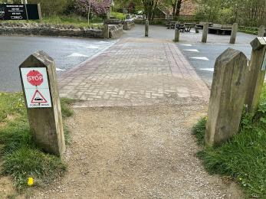
Pathway crossing the road from the accessible parking spaces to the cycle hub.
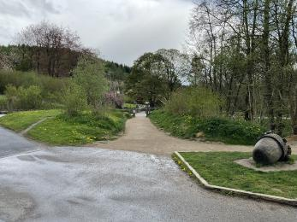
Smoothway route from the car park to the road crossing, leading to the cycle hub.
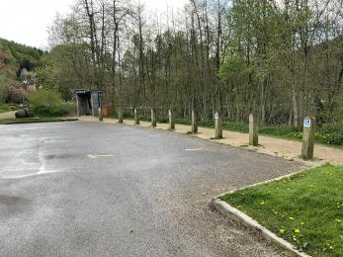
Five accessible parking bays close to the cycle hub.

Arrival

Path to main entrance
- From the street to the main entrance, there is level access.
- The path is 1570mm wide, or more.

Main entrance
- The door is 1570mm wide.
- The main entrance has 1 steps.
- The main door is side hung and manual.
- The other entrance door is 860.00mm wide.
- The accessible entrance door is around the back of the cycle hub, entering next to the till, and it has a very slight gradient.
- There is also a side door which has level access down a slope, through a door with a width of 770mm. The side door leads to the lower side area of the shop and then has internal stairs which lead up to the main shop area, where the till is located.
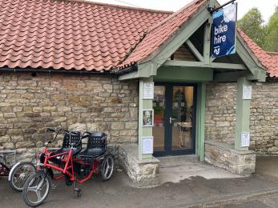
Main entrance set of double doors with one step and shelter.
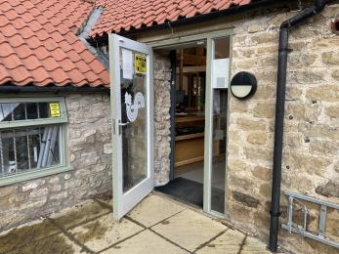
Accessible level access entrance into the back of the shop with glass door and manifestations
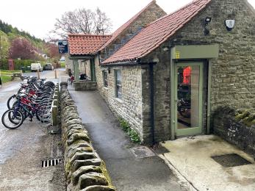
Side accessible entrance into the lower level of the shop via a slope.

Getting around inside

Visual Impairment - General Information
- We have contrast markings on all glass doors and high colour contrast between walls and doorframes.
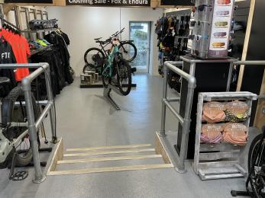
The lower level of the shop showing bright lighting and silver metal rails against grey floors.

Ticket/ information desk

Till and Information Point at the Cycle Hub and Shop
- From the main entrance to the desk, there is level access. There is a permanent ramp. The route is 860mm wide, or more.
- The door is 860mm wide, or more.
- The level access route to the till point in the Cycle Hub and shop is around the back of the building, up a gradual access ramp and through the 860mm manually operated door. There is one step to access the Cycle Hub and shop at the front of the building.
There is no lowered counter at the desk and the desk height measures 940mm. However, staff are very attentive and helpful, so they can assist people by coming out from behind the desk if required.
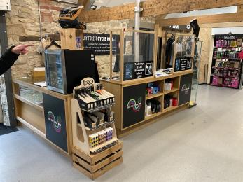
Information and till desk in the cycle hub.

Things to See and Do
- We have a complimentary ticket policy for personal assistants.

Dalby Forest Cycle Hub and Shop
- From the main entrance to this area, there is level access. There is a permanent ramp. The route is 860mm wide, or more. The door is 860mm wide.
- Some display information is low, for wheelchair users.
- The level access route to the Cycle Hub Shop is around the back of the building, up a gradual access ramp and through the 860mm manually operated door. There is one step to access the Cycle Hub and shop at the front of the building.
There is also a lower area of the Cycle Hub Shop which is accessed from the main Cycle Hub via a series of steps. However, this lower area can also be reached via a level access pathway outside to the right of the building which leading to the side entrance door. This entry point measures 770mm wide.
Cycle Hub main entrance doorway, with stepped access, to the right with and adapted cycle on the left
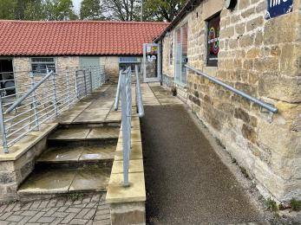
Gradual ramp with handrails leading to the level access entry point at the Cycle Hub.
Level access, outward opening entrance doorway to the rear of Dalby Forest Cycle Hub.
Level access route into lower area of Cycle Hub shop showing access ramp and doorway.
Interior view of lower area in Cycle Hub shop showing steps in the foreground, cycle display and level access entry point.
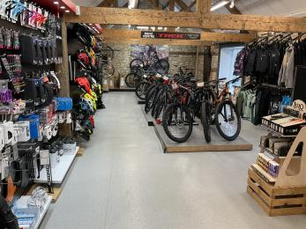
Upper area of Dalby Forest Cycle Hub showing clear circulation space around displays of cycles and cycling equipment.
Till point within Dalby Forest Cycle Hub with clear circulation space in front.

Public toilet

Toilet facilities next to the Cycle Hub
- There is a public toilet for disabled visitors.
- From the main entrance to the public toilet, there is level access. There is a permanent ramp.
- The route is 1020mm wide, or more.
- The toilet door is 820mm wide.
- The direction of transfer onto the toilet is to the right.
- There is 1570mm at the side of the toilet. There is 2460mm in front of the toilet. The toilet seat is 480mm high. The toilets have handrails.
- There is a drop-down grab rail on the right hand side of the toilet and two fixed grab rails on the left hand side of the toilet, all with good visual contrast against the surrounding walls.
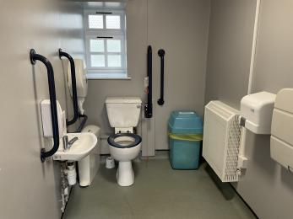
Accessible toilet at the cycle hub showing good visual contrast between the grab rails and walls and between the toilet and seat

Getting around outside

Picnic Area

Picnic benches near the Dalby Forest Cycle Hub (two areas).
- From the car park to the picnic area, there is level access. The path is 1000mm wide, or more.
- The entrance is 1570mm wide.
- Some tables have space for wheelchair users. You can bring your own food to the picnic area.
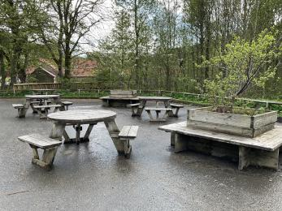
Picnic area between the car park and the Cycle Hub with some wheelchair accessible picnic benches.
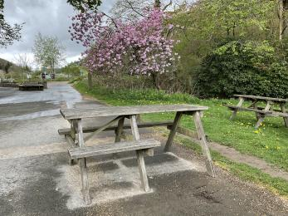
Wheelchair accessible bench in front of the cycle hub.

Customer care support

Accessibility equipment
- There is a large variety of adapted/accessible bicycles for both children and adults to hire to suit different abilities and access needs.
- For a list of more items, please go to https://www.dalbyforestcyclehub.co.uk/bike-hire/adapted-bike-hire/.
- There is no specific spend area for assistance dogs, as the whole forest can be used and waste collected/disposed of appropriately.
- We have an area to charge mobility scooters and battery powered wheelchairs.
- There are plug sockets inside the shop, where people can charge their mobility scooters etc.
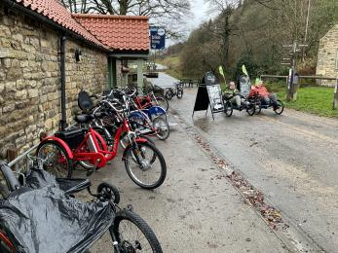
Range of adapted cycles outside Dalby Forest Cycle Hub.
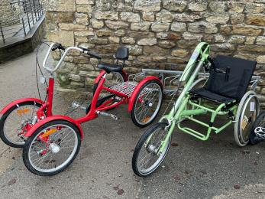
Close up of two adapted cycles outside Dalby Forest Cycle Hub.

Emergency evacuation procedures
- We have emergency evacuation procedures for disabled visitors.
- There is a pager system where cycle hire users can page back to staff members at the shop who can come and help provide help in the forest, as there is known to be a lack of signal in many areas.

Customer care support
- Some staff have disability awareness training.
- We have other services for people with accessibility requirements.
- There is a free bike testing service where people can come and try out which bike is suitable for them and their needs.

Guide last updated: 29 June 2022

