Accessibility Guide for Copperfield House
info@coquetcottages.co.uk, 01665 710700, https://coquetcottages.co.uk/northumberland-holiday-cottages/copperfield-house/
Contact for accessibility enquiries: Reservations Team
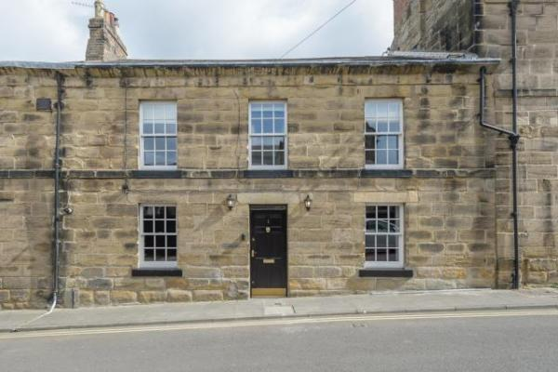

Welcome
Copperfield House provides unique accommodation in Alnwick Market Town. Sleeping 4 guests in 3 bedrooms (with flexible sleeping arrangements), Copperfield House features an eye-catching copper bath in the family bathroom and two wood burning stoves. Copperfield House is much more than just a base. It is an Instagram-worthy haven that is as much about style as it is comfort.
Walk to Alnwick Castle and Gardens, dine at the Alnwick Treehouse, reach Alnmouth beach in 10 minutes drive or head over to Rothbury in the countryside for beautiful walks and a pretty village. 1 dog welcome, free Wi-Fi provided.

At a Glance

Level Access
- The main entrance has 1 step. There is no lift and no ramp.
- There is level access from the main entrance to:
  - Washing Machine
  - Living Room

Access with steps
- There are steps from the main entrance to:
  - Bedroom
  - Small Courtyard

Bedrooms
- We have non-allergic bedding.

Hearing
- The (bedroom) TVs have subtitles.

Getting here
1 Howick Street
Alnwick
NE66 1UY

Travel by public transport
- You can get to Copperfield House by bus.
- The nearest bus stop is located in Green Batt, approximately 200 yards from Copperfield House. The bus stop is 0.2 miles / 0.3 km from Copperfield House.

Travel by taxi
- You can get a taxi with Sovereign Taxis by calling 01665 602200.

Parking
- There is a drop-off point at the main entrance. The drop-off point does not have a dropped kerb.
- There is public parking available on the residential street. There is no designated parking bay for Copperfield House so a parking space cannot be guaranteed. Nearby residential streets also offer public parking.
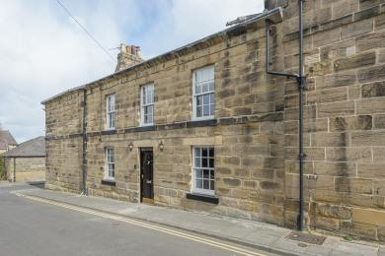
Howick Street - Copperfield House

Arrival

Path to main entrance
- From the street to the main entrance, there is 1 step. There is no ramp and no lift.

Main entrance
- The door is 762mm wide.
- The main entrance has 1 steps.
- The main door is side hung and manual.
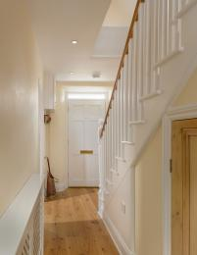
Entrance Hallway - Copperfield House

Getting around inside

Bedrooms
- All bedrooms have windows.
- Bedrooms have wall lights, bedside lamps and spot lights.
- Lights are LED. TVs have subtitles.
- All bedrooms are non-smoking.
- We have non-allergic bedding.
- Some bedrooms have fitted carpets.
- The bedroom nearest the main entrance has 14 steps.
- We have bathrooms with a separate shower.
- We have bathrooms with a bath.
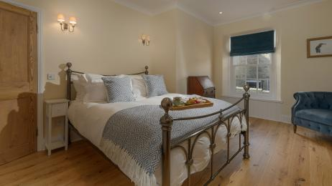
Bedroom 1 Copperfield House
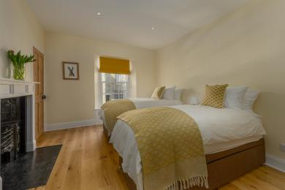
Bedroom 2 Copperfield House
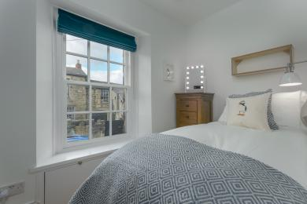
Bedroom 3 Copperfield House
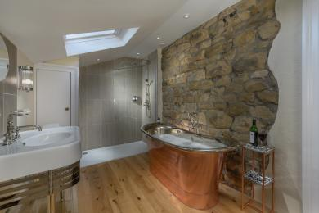
Bathroom - Walk in Shower and Separate Bath

Washing Machine
- From the main entrance to the laundry, there is level access. The route is 762mm wide, or more. From the main entrance to the laundry, there is 1 step. There is no lift and no ramp.
- We have an iron and ironing board.
- There is a washing machine in the kitchen on the ground floor. There is one small step at the threshold into the property, then level access to the laundry facilities once inside the cottage.

Self catering kitchen

Kitchen
- We have a separate kitchen and dining room. From the main entrance to the kitchen, there is level access.
- The route is 762mm wide, or more.
- The door is 762mm wide.
- From the main entrance to the kitchen, there is 1 step. There is no lift and no ramp.
- From the main entrance to the dining room, there is level access. The route is 762mm wide, or more. The door is 762mm wide.
- From the main entrance to the dining room, there is 1 step. There is no lift and no ramp.
- The kitchen and dining room are separate and are both on the ground floor.
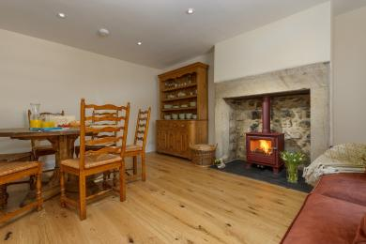
Dining Room - Copperfield House
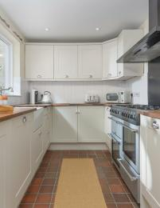
Kitchen - Copperfield House

Lounge

Living Room
- From the main entrance to the lounge, there is level access. The route is 762mm wide, or more. The door is 762mm wide.
- The living room is on the ground floor with one small step at the threshold into the property, then level access to the living room once inside the cottage.
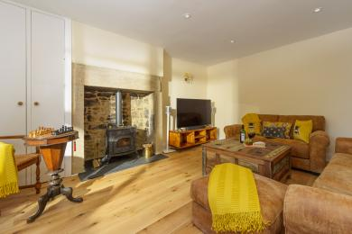
Living Room - Copperfield House

Getting around outside

Terrace

Small Courtyard
- To get to a table, there are 1steps steps.
- From the main entrance to the terrace, there is 1 step.
- There is one small step at the threshold in to the cottage, level access to the rear door once inside the cottage, and one small step down to the courtyard at the back of the property. There is no external side or rear access to the courtyard. Guests must come through the house to the terrace area.

Customer care support

Accessibility equipment
- For a list of more items, please go to http://www.redcross.org.uk/Where-we-work/HealthandSupport?loc=ne65+0xp&r=50&s....
- The nearest toilet area for assistance dogs is the rear courtyard. Guests must clean up after their dogs to ensure the courtyard is kept well-presented and pleasant during their stay and for future guests.
- You can hire mobility equipment from Red Cross by calling 01912 737961.

Guide last updated: 12 April 2022

