Accessibility Guide for Hauxley Wildlife Discovery Centre & Nature Reserve
mail@northwt.org.uk, 0191 284 6884, https://www.nwt.org.uk/get-involved/visitor-centres/hauxley-wildlife-discovery-centre
Contact for accessibility enquiries: Alex Lister
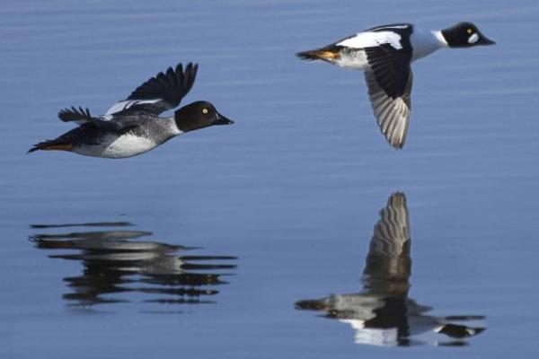

Welcome
Hauxley Wildlife Discovery centre is one of the best wildlife watching spots in the North East. It's a great place for birds and butterflies and a great place to see red squirrels and tree sparrows. Wildlife changes with the seasons so there’s something to see all year round.
The eco-friendly Visitor Centre is a straw-bale building and a starting point for the walks around the reserve, offering fantastic views across the length of Druridge Bay the Lookout Cafe sells a range of hot and cold refreshments including freshly brewed coffee, scones baked on site each day, as well as sandwiches, toasties and soup.

At a Glance

Level Access
- There is level access from the main entrance to:
  - Dining Table
  - Reception
  - Reception Toilet
  - The Lookout Café
  - Classroom
  - Nature reserve
- There is level access from the car park to:
  - Courtyard
- The hide entrance has level access.

Hearing
- The fire alarm has flashing lights.
- We have a hearing loop in the reception & the classroom .
- Some staff have disability awareness training.

Visual
- Glass doors have contrast markings.

General
- There is at least 1 public toilet for disabled visitors.
- Some staff have disability awareness training.

Getting here
Hauxley Wildlife Discovery Centre & Nature Reserve
Low Hauxley
Morpeth
NE65 0JR

Travel by taxi
- You can get a taxi with PHOENIX by calling 01670 333000. The taxi company has a wheelchair accessible vehicle.

Parking
- We have a car park. There are accessible parking spaces. The parking is less than 50 metres from the main entrance. Parking is not free.
- There is a drop-off point at the main entrance. The drop-off point has a dropped kerb.
- From the car park to the entrance, there is level access. The route is 2500mm wide, or more.
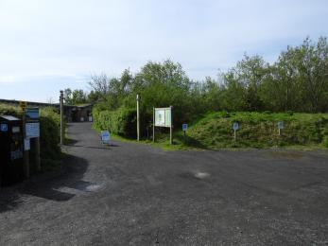
Car Park

Arrival

Path to main entrance
- From the street to the main entrance, there is level access.
- The path is 2500mm wide, or more.

Main entrance
- The main entrance has level access.
- The door is 1100mm wide.
- The door has a push button to open it.
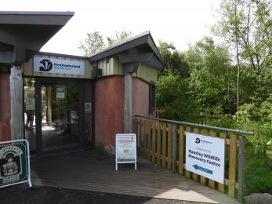
Main entrance
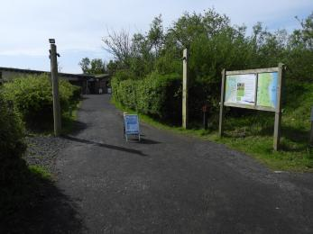
Route from car park to main entrance

Getting around inside

Visual Impairment - General Information
- We have contrast markings on all glass doors.
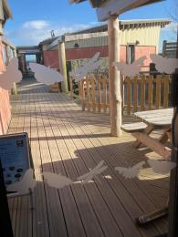
Contrast markings

Ticket/ information desk

Reception
- From the main entrance to the desk, there is level access. The route is 1800mm wide, or more.
- Height of reception desk 1050mm.
We generally have volunteers stationed around the front door to provide information and offer assistance to visitors as necessary.
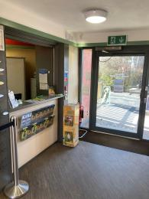
Reception area

Public toilet

Reception Toilet
- There is a public toilet for disabled visitors.
- From the main entrance to the public toilet, there is level access. The route is 1300mm wide, or more.
- The toilet door is 800mm wide.
- The direction of transfer onto the toilet is to the left.
- There is 1300mm at the side of the toilet. There is 2000mm in front of the toilet. The toilet seat is 470mm high. The toilets have handrails.
- If accessing with a large wheelchair with a poor turning circle it can be easier to enter from the classroom. You may need to ask at reception.
The cafe toilet entrance also has more turning room.
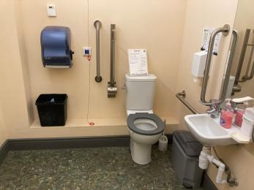
Reception toilet

Shop

The Lookout Café
- From the main entrance to the shop, there is level access. The route is 900mm wide, or more. The door is 900mm wide.
- The route through the shop is 800mm wide, or more.
- Small shop area to rear of cafe seating. Can become obstructed when cafe is busy.
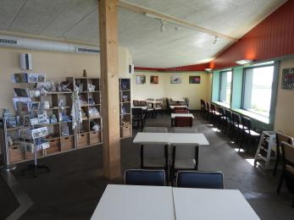
Shop area

Place to eat and drink

The Lookout Cafe
- From the main entrance to the dining area, there is level access. The route is 900mm wide, or more. The door is 900mm wide.
- To get to a table, there are no steps.
- If you need table service, staff can help you.
- The route through the dining area is 800mm wide, or more.
- There is no background music.
- We cater for sugar free (diabetic), vegetarian, gluten free (celiacs) and vegan specific diets.
- Please ask if more infomation needed, 0191 284 6884 or mail@northwt.org.uk
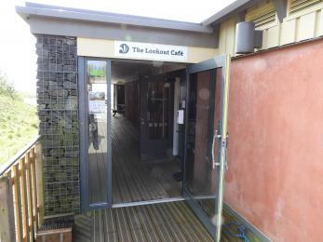
Café entrance
Seating area
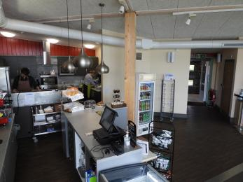
Till
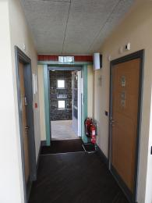
Entrance corridor and toilet access

Classroom
- From the main entrance to this area, there is level access. The route is 800mm wide, or more.
- The door is 800mm wide.
- Room avalible to hire

Getting around outside

Designated Walking Trail

Accessible route
- The trail is 1200metres long. The trail has a hard surface. The trail is sloped. The trail has seats. There are bird hides along the trail.
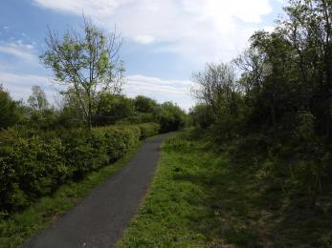
Path from visitor centre to top hide

Top Hide
- At the hide entrance, there is level access. The door is 800.00mm wide.
- There are low windows in the hide, so wheelchair users can see outside.

Tern Hide
- At the hide entrance, there is level access. The door is 800.00mm wide.
- There are low windows in the hide, so wheelchair users can see outside.

Picnic Area

Courtyard
- From the car park to the picnic area, there is level access. The path is 1100mm wide, or more.
- The entrance is 1100mm wide.
- Some tables have space for wheelchair users. You can bring your own food to the picnic area.
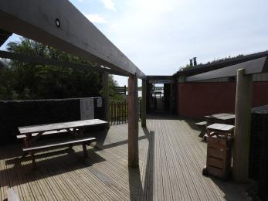
Courtyard and picnic tables

Nature reserve
- From the main entrance to this area, there is level access. The route is 1100mm wide, or more. The entrance is 1100mm wide.
- See attatched map
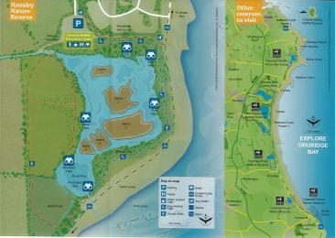
Site map

Customer care support

Accessibility equipment
- We have a hearing loop in the reception & the classroom .
- We do not allow dogs (other than assistance dogs) on to the reserve including the café, with this in mind we have a dog walkers route from the car park to the beach this route makes an ideal toilet area.
- We have an area to charge mobility scooters and battery powered wheelchairs.
- Ask at reception and you will be directed to a number of indoor sockets that are free to use.

Emergency evacuation procedures
- We have emergency evacuation procedures for disabled visitors.
- The fire alarm has flashing lights.

Customer care support
- Some staff have disability awareness training.

Guide last updated: 17 May 2022

