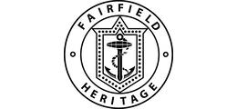
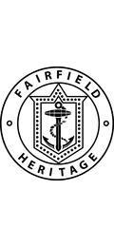

Accessibility Guide for Fairfield Heritage
mail@fairfieldgovan.co.uk, 0141 445 5866, https://www.fairfieldgovan.co.uk/
Contact for accessibility enquiries: Abigail Morris
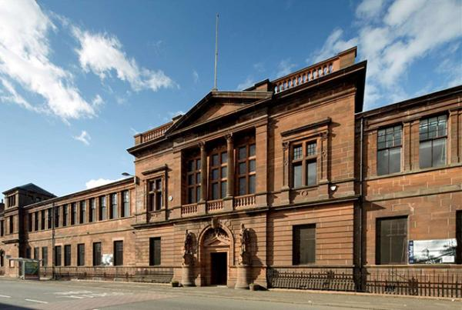

Welcome
Welcome to Fairfield Heritage, a community museum dedicated to telling the story of Govan’s outstanding role in world shipbuilding.
To overcome the presence of three steps at the main entrance, level access can be gained via a lift at the Reception to the rear of the building which is accessed through the gate at corner of Govan Road and Elder Street
The reception, heritage rooms, boardroom, gift shop and toilets are all on the same level.
More information on disabled/easy access can be found in the Arrival/Getting around inside tabs above.

At a Glance

Level Access
- The main entrance has 3 steps. There is no lift and no ramp.

Hearing
- We have a hearing loop in Reception.

Getting here
1048 Govan Road
Govan
Glasgow
G51 4XS

Travel by public transport
- You can get to Fairfield Heritage by bus and metro.
- McGill's buses No. 26 and No. 23 from the city centre to Braehead or Erskine. Alight at the second stop after Govan Cross, 0.1 miles / 0.2 km further along Govan Road you will see the two-storey red sandstone Fairfield building with an entrance on Govan Road. First Buses 3, 34A, 49, 90, 189 and 190 all stop at the Govan bus/underground interchange. After alighting at the interchange, turn left towards the statue of Mary Barbour and keep following Govan Road for 0.3 mile until you see Fairfield on the right just before Elder Park. The bus stop is 0.1 miles / 0.2 km from Fairfield Heritage.
- The nearest underground station is Govan. The underground station is 0.3 miles / 0.5 km from Fairfield Heritage.
- Fairfield is 0.3 mile from Govan underground station and Govan Cross. On exiting the underground, turn left towards the statue of Mary Barbour and keep following Govan Road until you see Fairfield on the right just before Elder Park.

Travel by taxi
- You can get a taxi with Glasgow Taxis (Black Hackney) by calling 0141 429 7070. The taxi company has a wheelchair accessible vehicle.

Parking
- We have a car park. There are accessible parking spaces. The parking is less than 50 metres from the main entrance. Parking is free.
- There is a drop-off point at the main entrance. The drop-off point does not have a dropped kerb.
- From the car park to the entrance, there is level access. There is a lift. For disabled access to Fairfield drive through the gate on Govan Road at Elder Street.
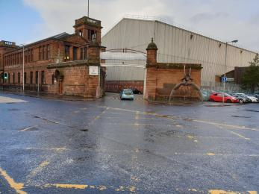
Disabled access via Govan Road at Elder Street

Arrival

Path to main entrance
- From the street to the main entrance, there is level access.

Main entrance
- The door is 1000mm wide.
- The main entrance has 3 steps.
- The main door is side hung and manual.
- The other entrance door is 1000.00mm wide.
- The disabled entrance is to the rear of the building where there is free parking, to reach car park and disabled entrance drive or walk through the gate at the corner of Govan Road and Elder Street, follow the tramlines to the car park and centre entrance
- Wheelchair available on request
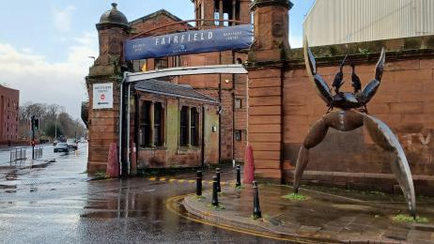
Enter through gate at corner of Elder Street and Govan Road
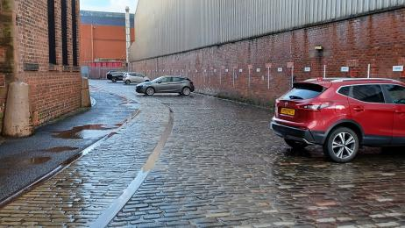
Follow tram lines to car park and disabled entrance
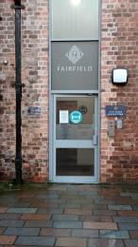
Entrance is on right in middle of building
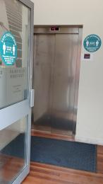
Lift to reception and level access to all heritage rooms

Getting around inside

Lift
- We have 1 lift.
- You can get a lift to all floors.

Lift to reception and heritage rooms
- The lift door is 900mm wide.
- The lift is 880mm wide. The lift is 1450mm deep.
- The lift buttons have raised numbers or letters.
- The lift shows the floor number, at each floor.
- Level access to all heritage rooms can be gained via a lift at the Reception at rear of the building. Lift width is 880mm between handrails. Lift numbers are in braille and controls have raised symbols. Press 0 on entering lift to access reception and all heritage rooms.
Entrance from car park to lift 1000mm wide
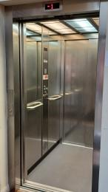
Entrance to lift is 900mm wide
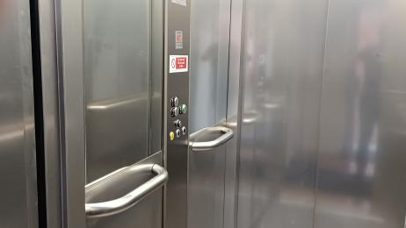
Lift is 880mm wide between handrails
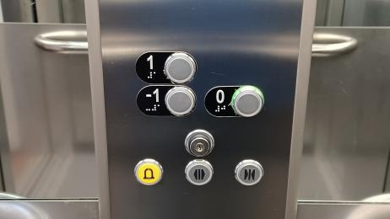
Lift numbers are in braille

Heritage Rooms
- Some display information is low, for wheelchair users. There are seats.
- Some videos have subtitles.
- The heritage rooms are accessible via lift at rear of building (Corner of Govan Road and Elder Street)
The heritage rooms are all on same level and are accessed via reception.

Public toilet

Unisex accessible toilet
- There is a public toilet for disabled visitors.
- The route is 950mm wide, or more.
- The toilet door is 880mm wide.
- There is 1680mm in front of the toilet. The toilet seat is 460mm high. The toilets have handrails.
- Unisex accessible toilet for public use.
Grab rail at sink and toilet.
Easy operation of taps.
Alarm pull cord.
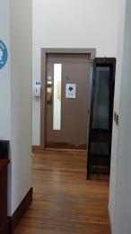
Corridor to toilet suite is 950mm wide or greater
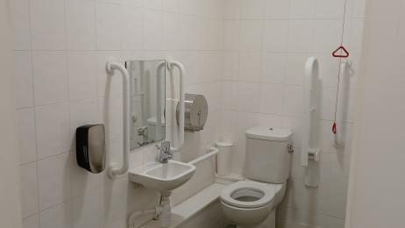
View of accessible toilet
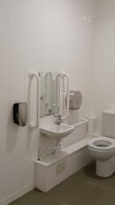
Accessible toilet
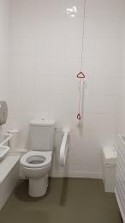
Toilet with handrails and alarm pullcord

Shop

Gift shop
- The route through the shop is 800mm wide, or more.
- The shop is in the foyer on same level as reception and heritage rooms.

Boardroom
- The boardroom is accessible via lift at rear of building (Corner of Govan Road and Elder Street)
The boardroom is on same level as reception, heritage rooms and gift shop

Customer care support

Accessibility equipment
- We provide wheelchairs. Wheelchairs are free.
- We have a hearing loop in Reception.

Emergency evacuation procedures
- We have emergency evacuation procedures for disabled visitors.
- We have other services for people with accessibility requirements.
- Chairs are available throughout heritage centre for people to rest

Guide last updated: 24 June 2022

