Accessibility Guide for Scottish Textiles Showcase
info@scottishtextilesshowcase.com, 01315583881, https://scottishtextilesshowcase.com
Contact for accessibility enquiries: Catherine Bruce-Gardyne
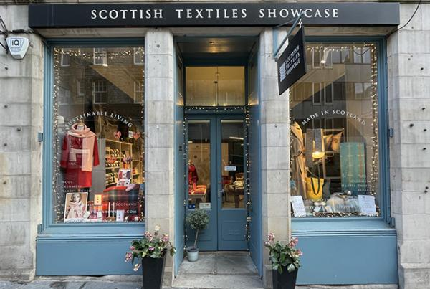

Welcome
We are an independent shop based in Edinburgh, specialising in Scottish made accessories and homeware. We stock a range of throws and blankets, Harris Tweed ladies coats, scarves and knitting wool. With a strong emphasis on sustainable living, many of our products have a low carbon footprint and all are made with natural fibres including cashmere, wool, alpaca and linen. Our mission is to celebrate the Made in Scotland story and the talented makers themselves. There is nothing we enjoy more than sharing our makers' stories with our customers so they too can appreciate the craftsmanship skills required to make these beautiful textile products.

At a Glance

Level Access
- There is level access from the main entrance to:
  - Scottish Textiles Showcase

Getting here
20 St. Mary's Street
Edinburgh
EH1 1SU

Travel by public transport
- You can get to Scottish Textiles Showcase by bus and train.
- There are numerous bus routes in close proximity to our store. North Bridge has several bus stops and is a five minute walk from our store. There are also bus stops close-by on Holyrood Road. The bus stop is 0.1 miles / 0.2 km from Scottish Textiles Showcase.
- The nearest train station is Waverley Station. The train station is 0.3 miles / 0.5 km from Scottish Textiles Showcase.

Parking
- There is a drop-off point at the main entrance. The drop-off point does not have a dropped kerb.
- There is a yellow line on the road outside, however customers can be dropped off.
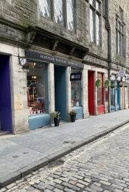
Scottish Textiles Showcase Edinburgh street view
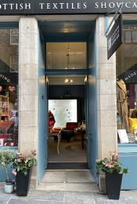
Scottish Textiles Showcase Edinburgh front entrance
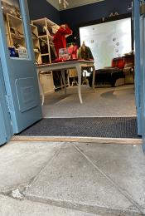
Scottish Textiles Showcase Edinburgh front entrance

Arrival

Path to main entrance
- From the street to the main entrance, there is level access.

Main entrance
- The main entrance has level access.
- The door is 1100mm wide.
- The main door is side hung and manual.
- We have double doors at the entrance to the shop which can open up to a width of 110cm. There is a small threshold from the street to the shop entrance which goes from 0-4cm as the street is on a slope.
Scottish Textiles Showcase threshold

Getting around inside

Visual Impairment - General Information
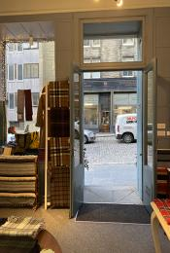
Scottish Textiles Showcase Edinburgh shop entrance with doors open
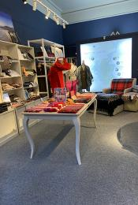
Scottish Textiles Showcase Edinburgh in-store lighting

Shop

Scottish Textiles Showcase
- From the main entrance to the shop, there is level access. The route is 1100mm wide, or more. The door is 1100mm wide.
- The route through the shop is 800mm wide, or more.
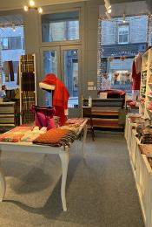
Scottish Textiles Showcase Edinburgh shop interior showing floor space between wall and table.

Customer care support

Accessibility equipment
- Dogs can use the road outside, alternatively there is a quiet lane behind the shop, or Arthur's seat is a 15 minute walk away.
- You can hire mobility equipment from Glenmore Mobility Hire by calling 0131 337 2333.
- You can hire mobility equipment from Saltire Mobility by calling 0131 629 0081.

Emergency evacuation procedures
- We have emergency evacuation procedures for disabled visitors.
- We are a small shop, emergency evacuation is by the front door.

Guide last updated: 12 February 2022

