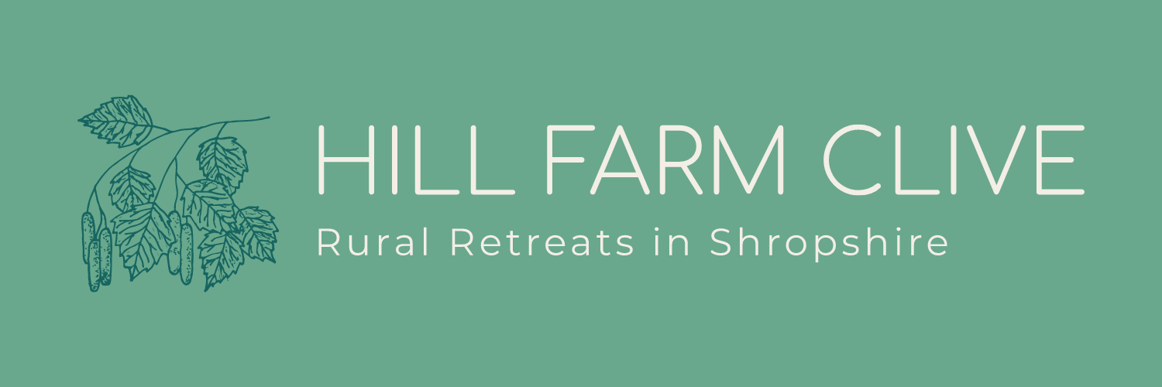

Accessibility Guide for Hill Farm Clive
louiseworthingtonuk@gmail.com, 07846791077, www.hillfarmclive.com
Contact for accessibility enquiries: Louise Worthington
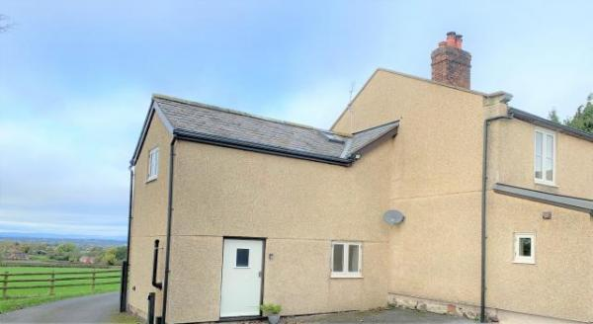

Welcome
Hill Farm Self-Catering Accommodation at Clive, near Shrewsbury

At a Glance

Level Access
- The main entrance has 1 step. There is no lift and no ramp.

Bedrooms
- We have non-allergic bedding.

Hearing
- The (bedroom) TVs have subtitles.

Visual
- We have information in large print.

General
- Staff are available 24 hours a day.
- We have emergency evacuation procedures for disabled visitors.

Getting here
Hill Farm
Clive
SHREWSBURY
SY4 5PX

Travel by public transport
- You can get to Hill Farm Clive by bus and train.
- • The nearest bus stop is in Clive. The bus stop is 0.4 miles / 0.6 km from the annexe. On a return journey, you can ask the bus driver to drop you off at the bottom of the drive. The bus stop is 0.4 miles / 0.6 km from Hill Farm Clive.
- The nearest train station is Yorton. The train station is 1.2 miles / 1.9 km from Hill Farm Clive.

Travel by taxi
- You can get a taxi with Go Carz Taxi by calling 01743 441144. The taxi company has a wheelchair accessible vehicle.

Parking
- We have a car park. The parking is less than 50 metres from the main entrance. Parking is free.
- There is a drop-off point at the main entrance. The drop-off point does not have a dropped kerb.
- From the parking to the main entrance, there is 1 step. There is no ramp and no lift.
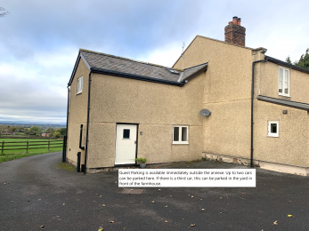
Parking is available immediately outside the property. There is ample space to turn in the yard.

Arrival

Path to main entrance
- From the street to the main entrance, there is 1 step. There is no ramp and no lift.

Main entrance
- The door is 1020mm wide.
- The main entrance has 1 steps.
- The main door is side hung and manual.
- When you arrive, we can help carry your luggage.

Getting around inside

Bedrooms
- All bedrooms have windows.
- Bedrooms have ceiling lights, bedside lamps, spot lights and natural daylight.
- Lights are LED and energy saving. TVs have subtitles.
- All bedrooms are non-smoking.
- We have non-allergic bedding.
- All bedrooms have fitted carpets.
- We can move the bedroom furniture, to improve accessibility.

Self catering kitchen
- We have an open plan kitchen.
- From the main entrance to the kitchen, there is 1 step. There is no lift and no ramp.
- The work surface is available with clear underspace.
- The hob is available with clear underspace and available at a height between 650mm and 900mm.
- The work surface is available with underspace and available at a height between 650mm and 900mm.
The crockery can be moved to base units on request.
2 ring cooker for use on table.

Customer care support

Customer care support
- We have information in large print.
- Staff are available 24 hours a day.

Guide last updated: 9 November 2021

