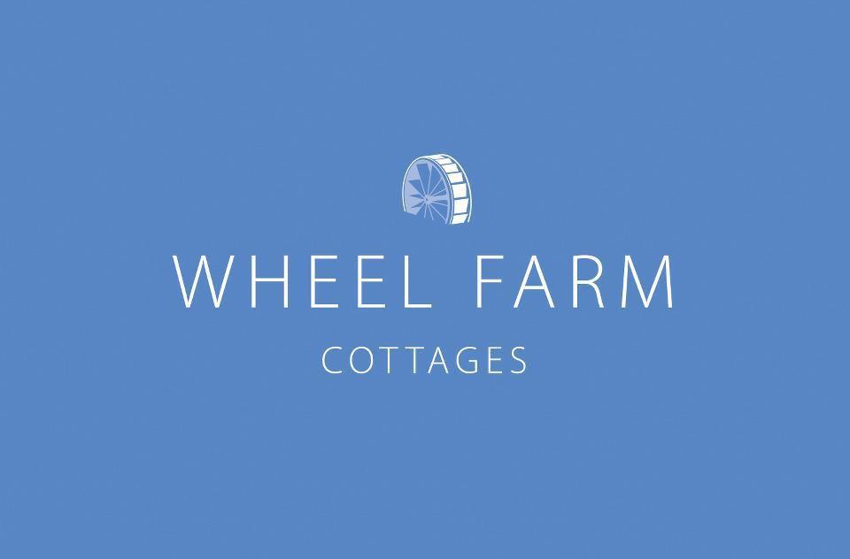
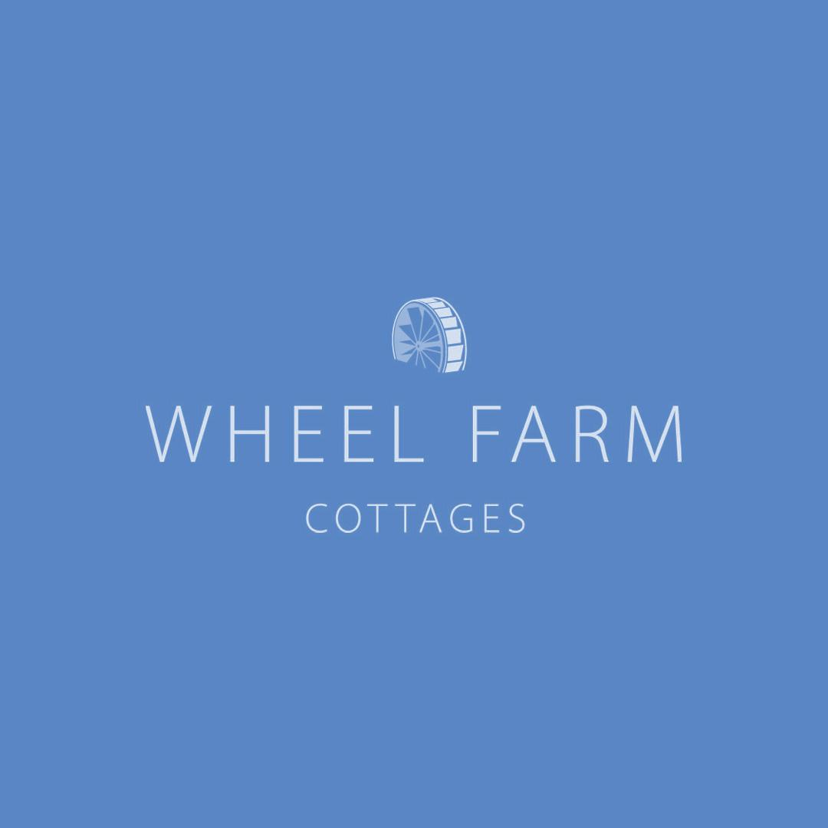

Accessibility Guide for Wheel Farm cottages
enquiries@wheelfarmcottages.co.uk, 01271 377 432, https://www.myfavouritecottages.co.uk/groups/wheel-farm
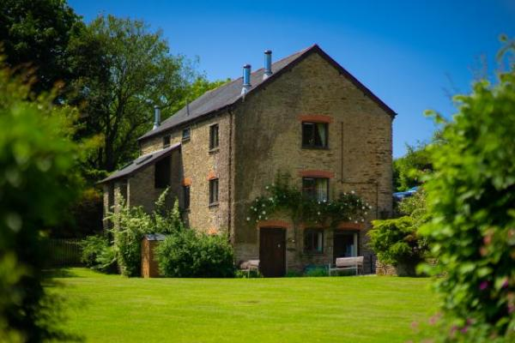

Welcome
Wheel Farm is a collection of 10 self-catered holiday cottages in the North Devon countryside just outside of Combe Martin. The complex is dog friendly and features a range of differently sized properties sleeping 2 to 14 guests, cottages can be booked together for a total of 50 guests!
Wheel Farm features a large indoor heated swimming pool with a sauna, tennis court and children's play area nestled in the tranquil grounds and gardens.
Being just a 15-minute drive from some of the best award-winning beaches in the UK, Wheel Farm is an ideal hub for surfers, sunbathers, or coastal walkers looking to enjoy North Devons beautiful scenery.

At a Glance

Level Access
- There is level access from the main entrance to:

Access with steps
- There are steps from the main entrance to:
  - Main lawn area

Level access bedrooms
- From the main entrance to the bedroom, there is level access.

Hearing
- The (bedroom) TVs have subtitles.

Visual
- The walls and the doors have high colour contrast.
- Some parts of the venue have low lighting.

Getting here
Wheel Farm, Berry Down
Combe martin
Ilfracombe
EX34 0NT

Travel by public transport
- Wheel Farm is too far away from public transport so must be accessed by car

Travel by taxi
- You can get a taxi with B-Line Taxis by calling 01271 322117. The taxi company has a wheelchair accessible vehicle.

Parking
- We have a car park. There are accessible parking spaces. The parking is less than 50 metres from the main entrance. Parking is free.
- There is a drop-off point at the main entrance. The drop-off point has a dropped kerb.
- From the parking to the main entrance, there are 3 steps. There is no ramp and no lift.
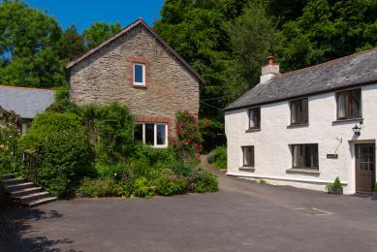
Steps leading to the farmhouse
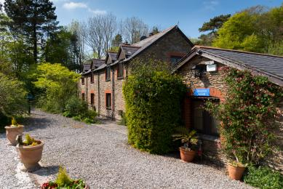
steps leading from the sloped carpark
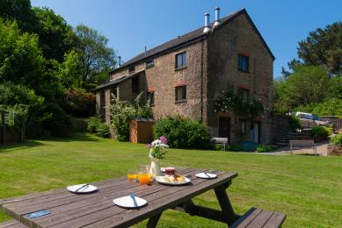
level lawn area
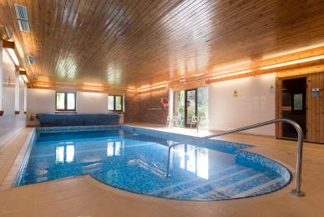
Pool area
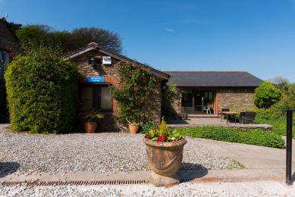
Ramped area

Arrival

Path to main entrance
- From the street to the main entrance, there are 3 steps. There is no ramp and no lift.
- The path is sloped.

Main entrance
- This entrance has a handrail.
- The main door is side hung and manual.
- When you arrive, we can help carry your luggage.

Getting around inside

Visual Impairment - General Information
- We have high colour contrast between walls and doorframes.
- Some parts of the venue have low lighting.
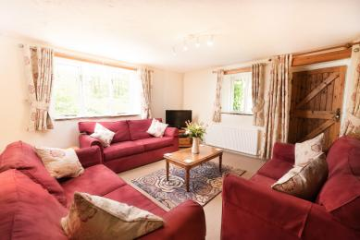
Low light area with pine doorframe against white wall

Bedrooms
- All bedrooms have windows.
- Bedrooms have ceiling lights and desk or table lamps.
- Lights are traditional filament. TVs have subtitles.
- All bedrooms are non-smoking.
- Some bedrooms have fitted carpets.
- some properties are dog free
- We can move the bedroom furniture, to improve accessibility.
- From the main entrance to this area, there is level access.

Lounge
- From the main entrance to the lounge, there is level access.

Getting around outside

Main lawn area
- From the main entrance to the gardens, there are 3 steps. There is no lift and no ramp.
- Some properties have level access to the gardens, some require a few steps
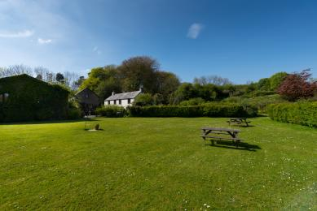
The main lawn area

Customer care support

Guide last updated: 3 February 2022

