Accessibility Guide for Burleigh Court Conference Centre & Hotel
info@welcometoimago.com, 01509 211515, https://www.burleigh-court.co.uk/
Contact for accessibility enquiries: Reservations team
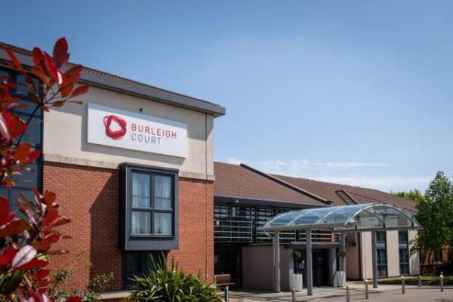

Welcome
Burleigh Court Hotel and Conference Centre offers a great range of accommodation from comfortable suites to executive rooms.
We are committed to making sure you enjoy a great night’s sleep with all of the creature comforts that you would expect from a 4-star hotel room. We have 185 en-suite double rooms including eight executive suites, 11 accessible rooms and 19 twin rooms.
All rooms are well-appointed with all the items you need for that home-from-home experience. All rooms include free 1gbps Wi-Fi network, flat screen TV, tea/coffee making facilities, hairdryer, ironing facilities and luxury toiletries.

At a Glance

Level Access
- There is level access from the main entrance to:
  - Reception lobby
  - Bedroom: Accessible bedrooms
  - Dining Table
  - Lounge
  - Bar
  - Burleigh Springs pool changing area
  - Burleigh Springs pool
  - Gym changing area
  - Gym
  - Disabled toilets
  - Courtyard

Bedrooms
- We have non-allergic bedding.
- There is an emergency call system next to the bed.
- We have a complimentary room policy for personal assistants.

Level access bedrooms
- From the main entrance to the bedroom, there is level access.
- The route to the bedroom is 750mm wide, or more.
- The bedroom door is 750mm wide, or more.
- There is unobstructed floor space 1200mm by 900mm, or more.
- The bathroom has a level access shower.

Hearing
- The fire alarm has flashing lights.
- The (bedroom) TVs have subtitles.
- We have a hearing loop in Reception and meeting rooms.
- All staff have disability awareness training.

Visual
- Glass doors and full-height windows have contrast markings.
- The walls and the doors have high colour contrast.

General
The accommodation is rated by the National Accessible Scheme as suitable for:
- Assisted wheelchair users
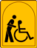
- There is at least 1 public toilet for disabled visitors.
- Staff are available 24 hours a day.
- All staff have disability awareness training.
- We have emergency evacuation procedures for disabled visitors.

Getting here
Burleigh Court
Loughborough University
Loughborough
LE11 3GR

Travel by public transport
- You can get to Burleigh Court Conference Centre & Hotel by bus and train.
- The popular University shuttle bus runs between the University and Loughborough's train station every 10 minutes during term time and 20 minutes out of term time. Kinchbus also operate an evening service from the University to Loughborough town centre and back from 6pm until 9pm each Monday to Friday evening during term time. The bus stop is 0.1 miles / 0.2 km from Burleigh Court Conference Centre & Hotel.
- The nearest train station is Loughborough. The train station is 3 miles / 4.8 km from Burleigh Court Conference Centre & Hotel.
- Loughborough mainline station is only 3 miles away, so 10 minutes in a cab. Regular intercity services operate from London St Pancras direct to Loughborough. This service is a 90 minute journey.

Travel by taxi
- You can get a taxi with ADT by calling 01509 260000. The taxi company has a wheelchair accessible vehicle.

Parking
- We have a car park. There are accessible parking spaces. The parking is less than 50 metres from the main entrance. Parking is free.
- There is a drop-off point at the main entrance. The drop-off point has a dropped kerb.
- From the car park to the entrance, there is level access. The route is 2000mm wide, or more.
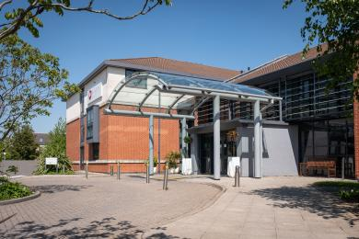
Burleigh Court_access from disabled parking

Arrival

Path to main entrance
- From the street to the main entrance, there is level access.
- The path is 2000mm wide, or more.

Main entrance
- The main entrance has level access.
- The door is 2000mm wide.
- The main door is sliding and automatic.
- It has a push button to open.
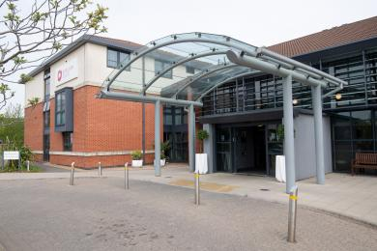
Burleigh Court_entrance

Getting around inside

Visual Impairment - General Information
- We have contrast markings on all glass doors, contrast markings on all full-height windows and high colour contrast between walls and doorframes.

Lift
- We have 1 lift.
- You can get a lift to all floors.

Lift to all floors
- The lift door is 800mm wide.
- The lift is 1300mm wide. The lift is 1200mm deep.
- The lift says the floor number at each floor.
- The lift buttons have raised numbers or letters.
- The lift shows the floor number, at each floor.

Reception lobby
- From the main entrance to reception, there is level access. The check-in desk has a low section for wheelchair users. You can sit down at reception.
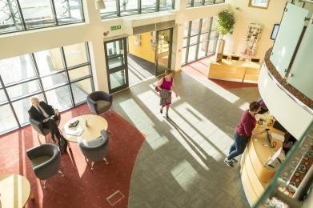
Burleigh Court_reception

Bedrooms
- All bedrooms have windows.
- Bedrooms have ceiling lights, wall lights, bedside lamps, desk or table lamps and natural daylight.
- Lights are LED. TVs have subtitles.
- All bedrooms are non-smoking.
- We have non-allergic bedding.
- All bedrooms have fitted carpets.
- We can move the bedroom furniture, to improve accessibility.
- We have a complimentary room policy for personal assistants.
- From the main entrance to this area, there is level access.

Accessible bedrooms

Accessible bedroom Accessible bedrooms
- From the main entrance to the bedroom, there is level access. There is a lift. The route to the bedroom is 2000mm wide, or more. The bedroom door is 870mm wide. There is 800mm at the side of the bed. The bed is 1050mm high. There is 1450mm under the bed.
- There is a low clothes rail. You can use the rail sitting down.
- There is an emergency call system next to the bed.
- The bedroom is double. The bedroom has an interconnecting room. The bathroom is ensuite. The bathroom door is 800mm wide.
- The bathroom has a separate shower. The shower has a seat. The shower has a handrail.
- The bathroom has a level access shower. The level access shower has a seat. There is a shower chair available. The level access shower has handrails.
- The toilets have handrails. The direction of transfer onto the toilet is to the left and right. There is 1700mm at the side of the toilet.
- There is 1800mm in front of the toilet. The toilet seat is 500mm high.
- The basin is 800mm high. The taps are lever operated. There is space under the basin, with no pedestal or boxing.
- The bathroom has an emergency call system.
- The walls and the bathroom fittings have high colour contrast.
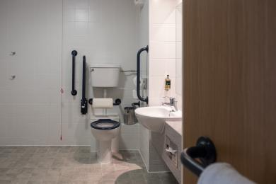
Burleigh Court_accessible bathroom
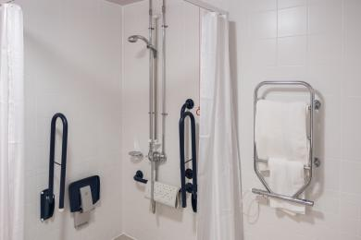
Burleigh Court_walk in shower

Lounge

Lounge
- From the main entrance to the lounge, there is level access. The route is 2700mm wide, or more. The door is 1700mm wide.
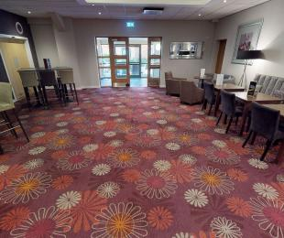
Burleigh Court_lounge

Bar

Bar
- From the main entrance to the bar, there is level access. The route is 2700mm wide, or more.
- The door is 1700mm wide.
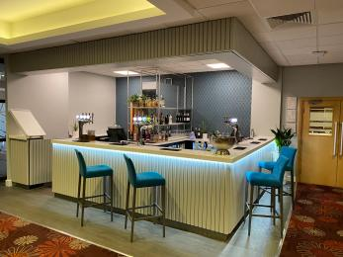
Burleigh Court_bar

Swimming pool

Burleigh Springs pool
- From the main entrance to the swimming pool changing area, there is level access. The route is 2700mm wide, or more.
- The door is 1700mm wide.
- There is a wide changing cubicle, for wheelchair users.
- From changing area to the swimming pool, there is level access. The route is 800mm wide, or more.
- The door is 800mm wide.
- The swimming pool has a hoist.
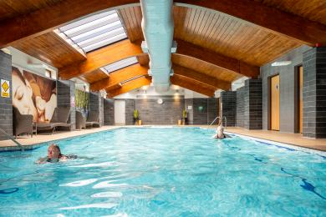
Burleigh Springs_pool

Gym

Gym
- From the main entrance to the gym changing area, there is level access. The route is 1100mm wide, or more.
- The door is 800mm wide.
- There is a wide changing cubicle for a wheelchair user.
- From the changing area to the gym, there is level access. The route is 100mm wide, or more.
- The door is 800mm wide.
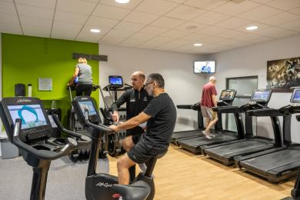
Burleigh Springs_gym

Public toilet

Disabled toilets
- There is a public toilet for disabled visitors.
- From the main entrance to the public toilet, there is level access. The route is 2000mm wide, or more.
- The toilet door is 900mm wide.
- The direction of transfer onto the toilet is to the left and right.
- There is 1000mm at the side of the toilet. There is 1000mm in front of the toilet. The toilet seat is 800mm high. The toilets have handrails.

Place to eat and drink

Restaurant
- From the main entrance to the dining area, there is level access. The route is 2700mm wide, or more. The door is 1700mm wide.
- To get to a table, there are no steps.
- If you need table service, staff can help you.
- The route through the dining area is 800mm wide, or more.
- There is background music sometimes.
- The table and plates have high colour contrast.
- We cater for sugar free (diabetic), vegetarian, gluten free (celiacs), lactose free (dairy free), nut free, vegan, kosher and halal specific diets.
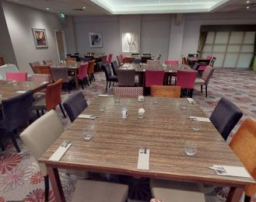
Burleigh Court_restaurant

Getting around outside

Smoking

Courtyard
- From the main entrance to the smoking area, there is level access. The route is 2700mm wide, or more.
- The entrance is 1700mm wide.
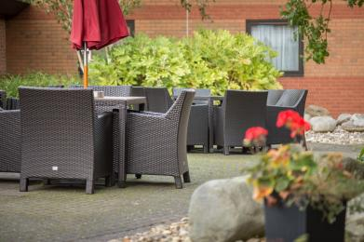
Burleigh Court_courtyard

Customer care support

Accessibility equipment
- We have a hearing loop in Reception and meeting rooms.
- Evac chair in fire exits
- For a list of more items, please go to https://www.burleigh-court.co.uk/about/access-statement/.
- We have an area to charge mobility scooters and battery powered wheelchairs.
- Reception
- You can hire mobility equipment from Mobility and Lifestyle by calling 0800 043 3342.

Emergency evacuation procedures
- We have emergency evacuation procedures for disabled visitors.
- The fire alarm has flashing lights.

Customer care support
- All staff have disability awareness training.
- Staff are available 24 hours a day.
- Night porters available from reception out of hours by calling 0 from bedroom phone

Guide last updated: 25 October 2021

