Accessibility Guide for Still Spirit
sales@stillspirit.com, 01358 747470, www.stillspirit.com
Contact for accessibility enquiries: Gregor Campbell
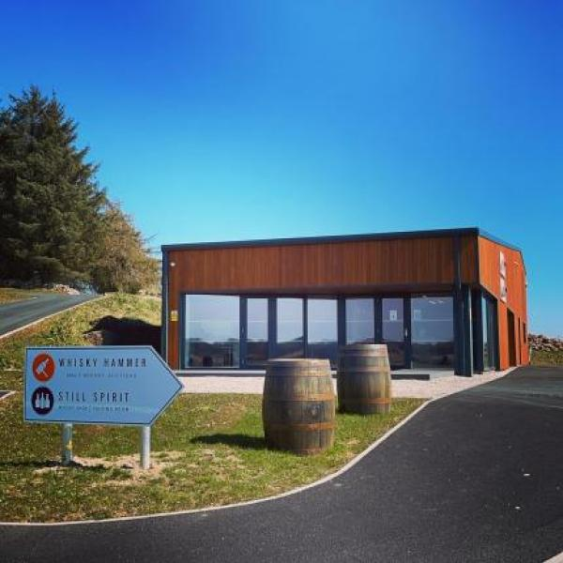

Welcome
Welcome to Still Spirit, Aberdeenshire's prestigious whisky shop and exquisite tasting room.
Visit our online shop today to browse our extensive selection of whisky, vodka and rum as well as our iconic online 'dram bar'.
If you are passing by we would also be delighted to welcome you in-store!

At a Glance

Level Access
- There is level access from the main entrance to:
  - Still Spirit

Hearing
- The fire alarm has flashing lights.
- We have a hearing loop in At checkout..
- All staff have disability awareness training.

Visual
- Glass doors and full-height windows have contrast markings.
- The walls and the doors have high colour contrast.

General
- There is at least 1 public toilet for disabled visitors.
- All staff have disability awareness training.

Getting here
Still Spirit Ltd
Whisky Hammer
Udny, Ellon
AB41 7PR

Travel by public transport
- You can get to Still Spirit by bus.
- The nearest bus stop is on the B999 in Pitmedden village. The bus stop is 0.5 miles / 0.8 km from Still Spirit.

Travel by taxi
- You can get a taxi with Pitmedden Taxis by calling 07895 328483.

Parking
- We have a car park. There are accessible parking spaces. The parking is less than 50 metres from the main entrance. Parking is free.
- There is a drop-off point at the main entrance. The drop-off point has a dropped kerb.
- From the car park to the entrance, there is level access. There is a permanent ramp.
- The route is 1800mm wide, or more.

Arrival

Path to main entrance
- From the street to the main entrance, there is level access.
- The path is 1800mm wide, or more.
- The path is sloped.

Main entrance
- The main entrance has level access.
- The door is 900mm wide.
- The main door is side hung and manual.

Getting around inside

Visual Impairment - General Information
- We have contrast markings on all glass doors, contrast markings on all full-height windows and high colour contrast between walls and doorframes.

Public toilet
- There is a public toilet for disabled visitors.
- From the main entrance to the public toilet, there is level access. The route is 1600mm wide, or more.
- The toilet door is 920mm wide.
- The direction of transfer onto the toilet is to the left.
- There is 900mm at the side of the toilet. There is 1900mm in front of the toilet. The toilets have handrails.

Shop

Still Spirit
- From the main entrance to the shop, there is level access. The route is 1600mm wide, or more. The door is 920mm wide.
- The route through the shop is 800mm wide, or more.

Customer care support

Accessibility equipment
- We have a hearing loop in At checkout..
- You can hire mobility equipment from Mobility Centre by calling 01224 699973.

Emergency evacuation procedures
- We have emergency evacuation procedures for disabled visitors.
- The fire alarm has flashing lights.

Customer care support
- All staff have disability awareness training.

Guide last updated: 20 September 2023

