Accessibility Guide for Folly View Holiday Let
merindaessex@yahoo.co.uk, 01588673191, www.follyviewlet.co.uk
Contact for accessibility enquiries: Merinda

Welcome
Folly View is a self contained holiday let sleeping four people on ground floor level.

At a Glance

Level Access
- The main entrance has 1 step. There is no lift and no ramp.
- There is level access from the main entrance to:
  - Bedroom: 1

Access with steps
- There are steps from the main entrance to:
  - Folly View Garden

Bedrooms
- We have non-allergic bedding.

Level access bedrooms
- From the main entrance to the bedroom, there is level access.
- The route to the bedroom is 750mm wide, or more.
- The bedroom door is 750mm wide, or more.
- There is unobstructed floor space 1200mm by 900mm, or more.

Hearing
- The (bedroom) TVs have subtitles.
- Some staff have BSL training.

Visual
- Glass doors and full-height windows have contrast markings.
- The walls and the doors have high colour contrast.

General
- Staff are available 24 hours a day.
- We have emergency evacuation procedures for disabled visitors.

Getting here
Orchard House
Clun Road
Craven Arms
SY7 9QS

Travel by public transport
- You can get to Folly View Holiday Let by bus and train.
- The nearest bus stop is on the A49, half a mile away from Folly View. The bus stop is 0.0 miles / 0.0 km from Folly View Holiday Let.
- The nearest train station is Craven Arms Railway Station is half a mile away. The train station is 0 miles / 0.0 km from Folly View Holiday Let.

Parking
- We have a car park. There are accessible parking spaces. The parking is less than 50 metres from the main entrance. Parking is free.
- From the parking to the main entrance, there is 1 step. There is no ramp and no lift. There is a small step from the car parking area onto the footpath, the path has a very slight slope for drainage.

Arrival

Path to main entrance
- From the street to the main entrance, there is 1 step. There is no ramp and no lift.
- The path is sloped.

Main entrance
- The door is 750mm wide.
- The main entrance has 1 steps.
- The main door is side hung and manual.
- When you arrive, we can help carry your luggage.
- There is a small step from the car parking area onto the foot path, which also has a slight slope.
There is one step, 19 cm high into Folly View.
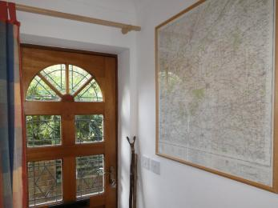
A photograph of the interior of the Folly View Entrance

Getting around inside

Visual Impairment - General Information
- We have contrast markings on all glass doors, contrast markings on all full-height windows and high colour contrast between walls and doorframes.

Bedrooms
- All bedrooms have windows.
- Bedrooms have ceiling lights, bedside lamps and natural daylight.
- Lights are energy saving. TVs have subtitles.
- All bedrooms are non-smoking.
- We have non-allergic bedding.
- All bedrooms have fitted carpets.
- We always clean thoroughly but if guests inform me of allergies before they arrive I can endeavour to make sure all soft furnishings have been cleaned and clean with non allergenic products before arrival.
- We can move the bedroom furniture, to improve accessibility.
- From the main entrance to this area, there is level access.

Accessible bedrooms

Accessible bedroom 1
- The route to the bedroom is 750mm wide, or more. The bedroom door is 750mm wide. There is 700mm at the side of the bed. The bed is 600mm high. There is 200mm under the bed.
- The bedroom is twin. The bathroom is separate. It is not an ensuite.
- The bathroom door is 660mm wide.
- The bathroom has a bath with an overhead shower. The direction of transfer onto the toilet is to the right. There is 550mm at the side of the toilet.
- There is 1280mm in front of the toilet. The toilet seat is 430mm high.
- The basin is 810mm high. There is no space under the basin.
- A stool is provided for sitting in the bathroom.
The flooring is vinyl.
There are shelves and flat survives for putting toiletries.
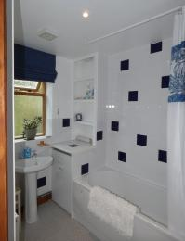
A photograph of the bathroom at Folly View

Self catering kitchen

Kitchen at Folly View
- We have an open plan kitchen.
- From the main entrance to the kitchen, there is level access.
- The route is 750mm wide, or more.
- The door is 750mm wide.
- The flooring in the kitchen area is vinyl.
It is lit with LED lighting and there is extra lighting on the extractor fan.
The table and chairs are movable.
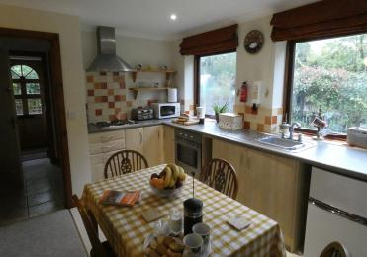
A photograph of the kitchen at Folly View

Lounge
- From the main entrance to the lounge, there is level access. The route is 750mm wide, or more. The door is 750mm wide.
- There is a sofa which seats up to three people, there is an armchair. Extra seating can be moved from the twin bedroom.
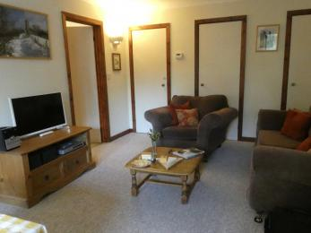
A photograph of the Living room at Folly View

Folly View Garden
- From the main entrance to this area, there is 1 step. There is no lift and no ramp.
- There is a small step down from the main entrance into the garden. There are two steps down from the patio door in bedroom one. The patio has a small step down but we are happy for the patio furniture to be moved onto the patio level with the grass.
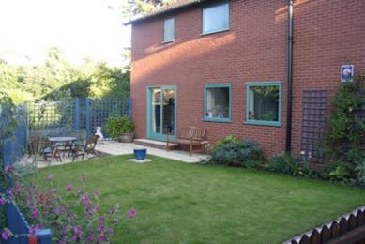
A photograph of the garden at Folly View.

Getting around outside
- From the main entrance to the area, there is 1 step.
- Ther is one step down from the main entrance into the garden. There are two steps down from the patio door in bedroom one into the garden. There is patio furniture and there is a step down onto the patio. The patio furniture an be moved onto the patio which is at the same level as the grass.
A photograph of the garden at Folly View.

Customer care support

Customer care support
- Some staff have BSL training.
- Staff are available 24 hours a day.

Guide last updated: 8 September 2021

