Accessibility Guide for Tregarthen's Hotel and Cottages
reception@tregarthens.com, 01720 422540, https://www.tregarthens.com/
Contact for accessibility enquiries: Reception Team
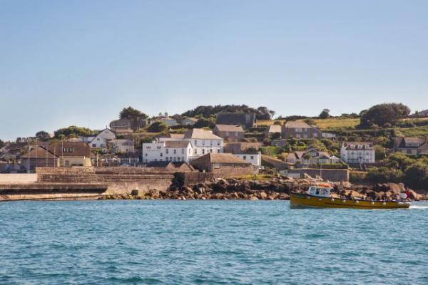

Welcome
Welcome to Tregarthen's, hotel and self catering cottages on St Mary's, Isles of Scilly, set right by the water's edge, just yards from the quay, where you can catch a boat to explore the off islands. Tregarthen's makes the perfect base for your holiday on Scilly. Isles as beautiful as these are rare, making Scilly a unique place to unwind. Enjoy fine dining in our restaurant, and relax on our Garden Terrace, where the sea views will take your breath away.
So whether you're looking for a relaxing holiday at the leading Isles of Scilly hotel, a family holiday or the ideal wedding venue, contact us today and we will help you plan your perfect Isles of Scilly escape.
Watch the video: Tregarthen's Hotel and Cottages

At a Glance

Level Access
- There is level access from the main entrance to:
  - Hotel Reception
  - Bedroom: We have 3 ground floor rooms.
  - Dining Table
  - Hotel Lounge
  - Hotel Bar
  - Hotel Toilets
  - Hotel Terrace

Bedrooms
- We have non-allergic bedding.

Level access bedrooms
- From the main entrance to the bedroom, there is level access.
- The route to the bedroom is 750mm wide, or more.
- The bedroom door is 750mm wide, or more.
- There is unobstructed floor space 1200mm by 900mm, or more.

Hearing
- The (bedroom) TVs have subtitles.
- Some staff have disability awareness training.

Visual
- Glass doors have contrast markings.
- The menu is in large print.

General
- There is at least 1 public toilet for disabled visitors.
- Staff are available 24 hours a day.
- Some staff have disability awareness training.
- We have emergency evacuation procedures for disabled visitors.

Getting here
Garrison Hill
St Mary's
TR21 0PP

Travel by public transport
- You can get to Tregarthen's Hotel and Cottages by boat or ferry.
- The nearest port is St Mary's. The port is 0.1 miles / 0.2 km from Tregarthen's Hotel and Cottages.
- The Scillonian Ferry arrives and departs from the Quay on St Mary's, a short walk from the hotel and cottages. Our porter will collect your luggage from the quayside and deliver it to your room or cottage. Flights to St Mary's airport are met by a shuttle bus service that will drop passengers in the square, near to the hotel entrance.

Travel by taxi
- You can get a taxi with DJ Cabs by calling 01720 423775.
- We have a transfer service for visitors. Wheelchair users can use the transfer service.
- Skybus transfer from St Mary's Airport to Hugh Town, dropping off in the square close to the hotel and cottages.

Parking
- There is a drop-off point at the main entrance. The drop-off point does not have a dropped kerb.
- Local taxis can drop off close to the hotel entrance.

Arrival

Path to main entrance
- From the street to the main entrance, there is 1 step. There is no ramp and no lift.

Main entrance
- The main entrance has level access.
- The door is 1600mm wide.
- The main door is side hung and manual.
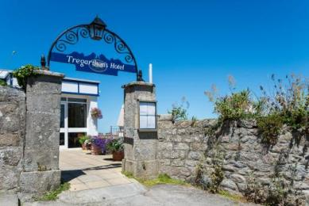
Hotel Entrance from Garrison Hill
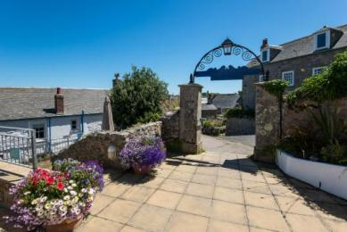
Hotel Entrance looking back to Garrison Hill
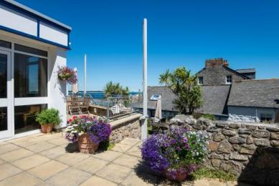
Hotel Front Door

Getting around inside

Visual Impairment - General Information
- We have contrast markings on all glass doors.

Hotel Reception
- From the main entrance to reception, there is level access. The check-in desk has a low section for wheelchair users. You can sit down at reception.
- Located adjacent to the lounge, allowing plenty of space to check in at leisure. We encourgae guests to take a seat on arrival and we can check you in there, rather than at the desk.
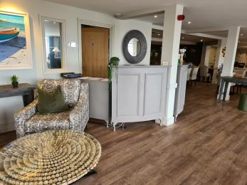
Hotel Reception Area
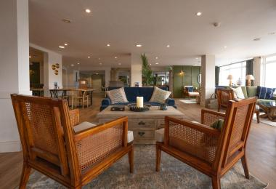
Hotel Lounge

Bedrooms
- All bedrooms have windows.
- Bedrooms have ceiling lights, wall lights, floor standing lights, bedside lamps, desk or table lamps and natural daylight.
- Lights are LED and energy saving. TVs have subtitles.
- All bedrooms are non-smoking.
- We have non-allergic bedding.
- All bedrooms have fitted carpets.
- To try to accommodate guests with food allergies or sensitivities, please inform us and we will make every effort to adhere to your requests.
- We can move the bedroom furniture, to improve accessibility.
- From the main entrance to this area, there is level access.
- We have bathrooms with a bath and overhead shower.

Accessible bedrooms

Accessible bedroom We have 3 ground floor rooms.
- The route to the bedroom is 750mm wide, or more. The bedroom door is 750mm wide. There is 0mm under the bed.
- The bedroom is flexible (either double or twin). The bathroom is ensuite. The bathroom door is 750mm wide.
- The bathroom has a separate shower. The shower has a handrail.
- There is space under the basin, with no pedestal or boxing.

Lounge

Hotel Lounge
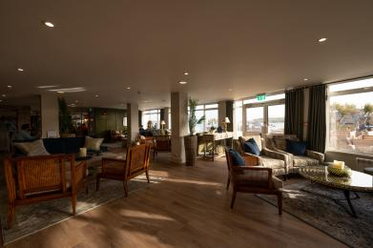
Hotel Lounge
- From the main entrance to the lounge, there is level access. The route is 1600mm wide, or more.

Bar

Hotel Bar
- From the main entrance to the bar, there is level access. The route is 1600mm wide, or more.
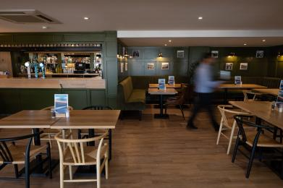
Hotel Bar

Public toilet

Hotel Toilets
- There is a public toilet for disabled visitors.
- From the main entrance to the public toilet, there is level access. The route is 800mm wide, or more.
- The toilet door is 800mm wide.
- The direction of transfer onto the toilet is to the front only.
- The toilets have handrails.
- We have an Ambulant toilet facility located near to the hotel entrance.
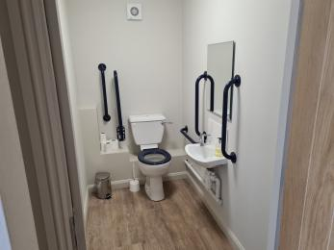
Accessible Toilet

Place to eat and drink

Hotel Restaurant
- From the main entrance to the dining area, there is level access. The route is 1600mm wide, or more. To get to a table, there are no steps.
- The menu is offered in large print.
- The route through the dining area is 800mm wide, or more.
- There is background music sometimes.
- We cater for sugar free (diabetic), vegetarian, gluten free (celiacs), lactose free (dairy free), nut free, low fat and vegan specific diets.
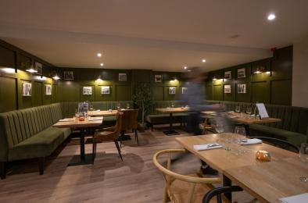
Hotel Restaurant

Cottages
- Some of the cottages are old buildings with narrow entrances and low ceilings. Please ask about the suitability of the cottage you are looking at staying in.
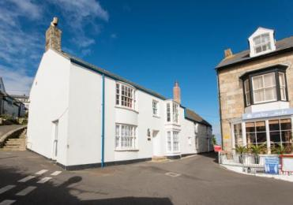
Starboard Light Cottage
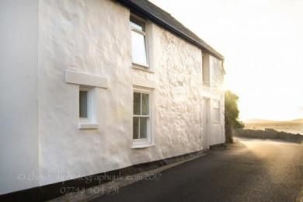
Port Light Cottage
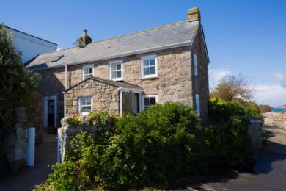
Gibson Cottage
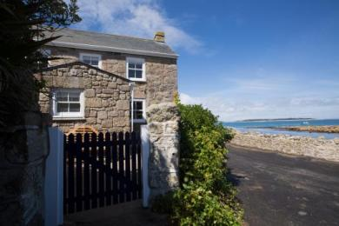
Hendra Cottage
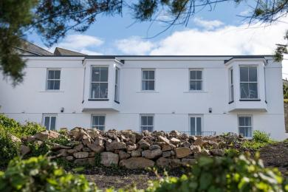
Gerwick and Gweal Cottages

Getting around outside

Terrace

Hotel Terrace
- From the main entrance to this area, there is level access. The route is 1600mm wide, or more.
- To get to a table, there are no steps.
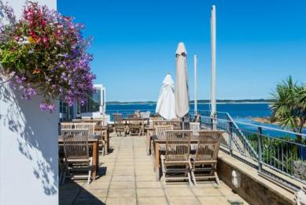
Hotel Terrace
Entrance to Hotel Terrace

Customer care support

Accessibility equipment
- Grab rails are available for use in hotel and cottage bathrooms on request.
- We have an area to charge mobility scooters and battery powered wheelchairs.
- We are happy to charge mobility scooters for guests.

Emergency evacuation procedures
- We have emergency evacuation procedures for disabled visitors.

Customer care support
- Some staff have disability awareness training.
- Paper based and digital local area information is available.
- Staff are available 24 hours a day.

Guide last updated: 9 June 2023

