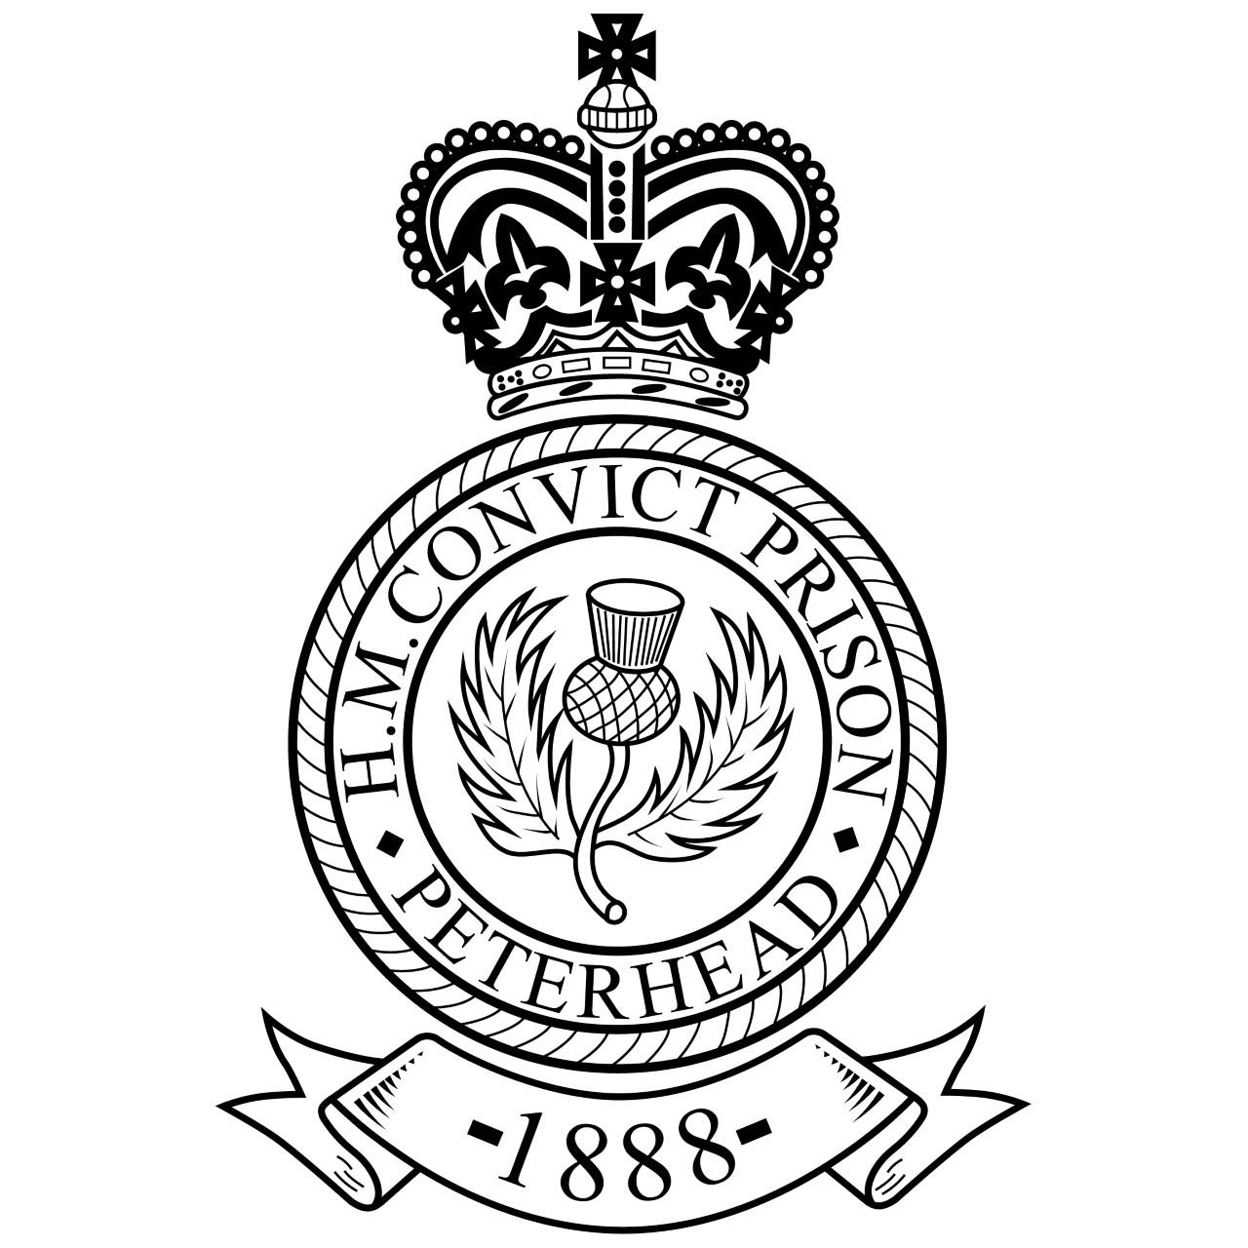

Accessibility Guide for Peterhead Prison Museum
heritage.hub@admiraltygateway.com, 01779581060, www.peterheadprisonmuseum.com
Contact for accessibility enquiries: Alex Geddes
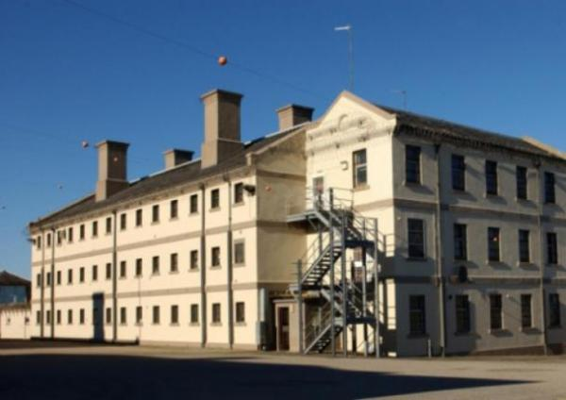

Welcome
We have created this Access Guide to outline the facilities and services we offer all our visitors
The Peterhead Prison Museum, Admiralty Gateway, South Road, Peterhead, Aberdeenshire, AB42 2ZX.
Grid Reference: NK135465
The Peterhead Prison Museum is a 5* Visitor Attraction located in Peterhead the largest town in NE Scotland.
Opening in 1888 and closing in 2013 it is known as "Scotland's Alcatraz" and is Scotland's only "Convict Prsion" and is unique in many ways.
Whether you take the full tour, or just visit our shop or award winning cafe we guarantee an experience not to be missed.
Watch the video: The experience

At a Glance

Level Access
- There is level access from the main entrance to:
  - Admission area
  - Picnic Area
  - Outside the main entrance
  - Heading outdoors
- There is level access from the car park to:
  - Relaxation

Hearing
- The fire alarm has flashing lights.
- We have a hearing loop in Main reception, admissions and cafe counter areas'..
- Some staff have BSL and disability awareness training.

Visual
- Glass doors and full-height windows have contrast markings.

General
- We have a complimentary ticket policy for personal assistants.
- Some staff have disability awareness training.

Getting here
Admiralty Gateway
South Road
Peterhead
AB422ZX

Travel by public transport
- You can get to Peterhead Prison Museum by bus.
- The nearest bus stop sits outside our main entrance and supports not only local bus services but those to and from Aberdeen City. The bus stop is 0.0 miles / 0.0 km from Peterhead Prison Museum.
- The bus stop sits outside our main reception area.

Travel by taxi
- You can get a taxi with Central Taxis by calling 01779434343. The taxi company has a wheelchair accessible vehicle.
- You can get a taxi with Astra Cabs by calling 01779499499. The taxi company has a wheelchair accessible vehicle.

Parking
- We have a car park. The parking is less than 50 metres from the main entrance. Parking is free.
- There is a drop-off point at the main entrance. The drop-off point does not have a dropped kerb.
- From the car park to the entrance, there is level access. The route is 1300mm wide, or more.
- There are clearly marked disabled parking spaces outside the main entrance, however the whole driveway is allocated to disabled parking suitable for a further 6 vehicles if required.
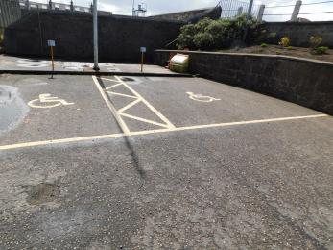
Parking bays

Arrival

Path to main entrance
- From the street to the main entrance, there is level access.
- The path is 1200mm wide, or more.
- The path is sloped.

Main entrance
- The main entrance has level access.
- The door is 800mm wide.
- The main door is side hung and manual.
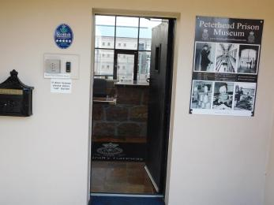
Main Door

Getting around inside

Visual Impairment - General Information
- We have contrast markings on all glass doors and contrast markings on all full-height windows.

Things to See and Do
- We have a complimentary ticket policy for personal assistants.

Admission area
- From the main entrance to this area, there is level access. There is a permanent ramp. The route is 4000mm wide, or more. The door is 850mm wide.
- Some display information is low, for wheelchair users. There are seats.
- There is a hearing loop.

Picnic Area
- From the main entrance to this area, there is level access. There is a permanent ramp. The route is 800mm wide, or more.
- The door is 800mm wide.
- Only open when weather permits.

Getting around outside

Picnic Area

Relaxation
- From the car park to the picnic area, there is level access. There is a permanent ramp. The path is 800mm wide, or more.
- The entrance is 800mm wide.
- Some tables have space for wheelchair users.
- Table service available if required.Area only open during summer months.

Smoking

Outside the main entrance
- From the main entrance to the smoking area, there is level access. The route is 4000mm wide, or more.

Heading outdoors
- From the main entrance to this area, there is level access. There is a permanent ramp. The route is 900mm wide, or more. The entrance is 800mm wide.

Customer care support

Accessibility equipment
- We provide wheelchairs. Wheelchairs are free.
- We have a hearing loop in Main reception, admissions and cafe counter areas'..
- Please note due to the low level parts within the grounds mobility scooters are not suitable, however on prior booking a standard wheelchair can be booked if required.
- Any external space is allowed within the grounds.

Emergency evacuation procedures
- We have emergency evacuation procedures for disabled visitors.
- The fire alarm has flashing lights.

Customer care support
- Some staff have disability awareness training.
- Some staff have BSL training.

Guide last updated: 19 May 2021

