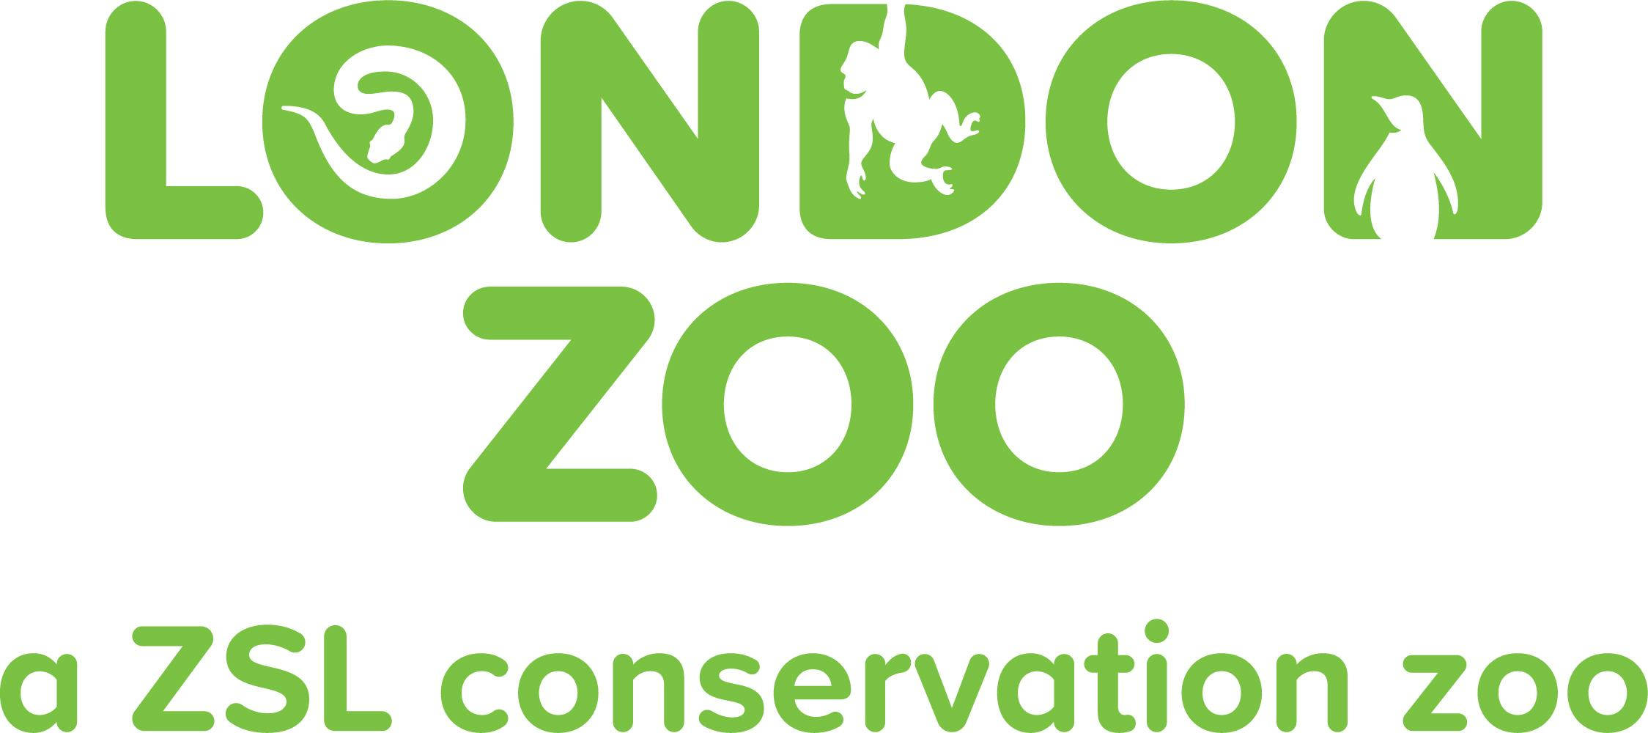

Accessibility Guide for London Zoo
general.enquiries@zsl.org, 0344 225 1826, www.londonzoo.org
Contact for accessibility enquiries: Supporter Contact team

Welcome
London Zoo is the world's oldest scientific zoo. It was opened in London on 27 April 1828, and was originally intended to be used as a collection for scientific study. In 1831 or 1832, the animals of the Tower of London menagerie were transferred to the zoo's collection. It was opened to the public in 1847. Today, it houses a collection of 673 species of animals, with 19,289 individuals, making it one of the largest collections in the United Kingdom. The zoo is sometimes called Regent's Zoo.
Watch the video: London Zoo - Accessibility

At a Glance

Level Access
- The main entrance has level access with a ramp. The ramp is permanent.
- There is level access from the main entrance to:
  - Dining Table
  - Gorilla Kingdom
  - Tiger Territory
  - The Outback
  - Attenborough Komodo Dragon House
  - Reptile House
  - Into Africa
  - In with the Lemurs
  - Rainforest Life
  - Happy Families
  - The Farmyard
  - Animal Adventure
  - Blackburn Pavillion
  - Land of Lions
  - Tiny Giants
  - In with the Monkeys
  - Butterfly Paradise
  - Penguin Beach
  - Giants of the Galápagos
  - Admissions
  - Aquarium Toilets
  - Sulawesi Crested Macaque/Aviary Toilets
  - The Terrace Restaurant Toilets
  - Toilets opposite Tiny Giants
  - Animal Adventure Toilets - By Splash Zone
  - Into Africa Toilets
  - Beach Hut
  - Barclay Court
- There is level access from the car park to:
  - Main Lawn

Visual
- Some parts of the venue have low lighting.

General
- We have a concessionary rate for disabled visitors.
- We have a complimentary ticket policy for personal assistants.
- There is at least 1 public toilet for disabled visitors.At least one toilet is a Changing Places toilet.
- Some staff have disability awareness training.

Getting here
London Zoo,
Regent’s Park,
LONDON
NW1 4RY

Travel by public transport
- You can get to London Zoo by bus and train.
- The closest bus top to our main entrance is: London Zoo (Stop B) Prince Albert Road, London, NW1 7ST The bus stop is 0.3 miles / 0.5 km from London Zoo.
- The nearest train station is Camden Town or Chalk Farm underground Stations. The train station is 0.8 miles / 1.3 km from London Zoo.
- Chalk Farm and Camden Town underground stations 0.8 miles from the zoo, and both stations are on the Northern Line.
Regents Park Underground station is 1.3 miles away from the zoo on the Bakerloo Line

Parking
- There is parking near the venue. There are accessible parking spaces. The parking is less than 50 metres from the main entrance. Parking is not free.
- There is a drop-off point at the main entrance. The drop-off point does not have a dropped kerb.
- From the car park to the entrance, there is level access. The route is 900mm wide, or more.
- There is a disabled parking bay in front of the entrance to the Zoo, and disabled visitors can also park on the main road for up to four hours. We do also have disabled parking spaces in the main car park.
We have a portable ramp at our main entrance for wheelchair users as there is not a drop kerb by the main gate. If you are parking at the main car park there is a route with drop kerbs right up to the main gate.

Arrival

Path to main entrance
- From the street to the main entrance, there is level access.
- The path is 970mm wide, or more.

Main entrance
- The main entrance has level access.
- There is a permanent ramp.
- The recommended route from the main car park, which is an estimated as a 6 minute walk, is:
Follow the pedestrian path from the car park to the Outer Circle.
Continue to travel west on the Outer Circle until you reach the traffic lights.
Cross the road at the traffic lights as there is a drop kerb here.
Continue to heading west on the Outer Circle until you reach the main entrance of the zoo.
The path has a few minor bumps, but is wide enough for these to be avoided.

Getting around inside

Visual Impairment - General Information
- Some parts of the venue have low lighting.

Lift
- We have 5 lifts.
- You can get a lift to all floors.

2 lift is Land of Lions, 1 in Tiger Territory, 1 in the foyer of the rainforest down to Nightlife and 1 in the Terrace Restaurant
- The lift is a platform lift.
- The lift says the floor number at each floor.
- Land of Lion near the play area and the Tiger Territory lifts are currently out of order. We apologise for any inconvenience caused.

Ticket/ information desk

Admissions
- From the main entrance to the desk, there is level access. The route is 900mm wide, or more.
- This area is where you show your tickets and have your bags checked. Currently all tickets need to be bought online before arrival.
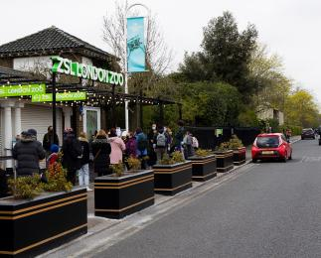
ZSL London Zoo Main Entrance

Things to See and Do
- We have a concessionary rate for disabled visitors.
- We have a complimentary ticket policy for personal assistants.
- We have performances with: audio-described, British Sign Language interpreted and relaxed.

Gorilla Kingdom
- From the main entrance to this area, there is level access. The route is 1450mm wide, or more. Some display information is low, for wheelchair users. Videos have subtitles.
- This exhibit is mostly outdoors with a indoor viewing area.
Our Gorilla Kingdom brings the African rainforest to the heart of London. You’ll be able to meet Africa’s most exciting residents, featuring our colony of western lowland gorillas. This is one encounter you’ll be sure to remember.
You may also meet our Colobus Monkeys, Mangabeys and Macaques.
This exhibit can be very busy at times.
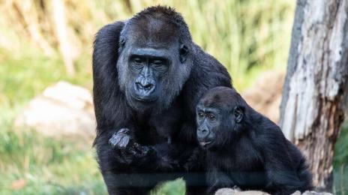
Gorilla Kingdom

Tiger Territory
- From the main entrance to this area, there is level access. There is a permanent ramp. There is a lift.
- From the lift to this area, the route is 920mm wide, or more. Some display information is low, for wheelchair users. There are seats.
- This exhibit is mostly outdoors but has some covered areas.
Visitors to Tiger Territory will embark on a journey through an Indonesian habitat, coming face-to-face with our tigers through the floor-to-ceiling glass windows. You may also meet our gibbons.
When leaving Tiger Terriorty there are 2 sheltered benches. It is often quiet and relaxing in this area.
Tiger Terriority Lift near the camels is currently out of order. However you can still viist this exhibit via the ramps if you use a wheelchair.
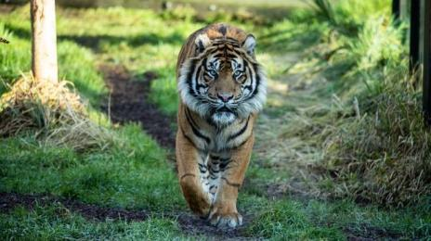
Tiger Territory

The Outback
- From the main entrance to this area, there is level access. There is a permanent ramp. The route is 1330mm wide, or more. Some display information is low, for wheelchair users. There are seats.
- This is exhibit is outdoors, however there is a covered area in front of the Mappin Pavillion function room.
This is a quiet area of the zoo where you can visit our emus and wallabys.
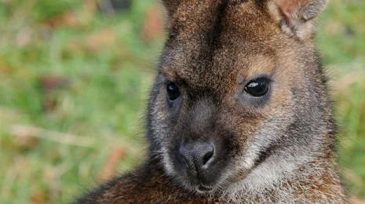
The Outback

Attenborough Komodo Dragon House
- From the main entrance to this area, there is level access. There is a permanent ramp. The route is 1400mm wide, or more. The door is 1200mm wide.
- Some display information is low, for wheelchair users. There are seats.
- The komodo dragon exhibit is indoors.
Come face to face with our dragon prowling his state-of-the-art dragon's lair, and enjoy panoramic views through an unbroken sweep of more than 20 metres of dragon-proof glass.
This area can be busy and noisy at times.
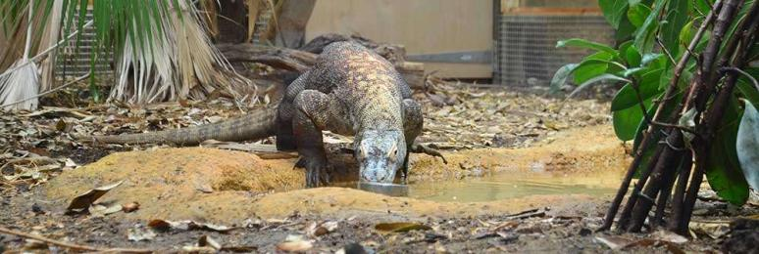
Komodo Dragon

Reptile House
- From the main entrance to this area, there is level access. There is a permanent ramp. The route is 2500mm wide, or more. The door is 1450mm wide.
- Some display information is low, for wheelchair users. Videos have subtitles.
- This is an indoor exhibit and is quite dark.
Enter the Reptile House to find ZSL London Zoo's amazing collection of reptiles and amphibians, including snakes, lizards, frogs and crocodiles!
Please be aware that there is a small raised area at the back of the reptile house that is only accessed via stairs and is not accessible to wheelchair users, however there is plenty to see and interactive with on the main floor.
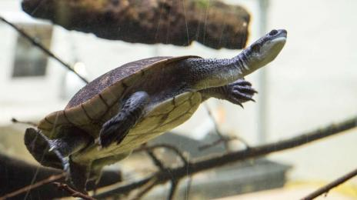
Reptile House

Into Africa
- From the main entrance to this area, there is level access. There is a permanent ramp. The route is 2000mm wide, or more. Some display information is low, for wheelchair users. There are seats.
- Videos have subtitles.
- Most of this exhibit is an outdoors, but there are some sections which are indoors, they are the Giraffe House, the Okapi House and the Hippo Hot Tub. The doors to these are at least 1400mm wide.
Into Africa offers the opportunity to come eye to eye with some of Africa’s most unusual animals. Giraffes, zebras, okapis, pygmy hippos, warthogs and African hunting dogs all feature in this exciting exhibit.
This area is often less busy than the rest of the zoo. The internal houses are darker then other area's of this exhibit.
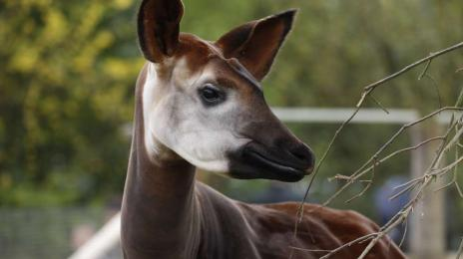
Into Africa

In with the Lemurs
- From the main entrance to this area, there is level access. There is a permanent ramp. The route is 2000mm wide, or more. The door is 1280mm wide.
- Some display information is low, for wheelchair users. There are seats.
- In with the Lemurs is a outdoor walk-through exhibit at ZSL London Zoo, where visitors can get closer than ever before to our ring-tail lemurs
Once you have passed through the outdoor area, you will enter the indoor lemur enclosure. Inside the building, it is quite dark, with overhead tunnels to enable the lemurs to access other parts of the enclosure.
Towards the back on the right of the enclosure there is the Madagascar at Night area, which is home to the aye ayes. This is a small, dark, quiet space with hand rails to guide you through. There are red lights in some of these exhibits as they are nocturnal animals.
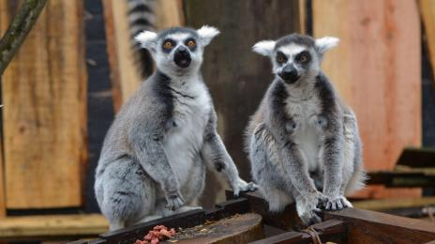
In with the Lemurs

Rainforest Life
- From the main entrance to this area, there is level access. There is a permanent ramp. The route is 2000mm wide, or more. The door is 1570mm wide.
- Some display information is low, for wheelchair users.
- See animals in a different light at Rainforest Life, ZSL London Zoo’s exciting indoor exhibit.
Enter London’s only living rainforest where you can come face-to-face with a variety of amazing rainforest species including monkeys, sloths, and tamanduas.
This area is frequently busy, and is hot and humid.
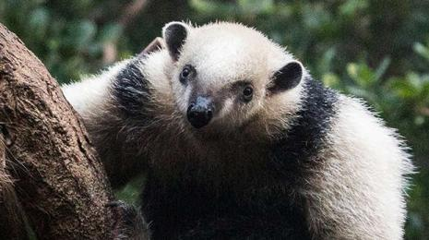
Rainforest Life

Night Life
- There is a lift.
- From the lift to this area, the route is 1130mm wide, or more.
- This is an indoor exhibit below Rainforest Life.
Step out of the light and into the ‘Night Life’ area, where you’ll discover the slender loris, rats and nocturnal wonders who make the dark their home.
This is a dark, quiet exhibit. There is a lift or staircase down to NIghtlife.
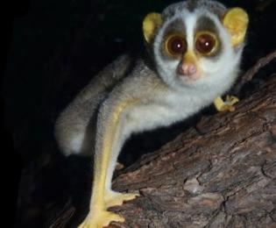
Night Life

Happy Families
- From the main entrance to this area, there is level access. There is a permanent ramp. The route is 2600mm wide, or more. Some display information is low, for wheelchair users. There are seats.
- This is an outdoor exhibit with 4 enclosures, one of which is a Grade 2 listed building, which is currently empty.
Here you will find our otter and meerekat families.
This area is often quiet.
There are some steps down to the side of the otter pool but this can also be viewed from the top of the steps. The otter holt is a small, dark indoor area. The entrance to the holt is approximately 1000mm wide with room to fit wheelchairs or mobility scooters inside.
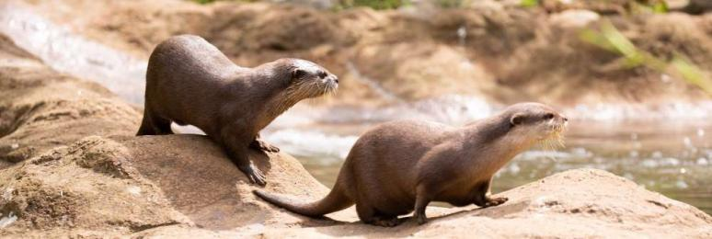
Happy Families

The Farmyard
- From the main entrance to this area, there is level access. The route is 1500mm wide, or more. Some display information is low, for wheelchair users.
- This is an outdoor exhbit.
Before entering the exhibit you will pass by our camels.
Once inside you may see our llamas, alpacas, before passing through our goat paddock.
This can often be a busy area.
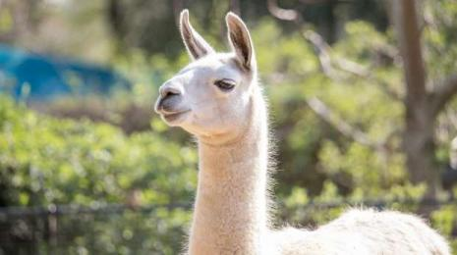
The Farmyard

Animal Adventure
- From the main entrance to this area, there is level access. The route is 1280mm wide, or more. The door is 1280mm wide.
- Some display information is low, for wheelchair users. There are seats.
- This is an outdoor play area and splash zone.
This area includes a catering kiosk offering hot drinks, snacks and tempting extras so you can relax and refuel, ready for exploring the rest of the Zoo.
It is also home to our coatis, meerkats and porcupines.
You will also find our Changing Places toilet here
This area can be very busy.
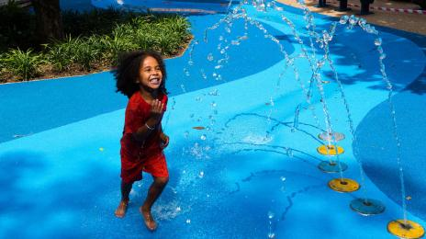
Animal Adventure
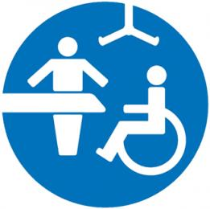
Changing Place

Blackburn Pavillion
- From the main entrance to this area, there is level access. There is a permanent ramp. The route is 2600mm wide, or more. The door is 1200mm wide.
- Some display information is low, for wheelchair users. There are seats.
- This is an indoor walkthrough exhibit.
An important part of ZSL London Zoo’s heritage, Blackburn Pavilion provides a tranquil home for more than 50 different species of birds. Originally built in 1883 as a Reptile House, this marvellous Victorian building has been restored to provide our flocks with a splendid place to spread their wings.
This is one of the quiest areas of the Zoo.
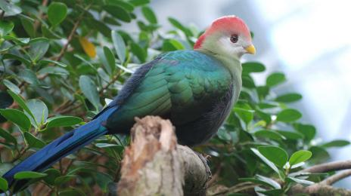
The Blackburn Pavillion

Land of Lions
- From the main entrance to this area, there is level access. There is a permanent ramp. There is a lift.
- From the lift to this area, the route is 1100mm wide, or more. The door is 1100mm wide.
- Some display information is low, for wheelchair users. There are seats.
- This mostly an an outdoor exhibit with some covered areas.
Three walkways cover the 2,500sqm exhibit, with thrilling, immersive Indian-themed areas to explore - including a train station, crumbling temple clearing, high street and guard hut.
There are 2 lifts at either end of the exhibit as well as ramps and stairs leading up to the top level. Both lifts are big enough to carry large wheelchairs or mobility scooters. The lift at the Blackburn Pavillion End of Land of lions is currently out of order, but we hope will be fixed in the next few days.
This exhibit is home to our lions and Hanuman langur monkeys.
The house is a dark area but the rest of the enclosure is outdoor,
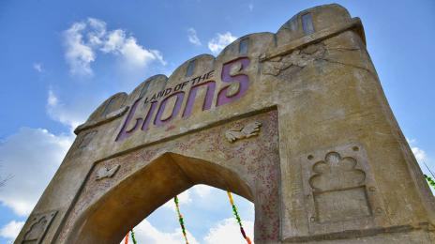
Land of Lions

Tiny Giants
- From the main entrance to this area, there is level access. There is a permanent ramp. The route is 2600mm wide, or more. The door is 1450mm wide.
- Some display information is low, for wheelchair users. There are seats.
- This is an indoor exhibit
Shining a spotlight on the planet’s smallest superheroes: from underwater corals and the aquatic wildlife they support, to industrious leafcutter ants, spiders and beetles – the exhibit celebrates the species we quite literally couldn’t live without. It is also home to spider walkthrough (in a enclosed space) as well as our new coral reef.
This is a dark and quieter area of the Zoo.
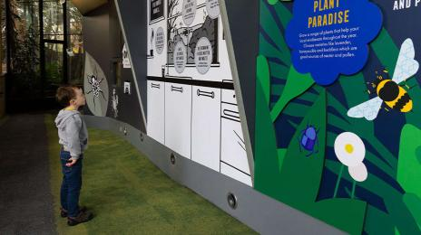
Tiny Giants

In with the Monkeys
- From the main entrance to this area, there is level access. There is a permanent ramp. The route is 2600mm wide, or more. The door is 950mm wide.
- Some display information is low, for wheelchair users.
- This is an outdoor walkthrough exhibit.
The enclosure covers an area of 1500m² and houses a breeding group of black-capped squirrel monkeys, in a habitat designed to recreate the Bolivian rainforests as closely as possible in the centre of London.
This exhibit is often busy.
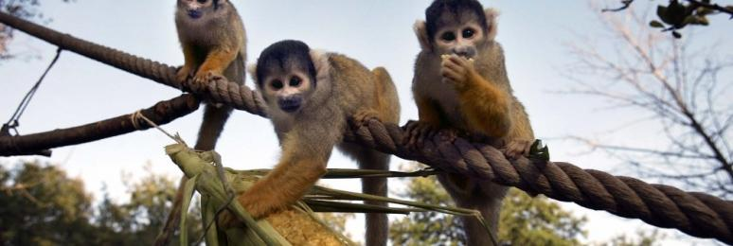
In with the Monkeys

Butterfly Paradise
- From the main entrance to this area, there is level access. The route is 1650mm wide, or more. The door is 1770mm wide.
- Some display information is low, for wheelchair users. There are seats.
- This is an indoor, warm and humid exhibit.
The exterior of the exhibit is shaped like a giant caterpillar, entering through the mouth of the caterpillar, visitors are immersed into a world of amazing and beautiful butterflies and moths from around the globe. Lose yourself in the rich variety of species as they delicately flutter around you, seeking out plants on which to feed and rest.
This is an often busy exhibit.
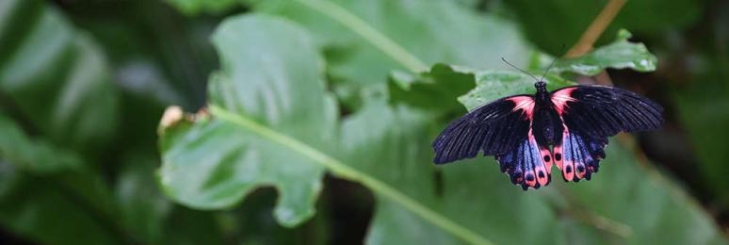
Butterfly Paradise

Penguin Beach
- From the main entrance to this area, there is level access. There is a permanent ramp. The route is 1270mm wide, or more. Some display information is low, for wheelchair users. There are seats.
- This is an outdoor exhibit.
Penguin Beach recreates a South American beach landscape in the heart of London, with stunning colony of Humboldt penguins.
This is a busy exhibit.
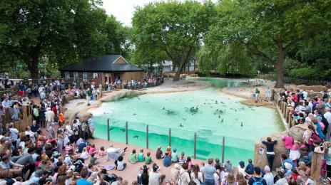
Penguin Beach

Giants of the Galápagos
- From the main entrance to this area, there is level access. The route is 28000mm wide, or more. The door is 2000mm wide.
- Some display information is low, for wheelchair users.
- When visiting the tortoises in Giants of the Galápagos you will be transported to the famous archipelago, surrounded by the sights and sensations of the pristine, isolated island chain.
Stroll through the island, while Dolly, Polly and Priscilla roam the forest just feet away, basking in the warmth of the 27degree tropical atmosphere - the perfect temperature for the 26-year-olds, who have an expected life span of over 100 years.
Explore the long life cycle of a giant Galápagos tortoise, to discover how tiny hatchlings the size of a hamster eventually grow into the biggest tortoises in the world; learn how giant tortoises went from roaming almost every continent on Earth to being marooned on islands 1000km from the nearest mainland – and how they evolved to survive.
This is a indoor warm exhibit.
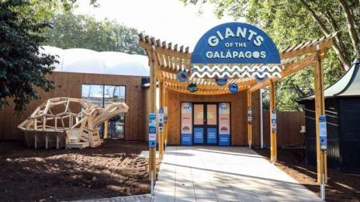
Giants of the Galápagos

Public toilet

Aquarium Toilets
- There is a public toilet for disabled visitors.
- From the main entrance to the public toilet, there is level access. The route is 900mm wide, or more.
- The toilet door is 850mm wide.
- The direction of transfer onto the toilet is to the right.
- There is 900mm at the side of the toilet. There is 200mm in front of the toilet. The toilet seat is 460mm high. The toilets have handrails.
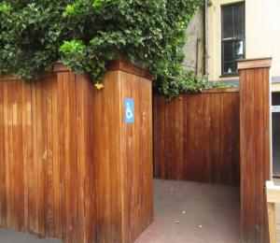
Aquarium Disabled Toilet

Public toilet

Sulawesi Crested Macaque/Aviary Toilets
- There is a public toilet for disabled visitors.
- From the main entrance to the public toilet, there is level access. There is a permanent ramp.
- The route is 2000mm wide, or more.
- The toilet door is 810mm wide.
- The direction of transfer onto the toilet is to the left.
- There is 950mm at the side of the toilet. There is 1500mm in front of the toilet. The toilet seat is 480mm high. The toilets have handrails.
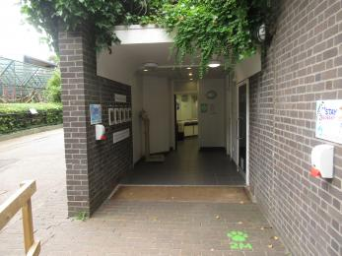
Sulawesi Crested Macaque/Aviary Toilets

Public toilet

The Terrace Restaurant Toilets
- There is a public toilet for disabled visitors.
- From the main entrance to the public toilet, there is level access. There is a permanent ramp.
- The route is 1500mm wide, or more.
- The toilet door is 850mm wide.
- The direction of transfer onto the toilet is to the left.
- There is 950mm at the side of the toilet. There is 1500mm in front of the toilet. The toilet seat is 460mm high. The toilets have handrails.
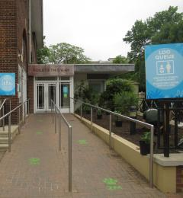
The Terrace Restaurant Toilets

Public toilet

Toilets opposite Tiny Giants
- There is a public toilet for disabled visitors.
- From the main entrance to the public toilet, there is level access. The route is 2000mm wide, or more.
- The toilet door is 820mm wide.
- The direction of transfer onto the toilet is to the left and right.
- There is 950mm at the side of the toilet. There is 1500mm in front of the toilet. The toilet seat is 480mm high. The toilets have handrails.
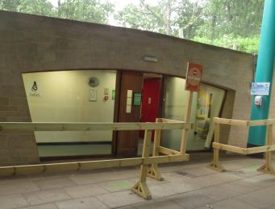
Toilets opposite Tiny Giants

Public toilet

Animal Adventure Toilets - By Splash Zone
- There is a public toilet for disabled visitors.
- The toilet is a Changing Places toilet.
- You need a RADAR key to open the public toilet.
- From the main entrance to the public toilet, there is level access. There is a permanent ramp.
- The route is 2000mm wide, or more.
- The toilet door is 1130mm wide.
- The direction of transfer onto the toilet is to the left and right.
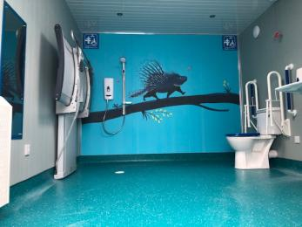
London Zoo Changing Places Toilet
- There is 950mm at the side of the toilet. There is 1500mm in front of the toilet. The toilet seat is 48mm high.

Public toilet

Into Africa Toilets
- There is a public toilet for disabled visitors.
- From the main entrance to the public toilet, there is level access. There is a permanent ramp.
- The route is 2000mm wide, or more.
- The toilet door is 820mm wide.
- The direction of transfer onto the toilet is to the front only.
- There is 1500mm in front of the toilet. The toilet seat is 460mm high. The toilets have handrails.
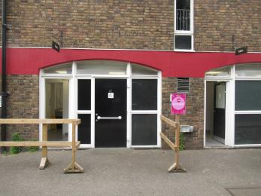
Into Africa Toilets

Shop

Zoo Shop
- The route through the shop is 800mm wide, or more.

Place to eat and drink

The Terrace Restaurant
- From the main entrance to the dining area, there is level access. There is a permanent ramp. The route is 2560mm wide, or more. The door is 1680mm wide.
- To get to a table, there are no steps.
- The dining area is self-service. If you need table service, staff can help you.
- The route through the dining area is 800mm wide, or more.
- There is no background music.
- We cater for sugar free (diabetic), vegetarian, gluten free (celiacs), lactose free (dairy free), nut free, low fat, high fibre and vegan specific diets.
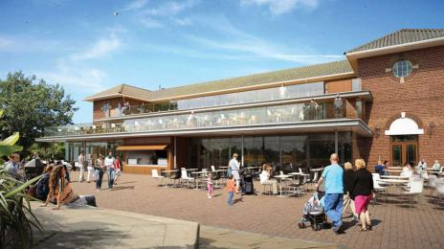
The Terrace Restaurant

Beach Hut
- From the main entrance to this area, there is level access. The route is 1000mm wide, or more.
- The Beach hut sells snacks and drinks. There is also an ATM outside. Located by penguin beach

Getting around outside

Wildlife Garden
- The route is sloped.
- The path around the Wildlife Garden is compacted sand. There are fairly steep slopes up to the upper level of the garden.

Woodland Walk
- The route is sloped.
- The paths in the woodland walk are made from bark chipping. This area is not suitable for buggies or wheelchairs.

Picnic Area

Main Lawn
- From the car park to the picnic area, there is level access. The path is 2000mm wide, or more.
- You can bring your own food to the picnic area.

Smoking

Barclay Court
- From the main entrance to the smoking area, there is level access. The route is 2000mm wide, or more.

Customer care support

Accessibility equipment
- We provide wheelchairs. There is a charge for wheelchairs.
- We have an area to charge mobility scooters and battery powered wheelchairs.
- Mobility scooters can be charged at various places, please ask a member of staff for guidance or contact the First Aid team.

Emergency evacuation procedures
- We have emergency evacuation procedures for disabled visitors.

Customer care support
- Some staff have disability awareness training.

Guide last updated: 6 September 2023

